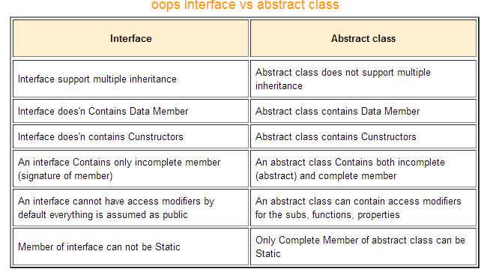

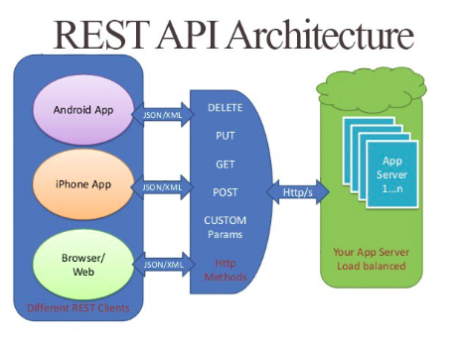

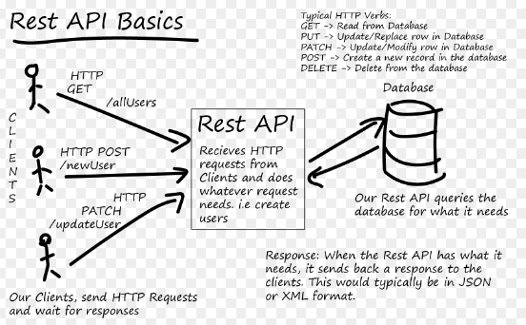

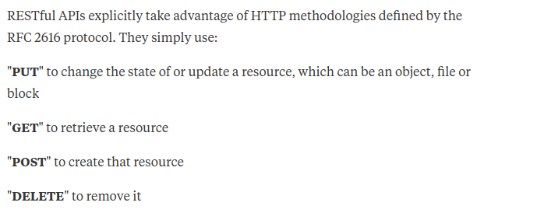

REST is a way to describe how the architecture of the Web—and other systems like it—is different.
The Web is an information network on top of the Internet, accessible through your browser. It has a different architecture than other computer systems in many ways.
REST is an architectural style to design systems like the Web. The main defining characteristic of REST are the four rules of the uniform interface. By definition, REST APIs are APIs that follow these four rules.
Rule 1: Offer access through resources.
In typical computer systems, clients and servers exchange commands: do this, do that. Suppose we want to model a to-do list in a non-REST way. In a technical language, that might look like this:
NOT REST
- /changeTodoList.php?item=35&action=changeTitle&title=new_title
Note how this is indeed an instruction: change something.
But a “changeTodoList” is not a thing, it's not a resource.
In the REST architectural style, servers only offer resources. Resources are conceptual things about which clients and servers communicate.
REST
- /todolists/7/items/35/
This above thing is not a command, it is the address of a resource, a thing.
You can then use this address to manipulate the to-do list using standard operations, instead of interface-specific commands.
Rule 2: Represent resources by representations.
A resource is a thing—and we can describe those things in different formats. For instance, humans might want to see an HTML version, which your browser transforms into a readable layout. But sometimes, interfaces on the Web are used by machines, too. They need a different format, such as JSON.
In a non-REST way, different formats have different addresses:
NOT REST
- browser: /showTodoList.php?format=html
- application: /showTodoList.php?format=json
The problem is then that systems using different formats cannot communicate with each other, because they use different addresses for the same things!
In a REST system, addresses identify things, not formats, so all systems use the same address for the same thing. How can they get different formats then? They explicitly ask for it!
REST
- browser: “I want /todolists/7/, please give me HTML.”
- application: “I want /todolists/7/, please give me JSON.”
The technique that enables this is called content negotiation.
Rule 3: Exchange self-descriptive messages.
In a REST system, we should be able to interpret any message without having seen the previous one.
Imagine the following conversation:
NOT REST
- /search-results?q=todo
- /search-results?page=2
- /search-results?page=3
The first request gets search results for “todo”; the second request gets the second page of that. Now imagine that you only see the second request. How would you know as a server what to do?
In REST, each message stands on its own:
REST
- /search-results?q=to-do
- /search-results?q=todo&page=2
- /search-results?q=todo&page=3
Note how each request can be interpreted by itself.
Another aspect of this, is that REST clients and servers only use standard operations, which are defined in a specification. For the Web, this specification is called HTTP.
Rule 4: Connect resources through links.
How can you navigate a website you've never seen before? You use links!
You don't have to manually edit the address bar in your browser every time you go to a new page.
In machine interfaces, this is not always the case. Suppose an application asks for your to-do list. It might receive the following representation:
NOT REST
- /todolists/7/
{ "name": "My to-dos", "items": [35, 36]}
Now how can you get the items of the list?
Good question! We'd have to read the documentation for that.
In REST, resources connect to each other through hyperlinks:
REST
- /todolists/7/
{ "name": "My to-dos", "items": ["/todolists/7/items/35/", "/todolists/7/items/36/"]}
Note how you don't have to read the manual to know how you can retrieve the items of your list. You just follow the links.
APIs that follow those rules are REST APIs
Follow those 4 rules in your interface, and you have a REST API.
Unfortunately, many interfaces that label themselves as “REST” are actually something else (“HTTP interfaces”), because they don't follow all of the rules. Rules 2 and 4 are often violated, but it's not entirely uncommon to see rule 1 being violated as well. For those developers, “REST” simple means “we didn't do the XML messages thing”.
This is why REST interfaces that follow all four rules are now often called “hypermedia APIs”, referring to the fourth rule.

Difference between SQL and NoSQL

Prerequisites – SQL, NoSQL
When it comes to choosing a database the biggest decisions is picking a relational (SQL) or non-relational (NoSQL) data structure. While both the databases are viable options still there are certain key differences between the two that users must keep in mind when making a decision.
The Main Differences:
- Type –
SQL databases are primarily called as Relational Databases (RDBMS); whereas NoSQL database are primarily called as non-relational or distributed database.
- Language –
SQL databases defines and manipulates data based structured query language (SQL). Seeing from a side this language is extremely powerful. SQL is one of the most versatile and widely-used options available which makes it a safe choice especially for great complex queries. But from other side it can be restrictive. SQL requires you to use predefined schemas to determine the structure of your data before you work with it. Also all of your data must follow the same structure. This can require significant up-front preparation which means that a change in the structure would be both difficult and disruptive to your whole system.
A NoSQL database has dynamic schema for unstructured data. Data is stored in many ways which means it can be document-oriented, column-oriented, graph-based or organized as a KeyValue store. This flexibility means that documents can be created without having defined structure first. Also each document can have its own unique structure. The syntax varies from database to database, and you can add fields as you go.
- The Scalability –
In almost all situations SQL databases are vertically scalable. This means that you can increase the load on a single server by increasing things like RAM, CPU or SSD. But on the other hand NoSQL databases are horizontally scalable. This means that you handle more traffic by sharding, or adding more servers in your NoSQL database. It is similar to adding more floors to the same building versus adding more buildings to the neighborhood. Thus NoSQL can ultimately become larger and more powerful, making these databases the preferred choice for large or ever-changing data sets.
- The Structure –
SQL databases are table-based on the other hand NoSQL databases are either key-value pairs, document-based, graph databases or wide-column stores. This makes relational SQL databases a better option for applications that require multi-row transactions such as an accounting system or for legacy systems that were built for a relational structure.
- Property followed –
SQL databases follow ACID properties (Atomicity, Consistency, Isolation and Durability) whereas the NoSQL database follows the Brewers CAP theorem (Consistency, Availability and Partition tolerance).
- Support –
Great support is available for all SQL database from their vendors. Also a lot of independent consultations are there who can help you with SQL database for a very large scale deployments but for some NoSQL database you still have to rely on community support and only limited outside experts are available for setting up and deploying your large scale NoSQL deployments.
Some examples of SQL databases include PostgreSQL, MySQL, Oracle and Microsoft SQL Server. NoSQL database examples include Redis, RavenDB Cassandra, MongoDB, BigTable, HBase, Neo4j and CouchDB.
Key highlights on SQL vs NoSQL:
SQL | NOSQL
RELATIONAL DATABASE MANAGEMENT SYSTEM (RDBMS) | Non-relational or distributed database system.
These databases have fixed or static or predefined schema | They have have dynamic schema
These databases are not suited for hierarchical data storage. | These databases are best suited for hierarchical data storage.
These databases are best suited for complex queries | These databases are not so good for complex queries
Verticlly Scalable | Horizontally scalable

What id thread Pool?

Thread pool is a collection of threads which are ready to execute when needed and again stored in our pool after finishing execution. because thread creation has some overhead so we create thread once and recycle it in a data structure call thread pool. e.g. server program always have thread pool where it stores thread which serve client request whenever a request come and after finish request it store again server thread pool.

ExecutorService pool = Executors.newFixedThreadPool(MAX_T);

Thread Pools in Java
Background
Server Programs such as database and web servers repeatedly execute requests from multiple clients and these are oriented around processing a large number of short tasks. An approach for building a server application would be to create a new thread each time a request arrives and service this new request in the newly created thread. While this approach seems simple to implement, it has significant disadvantages. A server that creates a new thread for every request would spend more time and consume more system resources in creating and destroying threads than processing actual requests.
Since active threads consume system resources, a JVM creating too many threads at the same time can cause the system to run out of memory. This necessitates the need to limit the number of threads being created.

What is ThreadPool in Java?
A thread pool reuses previously created threads to execute current tasks and offers a solution to the problem of thread cycle overhead and resource thrashing. Since the thread is already existing when the request arrives, the delay introduced by thread creation is eliminated, making the application more responsive.
- Java provides the Executor framework which is centered around the Executor interface, its sub-interface –ExecutorService and the class-ThreadPoolExecutor, which implements both of these interfaces. By using the executor, one only has to implement the Runnable objects and send them to the executor to execute.
- They allow you to take advantage of threading, but focus on the tasks that you want the thread to perform, instead of thread mechanics.
- To use thread pools, we first create a object of ExecutorService and pass a set of tasks to it. ThreadPoolExecutor class allows to set the core and maximum pool size.The runnables that are run by a particular thread are executed sequentially.
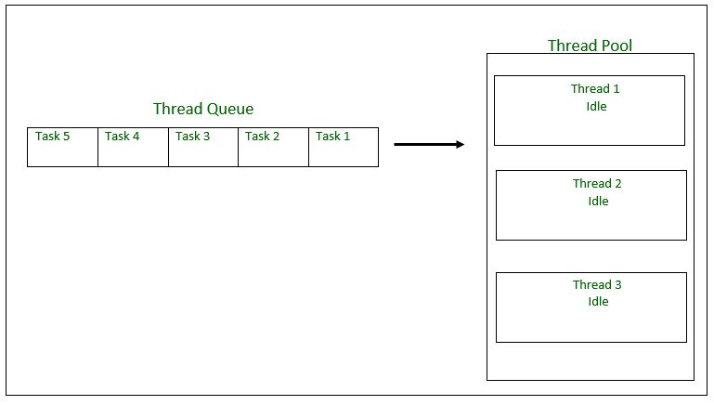
Thread Pool Initialization with size = 3 threads. Task Queue = 5 Runnable Objects
Executor Thread Pool Methods
Method Description
newFixedThreadPool(int) Creates a fixed size thread pool.
newCachedThreadPool() Creates a thread pool that creates new
threads as needed, but will reuse previously
constructed threads when they are available
newSingleThreadExecutor() Creates a single thread.
In case of a fixed thread pool, if all threads are being currently run by the executor then the pending tasks are placed in a queue and are executed when a thread becomes idle.

Thread Pool Example
In the following tutorial, we will look at a basic example of thread pool executor- FixedThreadPool.
Steps to be followed
1. Create a task(Runnable Object) to execute
2. Create Executor Pool using Executors
3. Pass tasks to Executor Pool
4. Shutdown the Executor Pool
filter_none
edit
play_arrow
brightness_4
// Java program to illustrate
// ThreadPool
import java.text.SimpleDateFormat;
import java.util.Date;
import java.util.concurrent.ExecutorService;
import java.util.concurrent.Executors;

// Task class to be executed (Step 1)
class Task implements Runnable
{
private String name;

public Task(String s)
{
name = s;
}

// Prints task name and sleeps for 1s
// This Whole process is repeated 5 times
public void run()
{
try
{
for (int i = 0; i<=5; i++)
{
if (i==0)
{
Date d = new Date();
SimpleDateFormat ft = new SimpleDateFormat("hh:mm:ss");
System.out.println("Initialization Time for"
+ " task name - "+ name +" = " +ft.format(d));
//prints the initialization time for every task
}
else
{
Date d = new Date();
SimpleDateFormat ft = new SimpleDateFormat("hh:mm:ss");
System.out.println("Executing Time for task name - "+
name +" = " +ft.format(d));
// prints the execution time for every task
}
Thread.sleep(1000);
}
System.out.println(name+" complete");
}

catch(InterruptedException e)
{
e.printStackTrace();
}
}
}
public class Test
{
// Maximum number of threads in thread pool
static final int MAX_T = 3;

public static void main(String[] args)
{
// creates five tasks
Runnable r1 = new Task("task 1");
Runnable r2 = new Task("task 2");
Runnable r3 = new Task("task 3");
Runnable r4 = new Task("task 4");
Runnable r5 = new Task("task 5");

// creates a thread pool with MAX_T no. of
// threads as the fixed pool size(Step 2)
ExecutorService pool = Executors.newFixedThreadPool(MAX_T);

// passes the Task objects to the pool to execute (Step 3)
pool.execute(r1);
pool.execute(r2);
pool.execute(r3);
pool.execute(r4);
pool.execute(r5);

// pool shutdown ( Step 4)
pool.shutdown();
}
}
Sample Execution
Output:
Initialization Time for task name - task 2 = 02:32:56
Initialization Time for task name - task 1 = 02:32:56
Initialization Time for task name - task 3 = 02:32:56
Executing Time for task name - task 1 = 02:32:57
Executing Time for task name - task 2 = 02:32:57
Executing Time for task name - task 3 = 02:32:57
Executing Time for task name - task 1 = 02:32:58
Executing Time for task name - task 2 = 02:32:58
Executing Time for task name - task 3 = 02:32:58
Executing Time for task name - task 1 = 02:32:59
Executing Time for task name - task 2 = 02:32:59
Executing Time for task name - task 3 = 02:32:59
Executing Time for task name - task 1 = 02:33:00
Executing Time for task name - task 3 = 02:33:00
Executing Time for task name - task 2 = 02:33:00
Executing Time for task name - task 2 = 02:33:01
Executing Time for task name - task 1 = 02:33:01
Executing Time for task name - task 3 = 02:33:01
task 2 complete
task 1 complete
task 3 complete
Initialization Time for task name - task 5 = 02:33:02
Initialization Time for task name - task 4 = 02:33:02
Executing Time for task name - task 4 = 02:33:03
Executing Time for task name - task 5 = 02:33:03
Executing Time for task name - task 5 = 02:33:04
Executing Time for task name - task 4 = 02:33:04
Executing Time for task name - task 4 = 02:33:05
Executing Time for task name - task 5 = 02:33:05
Executing Time for task name - task 5 = 02:33:06
Executing Time for task name - task 4 = 02:33:06
Executing Time for task name - task 5 = 02:33:07
Executing Time for task name - task 4 = 02:33:07
task 5 complete
task 4 complete
As seen in the execution of the program, the task 4 or task 5 are executed only when a thread in the pool becomes idle. Until then, the extra tasks are placed in a queue.
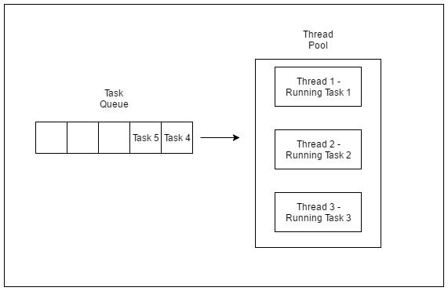
Thread Pool executing first three tasks
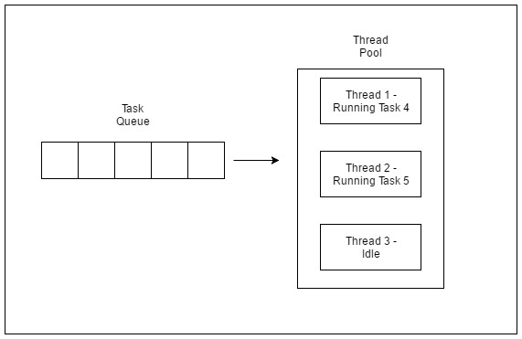
How to handle the cases where two persons are trying to access the same seat almost same time?
Lets take SeatBook and Transactions class which will be called from the main class. Here from the above code, We expand a bit the payment process which is not shown in the above code. In SeatBook class we will have reference to Transaction class also.
Now to ensure when two persons are trying to access the same seat almost at the same time then we would use Synchronized method of Thread class and will call a thread belong to each log in user.

JSP - Implicit Objects

Advertisements

Previous Page
Next Page

In this chapter, we will discuss the Implicit Objects in JSP. These Objects are the Java objects that the JSP Container makes available to the developers in each page and the developer can call them directly without being explicitly declared. JSP Implicit Objects are also called pre-defined variables.
Following table lists out the nine Implicit Objects that JSP supports −
S.No. | Object & Description
1 | request  This is the HttpServletRequest object associated with the request.
2 | response  This is the HttpServletResponse object associated with the response to the client.
3 | out  This is the PrintWriter object used to send output to the client.
4 | session  This is the HttpSession object associated with the request.
5 | application  This is the ServletContext object associated with the application context.
6 | config  This is the ServletConfig object associated with the page.
7 | pageContext  This encapsulates use of server-specific features like higher performance JspWriters.
8 | page  This is simply a synonym for this, and is used to call the methods defined by the translated servlet class.
9 | Exception  The Exception object allows the exception data to be accessed by designated JSP.

Garbage Collection in Java
Introduction
- In C/C++, programmer is responsible for both creation and destruction of objects. Usually programmer neglects destruction of useless objects. Due to this negligence, at certain point, for creation of new objects, sufficient memory may not be available and entire program will terminate abnormally causing OutOfMemoryErrors.
- But in Java, the programmer need not to care for all those objects which are no longer in use. Garbage collector destroys these objects.
- Garbage collector is best example of Daemon thread as it is always running in background.
- Main objective of Garbage Collector is to free heap memory by destroying unreachable objects.
Important terms :
- Unreachable objects : An object is said to be unreachable iff it doesn’t contain any reference to it. Also note that objects which are part of island of isolation are also unreachable.
Integer i = new Integer(4);
// the new Integer object is reachable via the reference in 'i'
i = null;
// the Integer object is no longer reachable.
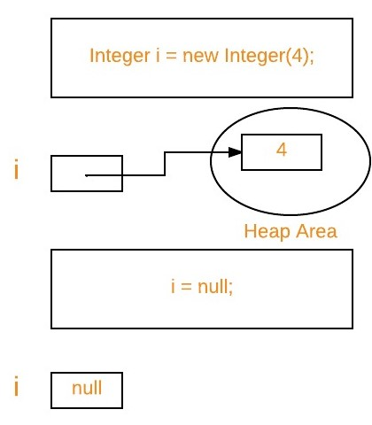
- Eligibility for garbage collection : An object is said to be eligible for GC(garbage collection) iff it is unreachable. In above image, after i = null; integer object 4 in heap area is eligible for garbage collection.
Ways to make an object eligible for GC
- Even though programmer is not responsible to destroy useless objects but it is highly recommended to make an object unreachable(thus eligible for GC) if it is no longer required.
- There are generally four different ways to make an object eligible for garbage collection.
    - Nullifying the reference variable
    - Re-assigning the reference variable
    - Object created inside method
    - Island of Isolation
All above ways with examples are discussed in separate article : How to make object eligible for garbage collection
Ways for requesting JVM to run Garbage Collector
- Once we made object eligible for garbage collection, it may not destroy immediately by garbage collector. Whenever JVM runs Garbage Collector program, then only object will be destroyed. But when JVM runs Garbage Collector, we can not expect.
- We can also request JVM to run Garbage Collector. There are two ways to do it :
    - Using System.gc() method : System class contain static method gc() for requesting JVM to run Garbage Collector.
    - Using Runtime.getRuntime().gc() method : Runtime class allows the application to interface with the JVM in which the application is running. Hence by using its gc() method, we can request JVM to run Garbage Collector.
filter_none
edit
play_arrow
brightness_4
// Java program to demonstrate requesting
// JVM to run Garbage Collector
public class Test
{
public static void main(String[] args) throws InterruptedException
{
Test t1 = new Test();
Test t2 = new Test();

// Nullifying the reference variable
t1 = null;

// requesting JVM for running Garbage Collector
System.gc();

// Nullifying the reference variable
t2 = null;

// requesting JVM for running Garbage Collector
Runtime.getRuntime().gc();

}

@Override
// finalize method is called on object once
// before garbage collecting it
protected void finalize() throws Throwable
{
System.out.println("Garbage collector called");
System.out.println("Object garbage collected : " + this);
}
}
Output:
Garbage collector called
Object garbage collected : Test@46d08f12
Garbage collector called
Object garbage collected : Test@481779b8
Note :
    - There is no guarantee that any one of above two methods will definitely run Garbage Collector.
    - The call System.gc() is effectively equivalent to the call : Runtime.getRuntime().gc()
Finalization
- Just before destroying an object, Garbage Collector calls finalize() method on the object to perform cleanup activities. Once finalize() method completes, Garbage Collector destroys that object.
- finalize() method is present in Object class with following prototype.
protected void finalize() throws Throwable
Based on our requirement, we can override finalize() method for perform our cleanup activities like closing connection from database.
Note :
  - The finalize() method called by Garbage Collector not JVM. Although Garbage Collector is one of the module of JVM.

How to make immutable object in Java:

To create immutable class in java, you have to do following steps.
- Declare the class as final so it can’t be extended.
- Make all fields private so that direct access is not allowed.
- Don’t provide setter methods for variables
- Make all mutable fields final so that it’s value can be assigned only once.
- Initialize all the fields via a constructor performing deep copy.
- Perform cloning of objects in the getter methods to return a copy rather than returning the actual object reference.
final keyword in java
final keyword is used in different contexts. First of all, final is a non-access modifierapplicable only to a variable, a method or a class.Following are different contexts where final is used.
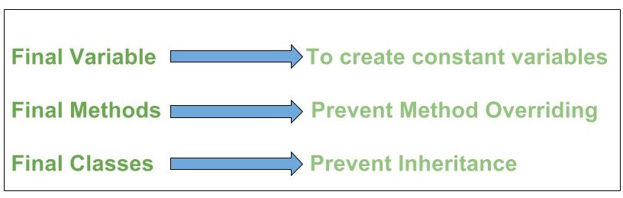
Final variables
When a variable is declared with final keyword, its value can’t be modified, essentially, a constant. This also means that you must initialize a final variable. If the final variable is a reference, this means that the variable cannot be re-bound to reference another object, but internal state of the object pointed by that reference variable can be changed i.e. you can add or remove elements from final array or final collection. It is good practice to represent final variables in all uppercase, using underscore to separate words.

How to access a constructor class in Java:
You can access it within the class itself (e.g. in a public static factory method)
If it's a nested class, you can access it from the enclosing class

If you declare any parameter as final, you cannot change the value of it. finalmeans you can't change the value of that variable once it was assigned. ... This only means that inside the method the final variables can not be reassigned.

Process vs Thread – Difference between Process and Thread
Process | Thread
1) System calls involved in process. | 1) No system calls involved.
2) Context switching required. | 2) No context switching required.
3) Different process have different copies of code and data. | 3) Sharing same copy of code and data can be possible among different threads..
4) Operating system treats different process differently. | 4) All user level threads treated as single task for operating system.
5) If a process got blocked, remaining process continue their work. | 5) If a user level thread got blocked, all other threads get blocked since they are treated as single task to OS. (Noted: This is can be avoided in kernel level threads).
6) Processes are independent. | 6) Threads exist as subsets of a process. They are dependent.
7) Process run in separate memory space. | 7) Threads run in shared memory space. And use memory of process which it belong to.
8) Processes have their own program counter (PC), register set, and stack space. | 8) Threads share Code section, data section, Address space with other threads.
9) Communication between processes requires some time. | 9) Communication between processes requires less time than processes.
10) Processes don’t share the memory with any other process. | 10) Threads share the memory with other threads of the same process
11) Process have overhead. | 11) Threads have no overhead.

That’s cleaver question….!!!
So basically A page fault is occurs when a program attempts to access a block of memory that is not stored in the physical memory, or RAM. The fault notifies the OS that it must locate the data in Virtual Memory, then transfer it from the storage device, such as an HDD or SSD, to the system RAM.
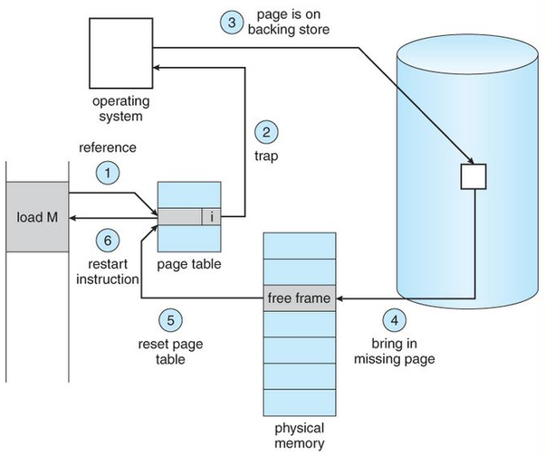
Page faults are common and are part of the normal way computers handlevirtual memory. In programming terms, a page fault generates an exception, which notifies the operating system that it must retrieve the memory blocks or "pages" from virtual memory in order for the program to continue. Once the DATA is moved into physical memory, the program continues as normal. This process takes place in the background and usually goes unnoticed by the user.

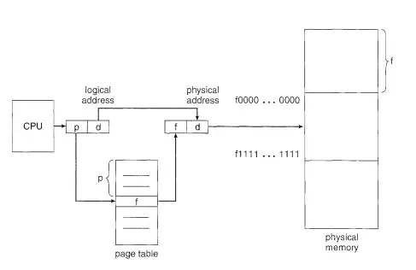

First of all let me explain how the mapping between logical address and physical address takes place.
The physical address is divided into fixed size blocks called frames. Similarly the logical address is divided into blocks of same size called pages. Now the logical address generated by the cpu is divided into two parts page no and offset. A page table contains an index to the page no and corresponding mapping to the frame no. The offset is added to this frame no and that gives the corresponding address in the physical memory.
The paging hardware is shown below :

Now when a page no is not found in the page table a page fault occurs.
So what happens when a page fault occurs ..
1. We check an internal table (usually kept with the process control block)
for this process to determine whether the reference was a valid or an
invalid memory access.
2. If the reference was invalid, we terminate the process. If it was valid, but
we have not yet brought in that page, we now page it in.
3. We find a free frame (by taking one from the free-frame list, for example).
4. We schedule a disk operation to read the desired page into the newly
allocated frame.
5. When the disk read is complete, we modify the internal table kept with
the process and the page table to indicate that the page is now in memory.
6. We restart the instruction that was interrupted by the trap. The process
can now access the page as though it had always been in memory.
These steps can be understood by the image below

Comparison of Scheduling Algorithms
By now, you must have understood how CPU can apply different scheduling algorithms to schedule processes. Now, let us examine the advantages and disadvantages of each scheduling algorithms that we have studied so far.

First Come First Serve (FCFS)
Let's start with the Advantages:
- FCFS algorithm doesn't include any complex logic, it just puts the process requests in a queue and executes it one by one.
- Hence, FCFS is pretty simple and easy to implement.
- Eventually, every process will get a chance to run, so starvation doesn't occur.
It's time for the Disadvantages:
- There is no option for pre-emption of a process. If a process is started, then CPU executes the process until it ends.
- Because there is no pre-emption, if a process executes for a long time, the processes in the back of the queue will have to wait for a long time before they get a chance to be executed.

Shortest Job First (SJF)
Starting with the Advantages: of Shortest Job First scheduling algorithm.
- According to the definition, short processes are executed first and then followed by longer processes.
- The throughput is increased because more processes can be executed in less amount of time.
And the Disadvantages:
- The time taken by a process must be known by the CPU beforehand, which is not possible.
- Longer processes will have more waiting time, eventually they'll suffer starvation.
Note: Preemptive Shortest Job First scheduling will have the same advantages and disadvantages as those for SJF.

Round Robin (RR)
Here are some Advantages: of using the Round Robin Scheduling:
- Each process is served by the CPU for a fixed time quantum, so all processes are given the same priority.
- Starvation doesn't occur because for each round robin cycle, every process is given a fixed time to execute. No process is left behind.
and here comes the Disadvantages:
- The throughput in RR largely depends on the choice of the length of the time quantum. If time quantum is longer than needed, it tends to exhibit the same behavior as FCFS.
- If time quantum is shorter than needed, the number of times that CPU switches from one process to another process, increases. This leads to decrease in CPU efficiency.

Priority based Scheduling
Advantages of Priority Scheduling:
- The priority of a process can be selected based on memory requirement, time requirement or user preference. For example, a high end game will have better graphics, that means the process which updates the screen in a game will have higher priority so as to achieve better graphics performance.
Some Disadvantages:
- A second scheduling algorithm is required to schedule the processes which have same priority.
- In preemptive priority scheduling, a higher priority process can execute ahead of an already executing lower priority process. If lower priority process keeps waiting for higher priority processes, starvation occurs.

Usage of Scheduling Algorithms in Different Situations
Every scheduling algorithm has a type of a situation where it is the best choice. Let's look at different such situations:

Situation 1:
The incoming processes are short and there is no need for the processes to execute in a specific order.
In this case, FCFS works best when compared to SJF and RR because the processes are short which means that no process will wait for a longer time. When each process is executed one by one, every process will be executed eventually.

Situation 2:
The processes are a mix of long and short processes and the task will only be completed if all the processes are executed successfully in a given time.
Round Robin scheduling works efficiently here because it does not cause starvation and also gives equal time quantum for each process.

Situation 3:
The processes are a mix of user based and kernel based processes.
Priority based scheduling works efficiently in this case because generally kernel based processes have higher priority when compared to user based processes.
For example, the scheduler itself is a kernel based process, it should run first so that it can schedule other processes.

Connection Pool:
Group of connection object ready to provide the services. It imporve the perfomance. We don’t need to start and close the connection seprately for every services instead we fetch it from the connection pool.

It can be use multiple times.



Design HashMap:

public class MyHashMap {
// for better re-sizing is taken as 2^4
private static final int SIZE = 16;

private Entry table[] = new Entry[SIZE];

/**
* To store the Map data in key and value pair.
* Used linked list approach to avoid the collisions
*/
class Entry {
final String key;
String value;
Entry next;

Entry(String k, String v) {
key = k;
value = v;
}

public String getValue() {
return value;
}

public void setValue(String value) {
this.value = value;
}

public String getKey() {
return key;
}
}

/**
* Returns the entry mapped to key in the HashMap.
*/
public Entry get(String k) {
int hash = k.hashCode() % SIZE;
Entry e = table[hash];

// Bucket is identified by hashCode and traversed the bucket
// till element is not found.
while(e != null) {
if(e.key.equals(k)) {
return e;
}
e = e.next;
}
return null;
}

/**
* If the map previously contained a mapping for the key, the old
* value is replaced.
*/
public void put(String k, String v) {
int hash = k.hashCode() % SIZE;
Entry e = table[hash];

if(e != null) {
// If we will insert duplicate key-value pair,
// Old value will be replaced by new one.
if(e.key.equals(k)) {
e.value = v;
} else {
// Collision: insert new element at the end of list
// in the same bucket
while(e.next != null) {
e = e.next;
}
Entry entryInOldBucket = new Entry(k, v);
e.next = entryInOldBucket;
}
} else {
// create new bucket for new element in the map.
Entry entryInNewBucket = new Entry(k, v);
table[hash] = entryInNewBucket;
}
}

public static void main(String[] args) {
MyHashMap myHashMap = new MyHashMap();

myHashMap.put("Awadh", "SSE");
myHashMap.put("Rahul", "SSE");
myHashMap.put("Sattu", "SE");
myHashMap.put("Gaurav", "SE");

Entry e = myHashMap.get("Awadh");
System.out.println(""+e.getValue());
}
}

HashCode vs Equals:

hashCode() method
hashCode() method is used to get the hash Code of an object. hashCode() method of object class returns the memory reference of object in integer form. Definition of hashCode() method is public native hashCode(). It indicates the implementation of hashCode() is native because there is not any direct method in java to fetch the reference of object. It is possible to provide your own implementation of hashCode().
In HashMap, hashCode() is used to calculate the bucket and therefore calculate the index.
equals() method
equals method is used to check that 2 objects are equal or not. This method is provided by Object class. You can override this in your class to provide your own implementation.
HashMap uses equals() to compare the key whether the are equal or not. If equals() method return true, they are equal otherwise not equal.
Difference betweeeb waiting and running state of thread:

Blocked- Your thread is in runnable state of thread life cycle and trying to obtain object lock. Wait- Your thread is in waiting state of thread life cycle and waiting for notify signal to come in runnable state of thread.

Singleton Class in Java
In object-oriented programming, a singleton class is a class that can have only one object (an instance of the class) at a time.
After first time, if we try to instantiate the Singleton class, the new variable also points to the first instance created. So whatever modifications we do to any variable inside the class through any instance, it affects the variable of the single instance created and is visible if we access that variable through any variable of that class type defined.
To design a singleton class:
- Make constructor as private.
- Write a static method that has return type object of this singleton class. Here, the concept of Lazy initialization in used to write this static method.
Normal class vs Singleton class: Difference in normal and singleton class in terms of instantiation is that, For normal class we use constructor, whereas for singleton class we use getInstance() method (Example code:I). In general, to avoid confusion we may also use the class name as method name hswhile defining this method (Example code:II)

