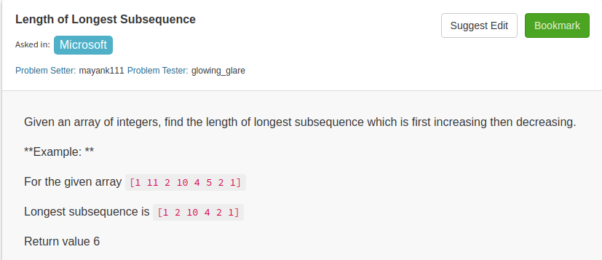

1.

public class Solution {
// DO NOT MODIFY THE LIST. IT IS READ ONLY
public int longestSubsequenceLength(final List<Integer> A) {
int n=A.size();
if(n==0)
return 0;
int a[]=new int[n];
int b[]=new int[n];
for(int i=0;i<n;i++){
a[i]=1;
b[i]=1;
}
for(int i=1;i<n;i++)
{
for(int j=0;j<i;j++){
if(A.get(i)>A.get(j) && a[i]<a[j]+1 ){
a[i]=a[j]+1;
}
}
}
for(int i=n-2;i>=0;i--){
for(int j=n-1;j>i;j--){
if(A.get(i)>A.get(j) && b[i]<b[j]+1){
b[i]=b[j]+1;
}
}
}
int max=a[0]+b[0]-1;
for(int i=1;i<n;i++){
if(a[i]+b[i]-1>max){
max=a[i]+b[i]-1;
}
}
return max;

}

}

2.

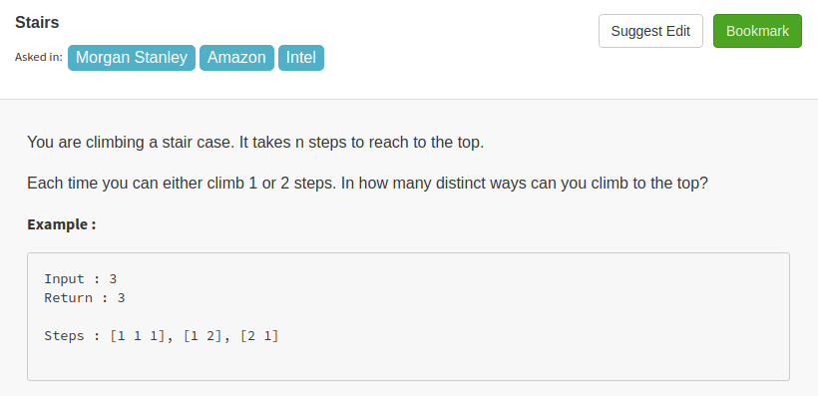

//I think it can be easily solved by fibonacci Series
//When we can take either 1 or 2 steps then we can add the previous two value to get the
//answer at that step

public class Solution {
public int climbStairs(int n) {
int[] a=new int[n];
Arrays.fill(a,-1);
return find_two_step(n,a);

}
public int find_two_step(int n,int[] a){
if(n<0){
return 0;
}
else if(n==0){
return 1;
}
else if(a[n]>-1){
return a[n];
}
else
a[n]=climbStairs(n-1)+climbStairs(n-2);
return a[n];
}

}

3. Repeating Subsequence

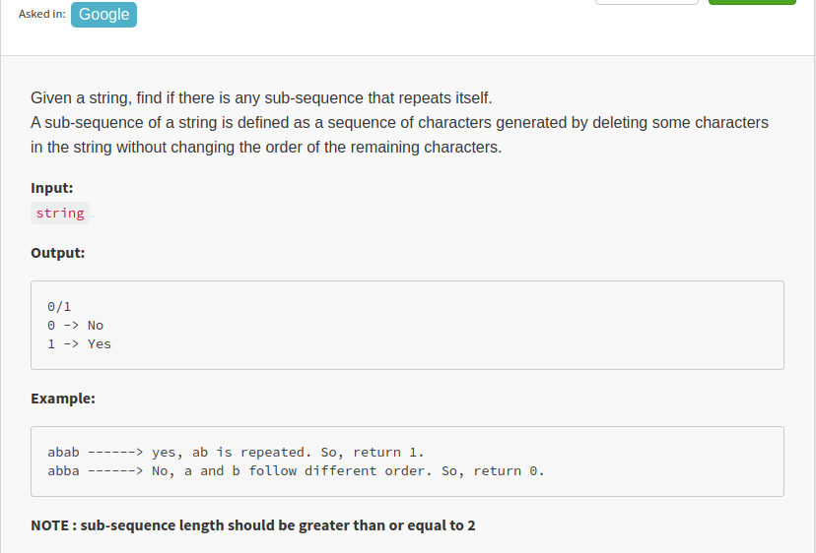

public class Solution {
public int anytwo(String A) {
int n=A.length();
int temp[][]=new int[n+1][n+1];
for(int i=1;i<=n;i++){
for(int j=1;j<=n;j++){
if(A.charAt(i-1)==A.charAt(j-1) && i!=j){
temp[i][j]=temp[i-1][j-1]+1;

}
else{

temp[i][j]=Math.max(temp[i-1][j],temp[i][j-1]);
}
}
}
if(temp[n][n]>1){
return 1;
}
return 0;
}
}

4.

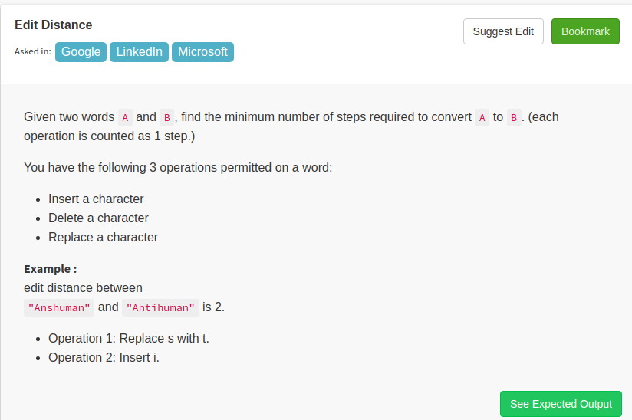

public class Solution {

public int minDistance(String a, String b) {
int an=a.length();
int bn=b.length();

int[][] temp = new int[an+1][bn+1];
for(int i=0;i<temp.length;i++){
temp[i][0]=i;
}
for(int i=0;i<temp[0].length;i++){
temp[0][i]=i;
}
for(int i=1;i<=an;i++){
for(int j=1;j<=bn;j++){
if(a.charAt(i-1)==b.charAt(j-1)){
temp[i][j]=temp[i-1][j-1];
}
else{

temp[i][j]=1+Math.min(temp[i-1][j-1],Math.min(temp[i-1][j],temp[i][j-1]));
}

}
}

return temp[an][bn];

}
}

5.

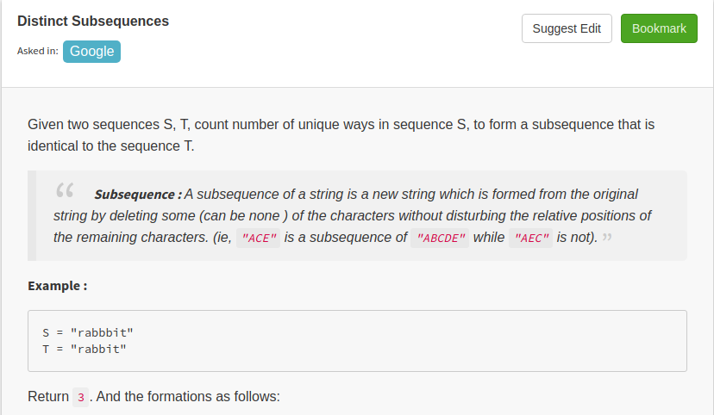

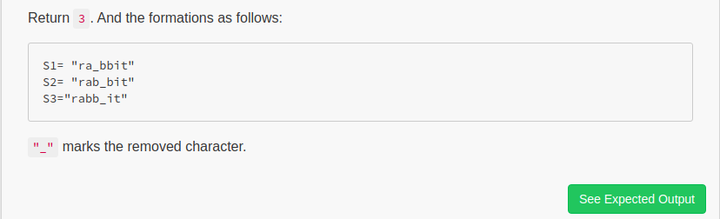

public class Solution {
public int numDistinct(String A, String B) {
int m=A.length();
int n=A.length();
int[][] dp=new int[n+1][m+1];
for(int i=0;i<=m;i++){
dp[i][0]=1;
}
for(int i=1;i<=m;i++){
for(int j=1;j<=n;j++){
if(A.charAt(i-1)==B.charAt(j-1)){
dp[i][j]=dp[i-1][j]+dp[i-1][j-1];
}
else{
dp[i][j]=dp[i-1][j];
}

}
}
return dp[m][n];
}
}

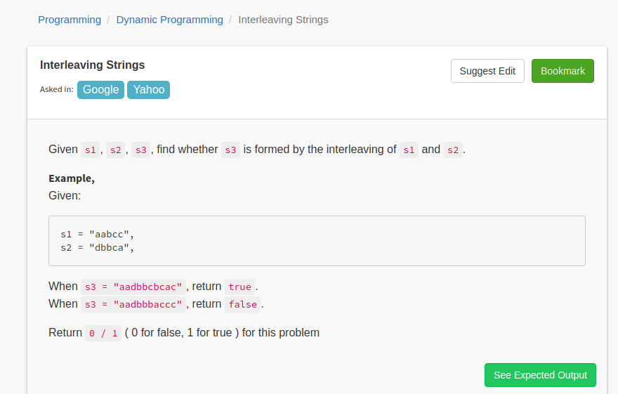

6.

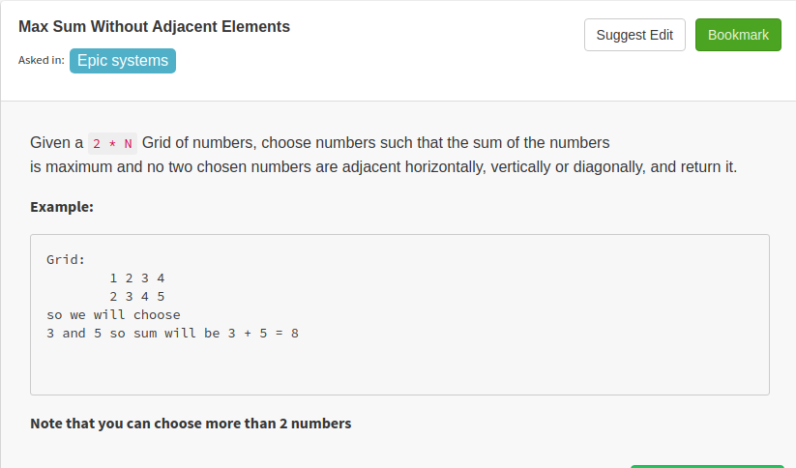

public class Solution {
public int adjacent(ArrayList<ArrayList<Integer>> A) {
int inclusive=Math.max(A.get(0).get(0),A.get(1).get(0));
int exclusive=0;
for(int i=1;i<A.get(0).size();i++){
int new_excl=Math.max(inclusive,exclusive);
inclusive=exclusive+Math.max(A.get(0).get(i),A.get(1).get(i));
exclusive=new_excl;
}
return Math.max(inclusive,exclusive);
}
}

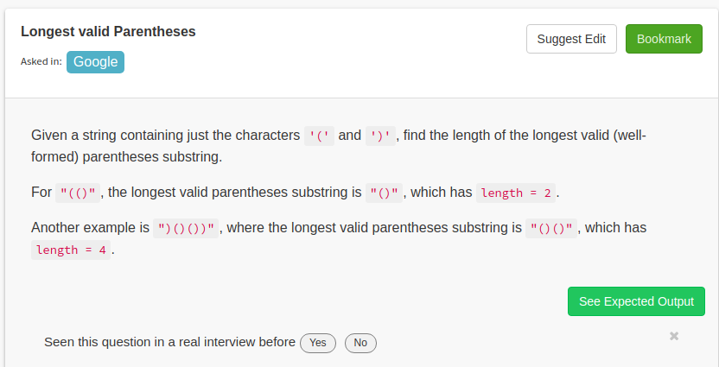

public class Solution {
public int longestValidParentheses(String A) {
int result=0;
Stack<Integer> st=new Stack<Integer>();
st.push(-1);
for(int i=0;i<A.length();i++){
if(A.charAt(i)=='('){
st.push(i);
}
else{
st.pop();
if(!st.isEmpty()){
result=Math.max(i-st.peek(),result);
}
else{
st.push(i);
}

}
}
return result;
}
}

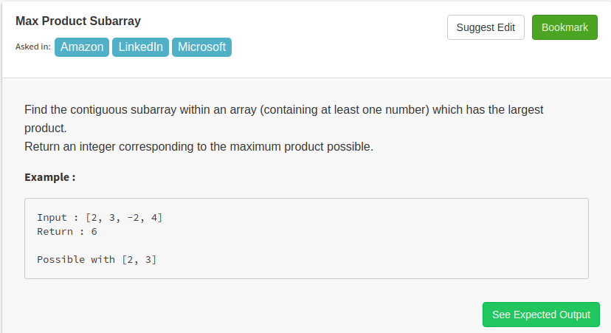

public class Solution {
// DO NOT MODIFY THE LIST. IT IS READ ONLY
public int maxProduct(final List<Integer> A) {
int local_max=A.get(0);
int local_min=A.get(0);
int max_prod=A.get(0);

for(int i=1;i<A.size();i++){
if(A.get(i)>0){
local_max=Math.max(A.get(i)*local_max,A.get(i));
local_min=Math.min(A.get(i)*local_min,A.get(i));
}
else{
int local_max_neg=Math.max(A.get(i)*local_min,A.get(i));
local_min=Math.min(A.get(i)*local_max,A.get(i));
local_max= local_max_neg;
}
max_prod=Math.max(local_max,max_prod);
}
return max_prod;
}
}

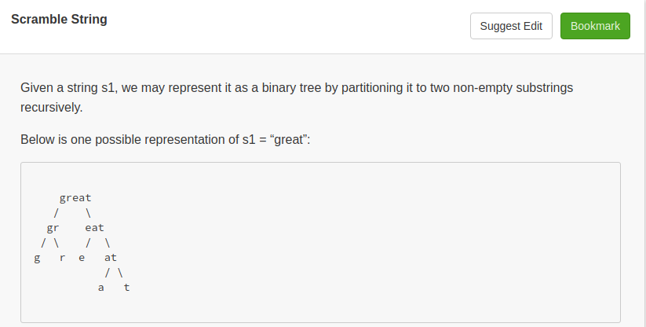
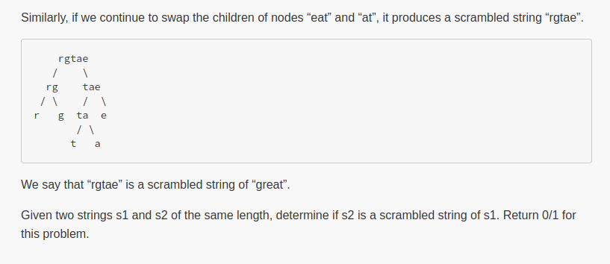

public class Solution {
// DO NOT MODIFY THE ARGUMENTS WITH "final" PREFIX. IT IS READ ONLY
public int isScramble(final String s1, final String s2) {

boolean flag=isScrambleString(s1,s2);
if(flag){
return 1;

}
return 0;

}
public static boolean isScrambleString(final String s1, final String s2){
if(s1==null||s2==null||s1.length()!=s2.length())
return false;
if(s1.equals(s2))
return true;
char a1[],a2[];
a1=s1.toCharArray();
a2=s2.toCharArray();
Arrays.sort(a1);Arrays.sort(a2);
if(!(new String(a1).equals(new String(a2))) )
return false;
for(int i=1;i<s1.length();i++){
if(isScrambleString(s1.substring(0,i),s2.substring(0,i)) && isScrambleString(s1.substring(i),s2.substring(i)) )
return true;
if(isScrambleString(s1.substring(0,i),s2.substring(s2.length()-i)) &&isScrambleString(s1.substring(i),s2.substring(0,s2.length()-i)) )
return true;
}
return false;
}
}

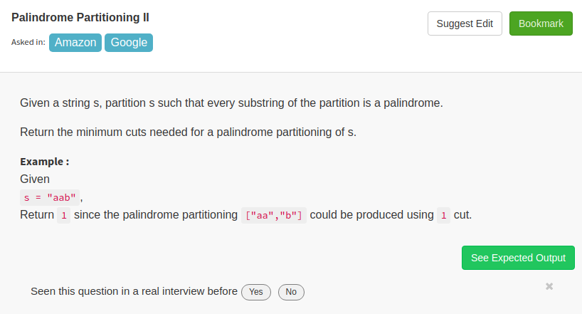

public class Solution {
public int minCut(String s) {
int n=s.length();
boolean[][] p=new boolean[n][n];
int[][] c=new int[n][n];
int i,j,k,l;
for(i=0;i<n;i++){
p[i][i]=true;
c[i][i]=0;
}
for(l=2;l<=n;l++){
for(i=0;i<n-l+1;i++){
j=i+l-1;
if(l==2){
p[i][j]=(s.charAt(i)==s.charAt(j));
}
else{

p[i][j]=(s.charAt(i)==s.charAt(j) && p[i+1][j-1]);
}
if(p[i][j]){
c[i][j]=0;
}
else{
c[i][j]=Integer.MAX_VALUE;
for(k=i;k<=j-1;k++)
{
c[i][j]=Math.min(c[i][j],c[i][k]+c[k+1][j]+1);
}
}
}
}
return c[0][n-1];
}
}

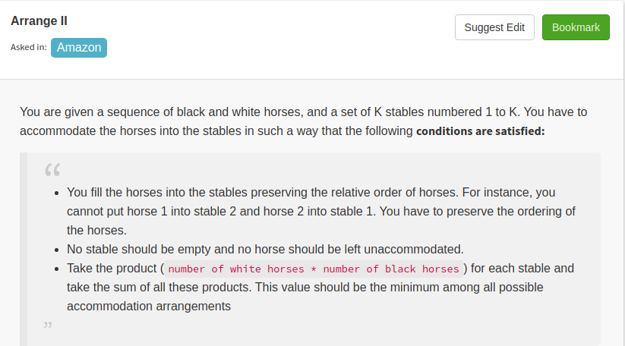
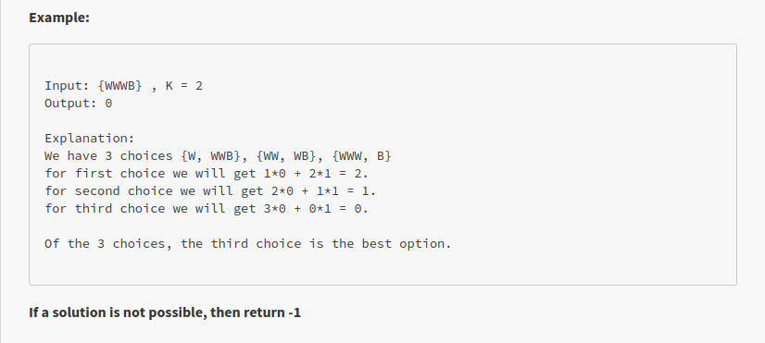

public class Solution {
public int arrange(String A, int B) {
int l=A.length();
if(l<B){
return -1;
}
int[][] dp=new int[l][B];
int wn=0;
int bn=0;
for(int i=0;i<l;i++){
if(A.charAt(i)=='B'){
bn++;
}
else{
wn++;
}
dp[i][0]=bn*wn;
}
for(int i=1;i<B;i++){
for(int j=0;j<l;j++){
if(i>j){
dp[j][i]=Integer.MAX_VALUE;
}
else{
int mv=Integer.MAX_VALUE;
wn=0;
bn=0;
for(int k=j-1;k>=0;k--){
if(A.charAt(k+1)=='B'){
bn++;
}
else{
wn++;
}
if(dp[k][i-1]+bn*wn>=0){
mv=Math.min(mv,dp[k][i-1]+wn*bn);
}
}
dp[j][i]=mv;
}
}
}
return (dp[l-1][B-1]>0?dp[l-1][B-1]:0);
}
}

