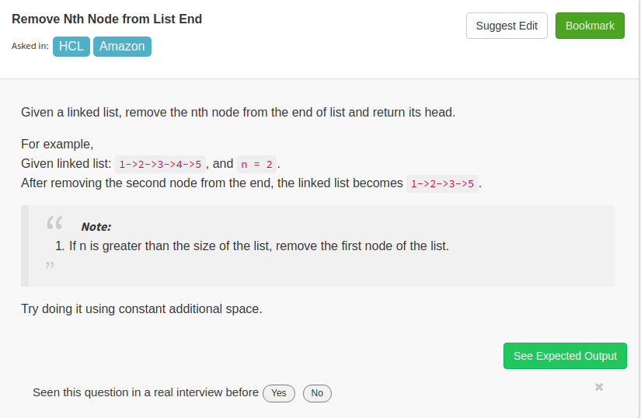

/**
* Definition for singly-linked list.
* class ListNode {
* public int val;
* public ListNode next;
* ListNode(int x) { val = x; next = null; }
* }
*/
public class Solution {
public ListNode removeNthFromEnd(ListNode A, int B) {
ListNode dummy=A;
int n=0;
if(A==null || A.next==null && B==1)
{
return null;
}
while(dummy!=null){
dummy=dummy.next;
n++;
}
if(B>=n){
return A.next;
}
int k=n-B;

dummy=A;

while(k>1){

dummy=dummy.next;

k--;
}
dummy.next=dummy.next.next;
return A;
}

}

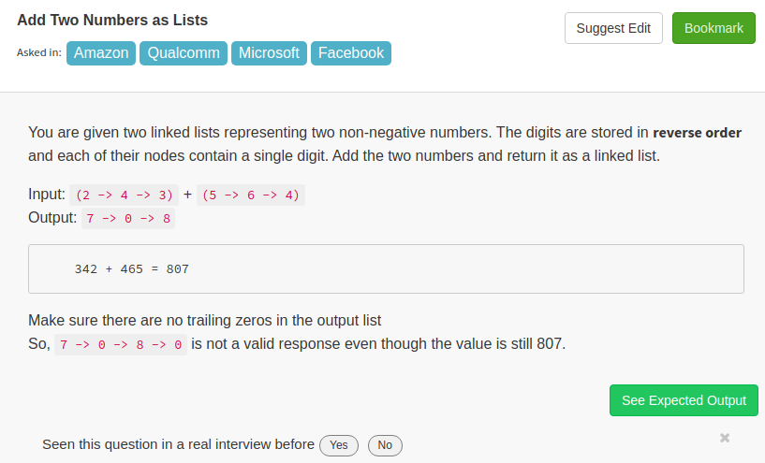

/**
* Definition for singly-linked list.
* class ListNode {
* public int val;
* public ListNode next;
* ListNode(int x) { val = x; next = null; }
* }
*/
import java.util.*;
public class Solution {
public ListNode addTwoNumbers(ListNode A, ListNode B) {
ListNode dummy=new ListNode(0);
ListNode p=dummy;
int c=0;
while(A!=null || B!=null || c!=0){
if(A!=null){
c+=A.val;
A=A.next;
}
if(B!=null){
c+=B.val;
B=B.next;
}
ListNode temp=new ListNode(c%10);
p.next=temp;
p=p.next;
c=c/10;
}
return dummy.next;

}
}
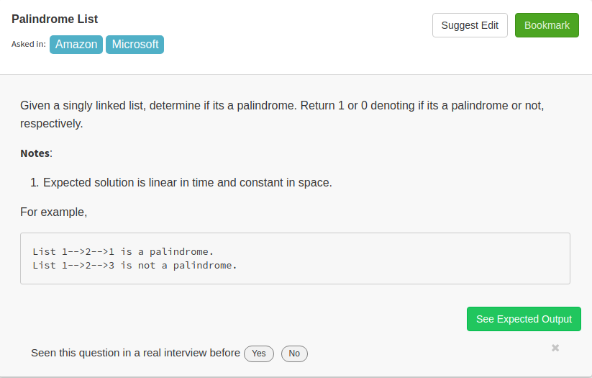

/**
* Definition for singly-linked list.
* class ListNode {
* public int val;
* public ListNode next;
* ListNode(int x) { val = x; next = null; }
* }
*/
public class Solution {
public int lPalin(ListNode A) {
ListNode dummy=Reverse_List(A);
boolean result=isPalindrome(A,dummy);
if(result){
return 1;
}
return 0;
}
ListNode Reverse_List(ListNode A){
ListNode head=null;
while(A!=null){
ListNode temp=new ListNode(A.val);
temp.next=head;
head=temp;
A=A.next;
}
return head;
}

boolean isPalindrome(ListNode A,ListNode B){
while(A!=null && B!=null){
if(A.val!=B.val){
return false;
}
A=A.next;
B=B.next;
}
return A==null && B==null;
}
}

