**SOURCE CODE**

from tkinter import messagebox

from tkinter import *

from tkinter import simpledialog

import tkinter

from tkinter import filedialog

from tkinter.filedialog import askopenfilename

import cv2

import random

import numpy as np

from keras.utils.np_utils import to_categorical

from keras.layers import MaxPooling2D

from keras.layers import Dense, Dropout, Activation, Flatten

from keras.layers import Convolution2D

from keras.models import Sequential

from keras.models import model_from_json

import pickle

import os

import pandas as pd

import matplotlib.pyplot as plt

main = tkinter.Tk()

main.title("Convolutional Neural Networks Model for Parkinson Disease Detection from Images")

main.geometry("1300x1200")

global filename

global image_classifier

def loadDLModel():

global image_classifier

with open('model/images_model.json', "r") as json_file:

loaded_model_json = json_file.read()

image_classifier = model_from_json(loaded_model_json)

json_file.close()

image_classifier.load_weights("model/images_model_weights.h5")

image_classifier._make_predict_function()

print(image_classifier.summary())

f = open('model/images_history.pckl', 'rb')

data = pickle.load(f)

f.close()

acc = data['accuracy']

accuracy = acc[48]*100

text.insert(END,"Deep CNN accuracy ")

text.insert(END,str(accuracy))

def imageDetection():

global image_classifier

labels = ['Healthy','Parkinson']

filename = filedialog.askopenfilename(initialdir="testImages")

image = cv2.imread(filename)

img = cv2.resize(image, (64,64))

im2arr = np.array(img)

im2arr = im2arr.reshape(1,64,64,3)

img = np.asarray(im2arr)

img = img.astype('float32')

img = img/255

preds = image_classifier.predict(img)

predict = np.argmax(preds)

img = cv2.imread(filename)

img = cv2.resize(img, (500,400))

cv2.putText(img, 'Image Data Predicted as : '+labels[predict], (10, 25), cv2.FONT_HERSHEY_SIMPLEX,0.7, (255, 0, 0), 2)

cv2.imshow('Image Data Predicted as : '+labels[predict], img)

cv2.waitKey(0)

def graph():

f = open('model/images_history.pckl', 'rb')

image = pickle.load(f)

f.close()

img_accuracy = image['accuracy']

img_loss = image['loss']

plt.figure(figsize=(10,6))

plt.grid(True)

plt.xlabel('Epochs')

plt.ylabel('Accuracy/Loss')

plt.plot(img_accuracy, 'ro-', color = 'red')

plt.plot(img_loss, 'ro-', color = 'green')

plt.legend(['Training Accuracy', 'Training Loss'], loc='upper left')

plt.title('Performance Comparison')

plt.show()

def close():

main.destroy()

font = ('times', 16, 'bold')

title = Label(main, text='Convolutional Neural Networks Model for Parkinson Disease Detection from Images',anchor=W, justify=CENTER)

title.config(bg='yellow4', fg='white')

title.config(font=font)

title.config(height=3, width=120)

title.place(x=0,y=5)

font1 = ('times', 13, 'bold')

loadButton = Button(main, text="Load Deep CNN model", command=loadDLModel)

loadButton.place(x=50,y=100)

loadButton.config(font=font1)

imageButton = Button(main, text="Detect Parkinson", command=imageDetection)

imageButton.place(x=50,y=150)

imageButton.config(font=font1)

graphButton = Button(main, text="Performance Graph", command=graph)

graphButton.place(x=50,y=200)

graphButton.config(font=font1)

exitButton = Button(main, text="Exit", command=close)

exitButton.place(x=50,y=250)

exitButton.config(font=font1)

font1 = ('times', 12, 'bold')

text=Text(main,height=20,width=78)

scroll=Scrollbar(text)

text.configure(yscrollcommand=scroll.set)

text.place(x=450,y=100)

text.config(font=font1)

main.config(bg='Sky Blue')

main.mainloop()

**RESULTS AND DISCUSSION**

Figure 1 displays examples of spiral drawings made by individuals who are healthy. It shows a few samples of spiral patterns drawn by individuals without Parkinson's disease. These samples are used as a reference for comparison with the spiral drawings from individuals with Parkinson's disease. Figure 2 displays an examples of wave patterns drawn by healthy individuals. These patterns are used as a baseline for wave drawings created by individuals without Parkinson's disease.

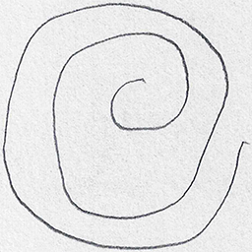

Figure 1: Sample spiral drawings from healthy patients.

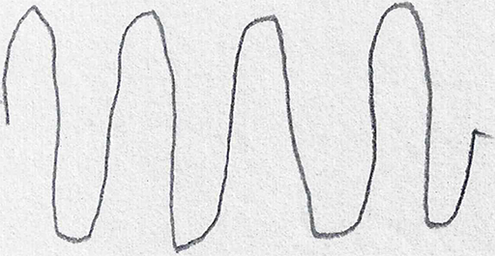

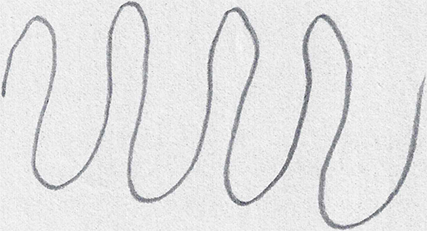

Figure 2: Sample wave drawings from healthy patients.

Figure 3 showcase examples of spiral drawings made by individuals diagnosed with Parkinson's disease. These drawings exhibit characteristic features associated with the motor control issues typically seen in Parkinson's patients. Figure 4 displays examples of wave patterns drawn by individuals with Parkinson's disease. The purpose is to demonstrate the differences between the wave patterns of healthy individuals and those with Parkinson's disease.

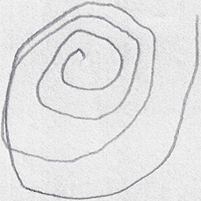

Figure 3: Sample sprial drawings from parkinson patients.

Figure 4: Sample wave drawings from Parkinson patients.

Figure 5: User interface of proposed CNN-based Parkinson disease detection from images.

Figure 6: Illustration of UI with Deep CNN model accuracy after loading the pre-trained model.

Figure 5 illustrates the graphical user interface (GUI) of proposed CNN-based Parkinson disease detection application. It shows the layout of buttons, text fields, and other components that users interact with when using this application. Figure 6 shows the accuracy of the pre-trained CNN model after it has been loaded, which helps to understand the reliability of the model's predictions. Figure 7 depicts the architecture of deep CNN model layer by layer. It shows the convolutional layers, pooling layers, fully connected layers, and other components of model, along with the specifications.

Figure 7: Layer-wise summary of proposed deep CNN model.

Figure 8: Sample test data used for evaluating the pre-trained proposed CNN model.

Figure 8 shows some examples of the test data used to evaluate the performance of proposed deep CNN model. It includes a few images that represent the input data the model is tested on. Figure 9 displays examples of images that have been input into trained CNN model, along with the model's predictions for each image. This is a visual representation of how well the model is performing in predicting whether an individual has Parkinson's disease based on their drawings.

Figure 9: Sample predicted images using proposed CNN model.

Figure 10: Performance analysis of obtained accuracy, and loss using proposed CNN model.

In Figure 10, x-axis represents training epoch and y-axis represents accuracy and loss values and with each increasing epoch, its accuracy getting increased, and loss is decreasing. At the final epoch, accuracy reached closer to 1 and loss reached closer to 0.