I need a mobile app that is similair to a game, This app is for learning english for Arabic speakers

Sample >>>> [**https://www.gamestolearnenglish.com**](https://www.gamestolearnenglish.com/)/.

I want it to be the same like this website.

But I also want students to be able to play against each other like they do in kahoot.com

[**https://m.youtube.com/watch?v=YtH4kYacFs4**](https://m.youtube.com/watch?v=YtH4kYacFs4)

I want the features similair to gamestop learn english.com and also to have the style of kahoot where players can challenge each others. I only have the english grammar which I have got translated into arabic.



This is the arabic version of the present simple present continous future simple and much and many. In addition it also has the past simple.

I want it to be a fun app where students can learn with animation and characters and great interface basically nearly the same as games tolearn english site but it has english and Arabic words for the students. I am an english teacher arabic isnt my first language but my students are.

Sp I do need help with making the language easy accessible and fun to learn

I want the app for both android and ios



I want it to be colourful



I basically want games to learn english but students can challenge against users around the world

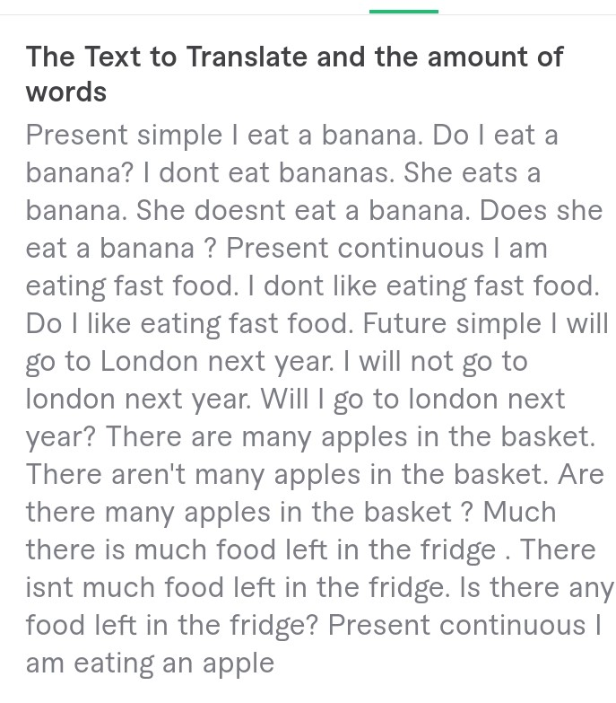

This is the translation but You have to make sure the Arabic sentences match with the English

So you need to translate the Arabic sentences,To make sure they match with the English sentences.

I will sent you the translation for the Arabic

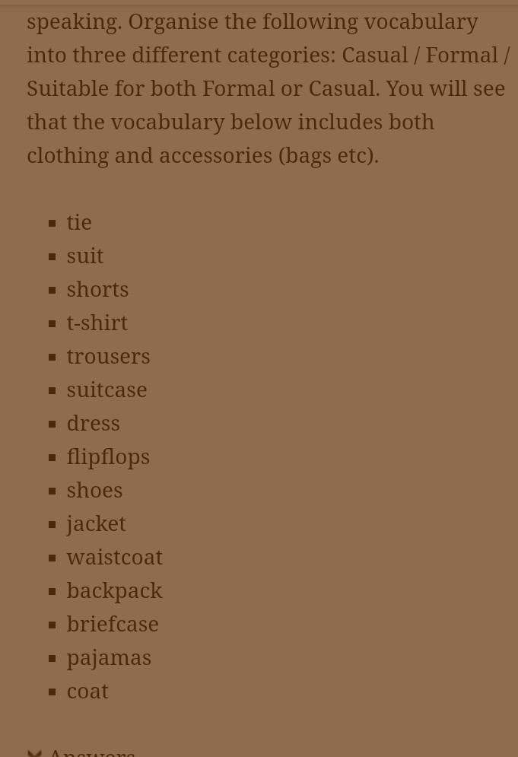

I want you to add this vocabulary list please



I want you to make the app exactly the same as gamesto learn english with all of the english grammar inside gamestolearn english please thank you. To have the same features and the same grammmar. Please thank you.

[**https://www.gamestolearnenglish.com**](https://www.gamestolearnenglish.com/)/ please same like this with the grammar thank you.

I also want a freemium and a premium for ny app but first I want to tot be freemium and have a option of being premium.  
  
AND ALSO YOU WILL UPLOAD THE APP TO PLAYSTORE