**About Us**

**NEXCO JAPAN LTD CO** – Global Cars and Machinery Exporter.

**Nexco Japan** is a quality Japanese used car supplier based in Chiba Prefecture, Japan.

We provide Japanese used vehicles, **RHD, LHD, Spare Parts, Tires, Construction and Agricultural Machinery**.  
We are registered listed company on the Tokyo Stock Exchange and well established company in Japan with a used car dealer license from **Japan Public and consumers Safety Commissions**.

Here at **Nexco Japan** we work hard to provide the most reliable and professional car export service, and is proud to say we have been doing so since long time.  
We take pride in our commitment to provide our customers with the best quality cars, at affordable prices, together with a smooth operations system to assist you every step of the way. We provide great quality vehicles directly from Japanese owners to you.

Our staff are all professionals, highly experienced, and bilingual.  
  
Our name, **NEXCO JAPAN**, is an abbreviation of National Export Company Japan. It has been our dream since the beginning to grow steadily and shine like a star. It is just another feather in our cap as we accomplish more and more goals to become the "shiniest star” in the industry.

Our business motto **"Car for Everyone"** represents worldwide business mission to satisfy our customer's needs for reliable cars in reasonable prices with the help of our utmost service and through establishment of a **"Globalized Network"** around the globe.

## **|| Company Details ||**

Logo here

|  |  |
| --- | --- |
| **Company Name** | NEXCO JAPAN 合同会社 |
| **CEO** | AMIN URA |
| **Head Office** | 〒 285-0844 Kamishizuhara 358-2, Sakura City, Chiba Prefecture Japan |
| **License** | Used Items Dealers Licensed by Tokyo Public Safety Commission -東京都公安委員会 |
| **Memberships** | * Japanese Car Trade Association * Export Bureau |
| **Phone** | +81-43-312-1411 |
| **Fax** | +81-43-312-1411 |
| **Email** | info@nexcojapan.com |
| **Official Page** | www.nexcojapan.com |
| **Business Description** | Global Automobile and Machinery Exporter |
| **Business Hours: (Head Office)** | 9am-6pm, Sat.8am-2pm JST |
| **Closed:** | Sundays & Public Holidays |

## **MEMBER OF**

 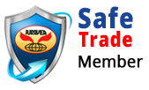Export Bureau manufacturing company directory

**OUR HEAD OFFICE**

Our Google map location here

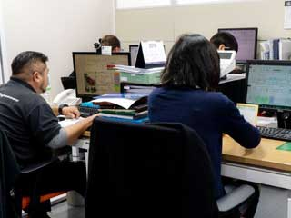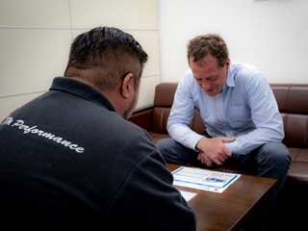

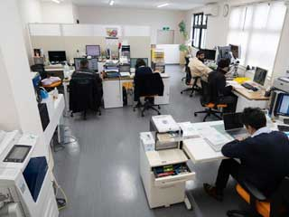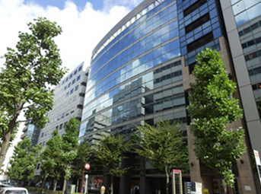

**CEO MESSAGE**

I am pleased to welcome you to the Nexco Japan Ltd Co website.

There are currently 1.4 billion cars in the world and 74 million of them are in use in Japan meaning that there is one car for every two people. Cars are such an integral part of our lives that we cannot even imagine our lives without them. As a global Cars & Machinery Exporter Company, NEXCO JAPAN has grown exporting quality second-hand Japanese vehicles at competitively low prices.

So be confident importing cars and machinery is very easy and we are always here to help you throughout the process from buying till delivery.

* WE PROGRESS **EVERYDAY**.

* WE CHALLENGE **EVERYTHING**.

* WE WORK FOR **EVERY** CUSTOMER'S HAPPINESS.

It will be a great pleasure and honor to be your trusted partner for importing used cars machinery and many more from Japan.



**Overseas Offices**

**NEXCO DUBAI (flag)**

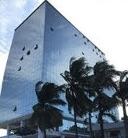

|  |  |
| --- | --- |
| **Office Hours** | **9am-6pm / Sat 8am-2pm** |
| **Office Address:** | **P.O BOX 825, Kulukulu, Sigatoka Fiji Islands** |
| **Contact Info:** | **+679-650-2900 / 679-896-6627** |
| **Email:** | **fiji@nexcojapan.com** |
| **Head Office(Japan)** | **+81-43-312-1411 / +81-80-8856-1417 ( Viber ,WhatsApp Icon)** |
|  |  |

**NEXCO THAILAND (flag)**

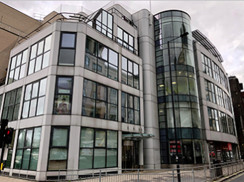

|  |  |
| --- | --- |
| **Office Hours** | **9am-6pm, Sat.8am-2pm** |
| **Office Address:** | **P.O BOX 825, Kulukulu, Sigatoka Fiji Islands** |
| **Contact Info:** | **+679-650-2900 / 679-896-6627** |
| **Email:** | **fiji@nexcojapan.com** |
| **Head Office(Japan)** | **+81-43-312-1411 / +81-80-8856-1417 ( Viber ,WhatsApp Icon)** |
|  |  |

**NEXCO FIJI (flag)**

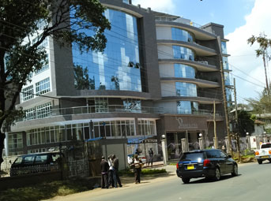

|  |  |
| --- | --- |
| **Office Hours** | **9am-6pm, Sat.8am-2pm** |
| **Office Address:** | **P.O BOX 825, Kulukulu, Sigatoka Fiji Islands** |
| **Contact Info:** | **+679-650-2900 / 679-896-6627** |
| **Email:** | **fiji@nexcojapan.com** |
| **Head Office(Japan)** | **+81-43-312-1411 / +81-80-8856-1417 ( Viber ,WhatsApp Icon)** |
|  |  |

**NEXCO Papa New Guinea (flag)**

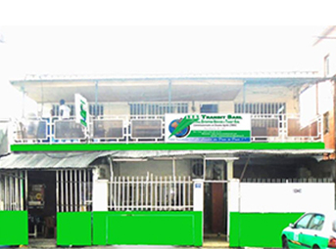

|  |  |
| --- | --- |
| **Office Hours** | **9am-6pm, Sat.8am-2pm** |
| **Office Address:** | **P.O BOX 825, Kulukulu, Sigatoka Fiji Islands** |
| **Contact Info:** | **+679-650-2900 / 679-896-6627** |
| **Email:** | **fiji@nexcojapan.com** |
| **Head Office(Japan)** | **+81-43-312-1411 / +81-80-8856-1417 ( Viber ,WhatsApp Icon)** |
|  |  |

**NEXCO Vanuatu (flag)**

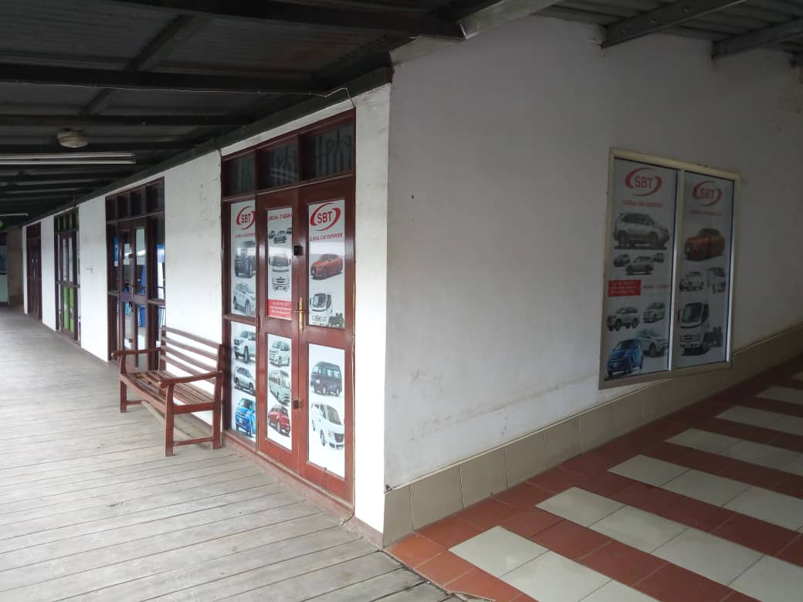

|  |  |
| --- | --- |
| **Office Hours** | **9am-6pm, Sat.8am-2pm** |
| **Office Address:** | **P.O BOX 825, Kulukulu, Sigatoka Fiji Islands** |
| **Contact Info:** | **+679-650-2900 / 679-896-6627** |
| **Email:** | **fiji@nexcojapan.com** |
| **Head Office(Japan)** | **+81-43-312-1411 / +81-80-8856-1417 ( Viber ,WhatsApp Icon)** |
|  |  |

**NEXCO PAKISTAN (flag)**

|  |  |
| --- | --- |
| **Office Hours** | **9am-6pm, Sat.8am-2pm** |
| **Office Address:** | **P.O BOX 825, Kulukulu, Sigatoka Fiji Islands** |
| **Contact Info:** | **+679-650-2900 / 679-896-6627** |
| **Email:** | **fiji@nexcojapan.com** |
| **Head Office(Japan)** | **+81-43-312-1411 / +81-80-8856-1417 ( Viber ,WhatsApp Icon)** |
|  |  |

**|| HOW TO BUY ||**

## MPORTANT NOTICE REGARDING REMITTANCE SCAM

All clients please be careful of fake NEXCO JAPAN Emails. Don't trust emails regarding payments to bank accounts other than mentioned on NEXCO JAPAN website. Please contact your sales staff immediately if any details are suspicious. NEXCO JAPAN can't be held responsible for clients being involved in any of such scams.

1. Choose Your Vehicle

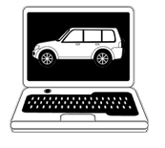

You can choose a vehicle from the top of page by Vehicle Type, Make, and Category or by using the advanced search system. You can also choose from the best-selling cars in your country page

Choose your country where you are going to register the car and choose the port (city) where the car will be delivered. Click the "Calculate" button and you can see the total price up to your destination port (city) you have chosen!

2. Order



You can see the details and pictures of the vehicle you have chosen.

Some options are available such as Escrow service

, Rear view camera & Monitor, Brand-new Batterｙ and Tires, if needed.

Please confirm all the details and fill your information out, then click "Order Now".

A proforma invoice will be sent to you by email, so please confirm and arrange the payment to the bank account which is mentioned on the proforma invoice.

3. Payment



Please complete the payment by Bank Telegraphic Transfer within 2 business days of the issue date of the proforma invoice. The Bank transfer charges must be paid by the purchaser. After the telegraphic transfer is completed, please send us a copy of the telegraphic transfer as proof of payment

**Remit us through T/T (Telegraphic Transfer) to our following bank Account;**

**We accept payment in USD or JPY only.**

|  |  |
| --- | --- |
| Name of Bank | Sumitomo Mitsui Banking Corporation |
| Name of Branch | Ueno Branch |
| Bank Address | 4-11-4, Taito, Taito-ku, Tokyo Japan |
| Account Title | NEXCO JAPAN LTD. |
| Account number | 779-2577165 |
| Swift Code | SMBCJPJT |
| Beneficiary Address | 1-4-18, Komagata, Taito-ku, Tokyo Japan |
| Beneficiary Contact # | +81-43-312-1411 |

On completion of your payment through bank, please provide us a copy of the bank receipt as PROOF OF PAYMENT by fax or email.   
In case of delay in payment, please do inform us at your earliest.

4. Reconditioning & Quality control

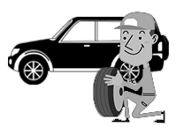

Once we confirm your full payment, we AUTOREC will do the reconditioning & maintenance service to keep the highest quality for your safe driving. XXXXXXX

5. Shipment

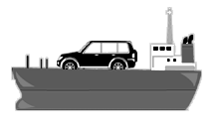

Your vehicle will be shipped on the earliest vessel and the shipping schedule will be updated as soon as it is confirmed. The Bill of Lading will be issued about 1 week after the departure date. As soon as the Bill of Lading is issued, we will dispatch all the necessary documents to you by DHL.

You can check the status of your purchase by accessing your account page at any time.

6. Collect your vehicles



Once you receive the shipping documents, you can start the clearing process for collecting your car and registering in your country.

Our local Offices or partner clearing agents will also be able to support you to clear the vehicle, if needed.

After these clearing processes, you can finally drive your dream vehicle away!!

**|| STOCKS ||**

1. USED CARS
2. USED MACHINERY
3. USED TIRES
4. AUTO PARTS
5. Commercial Vehicles

**|| CONTACT US ||**