Fiverr Task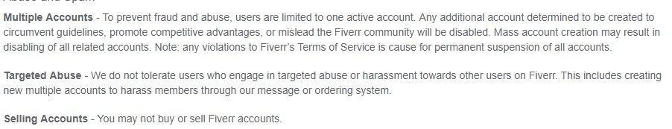

Upwork Task

