Digital food retail and the composition of the Indian household food basket - national evidence from 261,895 households
Pratik Kulkarni^{1*}, Sarvesh Kulkarni¹, Shivraj More¹, Atharv Mohite¹
¹ Department of Computer Science and Engineering, SKN Sinhgad College of Engineering, Pandharpur, Maharashtra, India
* Corresponding author: Pratik Kulkarni, pratikkulkarni8550@gmail.com
Abstract
Background. Online food retail is growing in low- and middle-income countries, yet what people buy online is known mostly from small, high-income samples. India's Household Consumption Expenditure Survey 2023-24 records online food purchasing alongside itemised food acquisition for the same households.
Methods. We analysed 261,895 households (14,827 sampling units) surveyed between August 2023 and August 2024, covering online purchasing across nine food categories and 186 food items. We calculated survey-weighted prevalence and modelled food-budget composition with weighted regression, adjusting for expenditure, education, internet use and demography, with state and survey-month effects, then repeated it under coarsened exact matching. Our estimates matched the published national figures within 0.01%.
Results. While 45.6% of households made an online purchase and 39.7% paid for services online, only 7.10% (95% CI 6.76-7.43) bought any food online. Adoption ranged from 0.34% in the poorest expenditure decile to 23.84% in the richest. Among online buyers, 36.6% opted for served processed food against 18.6% for vegetables. Adjusted for income and other variables, online purchasing was linked to a 1.81 percentage point increase in the food budget for packaged processed food (1.50-2.13) and 0.63 points less for vegetables (0.44-0.83), or about 0.23 kg less vegetable per capita every 30 days. Findings held across matching and other exposure models.
Conclusions. Online food shopping reaches a small, affluent, urban minority whose food budgets are heavier on packaged items and lighter on unprocessed groups than other households. Because the agency labels this data auxiliary and advises against using it for official estimates, our findings are provisional.
Keywords: e-commerce, food environment, ultra-processed food, nutrition transition, India, household survey

1. Introduction
Ultra-processed foods have displaced minimally processed foods in national diets across most of the world over the past three decades, and the pace of that shift is now fastest in middle-income countries (Baker et al., 2020; Popkin and Ng, 2022). India sits early on this curve. Retail sales of ultra-processed food grew at a compound annual rate of 13.4% between 2011 and 2021, but from a low base, and roughly 70% of those sales still pass through independent small grocers and the unorganised sector (Mukherjee et al., 2023). That makes India a useful place to observe which retail channels carry the shift while it is still forming, rather than reconstructing it after the fact.
Online food retail is one candidate channel. It has grown quickly in India: quick-commerce platforms delivering groceries within ten to thirty minutes accounted for roughly two-thirds of e-grocery orders by 2024, and three firms hold more than 85% of that market (USDA Foreign Agricultural Service, 2025). Whether this changes what households eat is unsettled. Reviews of the digital food retail environment find that online platforms promote energy-dense products more heavily than fresh ones, and that shoppers report difficulty comparing products online, but also that online ordering can reduce impulse purchasing (Trude et al., 2022; Bennett et al., 2024; Jia et al., 2024). The empirical base is thin and geographically narrow: mostly small samples, loyalty-card panels, or simulated storefronts in high-income countries. We are not aware of a nationally representative survey in any low- or middle-income country that has previously recorded online food purchasing together with itemised food acquisition for the same households.
India's Household Consumption Expenditure Survey 2023-24 does exactly that. Alongside the itemised food schedule that has anchored Indian consumption statistics for seven decades, the 2023-24 round added tick-boxes recording whether the household purchased each of nine food categories online, and a question on total 30-day online food expenditure. The survey covered 261,953 households across every state and union territory.
We use these data to ask three questions. How far does online food buying actually reach, and who does it reach? Among households that buy food online, which categories do they buy? And is online food purchasing associated with a different composition of the household food basket once income and other characteristics are held constant?
We report one finding that shapes how the others should be read: online purchasing in India is already broad, while online food purchasing is narrow. Nearly half of households buy something online. Fewer than one in fourteen buys food. Digital access is therefore not what limits online food buying, and the households that do buy food online are a distinctive group whose baskets differ from otherwise similar households in a consistent direction.
2. Data and methods
2.1 Data source
The HCES 2023-24 was conducted by the National Statistics Office from August 2023 to July 2024, with some fieldwork reaching into August 2024, using a stratified multistage design (Ministry of Statistics and Programme Implementation, 2025). Villages and urban blocks served as the first-stage units (FSUs), chosen by simple random sampling without replacement, with 18 households canvassed in each. States and union territories formed the basic strata, which were then divided by sector and sub-strata. The survey was organised into ten overlapping quarterly panels to distribute the workload throughout the year.
Each household was visited three times per quarter, covering a different questionnaire each time - food (FDQ), consumables and services (CSQ), and durable goods (DGQ). The sequence of these questionnaires was randomised to prevent any order-related bias.
We pulled the public-use microdata from the Ministry's portal. The archive contains fifteen levels and over 46 million records. Every entry was checked for errors, and each level aligned with the documented record counts and column widths before we started our analysis.
2.2 Sample
We retained 261,953 households for the adoption analysis. Fifty-eight households were dropped from the composition analysis because they had no food records, leaving 261,895 households: 154,314 rural and 107,581 urban, across 14,827 FSUs and 863 design strata. The survey multipliers add up to 291.6 million households and 1.22 billion people. This figure is lower than India's total projected population for the time, since the multipliers were calibrated to the sampling frame rather than population projections. However, as we are reporting only ratios and proportions, this does not affect our results.
2.3 Measuring online food purchasing
Question 4.1.3 in the food questionnaire asked households whether they made an online purchase or payment for nine specific categories - groceries, milk and milk products, vegetables, fresh fruits, dry fruits, egg, fish and meat, served processed food, packaged processed food, and other food items.
The reference period varies, "groceries" covers 30 days, while the other eight categories use a 7-day window. Because a longer time frame can naturally inflate prevalence, we cannot compare groceries directly to the rest. Our main comparison, fresh produce versus processed food, stays within the 7-day categories, so it remains unaffected. We defined our primary exposure as any of the nine categories, and we used a restricted version, only the 7-day categories, as a robustness check.
We also used two other measures. Question A2.6 tracked total expenditure on online food over 30 days. Parallel questions in the consumables and durables questionnaires allowed us to situate food e-commerce within the broader context of household online purchasing.
2.4 Data suitability and the statistical agency's guidance
The HCES 2023-24 data note specifies that the info on online purchasing, usual monthly expenditure, and total online spending was collected as auxiliary information. Its stated "sole purpose" is to help with internal consistency and validation, rather than generating official estimates. The note also discourages using the data for MPCE estimates below the state level.
We take these warnings seriously. We have not produced any estimates below the state level. Regarding the e-commerce data, it is true that these questions were not originally meant to be primary measurement tools and lack independent quality verification. This is why we present our findings as provisional.
Even so, there is still value in examining the data if the measures appear reliable. We treat this as an empirical question and report our evidence in Section 3.1, comparing the tick-boxes in Q4.1.3 with the expenditure data in QA2.6, which are located in separate blocks. Similarly, we use auxiliary household characteristics like social group and religion only as covariates, never to estimate population-level indicators.
2.5 Food acquisition outcomes
Sections 5 to 7 of the food questionnaire record the value and quantity for 186 items across thirteen groups. We parsed the item codes and labels directly from the survey documents to ensure accuracy. All 183 observed codes in the microdata resolved correctly to a questionnaire entry.
Because reference periods differ, 30 days for items like cereals and pulses, and 7 days for things like milk, vegetables, and processed foods, we scaled every value to a 30-day equivalent and divided by household size.
Group values were derived from the ministry's own sub-total codes. We summed quantities manually, as sub-totals sometimes combine different units (e.g., vegetable quantity excludes lemon, which is counted individually). Budget shares, defined as a group's value relative to the total food value, allow us to compare consumption patterns across households of varying means.
One notable trap in the microdata is the OutOfHome_Consumption_Value variable. Despite the name, this does not track food eaten outside the house. It actually refers to "consumption out of home produce", meaning produce from one's own garden or livestock, so we renamed it to avoid confusion. Food eaten away from home is correctly captured in Section 7.1 under "served processed food."
2.6 Consumption expenditure
We calculated monthly per capita consumption expenditure using the survey's standard manual: total expenditure TE = E1 + (E2/P2)·P1 + (E3/P3)·P1, where E1, E2 and E3 are expenditure compiled from the food, consumables and durables questionnaires and P1, P2 and P3 are the household sizes recorded at each visit, with MPCE = TE/P1 and the multiplier taken from the third visit. We scaled all section sub-totals to 30-day equivalents, resolving Section 11.4 at item level because rent (30 days) and other consumer taxes and cesses (365 days) share a section.
We specifically avoided the MONTHLY_CONSUMPTION_EXP field provided in the survey, as the questionnaire itself notes it is only for cross-validation and should not be treated as a primary source.
2.7 Statistical analysis
We use Taylor-series linearisation for descriptive estimates, with variance accumulated across FSUs within strata. Sixty strata contained only a single FSU, rather than dropping these, we pooled them within their respective state and sector so no household was excluded. This follows the with-replacement approximation common in survey software, which ignores the finite population correction and is thus slightly more conservative than the manual's SRSWOR variance.
Adoption models are survey-weighted logistic regressions, while composition and level models are survey-weighted linear regressions. Since budget shares are undefined for the eight households reporting zero food expenditure, our share models use 261,887 households. All standard errors are clustered on the FSU. Covariates include log MPCE, the highest education level in the household, any internet use in the last 30 days, urban residence, log household size, share female, mean age, the presence of children under five or members 60 and over, land ownership beyond the homestead, clean cooking fuel, public distribution system use, and categorical controls for social group, religion, household type, state, and survey month.
Because statsmodels doesn't fully support cluster covariance with frequency weights, we verified our standard errors against a hand-computed pseudo-maximum-likelihood sandwich (V = A⁻¹BA⁻¹), with B accumulated over FSU-level score sums. The two methods agree to four decimal places, and we keep this check as an automated test.
We re-estimated the composition models in five ways - using continuous exposure (log online food expenditure per capita), using reported 30-day online food expenditure, restricting exposure to the eight 7-day categories, looking only at urban households, and using coarsened exact matching (Iacus et al., 2012) on state, sector, MPCE decile, education band, household-size band, and internet use. Finally, we computed E-values on the budget share ratios to see how strong an unmeasured confounder would have to be to explain away the matched contrasts (VanderWeele and Ding, 2017).
2.8 Validation
We anchored our pipeline against published statistics from the Ministry of Statistics and Programme Implementation (2025) using four independent checks. MPCE for all 261,953 households reproduced the 2023-24 all-India averages within 0.01% (rural ₹4,121.78 vs. ₹4,122, urban ₹6,996.25 vs. ₹6,996). Food expenditure totals calculated from item sub-totals matched the questionnaire-level aggregate for all households. Food's share of MPCE, 47.03% rural and 39.69% urban, also matched the official figures. Finally, our sample structure (261,953 households across 14,827 FSUs, split into 154,357 rural and 107,596 urban) perfectly mirrors the survey report.
3. Results
3.1 Reliability of the e-commerce module
The expenditure and tick-box questions show strong agreement. Of the 19,842 households that ticked at least one online food category, none reported zero online food expenditure, meaning there is no logical contradiction. Raw agreement is 98.21% with a Cohen's κ of 0.885.
The measures also scale consistently, mean reported online food expenditure rises steadily with the number of categories ticked, from ₹1,274 for one category to ₹5,448 for seven, with an overall median of ₹1,400 among adopters.
The minor disagreement we found has a clear cause. An additional 4,685 households reported positive 30-day online food expenditure but ticked no category. Since eight of the nine tick-boxes refer to a 7-day window, households buying food online once or twice a month often report 30-day spending while leaving the tick-box blank. This means the binary exposure under-counts adopters, biasing composition estimates toward the null. Our expenditure-based exposure, which uses the 30-day window, identifies 24,527 adopters compared to 19,842 in the tick-box data.
While these patterns indicate a reliable instrument, they cannot prove the module is error-free or serve as a replacement for official agency validation.
3.2 How far online food buying reaches
While online purchasing is common in India, online food buying is not (Table 2, Figure 1A). Roughly 45.60% of households made an online purchase or payment, and 39.69% paid for services or bills. Durable goods buying reached 23.31%, but online food buying was 7.10% (95% CI 6.76, 7.43), representing 20.7 million households. Restricting this to the eight 7-day categories yields 5.64%.

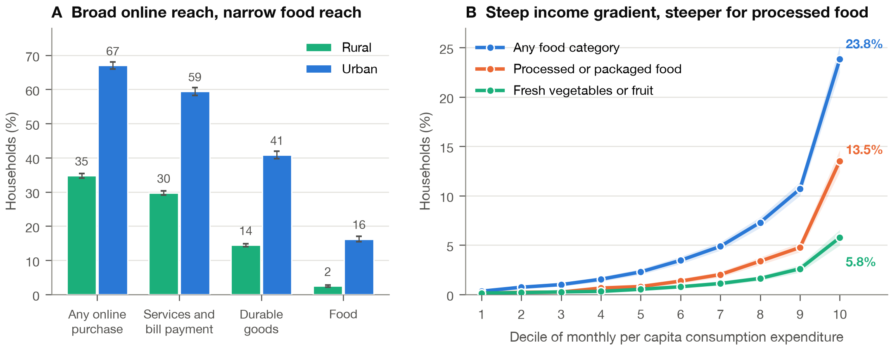
Figure 1. Online purchasing by domain and sector (A), and adoption of online food buying across deciles of monthly per capita consumption expenditure (B). Bars and bands are 95% confidence intervals.
Table 2. Prevalence of online purchasing, by domain and sector.
Category | All (%) | Rural (%) | Urban (%)
Any online purchase | 45.60 (0.30) | 34.78 (0.33) | 67.02 (0.53)
Any service or consumable | 39.69 (0.31) | 29.72 (0.33) | 59.43 (0.59)
Any durable good | 23.31 (0.25) | 14.46 (0.22) | 40.83 (0.57)
Any food category | 7.10 (0.17) | 2.48 (0.14) | 16.24 (0.41)
Groceries | 4.29 (0.13) | 1.38 (0.09) | 10.06 (0.34)
Milk | 1.44 (0.08) | 0.31 (0.03) | 3.68 (0.23)
Vegetables | 1.32 (0.08) | 0.44 (0.05) | 3.06 (0.21)
Fresh fruits | 1.00 (0.07) | 0.31 (0.04) | 2.36 (0.18)
Dry fruits | 0.62 (0.05) | 0.11 (0.01) | 1.64 (0.16)
Egg, fish and meat | 0.59 (0.05) | 0.28 (0.04) | 1.21 (0.13)
Served processed food | 2.60 (0.11) | 0.87 (0.09) | 6.02 (0.27)
Packaged processed food | 1.65 (0.08) | 0.26 (0.03) | 4.39 (0.22)
Other food items | 1.33 (0.07) | 0.39 (0.05) | 3.19 (0.19)
Any fresh (veg or fruit) | 1.69 (0.09) | 0.61 (0.06) | 3.85 (0.23)
Any processed | 3.54 (0.13) | 1.06 (0.10) | 8.46 (0.32)
Note. Groceries was asked over a 30-day reference period; the other eight food categories over 7 days. Standard errors in parentheses.
The rural-urban gap in food is far wider than in other domains. Rural households were less than half as likely to buy durables online as urban households (14.46% against 40.83%), but roughly one-sixth as likely to buy food online (2.48% against 16.24%).
3.3 Who buys food online
Households that bought food online differ sharply from those that did not (Table 1). Their monthly per capita consumption expenditure averaged ₹10,497 against ₹5,372; the highest education in the household was 14.96 years against 11.05; 76.8% lived in urban areas against 30.3%; and 35.3% used the public distribution system against 73.0%.
Table 1. Household characteristics by online food purchase status.
Characteristic | Unit | All households | Did not buy food online | Bought food online
Urban residence | % | 33.57 (0.26) | 30.26 (0.27) | 76.81 (0.86)
MPCE | Rs/capita/30d | 5,735.94 (38.88) | 5,372.18 (31.01) | 10,496.58 (171.09)
Household size | persons | 4.18 (0.01) | 4.19 (0.01) | 3.98 (0.03)
Highest education in household | years | 11.32 (0.02) | 11.05 (0.02) | 14.96 (0.06)
Any member used internet (30 d) | % | 83.39 (0.19) | 82.22 (0.20) | 98.80 (0.14)
Uses public distribution system | % | 70.28 (0.28) | 72.95 (0.27) | 35.26 (0.90)
Owns land | % | 48.26 (0.28) | 49.63 (0.28) | 30.38 (0.81)
Clean cooking fuel | % | 61.56 (0.30) | 59.40 (0.30) | 89.80 (0.86)
Food expenditure | Rs/capita/30d | 2,188.38 (6.57) | 2,102.37 (5.88) | 3,374.82 (32.01)
Vegetable quantity | kg/capita/30d | 7.15 (0.02) | 7.14 (0.02) | 7.35 (0.06)
Food groups acquired | count | 10.08 (0.02) | 10.06 (0.01) | 10.39 (0.05)
Households (n) | count | 261,895 | 242,053 | 19,842
Note. Weighted estimates with design-based standard errors in parentheses. MPCE is monthly per capita consumption expenditure.
Adoption rises steeply and smoothly with expenditure (Figure 1B), from 0.34% in the poorest decile to 23.84% in the richest: a 70-fold difference across a six-fold difference in expenditure.
In the adjusted model (Table 3), a one-log-unit increase in MPCE multiplies the odds of buying food online by 6.61 (95% CI 5.82–7.51). Each additional year of household education multiplies them by 1.100 (1.086–1.113), household internet use by 2.88 (2.20–3.77), and urban residence by 1.82 (1.56–2.13). Public distribution system use is associated with lower odds (OR 0.69, 0.63–0.75), as is scheduled-caste status (OR 0.85, 0.74–0.97). Land ownership beyond homestead shows no association once income is controlled (OR 1.02, 0.92–1.12).
Table 3. Adoption of online food purchasing (survey-weighted logistic regression).
Covariate | Odds ratio | 95% CI | p
Log monthly per capita consumption expenditure | 6.615 | 5.823–7.515 | <1e-16
Highest education in household (years) | 1.100 | 1.086–1.113 | <1e-16
Any member used internet (30 days) | 2.881 | 2.204–3.767 | 1.0e-14
Urban residence | 1.823 | 1.559–2.132 | 5.5e-14
Log household size | 2.567 | 2.306–2.858 | <1e-16
Share of members female | 0.893 | 0.753–1.061 | 0.198
Children under 5 (n) | 0.947 | 0.898–0.999 | 0.047
Members aged 60+ (n) | 1.021 | 0.968–1.077 | 0.445
Mean age of members (years) | 0.992 | 0.988–0.996 | 2.5e-04
Owns land beyond homestead | 1.018 | 0.923–1.123 | 0.718
Clean cooking fuel | 1.547 | 1.319–1.813 | 8.0e-08
Used public distribution system (30 days) | 0.689 | 0.630–0.754 | 5.1e-16
Social group: Not reported | 0.326 | 0.103–1.030 | 0.056
Social group: OBC | 1.009 | 0.920–1.106 | 0.854
Social group: SC | 0.845 | 0.738–0.966 | 0.014
Social group: ST | 1.116 | 0.908–1.371 | 0.298
Religion: Buddhism | 0.639 | 0.393–1.037 | 0.070
Religion: Christianity | 1.203 | 0.975–1.484 | 0.085
Religion: Islam | 1.004 | 0.870–1.159 | 0.952
Religion: Jainism | 1.040 | 0.660–1.640 | 0.866
Religion: Not reported | 1.007 | 0.152–6.647 | 0.994
Religion: Others | 2.318 | 1.262–4.255 | 0.007
Religion: Sikhism | 1.129 | 0.828–1.539 | 0.444
Religion: Zoroastrianism | 4.574 | 0.449–46.581 | 0.199
Household type: Casual labour in agriculture | 1.130 | 0.889–1.436 | 0.318
Household type: Casual labour in non-agriculture | 0.926 | 0.739–1.160 | 0.503
Household type: Regular wage in agriculture | 0.868 | 0.687–1.095 | 0.232
Household type: Regular wage in non-agriculture | 1.116 | 0.889–1.401 | 0.344
Household type: Self-employed in agriculture | 1.027 | 0.892–1.182 | 0.714
Household type: Self-employed in non-agriculture | 1.192 | 1.031–1.379 | 0.018
Observations / PSU clusters | 261,895 | 14,827
Note. Reference levels: social group Others, religion Hinduism, household type Others. State and survey-month fixed effects included and not shown.
Household internet use is close to universal among adopters (98.8%) but also high among non-adopters (82.2%). Connectivity is a precondition, not the constraint.
3.4 The gradient is steeper for processed food
Adoption gradients vary by category. When we fit the model to each category, served processed food shows the steepest income gradient (OR 5.96, 95% CI 5.03, 7.06), and vegetables show the shallowest (4.42, 3.59, 5.44). Packaged processed food is the most urban-concentrated category (urban OR 4.31, compared to 1.83 for vegetables and 1.03 for egg, fish, and meat).
This is evident across the expenditure distribution (Figure 1B). The ratio of processed to fresh food purchasing climbs from 0.85 in the poorest decile to 2.35 in the richest, suggesting that as households become wealthier, their online food baskets become increasingly processed.
Among the 19,842 online-buying households (Figure 2), 36.6% bought served processed food and 23.2% bought packaged processed food, whereas 18.6% bought vegetables, 14.1% bought fresh fruits, and 8.4% bought egg, fish, and meat. Groceries led at 60.5%, though its 30-day window makes direct comparison difficult.
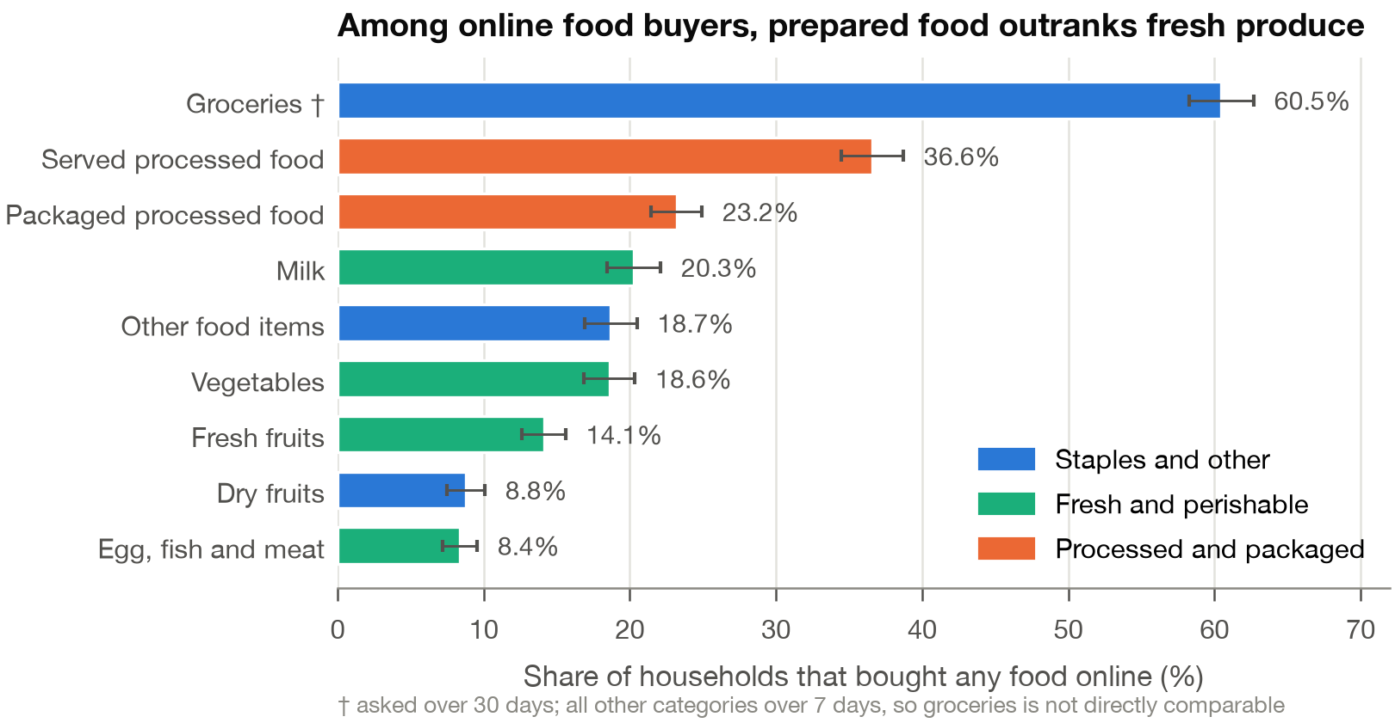
Figure 2. Share of the 19,842 households buying any food online who bought each category, with 95% confidence intervals. Groceries used a 30-day reference period and the other categories 7 days, so it is not comparable with them.
3.5 Food budget composition
Online food purchasing is linked to a distinct food basket (Table 4, Figure 3). After adjusting for consumption expenditure, education, internet use, urbanicity, demography, and other controls, online-buying households allocated:
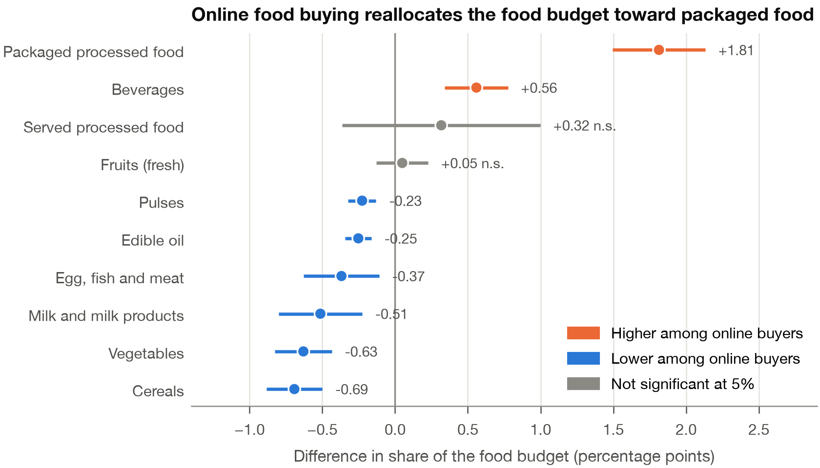
Figure 3. Adjusted difference in each food group's share of the household food budget between households that did and did not buy food online, in percentage points, with 95% confidence intervals.
Table 4. Food budget composition, in percentage points of the food budget.
Food group | Adjusted difference (pp) | 95% CI | p | Matched difference (pp) | Matched p | E-value
Packaged processed food | +1.81 | +1.49 to +2.13 | <1e-16 | +1.47 | <1e-16 | 1.66
Beverages | +0.56 | +0.34 to +0.78 | 4.2e-07 | +0.40 | 0.011 | 1.31
Served processed food | +0.32 | -0.36 to +1.00 | 0.361 | +0.73 | 0.310 | 1.29
Fruits (fresh) | +0.05 | -0.13 to +0.23 | 0.589 | +0.05 | 0.661 | 1.10
Pulses | -0.23 | -0.32 to -0.13 | 3.6e-06 | -0.25 | 1.6e-04 | 1.36
Edible oil | -0.25 | -0.34 to -0.16 | 3.5e-08 | -0.37 | 1.0e-06 | 1.40
Egg, fish and meat | -0.37 | -0.63 to -0.11 | 0.005 | -0.18 | 0.420 | 1.17
Milk and milk products | -0.51 | -0.80 to -0.23 | 4.6e-04 | -0.06 | 0.832 | 1.06
Vegetables | -0.63 | -0.83 to -0.44 | 2.5e-10 | -0.98 | 2.1e-09 | 1.44
Cereals | -0.69 | -0.88 to -0.50 | 1.5e-12 | -0.51 | 0.002 | 1.30
Observations | 261,887 |  |  | 125,681
Note. Adjusted differences are coefficients on any online food purchase from weighted linear models with the full covariate set and state and survey-month fixed effects. Matched differences come from coarsened exact matching on state, sector, MPCE decile, education band, household-size band and household internet use. E-values are computed on the ratio of matched shares. Positive values indicate a larger share among online buyers. The share models use 261,887 households, since a budget share is undefined for the eight households reporting no food expenditure.
• 1.81 percentage points more of their budget to packaged processed food (95% CI 1.50, 2.13, p = 7.4 × 10⁻²⁹)
• 0.56 points more to beverages (0.34, 0.78)
• 0.63 points less to vegetables (−0.83 to −0.44, p = 2.5 × 10⁻¹⁰)
• 0.69 points less to cereals (−0.88 to −0.50)
• 0.51 points less to milk and milk products (−0.80 to −0.23)
• 0.37 points less to egg, fish, and meat (−0.63 to −0.11)
• 0.25 points less to edible oil and 0.23 points less to pulses
Fresh fruit showed no significant difference (+0.05 points, 95% CI −0.13 to +0.23). Served processed food was not significant in the main specification, though it became significant under the 7-day exposure (+1.25 points, 0.50, 2.00). The trend is consistent - unprocessed groups either decreased or stayed the same, while processed categories and beverages increased.
Expenditure levels follow this pattern (Table 5). Total food expenditure was 4.7% higher for online buyers, but packaged processed expenditure was 23.3% higher and beverages were 14.0% higher, while vegetable spending showed no difference. Ultimately, online buyers spent slightly more per kilogram for vegetables (₹0.76 per kg higher, 0.24-1.29) but ended up taking home a smaller quantity (0.23 kg less per capita per 30 days, 95% CI −0.40 to −0.07).
Table 5. Levels, quantities and unit values.
Outcome | Difference | 95% CI | p
Vegetable quantity (kg/capita/30d) | -0.2338 | -0.3956 to -0.0720 | 0.005
log food expenditure per capita | +0.0469 | +0.0359 to +0.0579 | <1e-16
log vegetable expenditure per capita | +0.0306 | -0.0226 to +0.0837 | 0.260
log packaged processed expenditure per capita | +0.2331 | +0.1960 to +0.2702 | <1e-16
log served processed expenditure per capita | +0.2460 | +0.1921 to +0.3000 | <1e-16
log beverage expenditure per capita | +0.1404 | +0.0711 to +0.2096 | 7.2e-05
Number of food groups acquired | +0.0541 | -0.0001 to +0.1082 | 0.050
Vegetable unit value (Rs/kg) | +0.7645 | +0.2413 to +1.2877 | 0.004
Note. Log outcomes are natural logarithms of one plus the per-capita 30-day value, so coefficients approximate proportional differences. Weighted levels for the same outcomes are in Table 1.
The number of food groups acquired was marginally higher (+0.054 groups, 95% CI −0.0001 to +0.108). Whatever online buying does to the basket, it does not narrow the range of groups.
For context, households acquired 238.4 g of vegetables per capita per day (SE 0.7), or 59.6% of the 400 g the 2024 ICMR-NIN dietary guidelines recommend (ICMR-NIN, 2024). The shortfall is nearly identical in rural (239.5 g) and urban (235.7 g) areas. The composition shift documented here operates on a base that is already well below guideline.
3.6 Robustness
The two headline shifts hold across every specification (Figure 4).
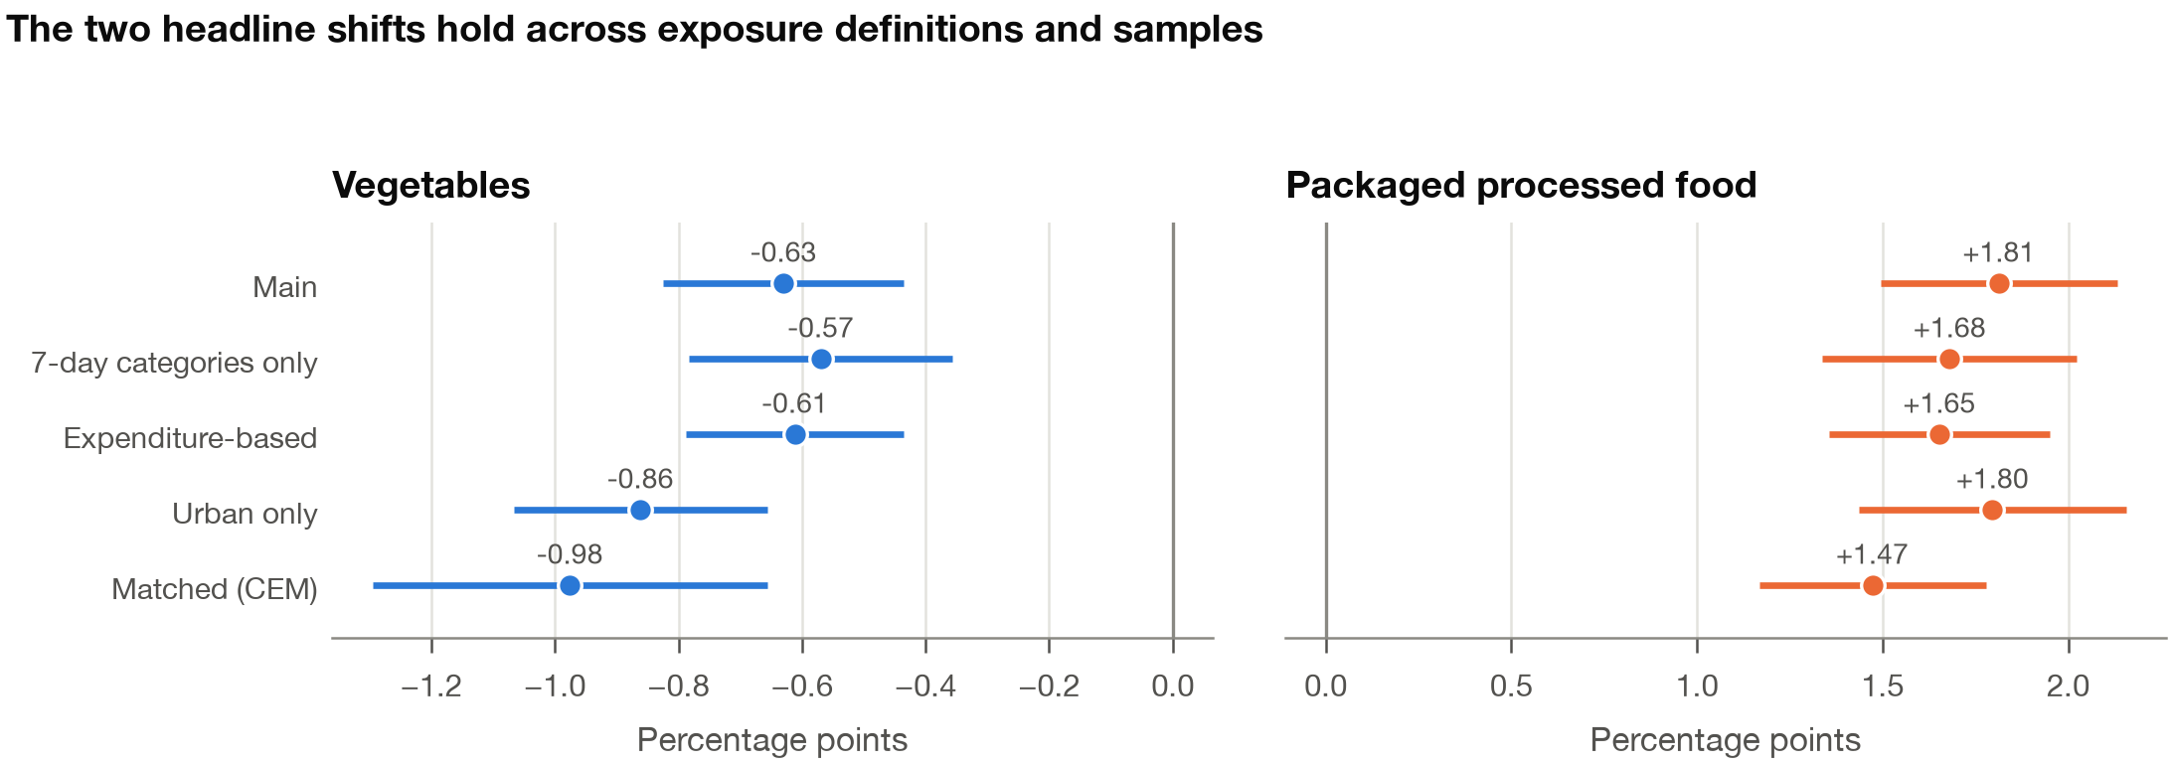
Figure 4. The vegetable and packaged-processed-food contrasts across five specifications, in percentage points of the food budget.

Coarsened exact matching retained 3,970 cells covering 125,681 households and 19,325 of 19,842 online buyers (97.4%). Matching helped a lot with balance - the standardised difference in log MPCE fell from 1.18 to 0.15, education from 0.84 to 0.03, internet use from 0.47 to 0.00, and public distribution system use from −0.81 to −0.15. In the matched sample, the vegetable share was 0.98 points lower among online buyers (p = 2.1 × 10⁻⁹) and the packaged processed share 1.47 points higher (p < 10⁻¹⁶). Cereals, pulses, edible oil and beverages kept their sign and significance, milk and egg, fish and meat did not survive matching, and we aren't claiming them.
Alternative exposures show the same thing. If we restrict to the eight 7-day categories - vegetables −0.57 points, packaged processed +1.68. Defining exposure from reported 30-day online food expenditure - −0.61 and +1.65. Urban households only - −0.86 and +1.81. A continuous exposure in log online food expenditure per capita gives the same signs and significance for every group.
E-values are 1.66 for the packaged processed contrast and 1.44 for vegetables. To explain these away, an unmeasured confounder would need associations of roughly that size, on the risk-ratio scale, with both online purchasing and the outcome. That isn't a huge threshold, and we'll return to it later.
4. Discussion
4.1 Principal findings
Three results stand out.
First, digital access isn't what limits online food buying in India. Nearly half of households buy something online and two in five pay for services online, but only one in fourteen buys food. Whatever actually holds back food e-commerce, like cold chains, delivery density, trust in quality, price, or habit, it isn't a lack of internet access.
Second, online food buying is heavily stratified. There's a 70-fold gap between the poorest and richest expenditure deciles, and a sixfold rural-urban gap. Any idea that e-commerce is a route to better food access has to face the fact that it currently reaches almost none of the households whose diets are furthest from guidelines.
Third, where it does reach, the basket looks different. Once we account for income and other variables, online buyers put 1.81 more percentage points of their food budget into packaged processed food and 0.63 fewer into vegetables. They also take home slightly less vegetable weight while paying slightly more per kilogram.
4.2 Relation to existing evidence
Our adoption results match the pattern seen in high-income countries - reviews consistently find online food retail is used mostly by higher-income, better-educated households (Trude et al., 2022, Bennett et al., 2024). That this same gradient appears in India at such an early stage of market development suggests this stratification is just how the channel works, rather than a sign of a specific market's maturity.
On composition, the literature is mixed, online ordering is sometimes credited for cutting down impulse buys but also faulted for reducing fresh produce purchases (Trude et al., 2022). Our results lean toward the latter, with the added observation that in India the displacement happens across all unprocessed groups, not just fresh produce. Reviews of delivery platforms show they promote energy-dense products more than fresh ones through discounting and imagery (Jia et al., 2024, Bennett et al., 2024). This is a plausible reason for what we see, even if our data can't test it directly.
Two Indian findings frame our own. Retail sales of ultra-processed food grew at 13.4% a year from 2011-2021, even though about 70% of sales still happen through kirana stores and the unorganised sector (Mukherjee et al., 2023). The digital channel is small, but it's the fastest-growing part of a fast-growing category. Also, among Indian adults, higher ultra-processed food intake is linked to lower dietary diversity and a higher risk of nutritional issues (Mediratta et al., 2023). This is why a shift of this size matters. We've identified a retail channel with an expanding user base that already has a tilted basket.
4.3 Interpretation and mechanism
We can't distinguish selection from causation. Maybe households that choose to buy food online already prefer packaged and prepared food, or maybe the channel itself is shifting what they buy. Both fit our results, and our cross-sectional design can't tell them apart.
Three data points suggest which is more likely. The association holds up even after matching for income, education, internet use, state, sector, and household size, so it's not just an affluence effect. It's consistent across seven unprocessed groups, a preference story would have to assume a general dislike for all unprocessed food rather than just a taste for specific things. And it shows up on the intensive margin, too - households that spend more rupees online show the same tilt.
On the other hand, the E-values are modest. A confounder associated with both online buying and packaged-food share at a risk ratio near 1.5 to 1.7 would be enough to explain it. Time use is the obvious candidate - households with less time for cooking might be more likely to both order online and buy prepared food. HCES doesn't measure time use, so we can't rule this out. It's the single biggest gap in this analysis.
4.4 Policy implications
Two implications follow, regardless of the underlying cause.
Online food retail isn't currently helping bridge dietary inequality in India, and it shouldn't be framed as an access solution for fresh produce. The households using it are the ones least likely to face access issues.
Where policy should focus is on what digital platforms sell and how they sell it. India is at an early enough stage that the retail-facing rules other countries adopted late, like nutrition labeling, or restrictions on discounting and default product placement, could be put in place now. Existing work already maps out the options for delivery platforms (Jia et al., 2024).
There's also a measurement implication. The e-commerce module in HCES 2023-24 appears to be the only nationally representative look at digital food purchasing in South Asia, yet it's listed as auxiliary and unvalidated. Including these items in validated survey instruments in the future, with a consistent reference period, would be cheap and would allow for a much better answer.
4.5 Limitations
The biggest limitation is the status of the exposure data. The statistical agency says these items were for internal consistency checks, not for official estimates. Our analysis shows the module behaves coherently (no logical contradictions, κ = 0.885, monotone dose-response), but coherence isn't the same as accuracy, and we don't have independent validation. Every finding here should be seen as provisional, meant to encourage better measurement rather than settle the issue.
The reference period isn't the same across all categories, which makes it hard to compare groceries to other items and means the binary exposure likely under-counts people who buy online only occasionally. This pulls our estimates toward the null.
The design is cross-sectional, so we can't make causal claims. HCES measures what people acquire, not what they eat, it doesn't track waste, who eats what in the house, or actual nutrients. We're describing budget composition, not total diet quality, and we don't use the NOVA classification (Monteiro et al., 2019) because HCES categories don't map onto it perfectly. "Packaged processed food" in the survey is close to, but not exactly, ultra-processed food.
Variance estimation clusters on the FSU without stratification, which is conservative. We don't report estimates below the state level, per survey guidance. Finally, the survey ran from August 2023 to August 2024, and India's quick-commerce market has grown quite a bit since then, current numbers are likely higher.
5. Conclusion
Across 261,895 Indian households, online food buying reached 7.10%, compared to 45.6% for general online shopping, ranging from 0.34% in the poorest deciles to 23.84% in the richest. Among those who did buy food online, prepared and packaged food outranked fresh vegetables by about two to one. Their food budgets contained 1.81 more percentage points of packaged processed food and 0.63 fewer of vegetables than otherwise similar households. These associations survive matching and four different ways of defining exposure. They sit on top of vegetable consumption levels that were already 40% below national guidelines, and they rely on survey items designated as auxiliary. Both the results themselves and the measurement gap they highlight suggest we should be treating digital food retail as a serious part of national dietary surveillance, not just a side note.
Declarations
Data availability. HCES 2023-24 unit-level data are distributed by the Ministry of Statistics and Programme Implementation through the microdata portal at https://microdata.gov.in/NADA/index.php/catalog/237 and require a portal account. The microdata are not redistributed here. All analysis code, the derived item dictionary, and the aggregate tables and figures reported in this paper are available at [repository URL], and reproduce the results from the official archive (SHA-256 acf7b9cc840676fb812c05c48f09fa034955fe2cad5112e6d9b6d852f5f2e267).
Ethics. This study analyses de-identified secondary data released for public research use. No ethical approval was required. No attempt was made to identify individuals or households, and no estimates below state level are reported, following the data producer's guidance.
Funding. [To be completed.]
Declaration of competing interest. [To be completed.]
CRediT author statement. [To be completed.]
Use of AI tools. [To be completed per journal policy.]
References
Baker, P., Machado, P., Santos, T., Sievert, K., Backholer, K., Hadjikakou, M., Russell, C., Huse, O., Bell, C., Scrinis, G., Worsley, A., Friel, S., Lawrence, M., 2020. Ultra-processed foods and the nutrition transition: global, regional and national trends, food systems transformations and political economy drivers. Obesity Reviews 21 (12), e13126. https://doi.org/10.1111/obr.13126
Bennett, R., Keeble, M., Zorbas, C., Sacks, G., Driessen, C., Grigsby-Duffy, L., Adams, J., Burgoine, T., Backholer, K., 2024. The potential influence of the digital food retail environment on health: a systematic scoping review of the literature. Obesity Reviews 25 (3), e13671. https://doi.org/10.1111/obr.13671
Iacus, S.M., King, G., Porro, G., 2012. Causal inference without balance checking: coarsened exact matching. Political Analysis 20 (1), 1–24. https://doi.org/10.1093/pan/mpr013
ICMR-NIN, 2024. Dietary Guidelines for Indians. Indian Council of Medical Research, National Institute of Nutrition, Hyderabad.
Jia, S.S., Todd, A.R., Vanderlee, L., Farrell, P., Allman-Farinelli, M., Sacks, G., Gibson, A.A., Partridge, S.R., 2024. Offline to online: a systematic mapping review of evidence to inform nutrition-related policies applicable to online food delivery platforms. BMC Medicine 22 (1), 542. https://doi.org/10.1186/s12916-024-03747-8
Mediratta, S., Ghosh, S., Mathur, P., 2023. Intake of ultra-processed food, dietary diversity and the risk of nutritional inadequacy among adults in India. Public Health Nutrition 26 (12), 2849–2858. https://doi.org/10.1017/S1368980023002112
Ministry of Statistics and Programme Implementation, 2025. Household Consumption Expenditure Survey: 2023-24. NSS Report No. 592. National Statistics Office, Government of India, New Delhi.
Monteiro, C.A., Cannon, G., Levy, R.B., Moubarac, J.-C., Louzada, M.L., Rauber, F., Khandpur, N., Cediel, G., Neri, D., Martinez-Steele, E., Baraldi, L.G., Jaime, P.C., 2019. Ultra-processed foods: what they are and how to identify them. Public Health Nutrition 22 (5), 936–941. https://doi.org/10.1017/S1368980018003762
Mukherjee, A., Mukhopadhyay, D., Mukherjee, E., Gupta, R., 2023. The Growth of Ultra-processed Foods in India: An Analysis of Trends, Issues and Policy Recommendations. Indian Council for Research on International Economic Relations and World Health Organization Country Office for India, New Delhi.
Popkin, B.M., Ng, S.W., 2022. The nutrition transition to a stage of high obesity and noncommunicable disease prevalence dominated by ultra-processed foods is not inevitable. Obesity Reviews 23 (1), e13366. https://doi.org/10.1111/obr.13366
Trude, A.C.B., Lowery, C.M., Ali, S.H., Vedovato, G.M., 2022. An equity-oriented systematic review of online grocery shopping among low-income populations: implications for policy and research. Nutrition Reviews 80 (5), 1294–1310. https://doi.org/10.1093/nutrit/nuab122
USDA Foreign Agricultural Service, 2025. India's E-commerce and Quick Commerce Market. GAIN Report IN2025-0043. United States Department of Agriculture, Mumbai.
VanderWeele, T.J., Ding, P., 2017. Sensitivity analysis in observational research: introducing the E-value. Annals of Internal Medicine 167 (4), 268–274. https://doi.org/10.7326/M16-2607

