Лабораторная работа №4

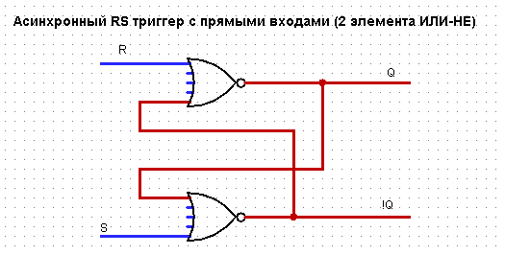

|  |  |  |  |
| --- | --- | --- | --- |
| a | b | x | y |
| 0 | 0 | ! | ! |
| 0 | 1 | 1 | 0 |
| 1 | 0 | 0 | 1 |
| 1 | 1 | 0 | 0 |

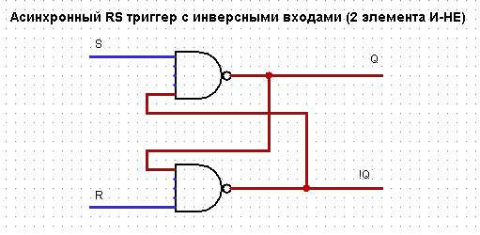

|  |  |  |  |
| --- | --- | --- | --- |
| a | b | x | y |
| 0 | 0 | 1 | 1 |
| 0 | 1 | 1 | 0 |
| 1 | 0 | 0 | 1 |
| 1 | 1 | ! | ! |

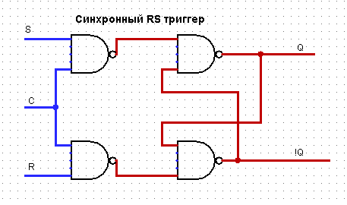

|  |  |  |  |  |
| --- | --- | --- | --- | --- |
| a | b | C | x | y |
| 0 | 0 | 0 | ! | ! |
| 0 | 0 | 1 | ! | ! |
| 0 | 1 | 0 | ! | ! |
| 0 | 1 | 1 | 0 | 1 |
| 1 | 0 | 0 | ! | ! |
| 1 | 0 | 1 | ! | ! |
| 1 | 1 | 0 | 1 | 0 |
| 1 | 1 | 1 | 1 | 1 |

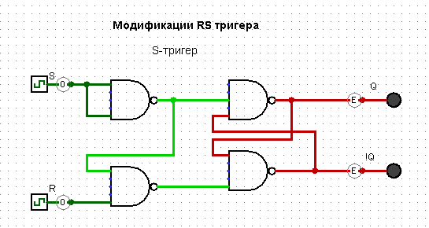

|  |  |  |  |
| --- | --- | --- | --- |
| a | b | x | y |
| 0 | 0 | ! | ! |
| 0 | 1 | 0 | 1 |
| 1 | 0 | 1 | 0 |
| 1 | 1 | 1 | 0 |

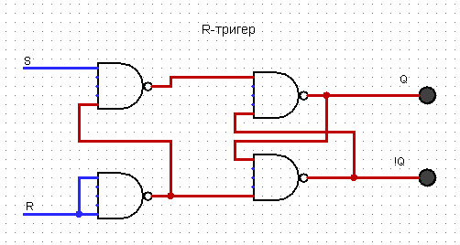

|  |  |  |  |
| --- | --- | --- | --- |
| a | b | x | y |
| 0 | 0 | ! | ! |
| 0 | 1 | 0 | 1 |
| 1 | 0 | 1 | 0 |
| 1 | 1 | 0 | 1 |

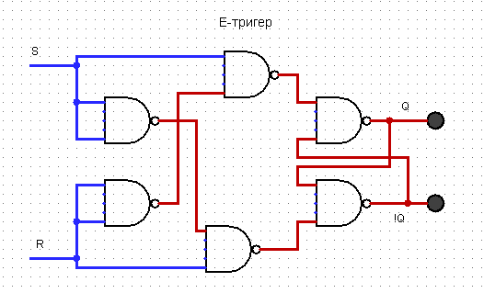

|  |  |  |  |
| --- | --- | --- | --- |
| a | b | x | y |
| 0 | 0 | ! | ! |
| 0 | 1 | 0 | 1 |
| 1 | 0 | 1 | 0 |
| 1 | 1 | ! | ! |

