CAR Rental Problem – Scenario 1

**Precondition/Assumption- Projects already migrated to azureDevops-git repo**

1. Created 3 projects in visual studio

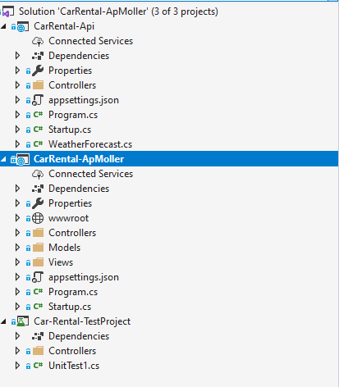

1. Created Organization->Project in AzureDevOps named it as CarRental

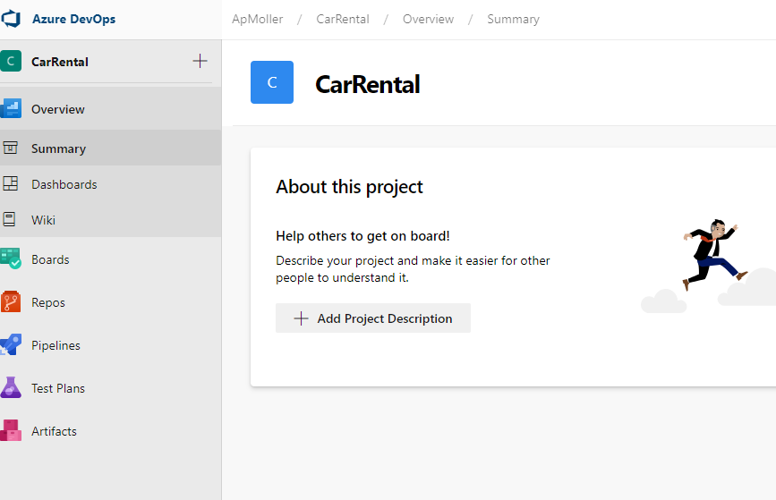

1. Pushed the local code base (Asp.net Web, API and Test ) to the created repo in AzureDevOps

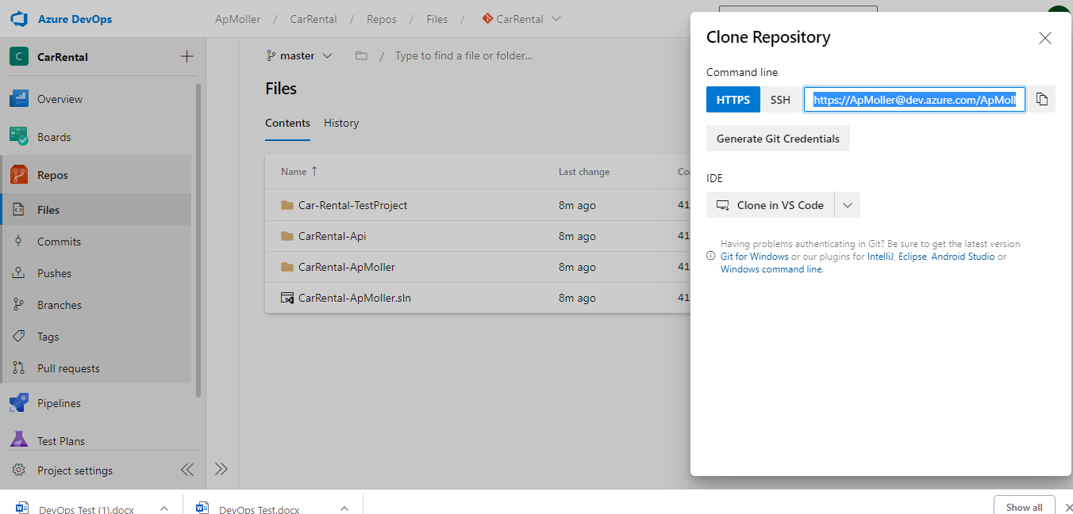

1. Add a comment on top of the code and Push to Git and Test Continues integration is working or not

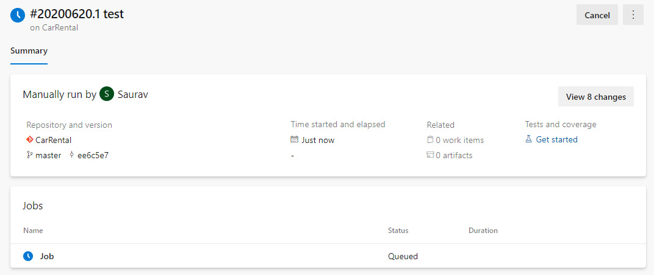

5) Kindly refer, azure-pipelines.yaml in the root folder for the complete task Lists

6)Click on new release and Add an Artifact from the drop location which was created in the build.yaml file

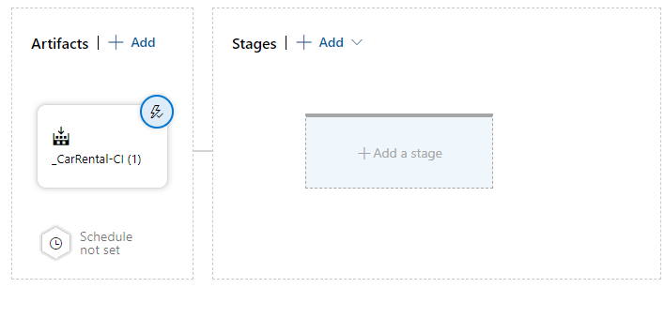

7) Add a Stage and Name it DEV

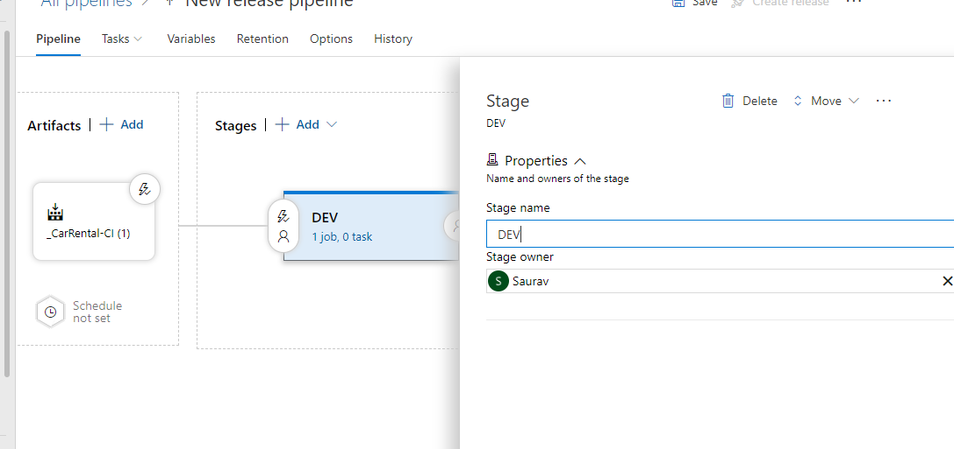

8) Add an Azure AppService Task

9) Enable Post Deployment Approval Check/Gate, and select an Approver

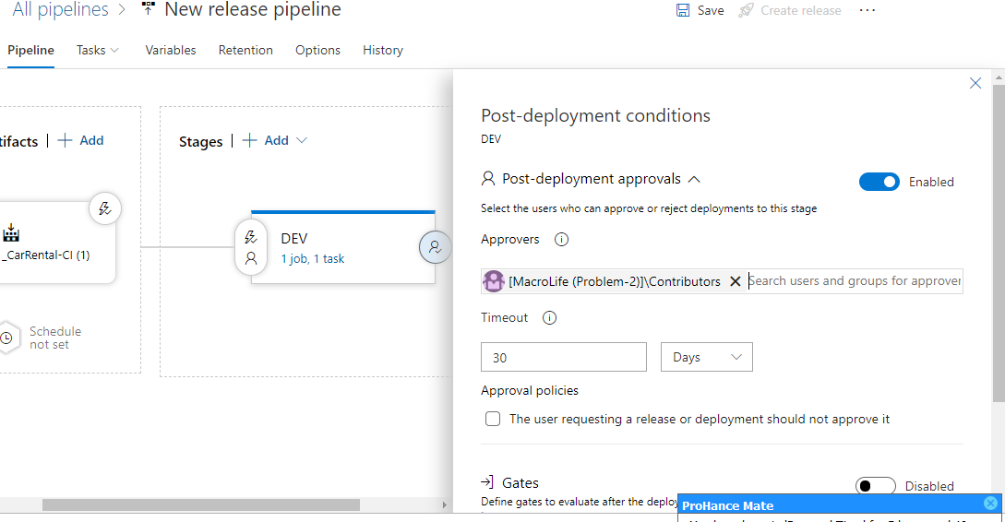

10) Click on Clone Stage and Create an Upstream Stage QA

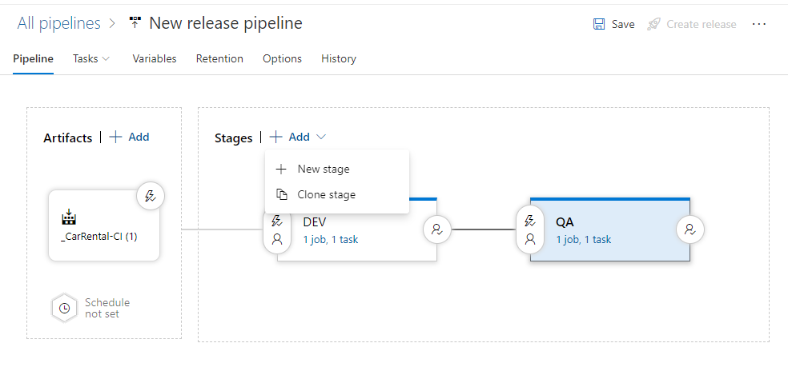

11) Click on Save and Overall release pipeline should look like this below-

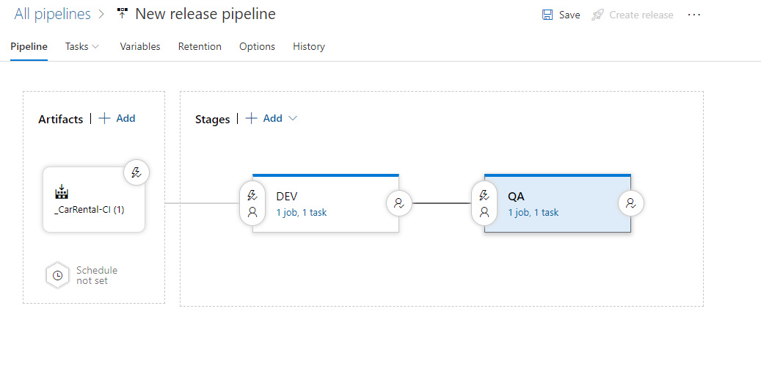

12) Create a new Release and select Auto Promote from DEV->QA below

