**Q2 - SCENARIO**

1. *What are different artifacts you need to create - name of the artifacts and its purpose?*

Ans)

a) Git repo - to store the ARM template file and json paramater file

b) Azure key vault - to store the Azure VM credentials

c) ARM template and Paramater file

d) Powershell script - to deploy the Arm template

e) Azure DevOps - CI/CD pipeline to deploy the Arm template

2) *List the tools you will to create and store the ARM templates.*

Ans)

**1) Visual Studio Code with ARM templates extensions**

**2) GitHub or azure Storage Account - Blob Storage**

1. *Explain the process and steps to create automated deployment pipeline.*

a) Create a project

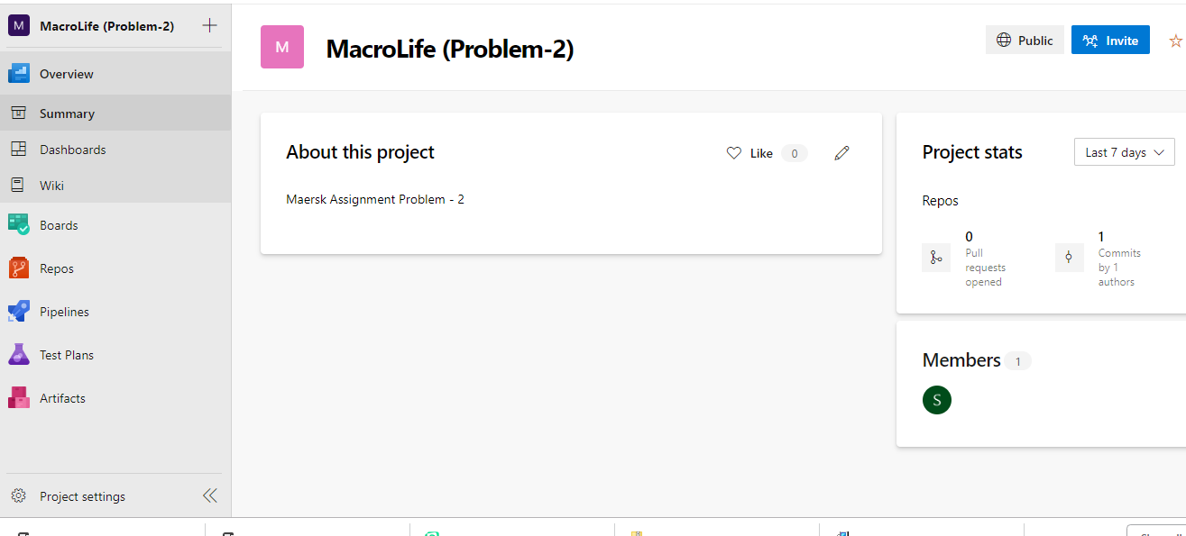

b) Create and Configure a pipeline

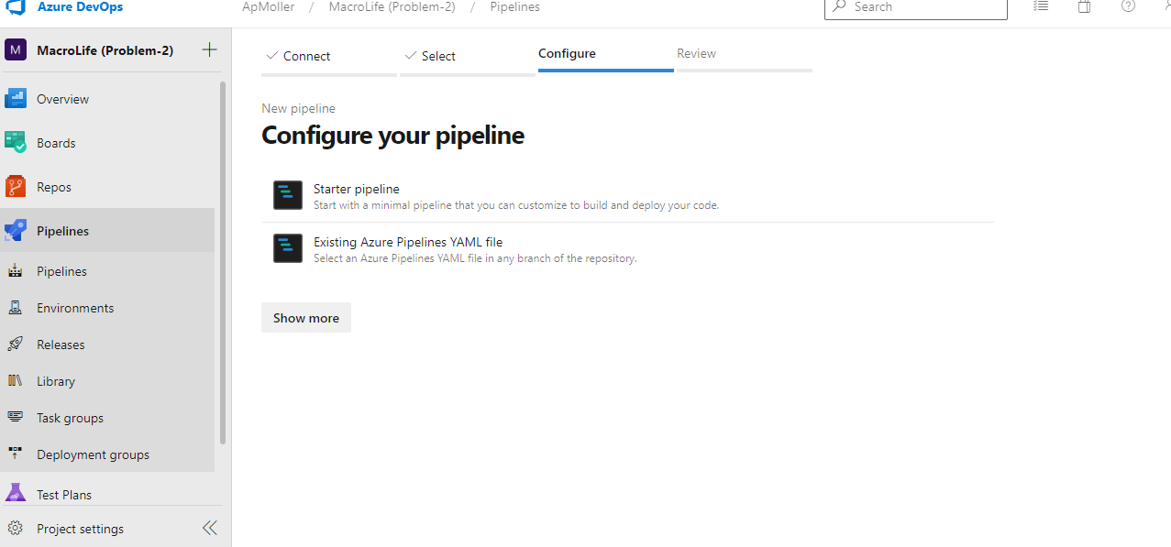

c) Create a YAML pipeline for ARM template as shown below -:

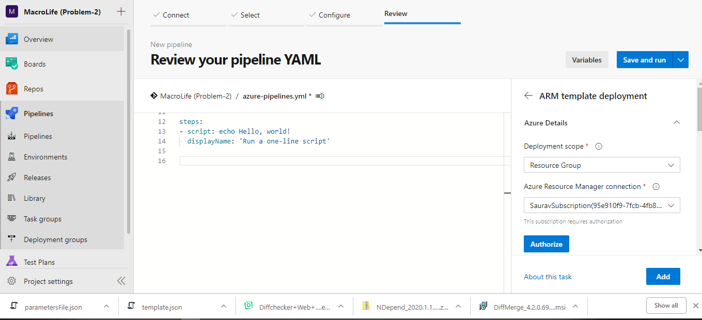

d) Login to Azure Portal and Create a ServicePrinciple with the below command

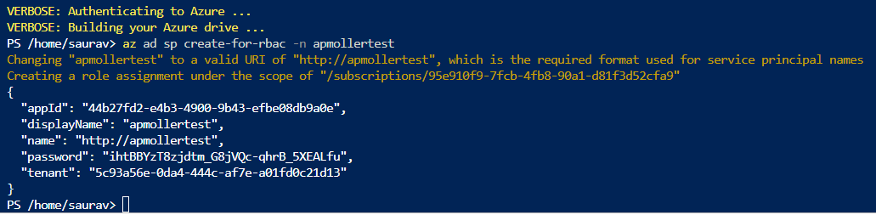

Output as shown above

e) Create a keyvault with the name MaerskVault

f) Add access policy to the keyvault

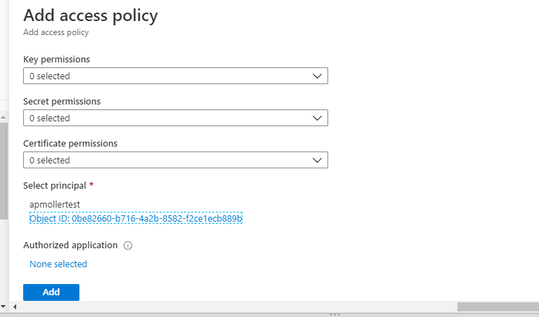

g) Provide Permission (GET,LIST)

h) Create a secret

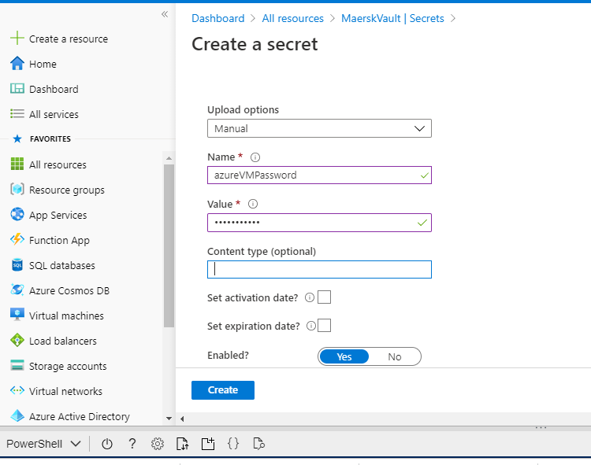

1. Add Azure Key value Task in the DevOps Pipeline

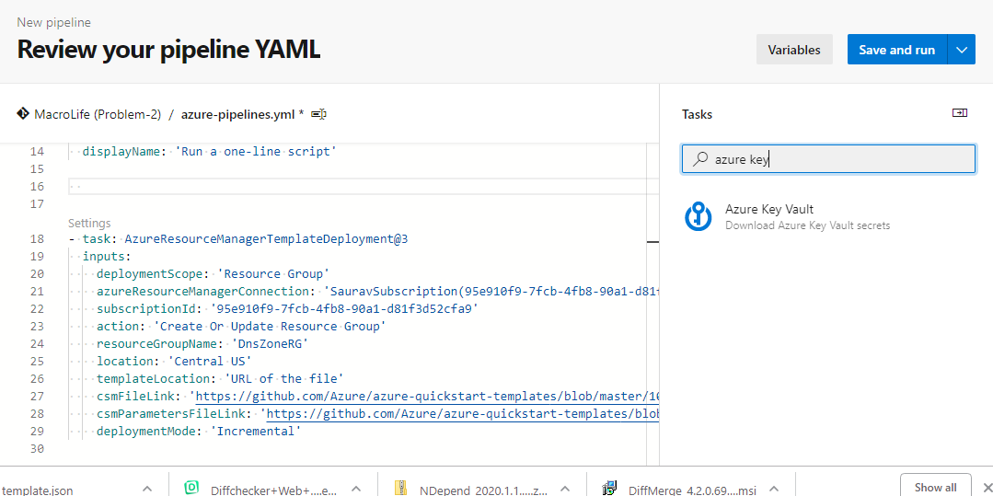

j) Add ARM template as the next Task

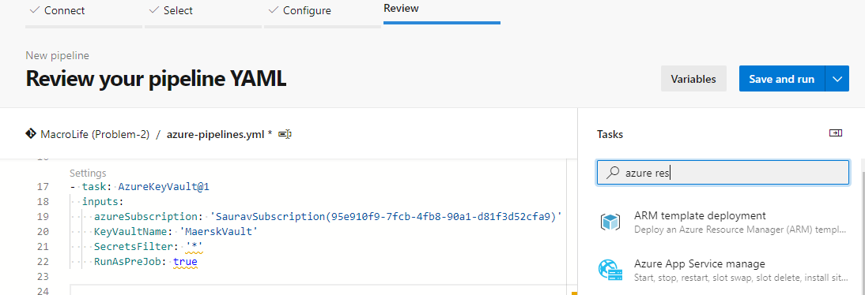

k) **Complete YAML**

# Starter pipeline

# Start with a minimal pipeline that you can customize to build and deploy your code.

# Add steps that build, run tests, deploy, and more:

# https://aka.ms/yaml

trigger:

- master

pool:

  vmImage: 'windows-latest'

steps:

- script: Starting ARM Demployemnt !

  displayName: 'Run a one-line script'

- task: AzureKeyVault@1

  inputs:

    azureSubscription: 'SauravSubscription(95e910f9-7fcb-4fb8-90a1-d81f3d52cfa9)'

    KeyVaultName: 'MaerskVault'

    SecretsFilter: '*'

    RunAsPreJob: false

- task: AzureResourceManagerTemplateDeployment@3

  inputs:

    deploymentScope: 'Resource Group'

    azureResourceManagerConnection: 'SauravSubscription(************************)'

    subscriptionId: '*****************************************'

    action: 'Create Or Update Resource Group'

    resourceGroupName: 'DnsZoneRG'

    location: 'Central US'

    templateLocation: 'URL of the file'

    csmFileLink: 'https://github.com/imsauravroy007/APMoller/blob/master/template.json'

    csmParametersFileLink: 'https://github.com/imsauravroy007/APMoller/blob/master/parametersFile.json'

    overrideParameters: '-adminUsername  $(vmPassword)'

    deploymentMode: 'Incremental'

l) SAVE and RUN the Build Pipeline

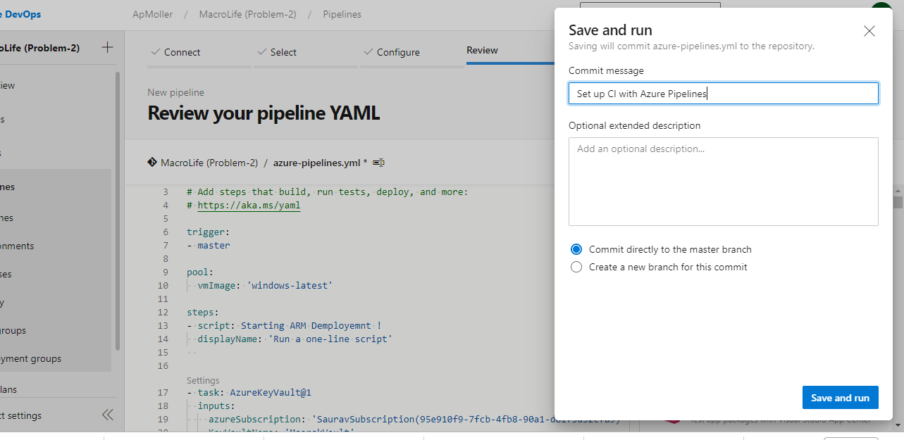

*4) Create a sample ARM template you will use to deploy a Windows VM of any size*

**Please find in the root folder**

1. **template.json**
2. **parametersFile.json**
3. *Explain how will you access the password stored in Key Vault and use it as Admin Password in the VM ARM template.*

**Already Explained in the Above Steps with Screenshots**