SCENERIO – 3

Step 1 – Create a azure container registry

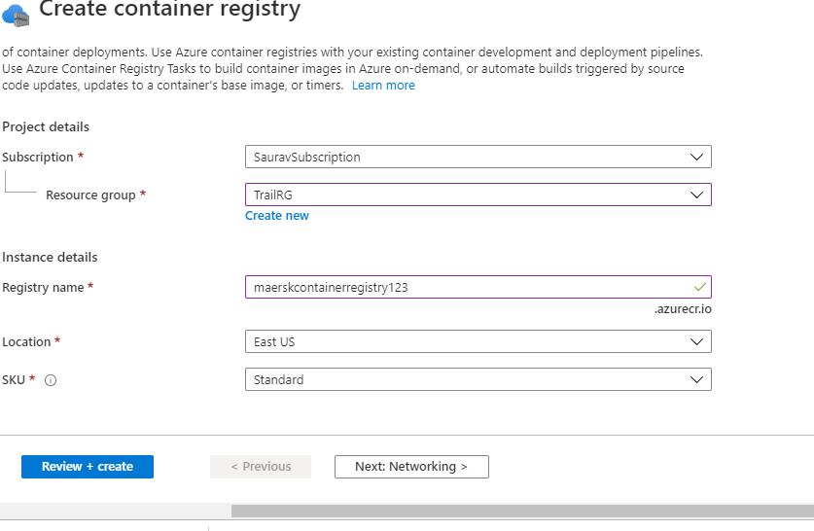

Step 2 - Create Kubernetes Cluster

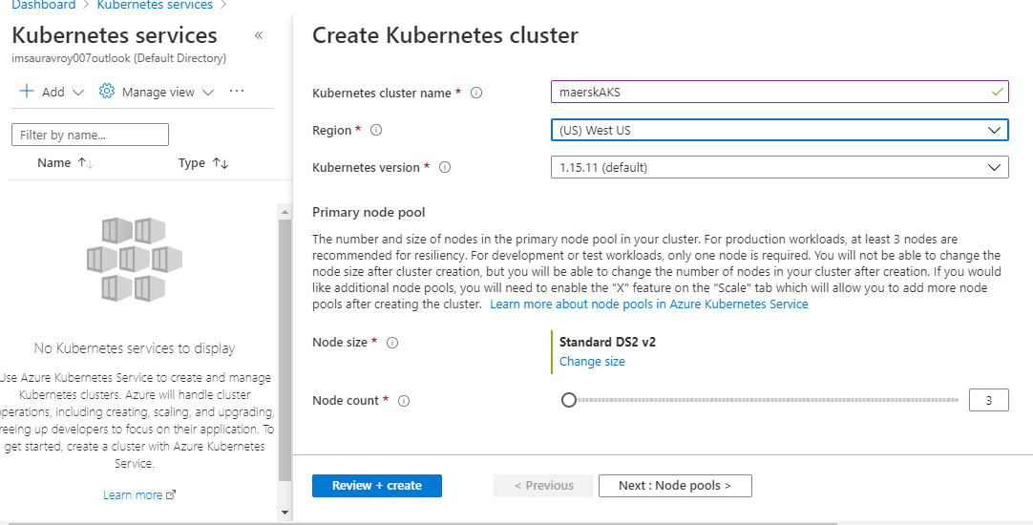

Step 3 - Authorize the AKS cluster to connect to ACR using Service Principle

**az command below** -:

CLIENT_ID=$(az aks show --resource-group TrailRG --name maerskAKS --query "servicePrincipalProfile.clientId" )

ACR_ID=$(az acr show --name maerskcontainerregistry123 --resource-group TrailRG --query "id")

az role assignment create --assignee CLIENT_ID --role acrpull --scope ACR_ID

Step 4 -