Order System Architecture
The order system routes client requests through an API Gateway to the OrderService and PaymentService. See the diagram below.
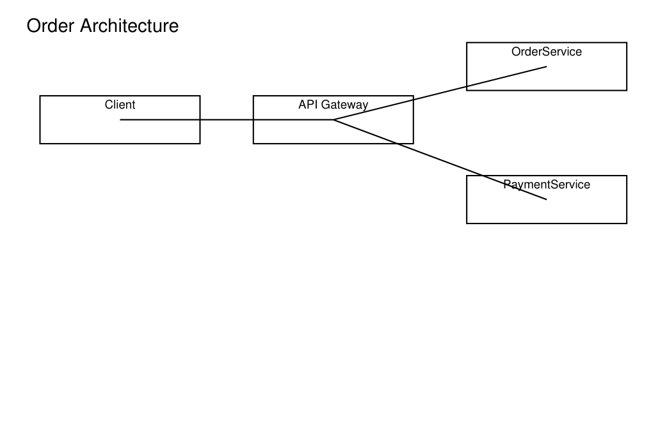

Scaling
OrderService runs a single instance today. PaymentService calls an external provider synchronously.

