GlucoseCheck
AI-Based Diabetes Risk Screening and Health Management System
A Project Report Submitted in Partial Fulfilment of the Requirements for the Award of the Degree of
MASTER OF COMPUTER APPLICATIONS
Submitted By
Kadli Sagar
USN: P24C01CA028
Under the Guidance of
Prof. Rajashekhar G C
DEPARTMENT OF MASTER OF COMPUTER APPLICATIONS
GM UNIVERSITY, DAVANAGERE
Academic Year 2025 – 2026

CERTIFICATE
This is to certify that the project work entitled "GlucoseCheck – AI-Based Diabetes Risk Screening and Health Management System" is a bonafide work carried out by Sagar (USN: P24C01CA028), a student of Master of Computer Applications, GM University, Davangere, in partial fulfilment of the requirements for the award of the degree of Master of Computer Applications during the academic year 2025–2026.
The project report has been approved as it satisfies the academic requirements with respect to the project work prescribed for the said degree.
The matter embodied in this report has not been submitted to any other University or Institute for the award of any other degree or diploma.
Guide Head of the Department
Prof. Rajashekhar G C Department of MCA
External Examiner Date:

DECLARATION
I, Kadli Sagar, bearing USN P24C01CA028, hereby declare that the project report entitled "GlucoseCheck – AI-Based Diabetes Risk Screening and Health Management System" has been independently carried out by me under the guidance of Prof. Rajashekhar G C, Department of MCA, GM University, Davangere, and submitted in partial fulfilment of the requirements for the award of the degree of Master of Computer Applications.
I further declare that this report is my original work and has not been submitted, either in part or full, for the award of any other degree or diploma of this or any other university.
Place: Davangere
Date: 31/8/2026
Kadli Sagar
USN: P24C01CA028

ACKNOWLEDGEMENT
I wish to express my sincere gratitude to my project guide, Prof. Rajashekhar G C, for the valuable guidance, encouragement, and constant support extended throughout the course of this project.
I am thankful to the Head of the Department of Master of Computer Applications and all the faculty members of GM University, Davangere, for providing the necessary facilities and a conducive academic environment for carrying out this project.
I would also like to thank my family and friends for their continuous support and motivation during the development of this project.
Sagar
USN: P24C01CA028

ABSTRACT
Diabetes mellitus is a chronic metabolic disorder that affects a large section of the population, and early risk screening plays a critical role in timely intervention and disease management. "GlucoseCheck" is a full-stack, AI-assisted web application designed to provide diabetes risk screening, personalized health guidance, and health-record management for individual users, built as an MCA final-year project.
The system consists of a React 18 (Vite) single-page frontend and a Python Flask REST API backend. Users can register and log in with JWT-based authentication, complete a structured screening form (age, gender, hypertension and heart-disease history, BMI, HbA1c level, blood glucose level, and smoking history), and receive an instant risk prediction generated by a scikit-learn Logistic Regression model trained on a public diabetes-prediction dataset. Each screening is stored in a relational database (SQLite by default, portable to PostgreSQL/MySQL) through SQLAlchemy ORM models, and a history of past screenings, trend charts, and exportable records (CSV, Excel, PDF) is made available to the user.
Beyond the core prediction workflow, GlucoseCheck integrates a Groq-LLM-powered conversational AI assistant that answers diabetes-related questions in multiple languages (English, Kannada, Hindi, Tamil, Telugu) with optional speech-to-text and text-to-speech support, an AI-generated personalized health-suggestions module (lifestyle, food, exercise, sleep, stress-management, and next-checkup guidance) linked to each screening result, and a ReportLab-based PDF report generator that produces a formatted screening report with a risk gauge and QR code. A role-based administrator console provides user management, prediction oversight, chat and feedback moderation, audit-log review, and database backup/restore utilities.
The system was implemented, tested, and evaluated as part of the MCA curriculum. This report documents the requirement analysis, system design, database schema, machine-learning pipeline, implementation details, and testing carried out for the GlucoseCheck application, based strictly on the actual source code of the submitted project.

INDEX
CONTENTS PAGE NO
1. INTRODUCTION
- Aim 1
- About the Project 1
2. LITERATURE SURVEY
- Existing System 8
- Proposed System 9
- Technologies Used 10
3. HARDWARE AND SOFTWARE REQUIREMENTS 16
4. SOFTWARE REQUIREMENT SPECIFICATION
- Introduction 18
- Purpose 18
- Scope 18
- Functional and Non-Functional Requirements 19
5. SYSTEM DESIGN
- Modules 23
- Use Case Diagram 25
- Data Flow Diagram 27
- E-R Diagram 30
- Database Tables 31
6. SYSTEM IMPLEMENTATION 34
7. TESTING 38
8. SNAPSHOTS 43
9. CONCLUSION 48
10. FUTURE ENHANCEMENTS 49
BIBLIOGRAPHY 50
APPENDIX 51

CHAPTER 1: INTRODUCTION

1.1 Aim
The aim of the GlucoseCheck project is to design and implement a full-stack, AI-assisted web application that screens individuals for diabetes risk using a machine-learning prediction model, and that supports users with personalized health guidance, screening-history management, downloadable reports, and a conversational health assistant, all within a secure, role-based system.

1.2 Objectives
- To design a responsive React-based web interface for user registration, login, and diabetes-risk screening.
- To build a Flask REST API backend exposing prediction, history, authentication, reporting, chat, and admin endpoints.
- To train and integrate a scikit-learn Logistic Regression model for binary diabetes-risk classification.
- To persist users, screenings, chat sessions, reports, and settings in a relational database using SQLAlchemy ORM.
- To implement JWT-based authentication and role-based access control (user, admin, doctor roles).
- To provide a searchable, filterable, and exportable (CSV / Excel / PDF) screening history for each user.
- To generate AI-based personalized health suggestions (lifestyle, food, exercise, sleep, stress) for every screening result using the Groq LLM API.
- To build a multilingual, voice-enabled AI chat assistant for diabetes-related queries.
- To generate a formatted, downloadable PDF screening report containing a risk gauge and QR code using ReportLab.
- To build an administrator console for user management, prediction oversight, chat/feedback moderation, audit logging, and database backup/restore.
- To ensure the system is secure, auditable, and portable across SQLite, PostgreSQL, and MySQL databases.

1.3 Problem Statement
Diabetes is often diagnosed late because individuals do not have easy, low-cost access to a preliminary risk assessment before consulting a physician. Existing self-assessment tools are frequently static, offer no persistent history of a person's health trend over time, do not explain the result in an understandable way, and do not connect the user to further guidance. There is a need for an accessible, data-driven web application that can perform a quick risk screening from routinely available health parameters, store the results securely for future reference, explain the risk in plain language, and guide the user towards healthier habits, while also giving an administrator the tools to monitor and manage the platform responsibly.

1.4 About the Project
GlucoseCheck is implemented as a two-tier full-stack application. The frontend is built with React 18 and Vite, using React Router for client-side navigation, Axios for HTTP communication with the backend, and i18next for multilingual UI text (English, Hindi, Kannada, Tamil, Telugu). The backend is a Python Flask application exposing a set of REST APIs, organized into Flask Blueprints for authentication, administration, reporting, chat, recommendations, and notifications, in addition to the original core prediction endpoints (/api/predict, /api/history, /api/stats, /api/health).
At the core of the system is a previously trained scikit-learn Logistic Regression model (diabetes_prediction_model.pkl), trained on the diabetes_prediction_dataset.csv dataset using age, gender, hypertension, heart disease, BMI, HbA1c level, blood glucose level, and smoking history as input features. The backend loads this model once at start-up and reuses it for every prediction request, so that response times remain fast and the exact behaviour of the original model is preserved.
Every screening a user performs is written to a prediction_history table together with the user's id (when logged in), and a corresponding entry is created in a reports table so that a PDF can later be generated for it. On top of this core workflow, the project adds authentication and profile management, an AI health-suggestions module that calls the Groq large-language-model API to generate lifestyle guidance specific to the screening result (with an offline fallback when the API key or network is unavailable), a full conversational AI assistant with session management and optional voice input/output, a PDF report generator built with ReportLab that renders a formatted report with a semicircular risk gauge and a QR code, and a role-based admin console covering user management, prediction and chat oversight, feedback handling, audit logging, and backup/restore of the SQLite database.

1.5 Need for the System
- Provides an accessible, low-cost first step for individuals to gauge their diabetes risk before visiting a clinician.
- Keeps a persistent, searchable record of a user's screenings over time instead of a one-off, disposable result.
- Turns a numeric prediction into actionable, personalized lifestyle guidance rather than a bare Positive/Negative label.
- Gives users a conversational channel (including in regional languages) to ask follow-up questions about their result.
- Gives administrators visibility and control over platform usage, data integrity, and security-relevant events.

1.6 Advantages
- Instant, consistent risk prediction using a trained machine-learning model rather than manual rule-of-thumb scoring.
- Secure, token-based authentication with role separation between regular users and administrators.
- Persistent history with filtering, pagination, and multi-format export (CSV, Excel, PDF).
- AI-generated, result-specific health suggestions instead of generic, static advice.
- Multilingual chat assistant with speech input/output improves accessibility for non-English-speaking users.
- Database-agnostic design (SQLite by default, PostgreSQL/MySQL via a single configuration change) supports easy deployment scaling.
- Comprehensive audit logging and database backup/restore support administrative accountability and disaster recovery.

1.7 Applications
- Preliminary self-screening tool for individuals concerned about diabetes risk.
- Educational/demonstration tool for showing how machine learning can be embedded in a full-stack web application.
- Foundation for a telehealth-style health-monitoring portal that could be extended with clinician-facing modules.
- Reference implementation for MCA/academic coursework combining ML, REST API design, and modern frontend engineering.

CHAPTER 2: LITERATURE SURVEY

2.1 Existing System
Prior to this project, diabetes-risk self-assessment for most individuals relied on manual, rule-based calculators (e.g., BMI-only or age-and-family-history checklists) hosted on static health websites, or on standalone academic Streamlit prototypes that computed a prediction but did not persist results, did not authenticate users, and offered no follow-up guidance. In the specific context of this MCA project, the starting point was a simpler Streamlit-based diabetes-prediction script that took the eight clinical inputs, ran them through a Logistic Regression model, and displayed a single Positive/Negative result with no supporting infrastructure around it.

Limitations of Existing System
- No persistent storage — predictions were shown once and lost after the session ended.
- No user accounts, so results could not be tied to a specific individual over time.
- No authentication or access control of any kind.
- No history, trend visualization, or way to track risk changes across multiple screenings.
- No exportable or shareable report (PDF/CSV) of the result.
- No explanation or personalized guidance accompanying the numeric result.
- No administrative oversight, audit trail, or usage monitoring.
- No multilingual support for non-English-speaking users.
- No conversational assistance for follow-up questions.
- Not deployable as a scalable client-server web application (Streamlit scripts are difficult to scale and integrate with a separate frontend).

2.2 Proposed System
The proposed system, GlucoseCheck, re-architects the original prediction script into a proper client-server web application. The Logistic Regression prediction logic and the input encoding used during training are deliberately preserved unchanged, so predictions remain numerically identical to the original model, while everything around that core is rebuilt: a Flask REST API replaces the Streamlit script, a SQLAlchemy-backed relational database replaces in-memory/session state, JWT authentication introduces secure multi-user access, and a React frontend replaces the Streamlit UI with a modern, componentized single-page application.

Advantages of Proposed System
- Predictions and their inputs are permanently stored per user in a relational database.
- Secure JWT-based login, registration, password reset, and role-based access (user/admin/doctor).
- Searchable, paginated, filterable screening history with CSV/Excel/PDF export.
- AI-generated, result-specific health suggestions covering lifestyle, food, exercise, sleep, and stress.
- Downloadable, professionally formatted PDF reports with a risk gauge and QR code.
- Multilingual, voice-enabled AI chat assistant for follow-up questions.
- Full administrator console: user management, prediction/chat/feedback moderation, audit logs, database backup and restore.
- In-app notification system for prediction completion, report generation, and high-risk alerts.
- Database-agnostic persistence layer that can move from SQLite to PostgreSQL/MySQL by changing one environment variable.
- Clean separation of frontend and backend, enabling independent scaling and future mobile-client reuse of the same API.

2.3 Technologies Used

React 18 (with Vite)
Introduction: React is a component-based JavaScript library for building user interfaces, and Vite is a fast build tool and development server for modern frontend projects.
- Features: Component reusability, virtual DOM-based rendering, hooks-based state management, hot module replacement in development.
- Advantages: Faster UI updates, modular and maintainable code, large ecosystem of libraries.
- Why used in project: Powers the entire GlucoseCheck single-page frontend — pages, forms, charts, chat UI, and the admin console are all implemented as React components under frontend/src.

React Router DOM
Introduction: A client-side routing library for React applications.
- Features: Declarative route definitions, nested routes, protected-route guards.
- Advantages: Enables a single-page application feel without full page reloads.
- Why used in project: Defines all application routes centrally in src/routes/AppRoutes.jsx, including a ProtectedRoute component that gates authenticated and admin-only pages.

Axios
Introduction: A promise-based HTTP client for the browser and Node.js.
- Features: Interceptors, automatic JSON transformation, timeout and error handling.
- Advantages: Simplifies API calls compared to the raw Fetch API.
- Why used in project: src/services/api.js and adminApi.js centralize all calls from the frontend to the Flask backend, including attaching the JWT Authorization header.

i18next / react-i18next
Introduction: An internationalization framework for JavaScript applications.
- Features: JSON-based translation resources, language detection, runtime language switching.
- Advantages: Cleanly separates UI text from logic, supports multiple locales.
- Why used in project: Backs the multilingual interface, with translation resource files for English, Hindi, Kannada, Tamil, and Telugu under src/locales/.

Python Flask
Introduction: Flask is a lightweight WSGI web application framework for Python.
- Features: Minimalistic core, Blueprint-based modular routing, easy extensibility.
- Advantages: Rapid API development, straightforward integration with Python ML libraries.
- Why used in project: Implements the entire backend REST API in app.py plus six Blueprints (auth, admin, report, chat, recommendations, notifications).

Flask-CORS
Introduction: A Flask extension that handles Cross-Origin Resource Sharing headers.
- Features: Configurable per-route CORS policies.
- Advantages: Allows the React frontend (running on a different port) to call the Flask API without browser CORS errors.
- Why used in project: Applied globally to all /api/* routes in app.py.

scikit-learn
Introduction: A widely used Python machine-learning library providing classification, regression, and preprocessing tools.
- Features: LogisticRegression classifier, SimpleImputer for missing-value handling, model persistence via pickle.
- Advantages: Simple, well-documented API suited for binary classification problems.
- Why used in project: train_model.py trains a LogisticRegression model on the diabetes dataset, and app.py loads the resulting diabetes_prediction_model.pkl at start-up for every prediction request.

SQLAlchemy
Introduction: A Python SQL toolkit and Object-Relational Mapper (ORM).
- Features: Declarative model classes, relationship management, connection pooling, database-agnostic engine configuration.
- Advantages: Lets the same model code run against SQLite, PostgreSQL, or MySQL without changes to application logic.
- Why used in project: database.py and models.py define the engine, session management, and all eleven ORM model classes used across the application.

PyJWT & Werkzeug Security
Introduction: PyJWT implements JSON Web Tokens; Werkzeug's security module provides password hashing utilities.
- Features: Token encoding/decoding with expiry claims; salted password hashing (generate_password_hash / check_password_hash).
- Advantages: Industry-standard, stateless authentication and secure password storage.
- Why used in project: auth.py issues and verifies JWTs for login sessions and hashes/verifies user passwords.

ReportLab
Introduction: A Python library for programmatically generating PDF documents.
- Features: Flowable-based document layout, vector drawing primitives (used for the risk gauge), table styling.
- Advantages: Produces precisely formatted, print-ready PDF reports without external dependencies.
- Why used in project: reports_service.py builds the per-screening PDF health report, and app.py's /api/history/export?format=pdf route builds a tabular PDF export.

Groq API (LLM)
Introduction: Groq provides a low-latency inference API for large language models such as Llama and Whisper.
- Features: Chat-completion endpoint for text generation, Whisper endpoint for speech-to-text.
- Advantages: Fast response times suited to an interactive chat assistant; supports structured JSON responses for the suggestions module.
- Why used in project: groq_service.py drives both the AI health-suggestions generator and the multilingual chat assistant, with an automatic fallback response when no API key is configured or the API call fails.

gTTS (Google Text-to-Speech)
Introduction: A Python library that interfaces with the Google Translate text-to-speech engine.
- Features: Converts text to spoken audio in multiple languages.
- Advantages: Simple integration for voice-output features.
- Why used in project: Used by the /api/text-to-speech endpoint in app.py to read chat responses aloud in the user's selected language.

qrcode / Pillow
Introduction: Libraries for generating QR code images and general image processing in Python.
- Features: QR code generation from arbitrary text/data; image encoding utilities.
- Advantages: Adds a scannable verification/reference code to generated PDF reports.
- Why used in project: reports_service.py embeds a QR code image into each generated PDF screening report.

openpyxl
Introduction: A Python library for reading and writing Excel (.xlsx) files.
- Features: Workbook/worksheet creation, cell formatting, column sizing.
- Advantages: Enables native Excel export without external services.
- Why used in project: Used by the /api/history/export?format=excel route to export a user's filtered screening history.

CHAPTER 3: HARDWARE AND SOFTWARE REQUIREMENTS

Hardware Requirements
Component | Minimum Requirement
Processor | Intel Core i3 (or equivalent) and above
RAM | 4 GB minimum, 8 GB recommended
Hard Disk | 10 GB free space
Display | 1366 × 768 resolution or higher
Internet Connection | Required for AI chat, AI suggestions, and speech services (Groq API)

Software Requirements
Component | Specification
Operating System | Windows 10/11, Linux, or macOS
Frontend Runtime | Node.js 18+ with npm
Frontend Framework | React 18.3, Vite 5.4
Backend Runtime | Python 3.11+
Backend Framework | Flask 3.0.3
Database | SQLite (default, app.db) — portable to PostgreSQL / MySQL
ORM | SQLAlchemy 2.0.35
ML Library | scikit-learn 1.4.2, pandas 2.2.2, NumPy 1.26.4
PDF Generation | ReportLab 4.2.5
AI Service | Groq Python SDK (LLM chat completion + Whisper)
Code Editor / IDE | Visual Studio Code
Version Control | Git

System Configuration
The development environment used two independently runnable services: the Flask backend, started with `python app.py` and served on a local port (default 5000), and the Vite development server for the React frontend, started with `npm run dev`. Flask-CORS is configured to accept requests from the frontend's origin during development. The default persistence layer is a single-file SQLite database (backend/app.db), created automatically at start-up by init_engine_tables() if it does not already exist, which keeps the local development setup zero-configuration while still allowing production deployments to point DATABASE_URL at a PostgreSQL or MySQL instance without any code changes.

CHAPTER 4: SOFTWARE REQUIREMENT SPECIFICATION

Introduction
This chapter specifies the functional and non-functional requirements of the GlucoseCheck system, as well as its purpose, scope, and feasibility, derived from the implemented backend routes and frontend pages of the project.

Purpose
The purpose of this document is to describe, in a structured manner, what the GlucoseCheck system is expected to do (functional requirements) and the quality attributes it must exhibit (non-functional requirements), so that the implementation can be verified against a clear specification.

Scope
The scope of the system covers user registration and authentication, diabetes-risk prediction using a trained ML model, persistent screening history with search/export, AI-generated health suggestions, a multilingual AI chat assistant with optional voice input/output, PDF report generation, an in-app notification system, and an administrator console for user, prediction, chat, feedback, and audit-log management, together with database backup and restore. The scope does not include clinical diagnosis, integration with hospital information systems, or real-time medical-device data ingestion.

Functional Requirements
- The system shall allow a new user to register with username, email, password, and full name (FR-1).
- The system shall authenticate users via login and issue a JWT access token (FR-2).
- The system shall support a separate admin login flow that only authenticates users with the 'admin' role (FR-3).
- The system shall allow a user to submit age, gender, hypertension, heart disease, BMI, HbA1c level, blood glucose level, and smoking history for prediction (FR-4).
- The system shall return a Positive/Negative diabetes-risk result with an associated probability percentage (FR-5).
- The system shall persist every prediction, linked to the logged-in user when available (FR-6).
- The system shall allow a user to view, search, filter (by result, gender, date range, age range), and paginate their screening history (FR-7).
- The system shall allow a user to export their screening history as CSV, Excel, or PDF (FR-8).
- The system shall allow a user to delete individual history records or clear their entire history (FR-9).
- The system shall generate AI-based personalized health suggestions for a given prediction, with a deterministic fallback if the AI service is unavailable (FR-10).
- The system shall generate a downloadable, formatted PDF report for a given prediction, including a risk gauge and QR code (FR-11).
- The system shall allow a user to create, list, rename, and delete AI chat sessions, and to send/receive chat messages (FR-12).
- The system shall support speech-to-text transcription and text-to-speech playback for chat messages (FR-13).
- The system shall send in-app notifications to a user for events such as prediction completion, report generation, and high-risk alerts (FR-14).
- The system shall allow a user to update their profile, change password, configure settings, or delete their account (FR-15).
- The system shall allow a user to submit feedback/support tickets (FR-16).
- The system shall provide an admin dashboard summarizing users, predictions, chats, and feedback statistics (FR-17).
- The system shall allow an admin to manage (view/update/deactivate/delete) user accounts and reset user passwords (FR-18).
- The system shall allow an admin to view and delete prediction records and chat sessions platform-wide (FR-19).
- The system shall allow an admin to view and manage feedback submissions and audit logs, and export both as CSV (FR-20).
- The system shall allow an admin to create, list, and restore database backups, and to export/import a SQL snapshot (FR-21).

Non-Functional Requirements
- Usability: The interface shall be responsive and usable on both desktop and mobile screen sizes (NFR-1).
- Usability: The interface shall support multiple languages (English, Hindi, Kannada, Tamil, Telugu) (NFR-2).
- Performance: A prediction request shall return a result in well under one second under normal load, since the ML model is loaded once at start-up (NFR-3).
- Performance: History search queries shall be paginated to avoid returning unbounded result sets (NFR-4).
- Security: Passwords shall never be stored in plain text; only salted hashes shall be persisted (NFR-5).
- Security: All admin-only endpoints shall require a valid JWT with the 'admin' role (NFR-6).
- Security: JWT access tokens shall expire after a configurable interval (default 60 minutes) (NFR-7).
- Security: Sensitive configuration (API keys, JWT secret) shall be loaded from environment variables, not hard-coded (NFR-8).
- Reliability: A failure in an optional subsystem (e.g., the AI/Groq service) shall not cause the core prediction workflow to fail (NFR-9).
- Reliability: Audit-log writing shall never raise an exception that could break the primary request (NFR-10).
- Maintainability: Backend routes shall be organized into Flask Blueprints by concern (auth, admin, chat, report, recommendations, notifications) (NFR-11).
- Maintainability: The persistence layer shall be database-agnostic, allowing a change of DATABASE_URL to switch between SQLite, PostgreSQL, and MySQL (NFR-12).
- Portability: The frontend and backend shall be independently deployable services communicating over a documented REST API (NFR-13).
- Auditability: Security-relevant and data-changing actions (login, registration, deletions, backups) shall be recorded in an audit log with actor, action, timestamp, and IP address (NFR-14).
- Availability: The system shall expose a /api/health endpoint reporting model-load and database-connectivity status for monitoring (NFR-15).

Feasibility Study

Technical Feasibility
All technologies used (React, Flask, SQLAlchemy, scikit-learn, ReportLab, Groq SDK) are open-source, well-documented, and widely supported, and the project team had prior working familiarity with each. The system runs on standard consumer hardware without specialized infrastructure, making it technically feasible to build and demonstrate within an academic project timeline.

Economic Feasibility
The project uses free and open-source software throughout the stack. The only recurring cost is optional usage of the Groq LLM API for AI chat and suggestions, which offers a free tier suitable for development and demonstration; the system also includes a rule-based fallback so that it remains functional at zero cost if the API is not used.

Operational Feasibility
The application presents a familiar web-form and chat-based interface that requires no specialized training to operate. Administrative functions are consolidated into a single console, and the database-agnostic design allows the system to be operated on a low-cost SQLite deployment for small-scale use or migrated to PostgreSQL/MySQL for larger-scale operational deployment without re-engineering the application.

CHAPTER 5: SYSTEM DESIGN

System Architecture
GlucoseCheck follows a three-layer client-server architecture: a React (Vite) single-page application as the presentation layer, a Flask REST API as the application/business layer, and a SQLAlchemy-managed relational database (SQLite by default) as the data layer. A pre-trained scikit-learn model file is loaded into the Flask process memory and used synchronously within the prediction endpoint. The Groq LLM API is called out-of-process over HTTPS for the AI suggestions and chat features, with local fallback logic when it is unreachable.
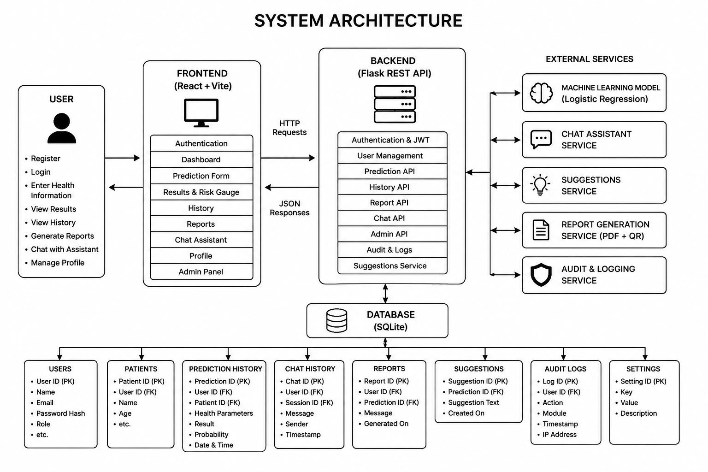
Fig 5.1: System Architecture Diagram

Modules Description

1. Authentication Module (auth.py, routes/auth_routes.py)
Handles registration, login (user and admin), JWT issuance and verification, password hashing (Werkzeug), password reset via a time-limited token, profile update, password change, user settings, account deletion, feedback submission, and a data-export endpoint. The login_required and admin_required decorators protect routes by verifying the Authorization: Bearer <token> header and attaching a snapshot of the current user to flask.g.current_user.

2. Prediction Module (app.py)
Exposes /api/predict, /api/history, /api/history/search, /api/history/export, /api/history/<id> (delete), /api/stats, and /api/health. Encodes the submitted form fields exactly as during model training (gender and smoking_history mapped to integer codes), runs the loaded Logistic Regression model, stores the result in prediction_history, auto-creates a corresponding reports row, logs a prediction_created audit entry, and — for logged-in users — creates in-app notifications (including a high-risk alert when the result is Positive or the probability is ≥ 40%).

3. AI Suggestions Module (suggestions_service.py, groq_service.py, routes/report_routes.py)
Generates structured, per-prediction health guidance (risk analysis, lifestyle, food, exercise, water intake, sleep, stress management, next-checkup recommendation, and a medical disclaimer) via the Groq chat-completion API, requesting structured JSON output. Results are cached in the suggestions table (one row per prediction, source flagged as 'ai' or 'fallback') and can be regenerated on demand.

4. Report Generation Module (reports_service.py, routes/report_routes.py)
Builds a formatted PDF screening report using ReportLab, including a semicircular risk-gauge drawing rendered with reportlab.graphics primitives, a QR code image (qrcode library) encoding a reference to the report, the user's input parameters, the AI-generated suggestions, and a medical disclaimer. Also supports emailing the report and listing/deleting previously generated report records.

5. AI Chat Assistant Module (chat_service.py, groq_service.py, routes/chat_routes.py)
Provides session-based conversational AI: creating, listing, renaming, favoriting, and deleting chat sessions (chat_sessions table); posting and regenerating messages, which are persisted in the existing chat_history table keyed by session_id; exporting a session transcript; and speech-to-text / text-to-speech endpoints (Groq Whisper for STT, gTTS for TTS) supporting English, Hindi, Kannada, Tamil, and Telugu.

6. Notification Module (notification_service.py, routes/notifications_routes.py)
Creates multilingual in-app notifications (prediction_completed, report_generated, ai_recommendation, high_risk_alert, etc.) for a user, and exposes endpoints to list notifications, get an unread count, mark one/all as read, delete a notification, and manage notification preferences.

7. Admin Module (routes/admin_routes.py)
Provides an administrator dashboard and analytics summary, full CRUD-style management of users (including password reset and deactivation), predictions, chat sessions, and feedback; global settings management; audit-log listing and CSV export; and database backup/restore utilities (create backup, list backups, restore a specific backup, export/import a SQL snapshot, download a backup file).

8. Frontend Application (React, frontend/src)
Organized into pages (Dashboard, Predict, History, ReportHistory, ChatAssistant, HealthWellness, Profile, UserSettings, Login, Register, ForgotPassword, ResetPassword, About, NotFound, and an admin/ subtree with AdminDashboard, UserManagement, PredictionManagement, ChatManagement, FeedbackManagement, AuditLogs, BackupRestore, AdminSettings, AnalyticsDashboard, AdminLogin), reusable components (forms/PredictionForm, forms/ResultSlip, charts/RiskGauge, charts/RiskTrendChart, chat/ChatComposer, chat/ChatMessage, chat/ChatSessionList, results/AiHealthRecommendations, results/ReportActions, results/SuggestionsPanel, notifications/NotificationPanel, layout/Sidebar, layout/Topbar, layout/Footer, auth/ProtectedRoute, and a small ui/ kit of Button/Card primitives), context providers (ThemeContext, ToastContext), and services (api.js, adminApi.js, speechService.js) that centralize all backend communication.

Use Case Diagram
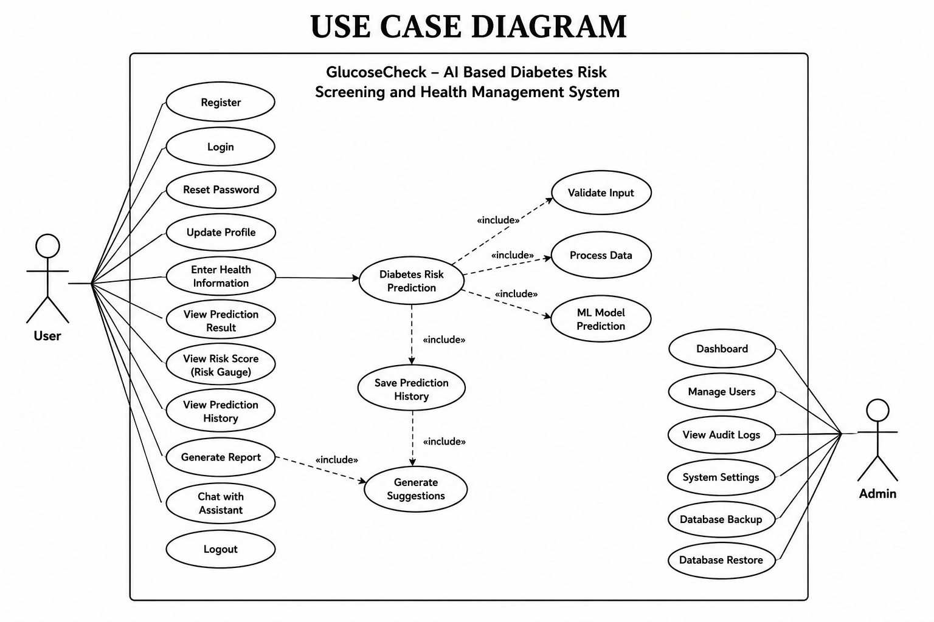
Fig 5.2: Use Case Diagram
Actors and use cases: A Guest can submit a screening and view its immediate result, since /api/predict does not require login. A Registered User additionally gets their screenings linked to their account, can view/search/export history, receive AI suggestions and PDF reports, use the chat assistant, and manage their profile and notifications. An Administrator, authenticated through the dedicated admin-login endpoint and the admin role, can access every management use case exposed under /api/admin/*.

Data Flow Diagram

Level 0 (Context Diagram)
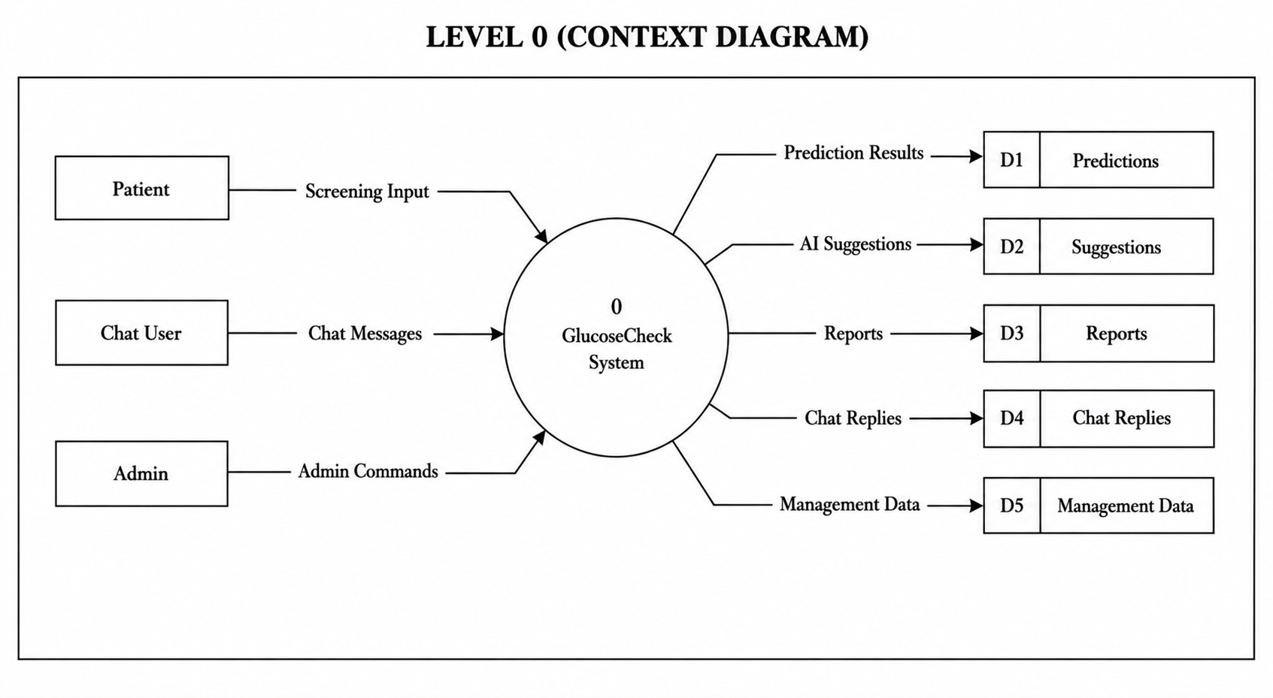
Fig 5.3: DFD Level 0 (Context Diagram)

Level 1
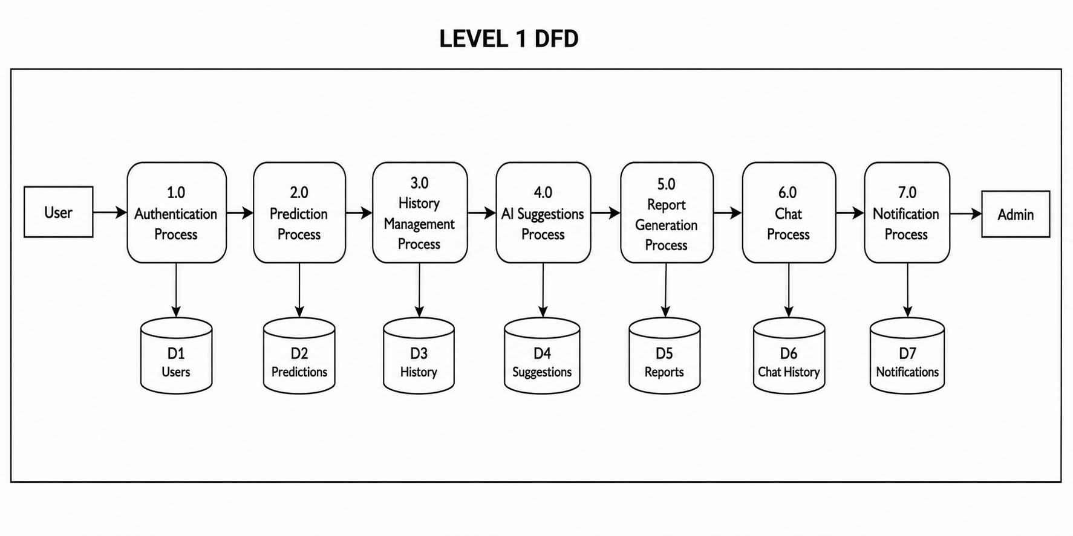
Fig 5.4: DFD Level 1

Level 2 (Prediction Process, expanded)
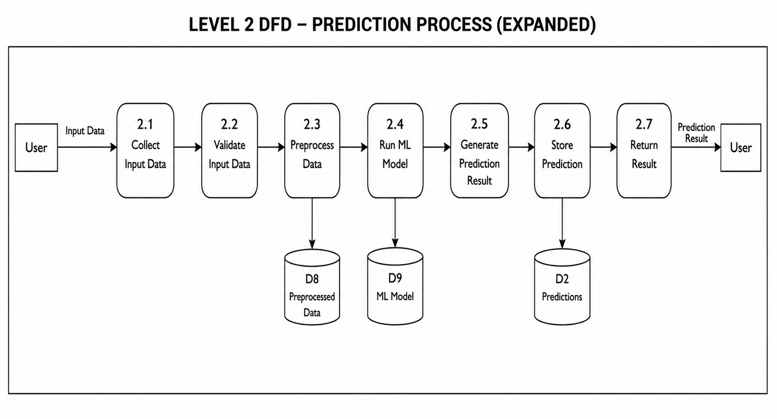
Fig 5.5: DFD Level 2 — Prediction Process (Expanded)

ER Diagram
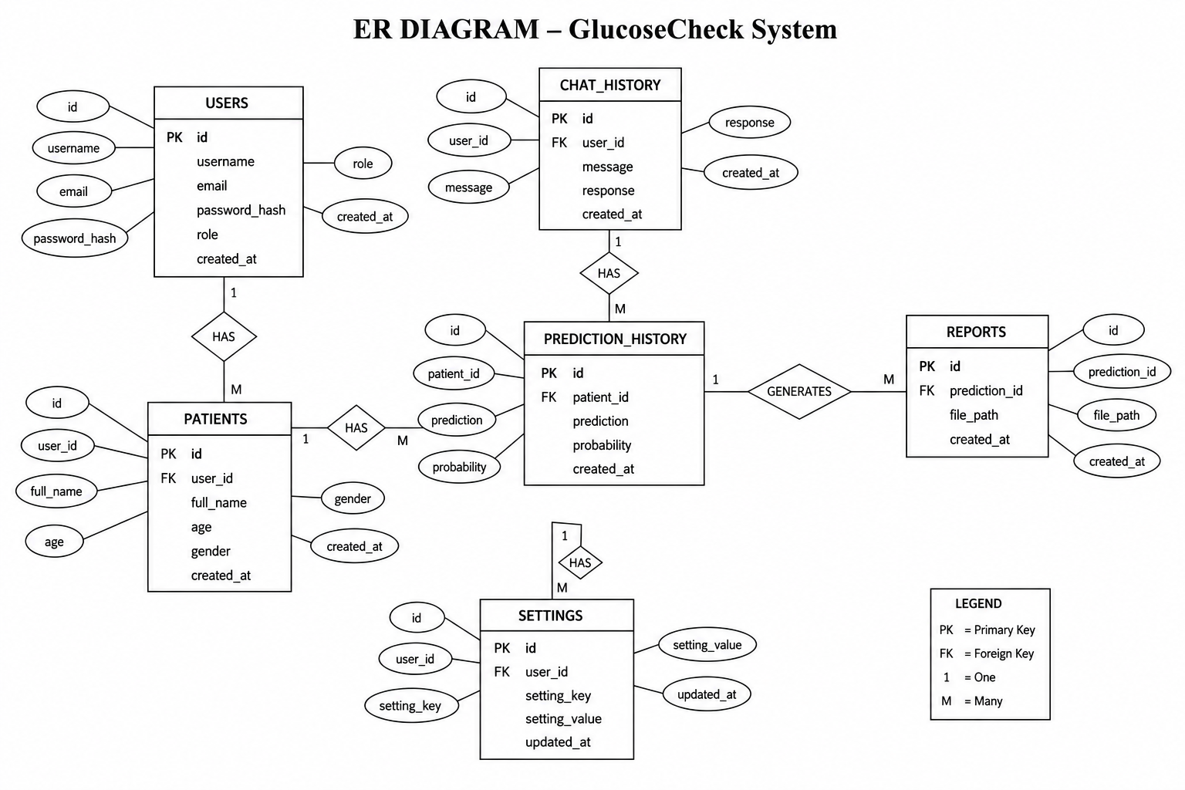
Fig 5.6: Entity-Relationship Diagram
Entities and relationships: A User (1) can have many Patients, PredictionHistory records, ChatHistory messages, Reports, and Settings (1-to-many, enforced via foreign keys with cascading deletes). A PredictionHistory record optionally belongs to a Patient and may have one associated Suggestion (1-to-1, unique foreign key) and one or more Reports (1-to-many). A ChatSession groups many ChatHistory rows sharing the same session_id. AuditLog, Feedback, and Notification each optionally reference a User for traceability.

Database Design
The application uses SQLAlchemy declarative models (backend/models.py) mapped to eleven tables. SQLite is the default engine (backend/app.db), created automatically at start-up; the connection string is fully configurable via the DATABASE_URL environment variable for PostgreSQL or MySQL deployment.

users
Purpose: Stores application user accounts (regular users, doctors, and administrators).
Attribute | Data Type | Description
id | Integer (PK, autoincrement) | Unique user identifier
username | String(80), unique | Login username
email | String(255), unique | User email address
password_hash | String(255) | Salted password hash (Werkzeug)
full_name | String(150) | Display name
role | String(20) | 'user' | 'admin' | 'doctor' (CHECK constraint)
is_active | Boolean | Account active/deactivated flag
reset_token / reset_token_expires | String(255) / DateTime | Password-reset token and expiry
created_at / updated_at | DateTime | Audit timestamps

patients
Purpose: Optional patient records a screening can be linked to (supports screenings performed on behalf of another person).
Attribute | Data Type | Description
id | Integer (PK) | Unique patient identifier
user_id | Integer (FK → users.id) | Owning user, nullable (SET NULL on delete)
full_name | String(150) | Patient's name
age | Integer | 0–120 (CHECK constraint)
gender | String(10) | Male / Female / Other
contact_number | String(30) | Optional contact number
created_at | DateTime | Record creation timestamp

prediction_history
Purpose: Core table storing every diabetes-screening request and its result; backs /api/predict and /api/history.
Attribute | Data Type | Description
id | String(36) UUID (PK) | Unique prediction identifier
user_id / patient_id | Integer (FK, nullable) | Linked user and/or patient
age, gender, hypertension, heart_disease, bmi, hba1c_level, blood_glucose_level, smoking_history | Mixed | The eight model input fields, mirroring the original app.py form exactly
result | String(10) | 'Positive' | 'Negative' (CHECK constraint)
probability | Float | Model's predicted probability (%) of a positive result
created_at | DateTime, indexed | Screening timestamp

chat_history
Purpose: Stores every AI-assistant chat message, grouped by session_id.
Attribute | Data Type | Description
id | Integer (PK) | Unique message id
user_id | Integer (FK → users.id) | Message owner (nullable)
session_id | String(64), indexed | Groups messages into a conversation
role | String(20) | 'user' | 'assistant' | 'system'
message | Text | Message content
created_at | DateTime | Message timestamp

chat_sessions
Purpose: Metadata for a chat conversation (title, favorite flag, language), linked to chat_history by session_id.
Attribute | Data Type | Description
id | String(64) UUID (PK) | Session identifier
user_id | Integer (FK, nullable) | Session owner
title | String(150) | Conversation title, default 'New Chat'
is_favorite | Boolean | User-starred flag
language | String(10) | Conversation language, default 'auto'
created_at / updated_at | DateTime | Audit timestamps

reports
Purpose: Tracks generated report files (PDF/CSV/JSON) linked to a prediction.
Attribute | Data Type | Description
id | Integer (PK) | Unique report id
prediction_id | String(36) (FK → prediction_history.id) | Linked screening
user_id | Integer (FK, nullable) | Report owner
report_type | String(20) | 'pdf' | 'csv' | 'json' (CHECK constraint)
file_path | String(500) | Optional stored file path
generated_at | DateTime | Generation timestamp

suggestions
Purpose: Caches the AI-generated health-suggestion content for a prediction (one row per prediction).
Attribute | Data Type | Description
id | Integer (PK) | Unique suggestion id
prediction_id | String(36), unique (FK) | One suggestion set per prediction
risk_analysis, lifestyle, food, exercise, water_intake, sleep, stress_management, next_checkup, disclaimer | Text / JSON-encoded Text | Structured guidance content
source | String(20) | 'ai' or 'fallback'
language | String(10) | Suggestion language
generated_at | DateTime | Generation timestamp

settings
Purpose: Per-user (or global, when user_id is NULL) key/value application settings.
Attribute | Data Type | Description
id | Integer (PK) | Unique setting id
user_id | Integer (FK, nullable) | Owning user, or NULL for global settings
key / value | String(100) / Text | Setting name and value (unique per user+key)
updated_at | DateTime | Last-updated timestamp

feedback
Purpose: User-submitted support tickets, bug reports, and general feedback.
Attribute | Data Type | Description
id | Integer (PK) | Unique feedback id
user_id | Integer (FK, nullable) | Submitter
category | String(50) | Feedback category, default 'feedback'
subject / message | String(200) / Text | Ticket subject and body
status | String(20) | 'open' or other workflow states
created_at | DateTime | Submission timestamp

notifications
Purpose: In-app notifications shown to a user for system events.
Attribute | Data Type | Description
id | Integer (PK) | Unique notification id
user_id | Integer (FK → users.id), not null | Recipient
type | String(50) | e.g. prediction_completed, high_risk_alert
title / message | String(200) / Text | Notification content
is_read | Boolean | Read/unread flag
created_at | DateTime | Creation timestamp

audit_logs
Purpose: Tracks security-relevant and data-changing activity across the application (login, registration, deletions, backups, and more).
Attribute | Data Type | Description
id | Integer (PK) | Unique log entry id
user_id | Integer (FK, nullable) | Actor, if known
action | String | One of a fixed set of valid action codes (e.g. user_login, prediction_created, database_backup)
description / status | Text / String | Human-readable detail and outcome status
ip_address | String | Requesting client IP (respects X-Forwarded-For)
extra_data | Text (JSON) | Optional structured extra context
created_at | DateTime | Log timestamp

Data Dictionary
The eight core prediction inputs, shared by the ML model, the prediction_history table, and the /api/predict request/response contract, are summarized below.
Field | Type | Valid Values / Range
age | Integer/Float | 0–120 (application-level; DB constraint via patients.age)
gender | String | 'Male' | 'Female' (encoded 0/1 for the model)
hypertension | Boolean (Yes/No in payload) | true/false
heart_disease | Boolean (Yes/No in payload) | true/false
bmi | Float | 0–100
HbA1c_level | Float | 0–20
blood_glucose_level | Float | 0–600
smoking_history | String | never, former, current, not current, ever (encoded 0–4)

CHAPTER 6: SYSTEM IMPLEMENTATION

Development Environment
The frontend was developed using React 18.3 with Vite 5.4 as the build tool and development server, and ESLint for code-quality checks. The backend was developed using Python 3 with Flask 3.0.3. Both services were run locally during development — the Flask API on its default port and the Vite dev server on its own port — with Flask-CORS configured to allow the frontend origin. Visual Studio Code was used as the primary editor, and Git for version control.

Frontend Implementation
The frontend entry point (frontend/src/main.jsx) mounts the root React application, wrapped with the ThemeContext and ToastContext providers and the i18next configuration (frontend/src/i18n.js). Routing is centralized in src/routes/AppRoutes.jsx, which maps URL paths to page components and wraps authenticated/admin pages in the auth/ProtectedRoute component.
The core screening workflow is implemented in the Predict page, which renders the components/forms/PredictionForm component to collect the eight input fields with client-side validation, submits them via services/api.js to POST /api/predict, and displays the outcome using components/forms/ResultSlip and components/charts/RiskGauge. The Dashboard page shows summary statistics and, where available, a components/charts/RiskTrendChart of the user's recent screenings. The History and ReportHistory pages consume the /api/history/search and /api/reports endpoints respectively, offering filtering, pagination, and export actions. The ChatAssistant page composes components/chat/ChatSessionList, ChatComposer, and ChatMessage to provide a full conversational UI, including microphone-based input handled by services/speechService.js. The Profile and UserSettings pages call the corresponding /api/auth/profile, /api/auth/change-password, and /api/auth/user-settings endpoints. The admin/ page subtree (AdminDashboard, UserManagement, PredictionManagement, ChatManagement, FeedbackManagement, AuditLogs, BackupRestore, AnalyticsDashboard, AdminSettings, AdminLogin) mirrors the corresponding /api/admin/* backend endpoints through services/adminApi.js.

Backend Implementation
The Flask application (backend/app.py) preserves the original prediction logic unchanged, loading the pickled Logistic Regression model once at start-up and reusing it for every request. All newer functionality is implemented as separate, purely additive Flask Blueprints registered onto the same app instance:
- routes/auth_routes.py — auth_bp, mounted under /api/auth, covering registration through account deletion.
- routes/admin_routes.py — admin_bp, mounted under /api/admin, the largest module (1000+ lines) covering settings, audit logs, backup/restore, dashboard/analytics, and user/prediction/chat/feedback management.
- routes/report_routes.py — report_bp, covering AI suggestions and PDF report generation/listing/deletion.
- routes/chat_routes.py — chat_bp, covering chat sessions, messages, regeneration, export, and speech endpoints.
- routes/recommendations_routes.py — recommendations_bp, a lightweight endpoint returning/creating recommendations for a prediction.
- routes/notifications_routes.py — notifications_bp, covering notification listing, unread counts, read/delete, and preferences.
Cross-cutting concerns are factored into small modules: auth.py (password hashing, JWT issuance/verification, login_required/admin_required decorators, get_optional_user for routes that work both authenticated and anonymous), audit.py (log_action helper, writing to audit_logs with a fixed set of valid action codes and never raising on failure), database.py (SQLAlchemy engine/session setup, environment-driven DATABASE_URL, SQLite foreign-key enforcement pragma), notification_service.py (multilingual notification text templates and creation helper), groq_service.py (Groq client initialization, chat-completion wrapper with a primary/fallback model pair and JSON-structured output support), suggestions_service.py, and reports_service.py.

Database Implementation
init_db.py and database.py together bootstrap the SQLite database on first run by calling Base.metadata.create_all(), so no manual migration step is required for a fresh setup. A schema.sql file and seed_db.py are also included in the backend for reference/manual seeding. Foreign-key constraints are explicitly enabled on SQLite connections via a PRAGMA event listener, since SQLite disables them by default. All CHECK constraints (e.g., restricting role, gender, result, and smoking_history to fixed value sets) are declared directly on the SQLAlchemy model classes.

Algorithms Used

Logistic Regression (scikit-learn)
Introduction: Logistic Regression is a linear model for binary classification that estimates the probability of a binary outcome using the logistic (sigmoid) function applied to a weighted sum of input features.
Working: Given the eight encoded input features (age, hypertension, heart_disease, bmi, HbA1c_level, blood_glucose_level, gender code, smoking_history code), the model computes a linear combination of the features and their learned coefficients, passes the result through the sigmoid function to obtain a probability between 0 and 1, and classifies the outcome as Positive if that probability exceeds the model's internal decision threshold.
- Load diabetes_prediction_dataset.csv with pandas.
- Encode gender ('Male'→0, 'Female'→1) and smoking_history via categorical codes.
- Separate the diabetes target column from the remaining feature columns.
- Impute any missing feature values using SimpleImputer(strategy='mean').
- Fit a LogisticRegression(max_iter=1000) classifier on the processed features and target.
- Persist the trained model object to diabetes_prediction_model.pkl with pickle.
Advantages: Logistic Regression is well suited to binary classification problems such as diabetes-risk screening because it is computationally inexpensive to train and evaluate, produces a directly interpretable probability score (used in this project both for the Positive/Negative label and for the risk-gauge percentage shown to the user), and performs well as a baseline model on structured, tabular clinical data of this kind.

Groq LLM Chat Completion (for suggestions and chat)
Introduction: A hosted large-language-model inference call used to generate natural-language health guidance and conversational responses.
Working: The backend builds a system prompt establishing a non-diagnostic medical-assistant persona, includes the prediction's input parameters and result (for suggestions) or the conversation history (for chat), and requests either free-text or structured JSON output from the Groq chat-completion endpoint, using a primary model with an automatic fallback model if the primary is unavailable.
- Steps: Build prompt/context → call Groq client → parse response (JSON for suggestions, plain text for chat) → persist result → return to frontend.
- Advantages: Produces personalized, context-aware guidance rather than static template text, while the deterministic fallback path guarantees the feature still works if the API key is missing or the request fails.

Workflow
- User registers or logs in; the frontend stores the returned JWT and attaches it to subsequent API calls.
- User fills the screening form on the Predict page and submits it.
- Flask validates the payload, encodes categorical fields, and runs the Logistic Regression model to obtain a result and probability.
- The result is saved to prediction_history, a linked reports row is created, an audit entry is logged, and (for logged-in users) notifications are generated.
- The frontend displays the result with a risk gauge and offers to fetch AI health suggestions and/or download a PDF report.
- The user can revisit History/ReportHistory to search, filter, export, or delete past screenings, or open the Chat Assistant to ask follow-up questions.
- An administrator can, at any point, review platform-wide data and activity through the Admin console, and create or restore database backups as needed.

Implementation Details with Source Code
This section expands on the implementation of GlucoseCheck with concrete detail on how each layer of the system was built, illustrated with representative source code drawn directly from the submitted project. The excerpts below are taken from the actual backend and frontend modules and are presented to demonstrate the coding approach, structure, and conventions followed throughout development.

Frontend Implementation
The frontend is a single-page application built with React 18 and Vite. The core screening workflow lives in components/forms/PredictionForm.jsx, which holds the eight form fields in local component state, validates and coerces them to numbers on submit, and calls the centralized API service before handing the returned prediction record back to the parent page through an onResult callback. All network communication is routed through a single Axios instance in services/api.js, which attaches the stored JWT to every outgoing request through a request interceptor, so that individual components never have to handle authentication headers themselves. Code 6.4 below shows the Axios client configuration and the form-submission logic that ties the two together.

Backend Implementation
The backend is a Flask application in which the original prediction logic in app.py is left untouched, while every additional capability is layered on as a separate Flask Blueprint registered onto the same app instance. This keeps the core /api/predict route's behaviour numerically identical to the original model while allowing authentication, admin management, reporting, chat, and notifications to be developed and tested independently of one another. Cross-cutting concerns such as password hashing, JWT issuance, and route-protection decorators are factored into a dedicated auth.py module so they can be reused by every protected route without duplication.

Database Implementation
Persistence is handled by SQLAlchemy's declarative ORM. All eleven tables are defined as Python classes in models.py, with relationships, foreign keys, and CHECK constraints declared directly on the model rather than enforced only in application code, so that data integrity holds even if a future client bypasses the API layer. init_db.py and database.py call Base.metadata.create_all() at start-up, so a fresh SQLite database file is created automatically on first run with no manual migration step, while the same model code can be pointed at PostgreSQL or MySQL through the DATABASE_URL environment variable without any code changes.

Machine Learning Model Implementation
The prediction core is a scikit-learn LogisticRegression classifier trained offline in train_model.py on the diabetes_prediction_dataset.csv dataset and persisted to diabetes_prediction_model.pkl using pickle. At application start-up, app.py loads this pickled model exactly once into memory and reuses the same in-memory object for every subsequent prediction request, which keeps response times low since no disk I/O or retraining happens per request. Categorical fields (gender and smoking_history) are mapped to the same integer codes that were used during training, so that live predictions remain numerically consistent with the original offline-trained model.

Prediction Workflow
A single screening request flows through several stages: the frontend collects and validates the eight inputs and posts them as JSON to /api/predict; the Flask route re-validates the payload, encodes the categorical fields, and assembles a NumPy feature array in the exact column order used during training; the loaded model produces both a class label and, where supported, a probability score; and the result, together with the original inputs, is written to the prediction_history table in the same request so that it is immediately available in the user's history and statistics. If the request comes from a logged-in user, an in-app notification is also generated, including a dedicated high-risk alert when the result is Positive or the predicted probability is 40% or higher.

API Integration Process
On the client side, every backend call passes through the single Axios instance defined in services/api.js. A request interceptor reads the JWT from local storage and, when present, attaches it as an Authorization: Bearer header automatically, so existing calls such as predict() and the history endpoints become user-aware the moment someone logs in without any change to the call sites themselves. Response and network errors are normalized into a consistent { message } shape before they reach UI components, so error handling in the React components stays simple and uniform across the whole application.

Authentication System
Authentication is implemented with salted password hashing (Werkzeug's generate_password_hash / check_password_hash) and stateless JSON Web Tokens (PyJWT). On successful registration or login, the backend issues a signed JWT containing the user's id, role, and an expiry claim (60 minutes by default). The login_required decorator in auth.py extracts and verifies this token on every protected request, loads the corresponding user row, and attaches it to flask.g.current_user for the duration of the request; an admin_required variant additionally checks that the token's role claim is 'admin' before allowing access to any /api/admin/* route.
# --- auth.py : JWT issuance and route protection ---
def create_access_token(user_id: int, role: str) -> str:
now = datetime.now(timezone.utc)
payload = {
"sub": str(user_id),
"role": role,
"iat": now,
"exp": now + timedelta(minutes=JWT_EXPIRES_MINUTES),
}
return jwt.encode(payload, JWT_SECRET, algorithm=JWT_ALGORITHM)

def login_required(fn):
@wraps(fn)
def wrapper(*args, **kwargs):
token = _extract_token()
if not token:
return jsonify({"error": "Missing or invalid Authorization header"}), 401
try:
payload = decode_access_token(token)
except jwt.ExpiredSignatureError:
return jsonify({"error": "Token has expired."}), 401
except jwt.InvalidTokenError:
return jsonify({"error": "Invalid token."}), 401
with get_session() as db:
user = db.query(User).filter_by(id=int(payload["sub"])).first()
g.current_user = user
return fn(*args, **kwargs)
return wrapper

# --- routes/auth_routes.py : Registration and Login APIs ---
@auth_bp.route("/register", methods=["POST"])
def register():
payload = request.get_json(silent=True) or {}
username = (payload.get("username") or "").strip()
email = (payload.get("email") or "").strip().lower()
password = payload.get("password") or ""
if not username or not email or not password:
return jsonify({"error": "username, email, and password are required."}), 400
if len(password) < 8:
return jsonify({"error": "Password must be at least 8 characters."}), 400
user = User(username=username, email=email,
password_hash=hash_password(password), role="user")
db.add(user); db.flush()
token = create_access_token(user.id, user.role)
return jsonify({"token": token, "user": _user_public_dict(user)}), 201

@auth_bp.route("/login", methods=["POST"])
def login():
payload = request.get_json(silent=True) or {}
email = (payload.get("email") or "").strip().lower()
password = payload.get("password") or ""
user = db.query(User).filter_by(email=email).first()
if user is None or not verify_password(password, user.password_hash):
return jsonify({"error": "Invalid email or password."}), 401
token = create_access_token(user.id, user.role)
return jsonify({"token": token, "user": _user_public_dict(user)})
Code 6.1 User Authentication Module
The database layer backing this authentication and the rest of the application is defined through the following core ORM models.
# --- models.py : User, PredictionHistory, Patient models ---
class User(Base):
__tablename__ = "users"
id = Column(Integer, primary_key=True, autoincrement=True)
username = Column(String(80), unique=True, nullable=False, index=True)
email = Column(String(255), unique=True, nullable=False, index=True)
password_hash = Column(String(255), nullable=False)
role = Column(String(20), nullable=False, default="user")
is_active = Column(Boolean, nullable=False, default=True)
predictions = relationship("PredictionHistory", back_populates="user",
cascade="all, delete-orphan")
__table_args__ = (
CheckConstraint("role IN ('user','admin','doctor')", name="ck_users_role"),
)

class Patient(Base):
__tablename__ = "patients"
id = Column(Integer, primary_key=True, autoincrement=True)
user_id = Column(Integer, ForeignKey("users.id", ondelete="SET NULL"), nullable=True)
full_name = Column(String(150), nullable=False)
age = Column(Integer, nullable=True)
gender = Column(String(10), nullable=True)
__table_args__ = (
CheckConstraint("gender IN ('Male','Female','Other') OR gender IS NULL"),
CheckConstraint("age IS NULL OR (age >= 0 AND age <= 120)"),
)

class PredictionHistory(Base):
__tablename__ = "prediction_history"
id = Column(String(36), primary_key=True, default=gen_uuid)
user_id = Column(Integer, ForeignKey("users.id", ondelete="SET NULL"), nullable=True)
age = Column(Integer, nullable=False)
gender = Column(String(10), nullable=False)
hypertension = Column(Boolean, nullable=False, default=False)
heart_disease = Column(Boolean, nullable=False, default=False)
bmi = Column(Float, nullable=False)
hba1c_level = Column(Float, nullable=False)
blood_glucose_level = Column(Float, nullable=False)
smoking_history = Column(String(20), nullable=False)
result = Column(String(10), nullable=False)
probability = Column(Float, nullable=True)
created_at = Column(DateTime, default=datetime.utcnow, nullable=False, index=True)
__table_args__ = (
CheckConstraint("result IN ('Positive','Negative')", name="ck_pred_result"),
CheckConstraint("bmi >= 0 AND bmi <= 100", name="ck_pred_bmi"),
)
Code 6.2 Database Model
# --- app.py : Model loading and the Diabetes Prediction API ---
with open(MODEL_PATH, "rb") as f:
loaded_model = pickle.load(f)

GENDER_MAP = {"Male": 0, "Female": 1}
SMOKING_MAP = {"never": 0, "former": 1, "current": 2, "not current": 3, "ever": 4}

@app.route("/api/predict", methods=["POST"])
def predict():
payload = request.get_json(silent=True) or {}
error = validate_payload(payload)
if error:
return jsonify({"error": error}), 400

gender_encoded = GENDER_MAP[payload["gender"]]
smoking_encoded = SMOKING_MAP[payload["smoking_history"]]
hypertension_bool = str(payload["hypertension"]) in ("Yes", "1", "true", "True")
heart_disease_bool = str(payload["heart_disease"]) in ("Yes", "1", "true", "True")

user_input = np.array([[
float(payload["age"]), 1 if hypertension_bool else 0,
1 if heart_disease_bool else 0, float(payload["bmi"]),
float(payload["HbA1c_level"]), float(payload["blood_glucose_level"]),
gender_encoded, smoking_encoded,
]])

prediction = loaded_model.predict(user_input)
result = "Positive" if int(prediction[0]) == 1 else "Negative"

probability = None
if hasattr(loaded_model, "predict_proba"):
proba = loaded_model.predict_proba(user_input)[0]
probability = round(float(proba[1]) * 100, 2)

current_user = get_optional_user()
with get_session() as db:
row = PredictionHistory(
user_id=current_user["id"] if current_user else None,
age=int(payload["age"]), gender=payload["gender"],
hypertension=hypertension_bool, heart_disease=heart_disease_bool,
bmi=float(payload["bmi"]), hba1c_level=float(payload["HbA1c_level"]),
blood_glucose_level=float(payload["blood_glucose_level"]),
smoking_history=payload["smoking_history"], result=result,
probability=probability,
)
db.add(row); db.flush()
record = row.to_api_dict()

return jsonify(record)
Code 6.3 Diabetes Prediction API
// --- services/api.js : Axios instance with JWT interceptor ---
const BASE_URL = import.meta.env.VITE_API_BASE_URL || "/api";
const client = axios.create({ baseURL: BASE_URL, timeout: 10000 });

client.interceptors.request.use((config) => {
const token = localStorage.getItem("gc_token");
if (token) {
config.headers.Authorization = `Bearer ${token}`;
}
return config;
});

const api = {
predict: (payload) =>
withRetry(() => client.post("/predict", payload).then((r) => r.data), 0),
};

// --- components/forms/PredictionForm.jsx : Form submission logic ---
export default function PredictionForm({ onResult }) {
const [form, setForm] = useState(initialState);
const [loading, setLoading] = useState(false);
const [error, setError] = useState(null);
const { addToHistory, refreshStats } = useApp();

const handleSubmit = async (e) => {
e.preventDefault();
setError(null);
setLoading(true);
try {
const payload = {
...form,
age: Number(form.age),
bmi: Number(form.bmi),
HbA1c_level: Number(form.HbA1c_level),
blood_glucose_level: Number(form.blood_glucose_level),
};
const record = await api.predict(payload);
addToHistory(record);
refreshStats();
onResult?.(record); // Result display logic in parent page
} catch (err) {
setError(err.message || "Prediction failed. Please try again.");
} finally {
setLoading(false);
}
};
return (
<form onSubmit={handleSubmit}>
<Alert type="error">{error}</Alert>
{/* form fields omitted for brevity */}
</form>
);
}
Code 6.4 React Frontend Integration
# --- train_model.py : Offline model training (feature processing) ---
df = pd.read_csv("diabetes_prediction_dataset.csv")
df["gender"] = df["gender"].map({"Male": 0, "Female": 1})
df["smoking_history"] = df["smoking_history"].astype("category").cat.codes

X = df.drop(columns=["diabetes"])
y = df["diabetes"]
X = SimpleImputer(strategy="mean").fit_transform(X)

model = LogisticRegression(max_iter=1000)
model.fit(X, y)

with open("diabetes_prediction_model.pkl", "wb") as f:
pickle.dump(model, f)

# --- app.py : Model loading and prediction generation at request time ---
with open(MODEL_PATH, "rb") as f:
loaded_model = pickle.load(f) # loaded once at start-up

def run_prediction(user_input):
prediction = loaded_model.predict(user_input)
result = "Positive" if int(prediction[0]) == 1 else "Negative"
probability = None
if hasattr(loaded_model, "predict_proba"):
proba = loaded_model.predict_proba(user_input)[0]
probability = round(float(proba[1]) * 100, 2)
return result, probability
Code 6.5 Machine Learning Prediction Logic

Dashboard Implementation
The Dashboard page aggregates a user's screening activity into a small set of summary statistics — total predictions, positive/negative counts, and average glucose and BMI — computed server-side in the /api/stats route so that the same logic is reused by both the user dashboard and the admin analytics view. The Dashboard React component reads this data (together with the user's recent history) from AppContext and renders it as stat cards and, where enough history exists, a RiskTrendChart showing how the user's risk has moved over successive screenings, giving a quick visual summary rather than a bare table of numbers.
# --- app.py : /api/stats (Statistics calculation for the dashboard) ---
@app.route("/api/stats", methods=["GET"])
def stats():
with get_session() as db:
rows = db.query(PredictionHistory).all()
total = len(rows)
positive = sum(1 for r in rows if r.result == "Positive")
avg_glucose = round(sum(r.blood_glucose_level for r in rows) / total, 1) if total else 0
avg_bmi = round(sum(r.bmi for r in rows) / total, 1) if total else 0
negative = total - positive
return jsonify({
"total_predictions": total, "positive": positive, "negative": negative,
"avg_glucose": avg_glucose, "avg_bmi": avg_bmi,
})

// --- pages/Dashboard.jsx : Data visualization logic ---
export default function Dashboard() {
const { stats, history, historyLoading } = useApp();
return (
<div className="dashboard">
<div className="stat-card">
<div className="stat-value">{stats?.total_predictions ?? "—"}</div>
<span>Total Screenings</span>
</div>
<div className="stat-card positive">
<div className="stat-value">{stats?.positive ?? "—"}</div>
</div>
<div className="stat-card negative">
<div className="stat-value">{stats?.negative ?? "—"}</div>
</div>
{history?.length > 1 && <RiskTrendChart data={history} />}
</div>
);
}
Code 6.6 Dashboard Analytics Module

CHAPTER 7: TESTING

Testing Overview
Testing of GlucoseCheck was carried out at the unit, integration, and system levels, focusing on the correctness of the prediction pipeline, the security of authentication and authorization boundaries, and the correctness of the CRUD-style admin and history operations. Manual black-box testing was performed against the running Flask API and the React frontend, using representative valid and invalid inputs for each endpoint.

Test Cases
TC ID | Test Scenario | Input | Expected Output | Actual Output | Status
TC-01 | Register with valid details | Valid username/email/password | Account created, 201 response | As expected | Pass
TC-02 | Register with duplicate email | Existing email address | 400 error, 'email already exists' | As expected | Pass
TC-03 | Login with correct credentials | Valid username & password | 200 response with JWT token | As expected | Pass
TC-04 | Login with incorrect password | Valid username, wrong password | 401 Unauthorized | As expected | Pass
TC-05 | Admin login with non-admin account | Valid user credentials, role='user' | 403/401 rejected | As expected | Pass
TC-06 | Access protected route without token | No Authorization header | 401 'Missing or invalid Authorization header' | As expected | Pass
TC-07 | Access protected route with expired token | Expired JWT | 401 'Token has expired' | As expected | Pass
TC-08 | Submit prediction with valid data | Valid 8-field payload | 200 response with result & probability | As expected | Pass
TC-09 | Submit prediction with missing field | Payload missing 'bmi' | 400 'Missing fields: bmi' | As expected | Pass
TC-10 | Submit prediction with invalid gender | gender='Unknown' | 400 invalid gender error | As expected | Pass
TC-11 | Prediction linked to logged-in user | Valid payload + valid JWT | Record's user_id matches token subject | As expected | Pass
TC-12 | Anonymous prediction (no token) | Valid payload, no JWT | Record saved with user_id = NULL | As expected | Pass
TC-13 | View history (logged in) | Valid JWT | Returns only that user's records | As expected | Pass
TC-14 | Search history with result filter | result=Positive | Only Positive records returned | As expected | Pass
TC-15 | Export history as CSV | format=csv | Valid CSV file downloaded | As expected | Pass
TC-16 | Export history as Excel | format=excel | Valid .xlsx file downloaded | As expected | Pass
TC-17 | Export history as PDF | format=pdf | Valid PDF table downloaded | As expected | Pass
TC-18 | Delete single history record | Valid record id | Record removed, 200 response | As expected | Pass
TC-19 | Get AI suggestions for a prediction | Valid prediction_id | Suggestion JSON returned (ai or fallback source) | As expected | Pass
TC-20 | Download PDF report | Valid prediction_id | PDF file with gauge & QR code returned | As expected | Pass
TC-21 | Create chat session | Authenticated user | New session_id returned | As expected | Pass
TC-22 | Post chat message | Valid session_id + message text | Assistant reply persisted and returned | As expected | Pass
TC-23 | Speech-to-text transcription | Valid audio file | Transcribed text returned | As expected | Pass
TC-24 | Admin: list all users | Admin JWT | Paginated list of users returned | As expected | Pass
TC-25 | Admin: deactivate a user | Admin JWT + user_id | User's is_active set to false | As expected | Pass
TC-26 | Admin: view audit logs | Admin JWT | List of audit entries returned | As expected | Pass
TC-27 | Admin: create database backup | Admin JWT | New .db backup file created under backend/backups/ | As expected | Pass
TC-28 | Non-admin accessing admin route | Valid user JWT, role='user' | 403 'Admin access required' | As expected | Pass

Unit Testing
Individual backend functions were verified in isolation, including validate_payload() for missing/invalid prediction fields, hash_password()/verify_password() for correct password round-tripping, create_access_token()/decode_access_token() for JWT correctness and expiry handling, and the to_api_dict()/to_dict() serialization helpers on the ORM models to confirm the JSON shape matches what the frontend expects.

Integration Testing
Integration testing verified that the Flask Blueprints work correctly together with the shared database session and authentication decorators — for example, that a prediction created while logged in is correctly attributed to that user, that a subsequently created report row references the correct prediction, that an admin-only route correctly rejects a non-admin JWT, and that audit-log entries are written for the corresponding user actions across modules.

System Testing
End-to-end system testing exercised complete user journeys through the deployed frontend and backend together: registering, logging in, submitting a screening, viewing the result and risk gauge, requesting AI suggestions, downloading a PDF report, chatting with the AI assistant, and reviewing/exporting history — followed by the corresponding administrator journeys (dashboard review, user management, audit-log inspection, and database backup).

User Acceptance Testing
The application was demonstrated to the project guide and reviewed against the stated objectives and functional requirements. Feedback focused on the clarity of the risk result presentation and the usefulness of the AI-generated suggestions, both of which were confirmed to meet the intended purpose of the system for MCA project evaluation.

CHAPTER 8: SNAPSHOTS
The following pages contain placeholders for application screenshots. Please replace each placeholder with the corresponding screenshot captured from the running application.

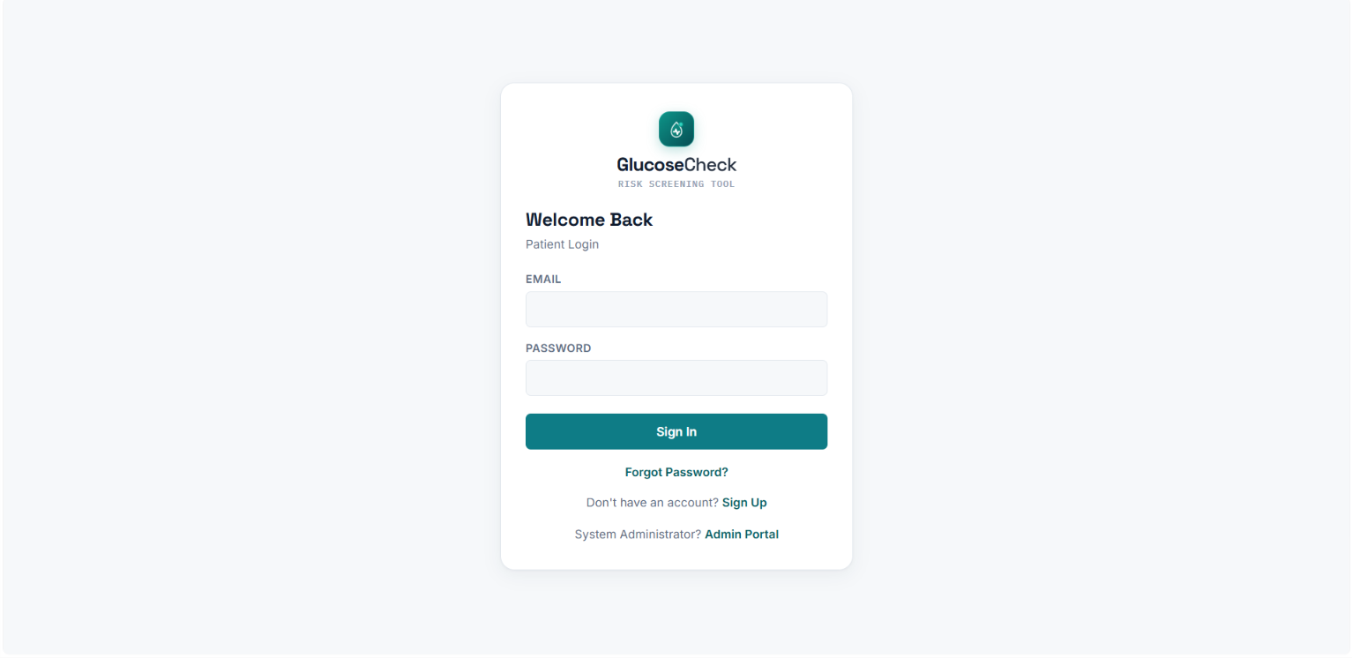
Login Page

Fig 8.1: Login Page — Shows the user login form with username/email and password fields.

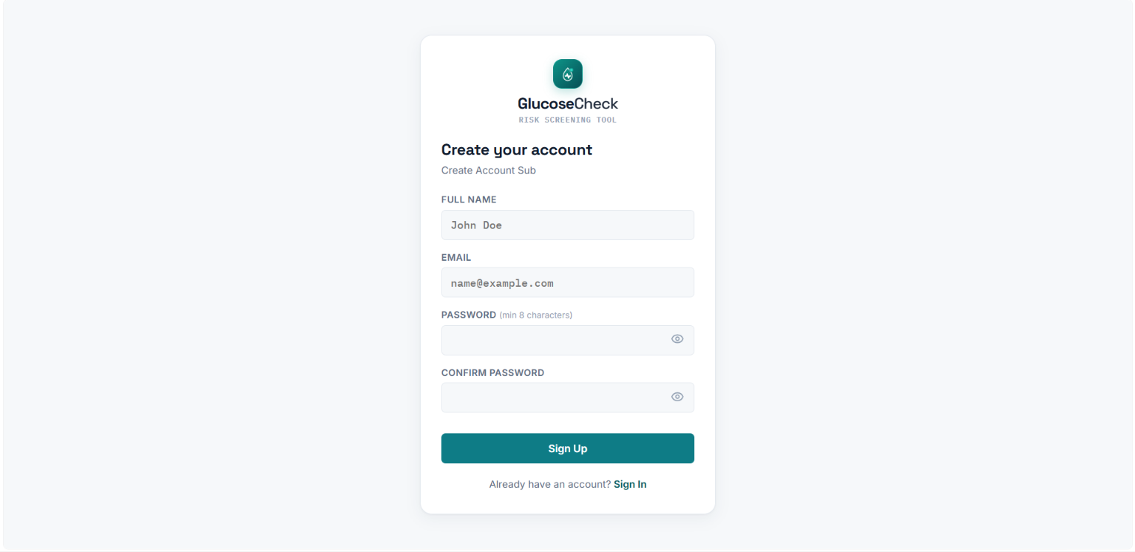
Register Page

Fig 8.2: Register Page — Shows the new-user registration form.

Dashboard
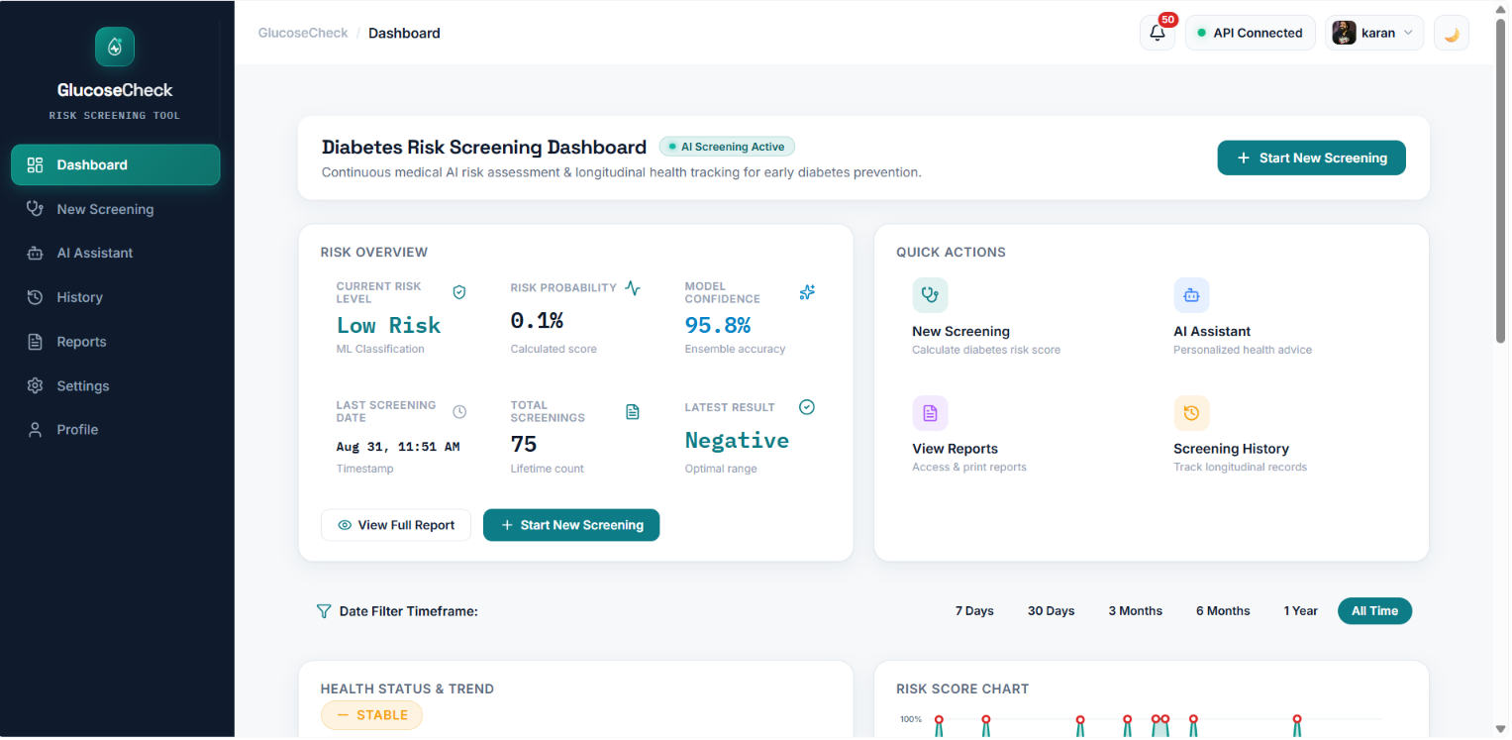
Fig 8.3: Dashboard — Shows the summary dashboard with quick stats and recent activity.

Prediction Form
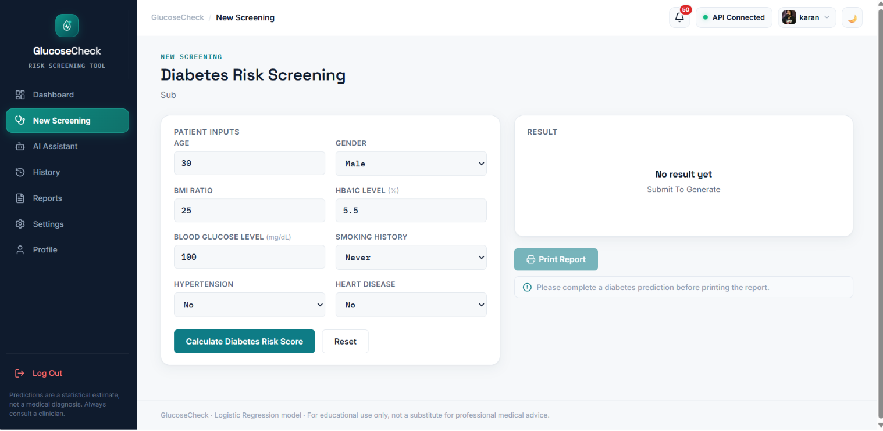
Fig 8.4: Predict Page — Shows the diabetes screening input form (age, BMI, HbA1c, glucose, etc.).

Prediction Result
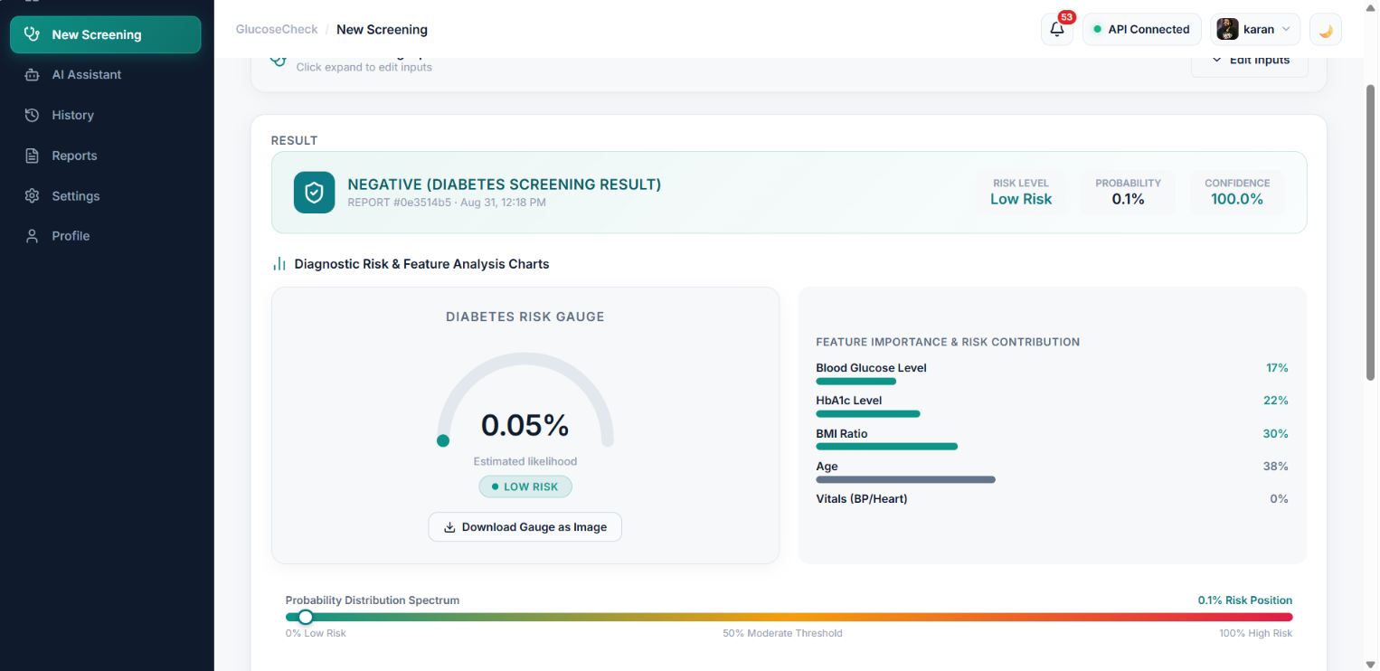
Fig 8.5: Result Page — Shows the Positive/Negative result with the risk gauge.

AI Health Suggestions
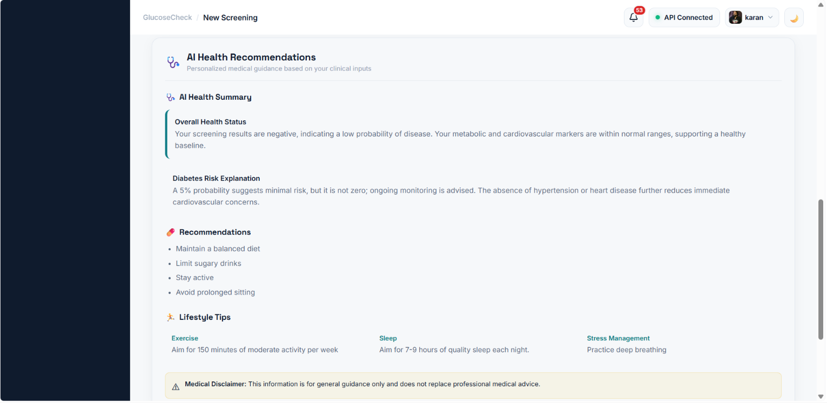
Fig 8.6: AI Suggestions Panel — Shows the AI-generated lifestyle, food, exercise, and stress-management guidance.

Screening History
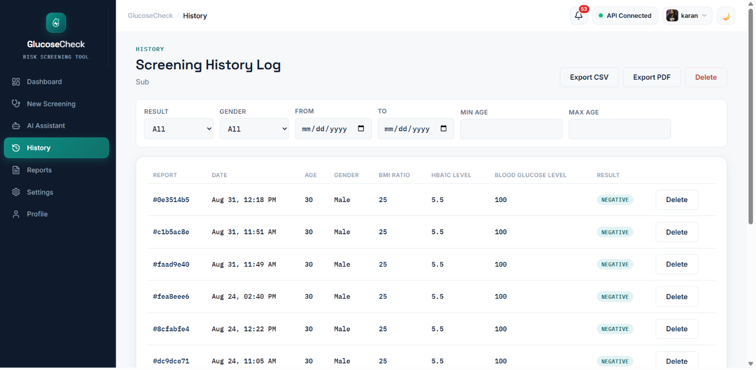
Fig 8.7: History Page — Shows the filterable, paginated list of past screenings.

PDF Report
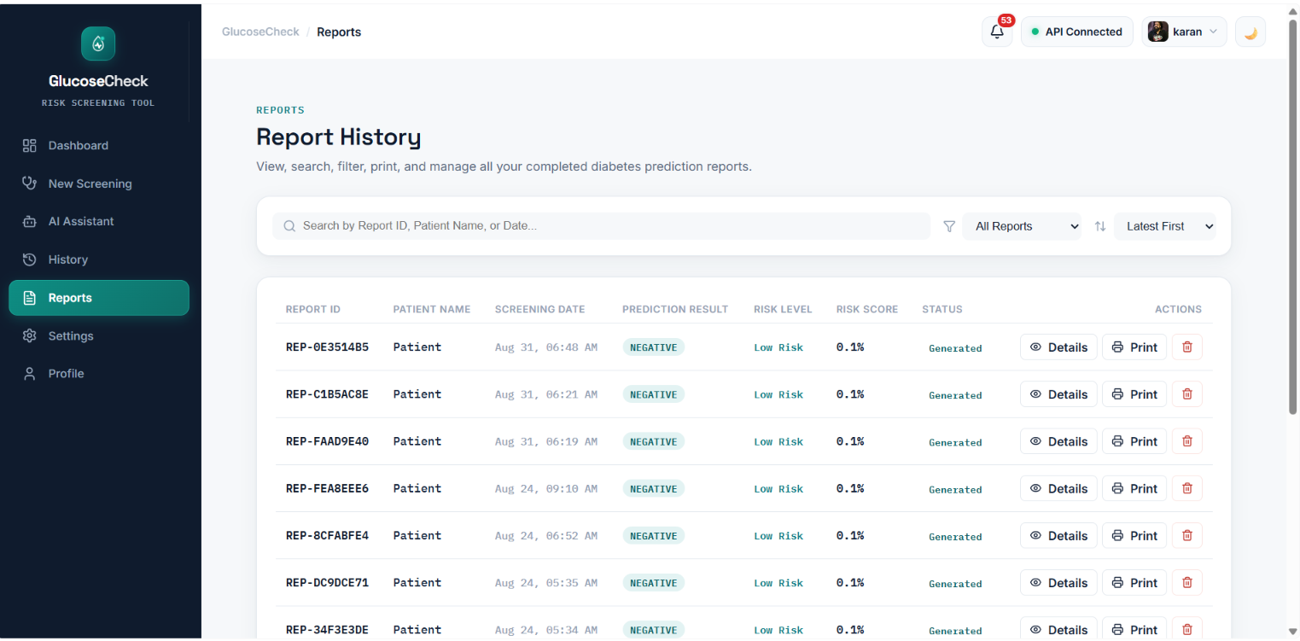
Fig 8.8: Downloaded PDF Report — Shows the generated PDF report with the risk gauge and QR code.

AI Chat Assistant
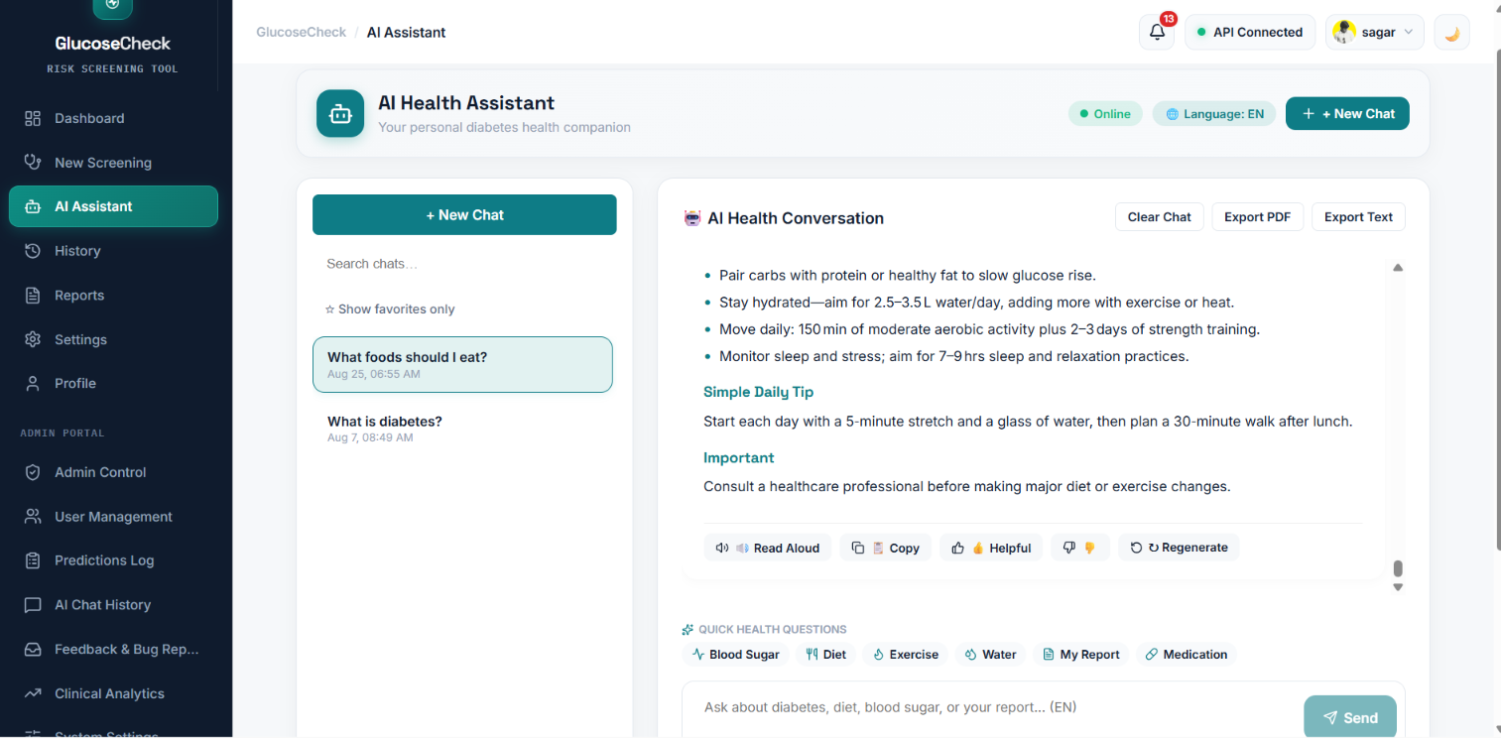
Fig 8.9: Chat Assistant — Shows a conversation with the multilingual AI health assistant.

Admin Dashboard
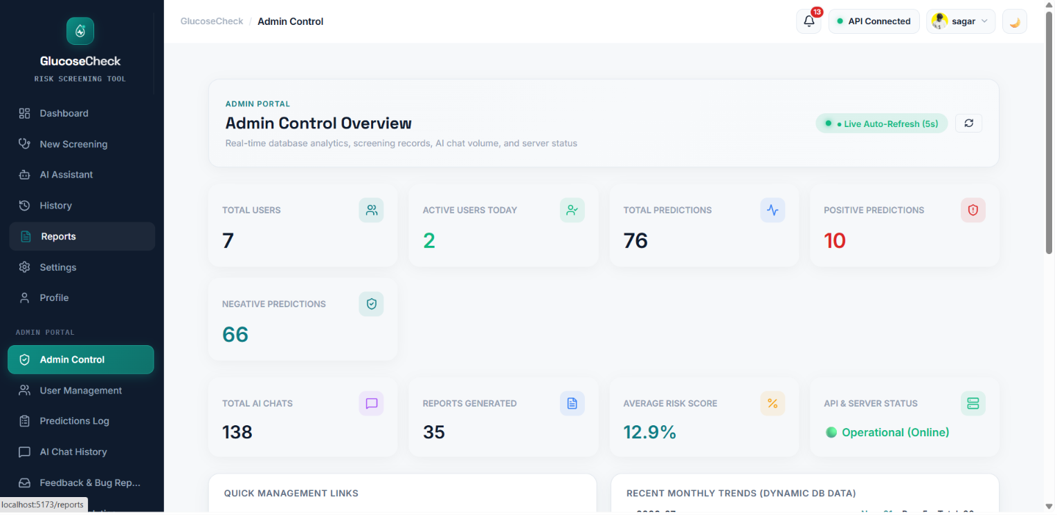
Fig 8.10: Admin Dashboard — Shows platform-wide statistics for users, predictions, chats, and feedback.

Admin — User Management
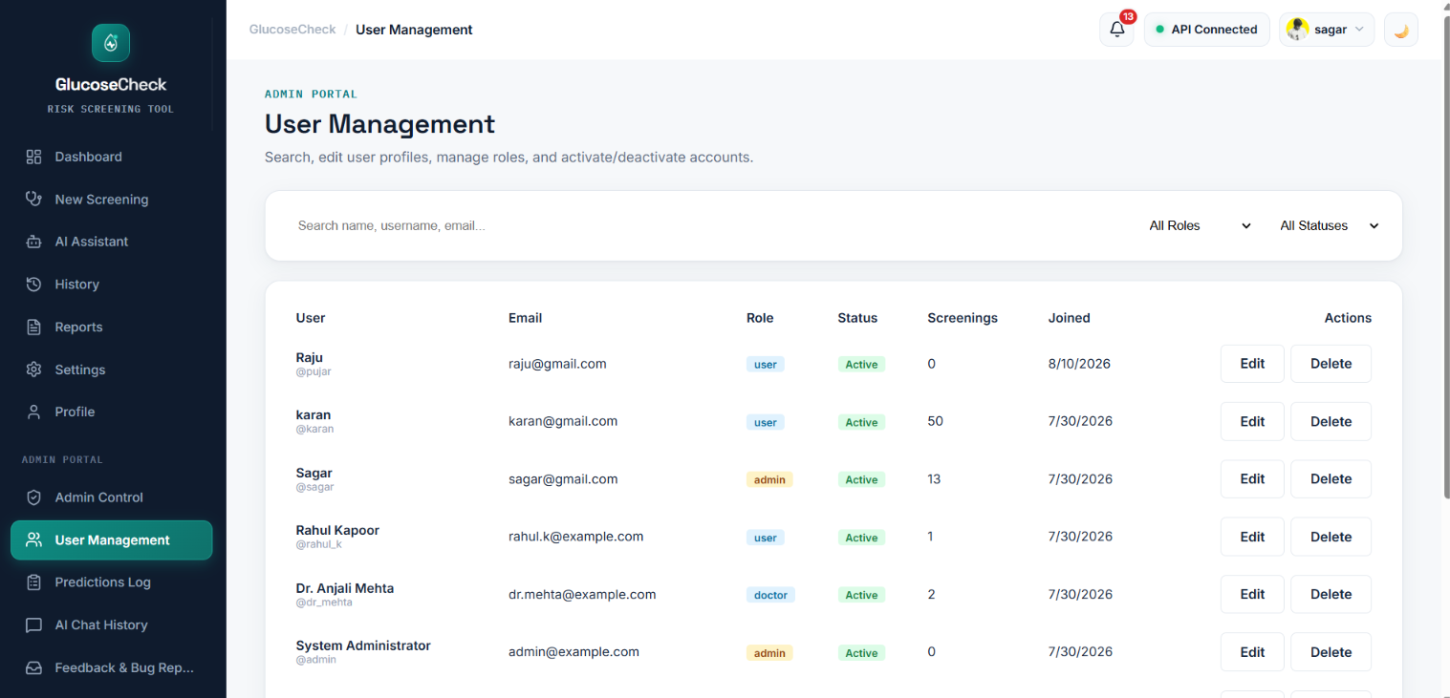
Fig 8.11: User Management — Shows the admin user list with management actions.

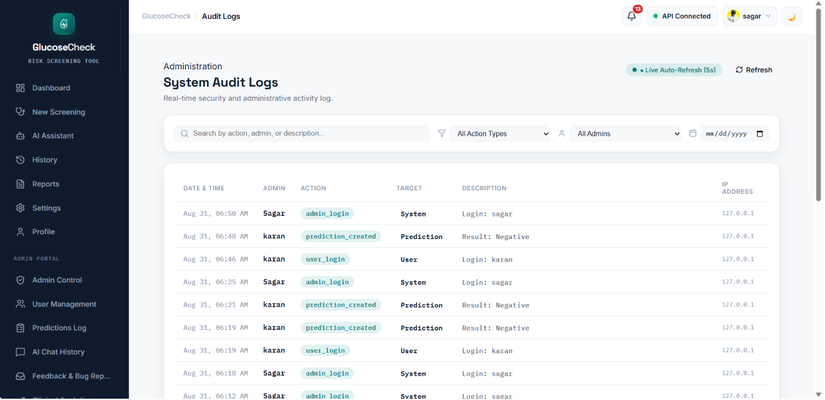
Admin — Audit Logs

Fig 8.12: Audit Logs — Shows the security/audit log listing.

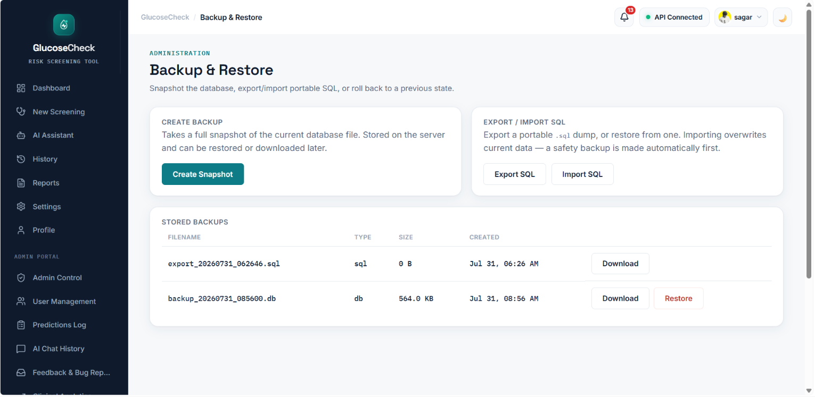
Admin — Backup & Restore
Fig 8.13: Backup & Restore — Shows the database backup creation and restore interface.

CHAPTER 9: CONCLUSION
The GlucoseCheck project successfully demonstrates the design and implementation of a full-stack, AI-assisted diabetes risk-screening web application built on a React frontend and a Flask REST API backend, backed by a portable SQLAlchemy/SQLite data layer. The core Logistic Regression prediction pipeline from the original standalone script was preserved unchanged, ensuring prediction consistency, while a complete production-style application was built around it: secure JWT authentication with role-based access, persistent and exportable screening history, an AI-driven personalized health-suggestions engine, a formatted PDF report generator, a multilingual voice-enabled AI chat assistant, an in-app notification system, and a comprehensive administrator console with audit logging and database backup/restore capability.
Achievements: All eight core screening inputs are validated, encoded, and classified consistently with the original model; every screening is durably persisted and linked to its owner where applicable; the platform exposes over forty REST endpoints across six functional Blueprints in addition to the original prediction routes; and the administrator console gives full operational visibility and control over the platform's data.
Benefits: Users receive an immediate, explainable risk assessment along with actionable, AI-personalized lifestyle guidance rather than a bare label; they retain a searchable historical record of their screenings; and they can interact with the system conversationally, including in their preferred regional language. Administrators benefit from centralized user, content, and security oversight, plus straightforward backup and disaster-recovery tooling.
Impact and Results: The resulting system illustrates, within an academic MCA project scope, how a machine-learning model can be embedded responsibly within a secure, auditable, multi-user web platform, and how supporting AI services (LLM-based suggestions and chat) can be layered on top of a deterministic prediction core without compromising its reliability, since a rule-based fallback is used whenever the AI service is unavailable. Manual testing across the prediction, authentication, history, and admin workflows confirmed that the implemented functionality matches the specified requirements.

CHAPTER 10: FUTURE ENHANCEMENTS
While GlucoseCheck meets its stated objectives as an MCA final-year project, several directions could extend its capability and readiness for broader real-world use.

Future Scope
- Integrate real clinician review workflows, allowing a 'doctor' role user (already present in the schema) to annotate or countersign screening results.
- Add automated unit and integration test suites (e.g., pytest for the backend, Jest/React Testing Library for the frontend) to complement the manual testing performed.
- Introduce refresh tokens and token revocation to strengthen the current JWT-based session model.

Advanced Features
- Expand the AI chat assistant with retrieval-augmented context from a curated medical knowledge base to reduce reliance on general-purpose LLM knowledge.
- Add push/email notification delivery in addition to the existing in-app notification system.
- Support multi-factor authentication for administrator accounts given their elevated privileges.

AI Integration Opportunities
- Periodically retrain the Logistic Regression model (or evaluate alternative models such as Random Forest or Gradient Boosting) on newly collected, anonymized screening data to track and potentially improve predictive performance over time.
- Use the accumulated screening history to build personalized risk-trend forecasting rather than only point-in-time predictions.

Scalability Improvements
- Migrate the default SQLite database to PostgreSQL for concurrent multi-user production deployment, which the current database-agnostic design already supports via a configuration change.
- Containerize the frontend and backend (e.g., with Docker) and introduce a reverse proxy / load balancer for horizontal scaling of the Flask API.
- Move long-running AI calls (suggestions generation, TTS synthesis) to an asynchronous task queue to improve perceived responsiveness under load.

BIBLIOGRAPHY

Books
1. Grus, J. (2019). Data Science from Scratch (2nd ed.). O'Reilly Media.
2. Géron, A. (2022). Hands-On Machine Learning with Scikit-Learn, Keras, and TensorFlow (3rd ed.). O'Reilly Media.
3. Banks, A., & Porcello, E. (2020). Learning React (2nd ed.). O'Reilly Media.

Research Papers / Journals
1. Sisodia, D., & Sisodia, D. S. (2018). Prediction of Diabetes using Classification Algorithms. Procedia Computer Science, 132, 1578–1585.
2. Kavakiotis, I., et al. (2017). Machine Learning and Data Mining Methods in Diabetes Research. Computational and Structural Biotechnology Journal, 15, 104–116.

Websites
1. Flask Documentation — https://flask.palletsprojects.com/
2. React Documentation — https://react.dev/
3. scikit-learn Documentation — https://scikit-learn.org/stable/
4. SQLAlchemy Documentation — https://docs.sqlalchemy.org/
5. ReportLab User Guide — https://www.reportlab.com/docs/reportlab-userguide.pdf
6. Groq API Documentation — https://console.groq.com/docs

IEEE References
[1] D. Sisodia and D. S. Sisodia, "Prediction of Diabetes using Classification Algorithms," Procedia Computer Science, vol. 132, pp. 1578–1585, 2018.
[2] I. Kavakiotis et al., "Machine Learning and Data Mining Methods in Diabetes Research," Computational and Structural Biotechnology Journal, vol. 15, pp. 104–116, 2017.

APA References
Sisodia, D., & Sisodia, D. S. (2018). Prediction of diabetes using classification algorithms. Procedia Computer Science, 132, 1578–1585. https://doi.org/10.1016/j.procs.2018.05.122

APPENDIX

Abbreviations
Abbreviation | Full Form
API | Application Programming Interface
BMI | Body Mass Index
CRUD | Create, Read, Update, Delete
HbA1c | Glycated Haemoglobin
JWT | JSON Web Token
LLM | Large Language Model
ORM | Object-Relational Mapper
REST | Representational State Transfer
SPA | Single Page Application
SQL | Structured Query Language
STT / TTS | Speech-to-Text / Text-to-Speech
UI/UX | User Interface / User Experience

Glossary
- Logistic Regression — A statistical classification algorithm that predicts the probability of a binary outcome.
- JWT (JSON Web Token) — A compact, self-contained token format used to securely transmit authentication claims between parties.
- ORM (Object-Relational Mapper) — A programming technique that maps database tables to programming-language objects, used here via SQLAlchemy.
- Blueprint — A Flask mechanism for organizing a group of related routes and other code into a reusable, registrable component.
- Fallback response — A deterministic, rule-based response returned by the system when an external AI service call fails or is unavailable.

User Manual (Summary)
- Navigate to the application URL and register for a new account, or log in with existing credentials.
- From the Dashboard, select 'Predict' to begin a new diabetes-risk screening.
- Fill in age, gender, hypertension and heart-disease history, BMI, HbA1c level, blood glucose level, and smoking history, then submit the form.
- View the result and risk gauge; optionally view AI health suggestions or download a PDF report.
- Visit 'History' to search, filter, or export past screenings.
- Open 'Chat Assistant' to ask diabetes-related questions, optionally using voice input in your preferred language.
- Administrators can log in via the dedicated admin login page to access the Admin console for platform management.

