Document vs Windows Object

## **Introduction:**

This blog is about the difference between the Document Object and the Windows Object in the JavaScript, Before going through the differences let us know what is a Document and what is a Windows Object in JS one by one.

## **Document Object:**

JavaScript Document object is an object that provides access to all HTML elements of a document. When an HTML document is loaded into a browser window, then it becomes a document object. The document object stores the elements of an HTML document, such as HTML, HEAD, BODY, and other HTML tags as objects. The HTML DOM document object is the owner of all other objects in your web page.

## **Windows Object:**

So now let us know what is a Windows Object in the JavaScript. It gives access to the browser's methods and attributes as the global object in the browser environment. The window object is the global object in the web browser environment. It represents the current window or frames that the JavaScript code is running in. A browser window is represented by the window object. The browser produces one window object for the HTML content and one extra window object for each frame when a document contains frames.

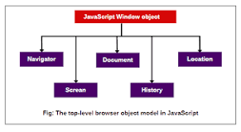

## **Document vs Windows:**

Once the browser is loaded the Windows Object is loaded as the properties of the Windows are stored in Windows Object. Where as the object inside the Windows object is the Document object and it is used to modify inside a document.

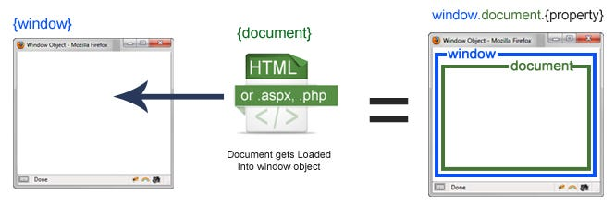

In much simple terms Windows Object is in the top level Hierarchy and Document object comes in below of the Windows Object.