HTTP 1 VS HTTP 2

## **Introduction:**

This blog is about the difference between the HTTP1 & HTTP2.

So before going to the differences, lets know what is HTTP, HTTP is **Hyper Text Transfer Protocol**. Hyper Text Transfer Protocol is a protocol which is in default in the browser, Its usage is to load web pages using HyperLinks.

## **HTTP 1:**

HTTP 1’s First usable version was created in the year 1991,As it went through several development stages. The first version was HTTP/1.1. HTTP is a top-level application protocol that exchanges information between a client computer and a local or remote web server.

## **HTTP 2:**

HTTP 2 by the name itself it describes that it is next or updated version of the HTTP1.So basically HTTP 2 is the advanced version of in the terms of speed.So the job of HTTP2 is also same as to load a web page, but in this case it does it in a better and effective way. HTTP/2 began as the SPDY protocol, developed primarily at Google with the intention of reducing web page load latency by using techniques such as compression, multiplexing, and prioritization.

**HTTP 1 VS HTTP 2:**

So we have got know what is HTTP 1 and what is HTTP 2, in the above paras,

so let us know further what are the differences between these two protocols. So as we know the HTTP2 is much more faster and advanced than the HTTP1. So let us know that how does the HTTP 2 is much more effective than the HTTP1. So there are various methods that have been enabled in the HTTP 2 protocol in order to get the improvement done.

## **Multiplexing:**

Multiplexing is the one of the methods in the HTTP2, so that we can reduce the loading time of the website. So let us know more about the Multiplexing. In Multiplexing the packets between the Client and the Server are exchange at the same time, Unlike HTTP 1, where each packets are sent and then the each packets are received, only then the next the packets are sent, so typically it requires more time and hence the delay is occurred.

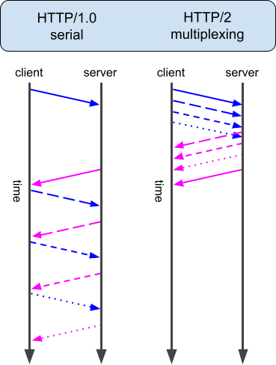

So have a look on the above image, where you can see the difference for easy understanding. Multiplexing is one of the factors where the data/ packets are sent received quickly and results us with the quick loading of the website is achieved through this.

## **HTTP 3:**

So once again the HTTP 3 is the next version of HTTP 2, the internet is grown and still its growing faster, there n number of websites been created daily, So just to make things quicker the next version is been in progress and will be launched soon.