Reinforcement Learning Driven Hybrid Clustering for Energy Optimization in IoT-WSNs

Shubham Kumar  
Department of Electronics and Communication *National Institute of Technology  
 Patna, India*  
shubhamk.pg24.ec@nitp.ac.in

Bharat Gupta  
Department of Electronics and Communication *National Institute of Technology  
 Patna, India*  
bharat@nitp.ac.in

Rakesh Ranjan  
Department of Electronics and Communication *National Institute of Technology  
 Patna, India*  
rr@nitp.ac.in

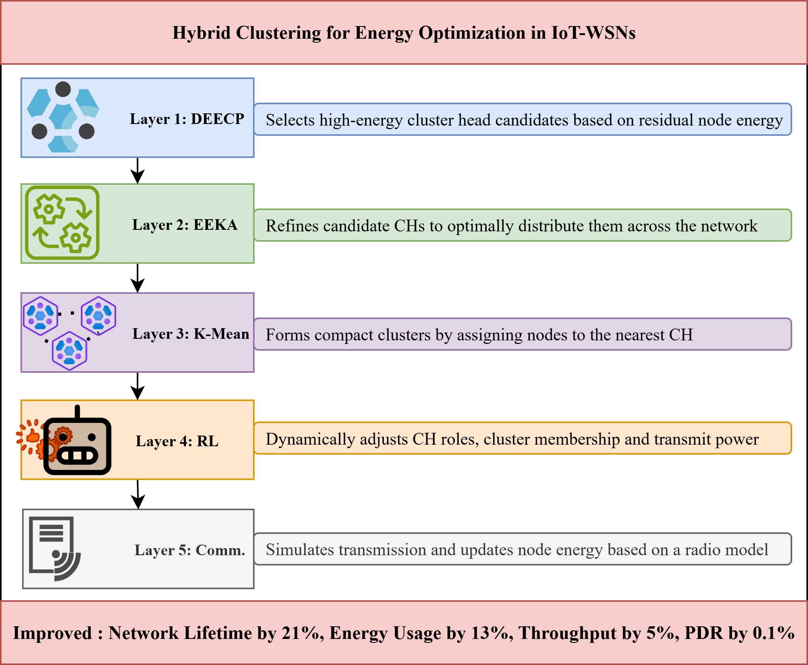***Abstract—*In the realm of the Internet of Things (IoT), Wireless Sensor Networks (WSNs) serve as a foundational technology, enabling diverse applications such as urban infrastructure management, industrial automation and environmental monitoring. Despite their widespread adoption, achieving energy efficiency and adaptive clustering remains a major challenge in prolonging the operational lifetime of WSNs. Traditional clustering algorithms such as Low-Energy Adaptive Clustering Hierarchy (LEACH) and Distributed Energy-Efficient Clustering (DEEC) often suffer from uneven energy consumption and static decision-making, limiting their scalability under dynamic network conditions. To address these limitations, this paper proposes a Reinforcement Learning-Driven Hybrid Clustering (RLHC) framework that integrates DEEC, the Energy-Efficient Knapsack Algorithm (EEKA) and K-Means with Q-learning-based adaptive optimization. In the proposed method, DEEC identifies high-energy cluster head (CH) candidates, EEKA ensures energy balance and uniform spatial distribution of CHs, K-Means forms compact clusters to minimize intra-cluster distances and the Q-learning agent dynamically learns optimal adjustment strategies by observing network states defined by residual energy, cluster load and packet delivery ratio (PDR) and executes actions such as CH switching, member reassignment and transmission power tuning. Through continuous interaction with the environment, the agent converges toward energy-optimal configurations. Simulation results demonstrate that the proposed RLHC method significantly enhances network lifetime, PDR and energy balance compared to optimized algorithms built on top of LEACH and DEEC. The improvements include a 21% increase in network lifetime, 13% reduction in energy consumption, 5% higher throughput and 0.1% improvement in PDR. This hybrid intelligence approach provides a scalable and adaptive solution for next-generation IoT-based WSN applications.**

***Keywords*—Reinforcement Learning (RL), Q-learning, Wireless Sensor Networks (WSNs), Distributed energy-efficient clustering (DEEC), Energy Efficient Knapsack Algorithm (EEKA), Energy Optimization, Internet of Things (IoT), K-Means Clustering.**

1. **INTRODUCTION**

Wireless Sensor Networks (WSNs) have emerged as a fundamental component of modern Internet of Things (IoT) ecosystems, enabling intelligent monitoring and data acquisition across diverse domains such as environmental observation, healthcare, smart agriculture and industrial automation [1], [2]. A WSN typically consists of numerous sensor nodes that collaboratively sense, process and transmit data to a base station. However, these nodes operate with constrained energy, limited computation and short communication ranges, making energy management a critical concern [3]. The efficient utilization of energy resources directly determines the network lifetime, data delivery reliability and overall system performance. Consequently, energy-aware clustering and routing protocols have become the cornerstone of sustainable WSN design.

Traditional clustering protocols such as LEACH and DEEC, along with their optimized successors such as EEKA have demonstrated notable improvements in balancing energy consumption through probabilistic cluster head (CH) selection and hierarchical communication [4]–[6]. However, these algorithms often rely on static parameters and lack adaptability to dynamic network states, resulting in premature node death and uneven energy distribution.