Hardware Implemented Real-Time Edge-Based Tomato Leaf Disease Classification using YOLOv11n

Shubham Kumar
Department of Electronics and Communication
National Institute of Technology Patna, Bihar, India
shubhamk.pg24.ec@nitp.ac.in
Bharat Gupta
Department of Electronics and Communication
National Institute of Technology Patna, Bihar India
bharat@nitp.ac.in
Shanti Jaiswal
Department of Electronics and Communication
National Institute of Technology Patna, Bihar India
shantij.ph23.ec@nitp.ac.in

Abstract—Tomato leaf diseases pose a significant challenge to crop yield and require timely detection for effective management. This paper presents a real-time edge-based system for tomato leaf disease classification using the lightweight YOLOv11 nano model, designed for deployment on resource constrained devices. The proposed approach performs on-device inference, reducing latency and minimizing reliance on continuous network connectivity. To support large-scale field monitoring, the system utilizes LoRa communication for transmitting inference results tagged with GPS coordinates from distributed edge nodes to a central base station. Then the collected data is uploaded to the Firebase cloud database and visualized through a web based interface which incorporates a grid based field visualization to spatially map disease distribution and provides real time updates to users, along with periodic notifications via Telegram. The model is trained on a dataset comprising over 13,000 tomato leaf images across 6 disease and 1 healthy categories. The complete system is implemented and evaluated in a real world scenario, demonstrating efficient real time performance and reliable classification accuracy. The proposed framework highlights the effectiveness of combining edge computing, low-power communication and spatial visualization for scalable and practical precision agriculture applications.

Keywords—Computer Vision, YOLO, Image Classification, Plant Disease Classification

- INTRODUCTION
Tomato is one of the most widely cultivated crops and plays a significant role in global agriculture due to its nutritional value and economic importance. In India, tomato cultivation is a cornerstone of agricultural productivity, accounting for approximately 11% of the country's total vegetable output. For specialized farmers, it serves as a primary economic driver, contributing as much as 32.2% to their total annual gross household income [1]. However, tomato yield is often threatened by various leaf diseases such as early blight, late blight, bacterial leaf spot, leaf mold, septoria leaf spot and yellow leaf curl virus. These diseases can spread rapidly under favorable environmental conditions and lead to severe yield losses if not detected and treated at an early stage. Traditionally, disease detection relies on manual inspection by farmers or experts, which is time-consuming, subjective and prone to errors. The process becomes even more challenging in real-world field conditions due to large farm lands, irregular or delayed inspection. Delayed or inaccurate diagnosis often results in ineffective treatment and significant economic losses [2]. Recent advancements in deep learning, particularly models from the YOLO family, have shown promising results in automated plant disease detection and classification [3]. But most existing approaches are cloud dependent and require continuous internet connectivity, limiting their deployment in rural and resource constrained environments. Furthermore, many solutions focus primarily on model accuracy without addressing real time deployment, communication and field level monitoring.
To address these challenges, this paper proposes a real time edge based system for tomato leaf disease classification using the lightweight YOLOv11n model. The system performs on-device inference and integrates LoRa communication to transmit classification results along with GPS coordinates to a central base station. The data is stored in the Firebase cloud database and visualized through a web-based interface, which provides real-time updates and periodic notifications via Telegram. A grid based visualization is incorporated to map disease distribution spatially across the field. The proposed system is trained on a dataset of over 13,000 images across six disease classes and one healthy class and is validated in real world conditions, demonstrating its effectiveness for scalable precision agriculture applications.
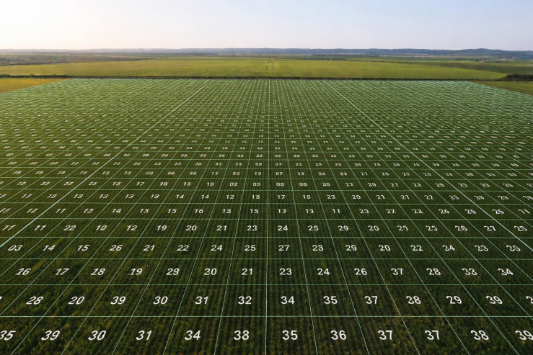
Figure 1. Grid-based field visualization for disease mapping.
Figure 1 represents a grid-based agricultural field visualization, where the entire field is divided into numbered cells for structured monitoring. Each grid cell corresponds to a specific region, enabling localized analysis of crop conditions and disease distribution. This representation facilitates efficient tracking, comparison and decision making, allowing users to quickly identify affected zones and take targeted actions for precision agriculture.
The remaining part of this paper is organized as follows. Section II represents a comprehensive literature review of existing approaches. Section III focus on the methodology of proposed method. Section IV presents the training setup and performance evaluation as well as comparative analysis of the proposed approach. Finally, Section V provides the conclusion and possible future research direction.

- RELATED WORK
Researchers have investigated various machine learning and deep learning techniques with the intent of using an early and precise identification of plant leaf diseases to enhance agricultural production by increasing the effectiveness of identifying diseased plants. In the past, most of the methods for identifying diseased plants were based on developing handcrafted features coupled with classical classifiers, but most encountered issues due to variations in the lighting, complexity of the background and disease pattern. However, with deep learning techniques such as CNNs and Object Detection Models, these challenges have been significantly reduced in recognition processing for plant diseases [4]. The current emphasis in scientific research has been focused on utilizing object detection frameworks with a particular interest in utilizing object detection models developed by the YOLO (You Only Look Once) family of models as they are capable of detecting objects and providing real-time detection of these objects with a high level of accuracy. The group of researchers conducted an analysis on each model's ability to accurately detect tomato leaf disease, particularly focusing on the analysis of each YOLO from the YOLOv8, YOLOv9, YOLOv10 and YOLOv11 series. The collective findings indicate that the YOLOv11 model produced the best relative accuracy and efficiency attributes and therefore may be ideally suited for use within the field of precision agricultural applications [5]. Improved versions of YOLO have been suggested by various researchers for more precise disease detection. One example is an improved version of the YOLOv8n algorithm, which uses enhanced feature extraction and increased robustness across different environmental conditions to successfully identify tomato diseases. Another example is the enhanced YOLOv10n algorithm, which incorporates multi-scale feature fusion as well as optimized detection heads, both have demonstrated that architectural changes can lead to serious improvements in both the classification and recall accuracy of disease detection [6].
Apart from YOLO-style methods, various non-YOLO style architectures have also been examined. For example, Transformers & CNNs have been combined into a single model like TomFormer, which provides competitive accuracy when detecting tomato disease by capturing local and global information from both types of networks. Hybrid models, such as Capsule-YOLO, have been proposed to improve how features are represented (segmenting) under complicated field conditions by being robust to occlusions and overlaps of leaves while achieving good accuracy. Most existing research concentrates primarily on enhancing the accuracy of their networks using controlled datasets like PlantVillage, which provides no realistic representation of actual growing conditions. Most of the methods required for deployment will utilize a cloud server for computing so that they must have an active internet connection and require considerable computing power to perform well enough during use. Therefore, implementing these applications in rural farm settings or in large area operations will be challenging, as either the coverage or reliability of the internet network found outside of great metropolitan cities will be very poor and therefore would create long latency issues or service disruption [7].
The DM-YOLO method addresses some of the issues that can occur during real world deployments by introducing alternative based approaches to improving the overall quality of the detection process using factors such as environment variation due to ambient lighting, occlusions and to deal with small lesions present on the plant. For instance, by developing lossy and dynamic methods to employ up-sampling, the DM-YOLO model has been developed to improve the ability of detecting tomato diseases in an overlapping manner under the extreme conditions of fields where diseases are often commonly found. Research into the development of an automated pest/disease detection system in a real-time manner that can be implemented, as opposed to establishing one but not yet usable, has also been the focus of YOLO-based researchers [8]. A fundamental drawback in present methodologies is that nearly all do not integrate a comprehensive end-to-end system involving elements such as edge computing, communications and visualization at the user level. Also, very few studies have included the use of low power communication technologies such as LoRa or provided insights at a spatial field level to aid in decision making.
The current proposed research effort will focus not only on accurately classifying diseases through the use of a lightweight YOLOv11n model, but also take into consideration issues related to deployment, including edge based inferences, long range LoRa communications, cloud based integration and grid-based field visualization. Using this holistic method will eliminate the existing disconnect between developing models and implementing those models in agriculture, thereby creating scalable and efficient solutions to precision farming.

- THE METHODOLOGY

References
[1] "Economic Analysis of Tomato Cultivation in Himachal Pradesh" is: H. Sharma, S. Sood and V. Kumar, Indian J. Econ. Dev., vol. 17, no. 4, pp. 960-965, Dec. 2021, doi: 10.35716/IJED/20213.

