

Video Portal

Submitted By: Submitted to:

Priyanshu Saki(11I5111) Er. Vaibhav Jain

Siddharth Saklecha(11I5122)

Devansh Parashar(11I5135)

**introduction**

iTube is a video portal where any user is capable of sharing and viewing videos over the internet. Users can also search and view videos uploaded by other users. Users can upload their videos by registering themselves with iTube. Users can also subscribe other users and enjoy the videos of the user(s) being subscribed. Users can also create their customized profiles which will contain their information. Users can also like or dislike the videos uploaded by other users, also users can leave a comment or multiple comments on the video. iTube also provides a platform for the users to promote and advertise their products, simply by subscribing to any of the advertising campaigns of iTube.

**DATA STORAGE**:

1. Users: Stores information about each user.

2. Videos: Takes Data for each video and its details.

3. Comments: Stores the details of the comments on every video.

4. Subscription: Takes the details of the users subscribed by all the users.

**MANIPULATION OF DATABASE:**

1. Registering a new user.
2. Uploading video.
3. Writing a comment on a video.
4. Subscribing a video.
5. Liking/disliking a video.
6. Liking/Disliking a comment.

**Software Requirement Specification**

**Purpose:**

Our objective is to create an open source video portal which enables the users to view and share videos. This open source portal will provide various facilities to the users like subscribing other users, leaving a comment on the video, like and dislike videos and comments. Furthermore, this portal also provides a platform for the users to promote and advertise their products.

Our Database Management project aims to provide computerized interface to all the data to be manipulated and stored, using Mysql and PHP. The application provides for,

1. Retrieval of any data based on particular search criteria
2. Storage of data, and its maintenance in a consistent manner.
3. Easy to use, interface with menus and forms, for clearer navigability

The application also does the necessary data validation, so that redundant or, unnecessary duplicate data are prevented from creeping into the database. It also traps most of the common data entry errors.

The Application differentiates between 3 types of users.

**1. Administrator:** The administrative user is another category, who is authorized to add, delete and modify the database content. The Administrator has the privileges to alter the database according to his/her will.

**2. Registered User:**  A registered user can upload, view, like/dislike videos from his/her account. Furthermore a registered user can also subscribe other registered users.

**3. Unregistered User:** One category is of users is Unregistered User who can only watch videos uploaded by the registered users..

Entities and Attributes:

**User:** User id, User name, First name, Last name, Gender, DOB, Email, Phone number, Password, Profile Picture Address.

**Videos**: Video id, Video name, Tags, Acceleration, 24-hr hits, Likes, Dislikes, Description, Up loader id, Video path, Thumbnail path, Hits, Upload date.

**Entity Relationship Diagram:**

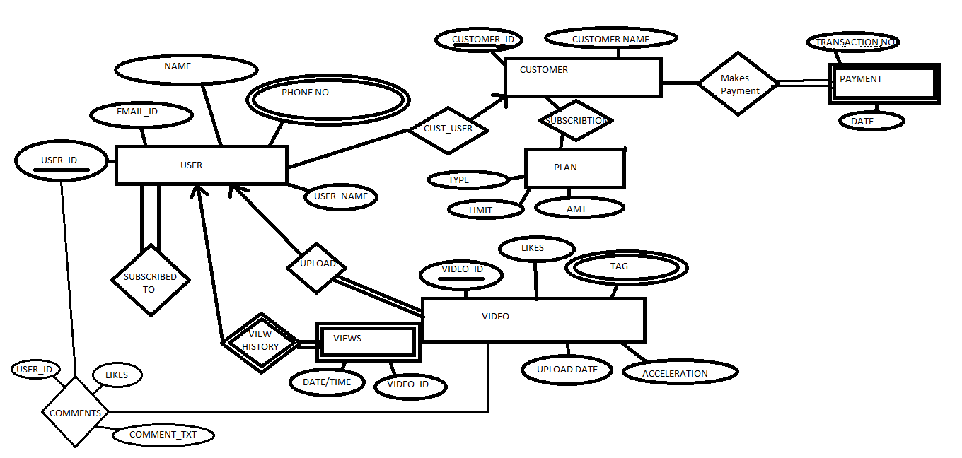

**Software products used:**

The following are the software that will be used in completing the project:

1. Mysql: As a back end to store the data .It is simple to use.
2. PHP: As the front end to create user friendly window interface.
3. Java provides comprehensive features that help in designing in detail.

**Why are we using PHP for front end?**

1. PHP pages easily combine static templates, including HTML or XML fragments, with code that generates dynamic content.
2. PHP pages are compiled dynamically into servlets when requested, so page authors can easily make updates to presentation code.
3. Developers can offer customized PHP tag libraries that page author access using an XML-like syntax.
4. Web authors can change and edit the fixed template portions of pages without affecting the application logic. Similarly, developers can make logic changes at the component level without editing the individual pages that use the logic.

**Why are we using Mysql for database (backend)?**

### 1. Scalability and Flexibility

The MySQL database server provides the ultimate in scalability, sporting the capacity to handle deeply embedded applications with a footprint of only 1MB to running massive data warehouses holding terabytes of information. Platform flexibility is a stalwart feature of MySQL with all flavors of Linux, UNIX, and Windows being supported. And, of course, the open source nature of MySQL allows complete customization for those wanting to add unique requirements to the database server.

### 2. High Performance

A unique storage-engine architecture allows database professionals to configure the MySQL database server specifically for particular applications, with the end result being amazing performance results. Whether the intended application is a high-speed transactional processing system or a high-volume web site that services a billion queries a day, MySQL can meet the most demanding performance expectations of any system. With high-speed load utilities, distinctive memory caches, full text indexes, and other performance-enhancing mechanisms, MySQL offers all the right ammunition for today's critical business systems.

### 3. High Availability

Rock-solid reliability and constant availability are hallmarks of MySQL, with customers relying on MySQL to guarantee around-the-clock uptime. MySQL offers a variety of high-availability options from high-speed master/slave replication configurations, to specialized Cluster servers offering instant failover, to third party vendors offering unique high-availability solutions for the MySQL database server.

### 4. Robust Transactional Support

MySQL offers one of the most powerful transactional database engines on the market. Features include complete ACID (atomic, consistent, isolated, durable) transaction support, unlimited row-level locking, distributed transaction capability, and multi-version transaction support where readers never block writers and vice-versa. Full data integrity is also assured through server-enforced referential integrity, specialized transaction isolation levels, and instant deadlock detection.

### 5. Web and Data Warehouse Strengths

MySQL is the de-facto standard for high-traffic web sites because of its high-performance query engine, tremendously fast data insert capability, and strong support for specialized web functions like fast full text searches. These same strengths also apply to data warehousing environments where MySQL scales up into the terabyte range for either single servers or scale-out architectures. Other features like main memory tables, B-tree and hash indexes, and compressed archive tables that reduce storage requirements by up to eighty-percent make MySQL a strong standout for both web and business intelligence applications.

### 6. Strong Data Protection

Because guarding the data assets of corporations is the number one job of database professionals, MySQL offers exceptional security features that ensure absolute data protection. In terms of database authentication, MySQL provides powerful mechanisms for ensuring only authorized users have entry to the database server, with the ability to block users down to the client machine level being possible. SSH and SSL support are also provided to ensure safe and secure connections. A granular object privilege framework is present so that users only see the data they should, and powerful data encryption and decryption functions ensure that sensitive data is protected from unauthorized viewing. Finally, backup and recovery utilities provided through MySQL and third party software vendors allow for complete logical and physical backup as well as full and point-in-time recovery.

### 7. Comprehensive Application Development

One of the reasons MySQL is the world's most popular open source database is that it provides comprehensive support for every application development need. Within the database, support can be found for stored procedures, triggers, functions, views, cursors, ANSI-standard SQL, and more. For embedded applications, plug-in libraries are available to embed MySQL database support into nearly any application. MySQL also provides connectors and drivers (ODBC, JDBC, etc.) that allow all forms of applications to make use of MySQL as a preferred data management server. It doesn't matter if it's PHP, Perl, Java, Visual Basic, or .NET, MySQL offers application developers everything they need to be successful in building database-driven information systems.

### 8. Management Ease

MySQL offers exceptional quick-start capability with the average time from software download to installation completion being less than fifteen minutes. This rule holds true whether the platform is Microsoft Windows, Linux, Macintosh, or UNIX. Once installed, self-management features like automatic space expansion, auto-restart, and dynamic configuration changes take much of the burden off already overworked database administrators. MySQL also provides a complete suite of graphical management and migration tools that allow a DBA to manage, troubleshoot, and control the operation of many MySQL servers from a single workstation. Many third party software vendor tools are also available for MySQL that handle tasks ranging from data design and ETL, to complete database administration, job management, and performance monitoring.

### 9. Open Source Freedom and 24 x 7 Support

Many corporations are hesitant to fully commit to open source software because they believe they can't get the type of support or professional service safety nets they currently rely on with proprietary software to ensure the overall success of their key applications. The questions of indemnification come up often as well. These worries can be put to rest with MySQL as complete around-the-clock support as well as indemnification is available through MySQL Enterprise. MySQL is not a typical open source project as all the software is owned and supported by Oracle, and because of this, a unique cost and support model are available that provides a unique combination of open source freedom and trusted software with support.

### 10. Lowest Total Cost of Ownership

By migrating current database-drive applications to MySQL, or using MySQL for new development projects, corporations are realizing cost savings that many times stretch into seven figures. Accomplished through the use of the MySQL database server and scale-out architectures that utilize low-cost commodity hardware, corporations are finding that they can achieve amazing levels of scalability and performance, all at a cost that is far less than those offered by proprietary and scale-up software vendors. In addition, the reliability and easy maintainability of MySQL means that database administrators don't waste time troubleshooting performance or downtime issues, but instead can concentrate on making a positive impact on higher level tasks that involve the business side of data.

**The Overall High level Description:**

**Product Functions:**

The user will have to register in order to comment, share/post or like a video on the portal. For the registration, user is required to enter some general information like email id, phone no, name, date of birth, etc. Once registered the user will be able to upload videos and also comment on and like or dislike videos.

After registration the user will be provided a profile that contains the information about the user. Based on the types of videos that the user views, more videos of same category and type will be suggested.

A video will have a record of the number of users commented on it, number of likes/dislikes it is bearing and its acceleration, which denotes the measurement of the video’s trend amongst the users.

A video will also include the information of the up-loader and the video type/category. A video may have multiple types or categories

Users of the portal who are interested in advertising and promoting their products on this portal must register themselves and will have to subscribe to a plan of advertisement. Based on plan the advertisement may be in form of video or poster.

A registered user will be provided the information of the videos uploaded by him and the other users who have subscribed the user.

**User Characteristics:**

Any person with basic computer skills can make use of the product.

**Specific Requirements:**

**Functions:**

1. The basic services that the Video Portal includes
2. Registering a new user.
3. Uploading of video(s).
4. Subscribing to other users.
5. Liking/Disliking videos.
6. Comment on a video.
7. The system shall provide for password protected administrator access to add, delete & modify the basic services offered by the portal.
8. User Interface & Security:

i. Graphical User Interface

ii. Floating Pop-up menu

iii. Customized Background Picture

iv. File based Encrypted Password Handling

**Performance Specification:**

The system is a multiuser system. The system efficient in terms of data retrieval. 95% of the transactions are completed within 2 seconds while the others may take few seconds.

**Hardware Requirements**

Any computer System with access to Internet

**Software Requirements**

Operating System. : Any OS that Supports access to the Internet

Developing Tool : PHP

Database : Mysql

**Application Interface**

