**GIFTS Material**

**For Children:**

1. **Pajama Bear**

**Price = $24.99**

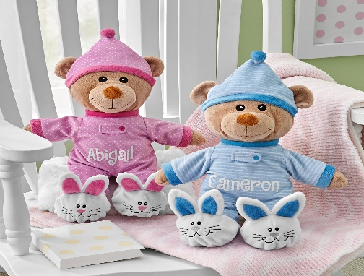

**This tired teddy is all ready to snuggle up with your little one and listen to a bedtime story.**

* **Made of 100% polyester.**
* **Spot clean.**
* **Personalize with any name up to 10 characters.**
* **Measures 12"H.**
* **Available in pink and blue.**
* **Item #30228659**

# Take Along Chair

# Price = $99.99

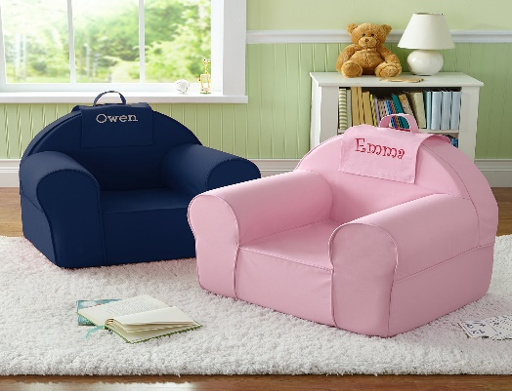

**A Personal Creations Exclusive! Nothing beats kicking back in your very own cozy, colorful chair. The tote-anywhere design ensures kids will always have the best seat in the house.**

* **Slipcover is 100% cotton and inside is foam**
* **Available in red, navy, teal, pink and purple with font color options**

1. **Just for Me Placemat**

**Price = $16.99**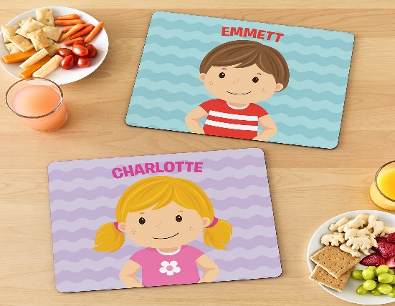

**A Personal Creations Exclusive! Kids will be thrilled to recognize themselves and their name on this one-of-a-kind placemat.**

* **Made of hardboard**
* **Features rounded corners**
* **Measures 11"Wx14"L**
* **Available in blue with boy icons and in purple with girl icons**
* **Personalize with any name up to 10 characters and your choice of icon**

1. **Flip & Sip® Water Bottle**

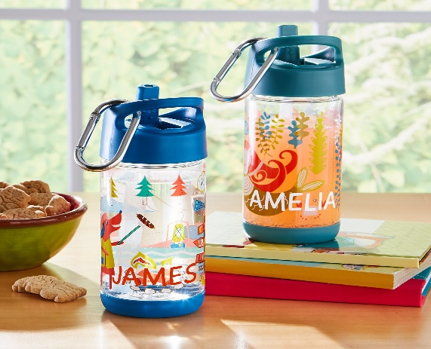**Price = $19.99**

**For kids with a thirst for super-cute characters, this high-quality water bottle—with a no-leak, easy-open spout—makes a wonderful companion.**

* **Spill-proof valve—no leaks even when spout is open**
* **Made of Tritan®, polypropylene and silicon**
* **Tritan is impervious to odors and stains, shatter and scratch-resistant**
* **Non-toxic and lead-, BPA- and phthalate-free**
* **Includes removable carabiner and extra straw**

1. **Baby's Five-Star Plush Robe**

**Price = $44.99**

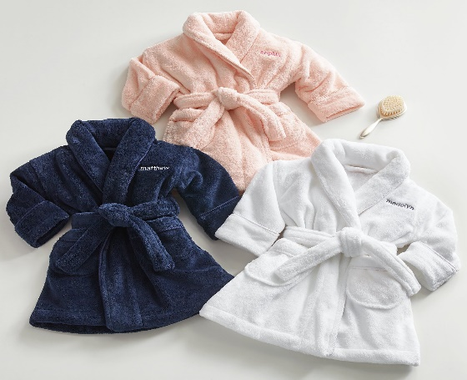

**With a reward this decadent, bath time may just become their favorite time of day. Made of thick, super soft plush, this robe acts like a high-quality towel, making it perfect for post-bath cuddles. Its large pockets and waist tie give it character and make it fun to wear.**

* **Made of plush polyester micro-fiber.**
* **Available in pink robe with gray or pink thread; white with gray, dark pink or navy thread; or navy with gray thread.**
* **Personalize with any name of up to 9 characters.**
* **Robe colors match back to adult robes.**
* **Baby sizes 6-12 mo., 12-24 mo.**

1. **Melissa & Doug® Turtle Ball Pit**

**Price = $79.99**

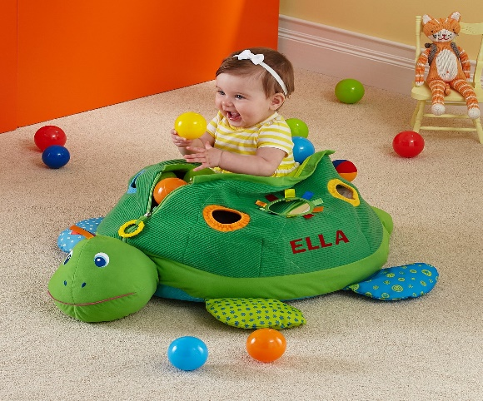

**Youngsters will have a ball with this crinkling, squeaking, multi-textured turtle! Filled with balls and covered with toys, kids can sit and play inside—and after playtime, it can be closed to store the balls and create a plush pillow toy.**

* **Made of polyester, polyfill stuffing and plastic**
* **Measures 17-1/4”Lx19-1/2"Wx9-1/2"H**
* **Includes 60 squeezable balls in two sizes and six colors**

1. **Legendary Friends Plush Dragon**

**Price = $24.99**

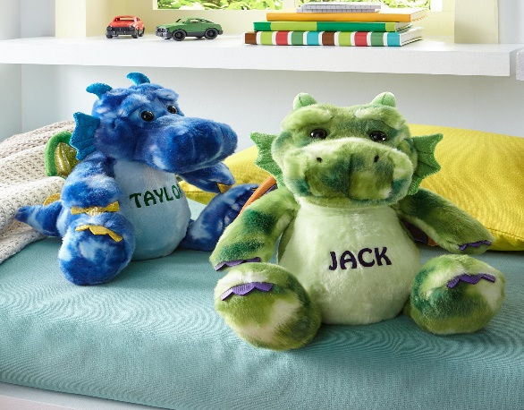

**Once upon a time there was a sweet little dragon looking for a new best friend—your little one! With his friendly expression and huggable softness, this irresistible critter is sure to steal their heart.**

* **Super-soft 100% polyester plush with shimmer fabric accents.**
* **Spot clean.**
* **Measures 12"H.**
* **Personalize with any name up to 9 characters.**
* **Available in green and blue.**
* **Suitable for ages 2+**

1. **Big Name Beach Towel**

**Price = $29.99**

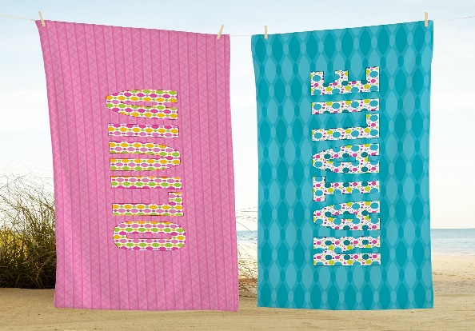

**A Personal Creations Exclusive! They’ll never be any confusion whose beach towel this is! Everything about it is big—big name, big size and big comfort.**

* **New and Improved! Heavy weight microfiber terry.**
* **Machine washable.**
* **Personalize with any name up to 10 characters.**
* **Measures 30"Wx60"L.**
* **Available in teal, pink, blue and green.**

1. **Melissa & Doug® Bubbles of Fun Bucket**

**Price = $24.99**

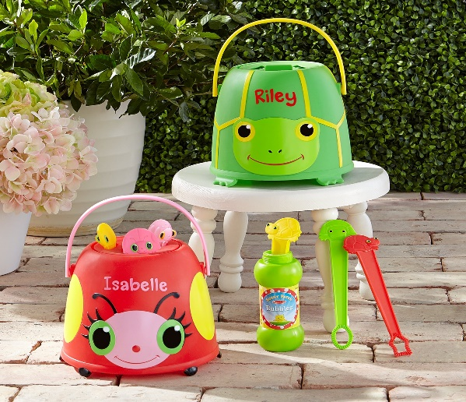

**This buggy bucket of fun has everything kids need for a bubblicious good time! Specially designed cap has 3 slots to minimize mess.**

* **Plastic bucket with sturdy handle and 3 dipping wands.**
* **Includes 8 oz. container of bubble solution.**
* **Personalize with any name up to 9 characters.**
* **Measures 7-1/2"H x 7-1/2" dia.**
* **Available in Lady Bug and Turtle designs.**
* **Ages 3+**

1. **Bitty Bites Good Lunch® Boxes**

**Price = $19.99**

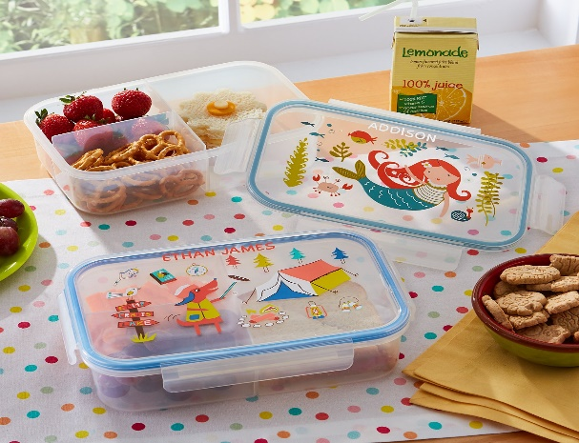

**Who needs plastic bags? Lunch is hassle-free and organized with our super-adorable, eco-friendly lunch box. It keeps contents neat and fresh until it's time to dig in.**

* **Made of food-safe, non-toxic, lead-free, PVC-free and phthalate-free polypropylene**
* **Locking lid design is great for storing food and protecting against spills**
* **High inner walls keep foods safely separated**

**For Men’s:**

1. **Monogram Wooden Watch**

**Price = $149.99**

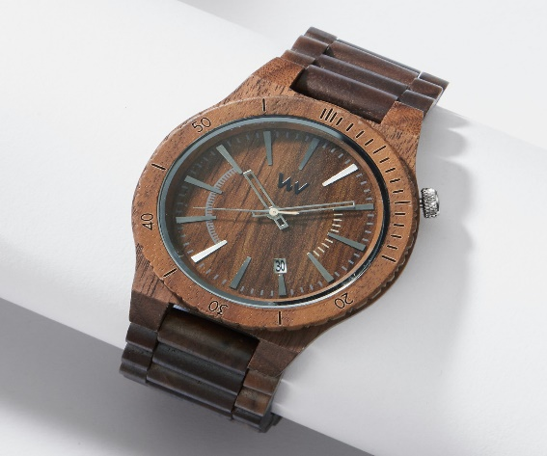

**Made from hypoallergenic wood, this striking watch makes a unique conversation piece. It combines one-of-a-kind style with eco-friendly features. In fact, for every watch sold, a tree is planted to help decrease deforestation.**

* **100% natural wood**
* **Hypoallergenic and completely free of toxic chemicals**
* **Miyota quartz movement.**
* **Hardened, scratch-proof mineral glass.**
* **Adjusts to fit any wrist**

1. **Ready2Go Leather Tech Organizer**

**Price = $29.99**

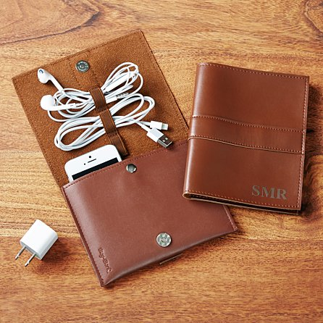

**Give high-tech travelers a stylish way to protect their smart phone or cut the clutter of cords and accessories that comes with it.**

* **Leatherette case with snap closure.**
* **Holds charging cords and/or headphones.**
* **Fits up to an iPhone® 5 & 6, but not suitable for an iPhone® 6 plus.**
* **Wipe clean with a soft cotton cloth.**

1. **Hidden Message Sunglass Travel Case**

**Price = $39.99**

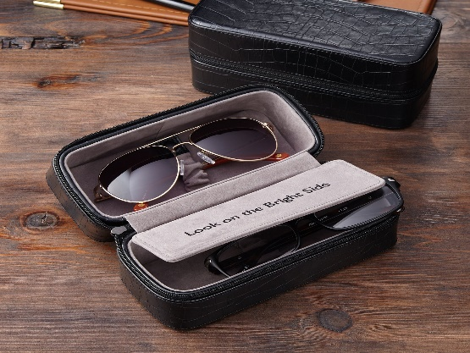

**If their sense of fashion starts with their specs, make sure they have an equally stylish place to stow them. This dual carrier means they’re never without a backup pair, and their hearts will lift every time they read your hidden message.**

* **Keep sunglasses safe and smudge-free in this gray velvet lined box with leather exterior.**
* **Holds 2 pairs of sunglasses or use one side to store other small items.**
* **Measures 7"Lx3"Dx3-1/4"H.**
* **Personalize with any message on the inside divider up to 25 characters or 3 letter monogram.**

1. **The Modern Mans Telescope**

**Price = $79.99**

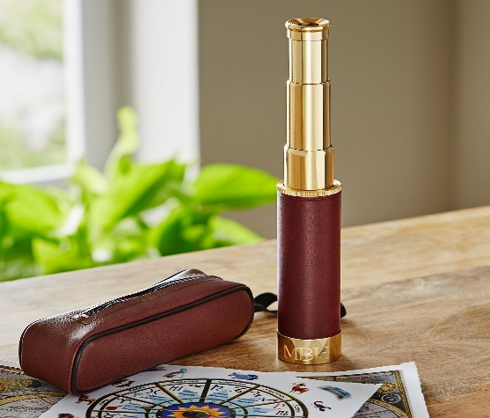

**Whether used for bird watching or cosmic exploration, this top-of-the-line telescope makes a truly eye-opening gift. The high-definition optical glass lens and go-anywhere design means it's always ready to provide a close-up view of the wonders of the world.**

* **Made of metal with faux leather handle.**
* **Magnification: 25X, refractor.**
* **Measures 5-3/8”Lx1-3/8” dia.**
* **Includes zip closure case with snap closure loop and wristlet strap.**
* **Personalize with any 3 letter monogram**

1. **Personalized Wooden Watch Case**

**Price = $59.99**

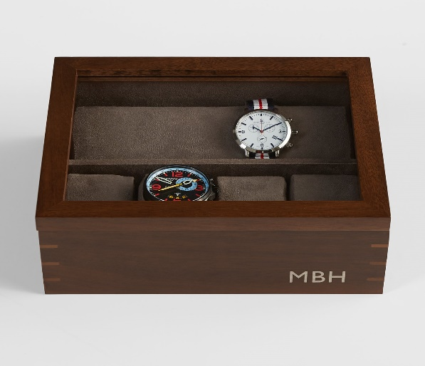

**Handsome and handy, this case will give his watch collection the presentation and protection it deserves while also storing cufflinks, bracelets and other small pieces of jewelry. The elegant glass top makes finding the watch he wants to wear a pleasure. Exclusively from RedEnvelope.**

* **Made of wood**
* **Microsuede interior and base to protect surfaces**
* **Removing front tray reveals a hidden storage compartment**
* **Holds up to 8 watches on 4 individual watch pillows**
* **Measures 9.5"Lx7.875"Wx3"H**
* **Personalize with any 3 initials or purchase non-personalized**

1. **Men's Five-Star Plush Robe**

**Price = $89.99**

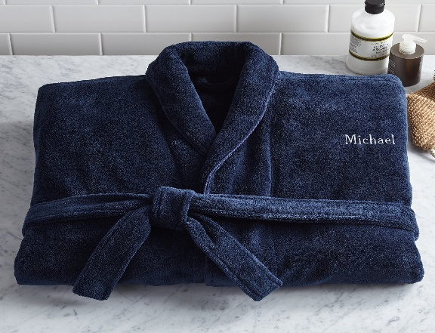

**Wrap yourself in decadence; this Turkish robe is as luxurious as those offered at five-star hotels. Soft and inviting, the plush, thirsty fabric acts like a high-quality towel, making it perfect for après bath, hot tub or shower. Transform your home into a villa of the highest extravagance. Exclusively from RedEnvelope.**

* **Made of plush polyester micro-fiber.**
* **Mid-calf length.**
* **Men's sizes M/L (42-46) and L/XL (48-52)**

1. **Men’s Classic Vintage Birthday T-Shirt**

**Price = $19.99**

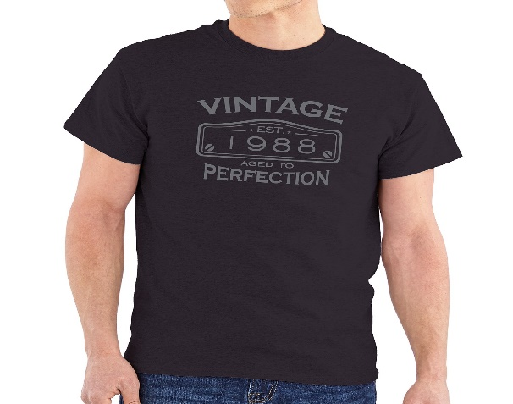

**A Personal Creations Exclusive! Let him know that he’s not getting older, he’s getting better!**

* **100% cotton.**
* **Machine washable.**
* **Personalize with any year.**
* **"Vintage" "Est." and "Aged to Perfection" will always appear.**
* **Available in men's sizes S–3XL.**

1. **Tech Fleece Jogger Pants**

**Price = $16.49**

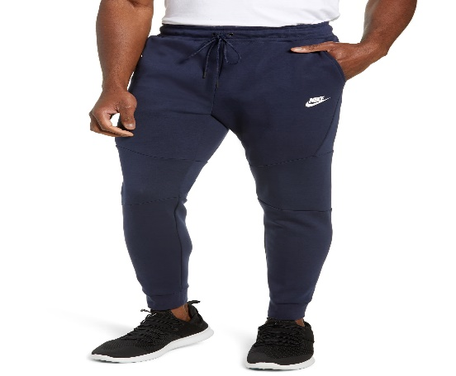

A bonded side-zip pocket furthers the streamlined silhouette of modern dropped-crotch jogger pants pieced together from cozy cotton-blend tech fleece in a tapered leg that ends with on-trend banded cuffs at the ankles.

* 28 1/2" inseam; 9" leg opening; 15" front rise; 16" back rise (size Medium).
* Elastic/drawstring waistband.
* Side slant pockets; side zip pocket.
* 66% cotton, 34% polyester.
* Machine wash cold, tumble dry low.
* By Nike; imported.
* Men's Sportswear

# Mormont Logo Leather Belt

# Price = $150

Heat-stamped for rich texture, a calfskin-leather belt boasting a prominent brass logo buckle makes a rugged addition to your look.

* 1 1/2" belt width; 2 1/4" x 3" buckle dimensions
* Calfskin leather
* Made in Italy
* Men's Designe

1. **Dot Silk Tie**

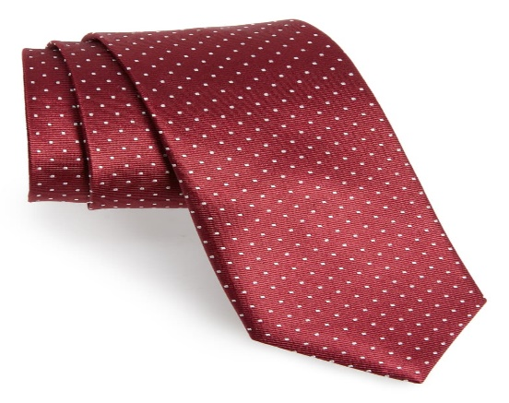 **Price = $19**

A crisp dot grid marks a slim tie cut from pure silk.

* 2 1/2" width; 58" length.
* 100% silk.
* Dry clean.
* By The Tie Bar; imported.
* Men's Furnishings

**For Women’s:**

1. **To The Moon and Back Birthstone Necklace**

**Price = $99.99**

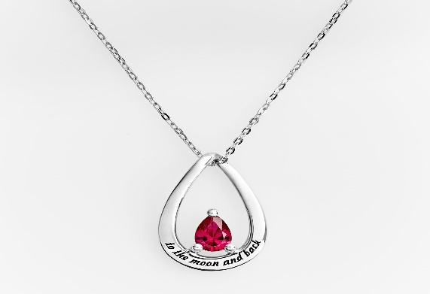

**Present the love of your life this radiant necklace one evening under the stars and create a moonlit moment you’ll always remember. While there's no way to measure your love for her, this necklace—sparkling with her birthstone—shows the lengths you’ll go to dazzle her.**

* **Made of sterling silver.**
* **Pendant measures 3/4"Hx1/2"W.**
* **Chain measures 18"L.**
* **Personalize with the birthstone of your choice.**
* **"To the moon and back" is engraved on the front**

1. **Open Heart Birthstone Cuff**

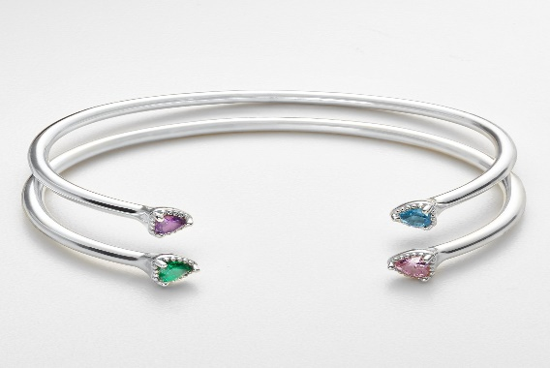**Price = $139.99**

**Excite and delight someone you adore with this subtle but stunning cuff bracelet. Crafted of lustrous sterling silver, it’s accented with a pair of petite birthstones celebrating special people in her life.**

* **Made of sterling silver**
* **Cuff is flexible for easy wearing and removal**
* **Heart-shaped stones measure 4mm each**
* **Measures 2 to 2.5"W overall with a 1.25" opening**
* **Customize with any two stones**

1. **Matte Revolution Lipstick**

**Price = $30**

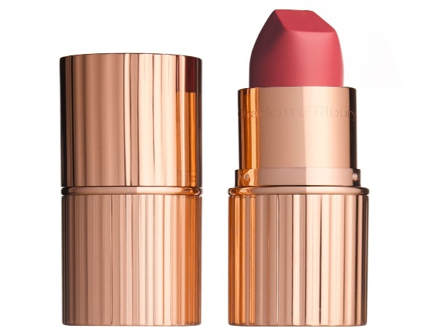

A magical, matte lipstick with a long-lasting, buildable, hydrating formula featuring 3D glow pigments to create lips that appear wider and fuller

* Cruelty-free

1. **Modern Bag – Blush**

**Price = $399**

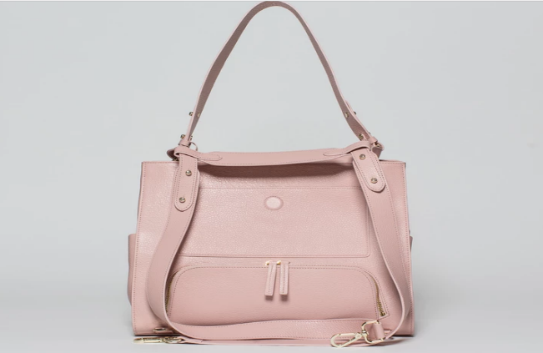

This Modern Bag is crafted from beautiful Italian pebble leather and finished with a waterproof coating. It's a carryall that you can use for everything: work, gym, travel, and keeping up with your little ones

* Sustainable Luxury
* Carry It All
* Perfect Travel Companion

1. **Daydream Cat Satchel**

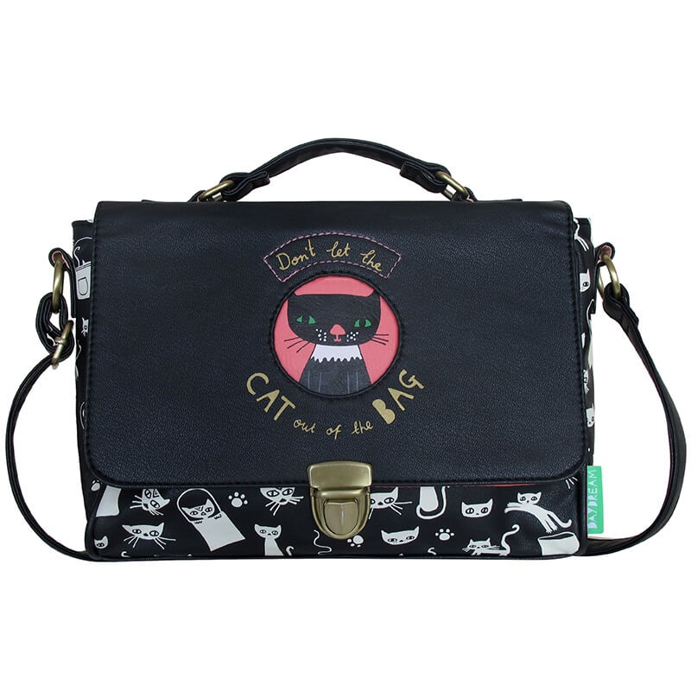**Price = $6.99**

Don’t let the cat out of the bag on this super cute Daydream Cat Satchel! Designed for the felinely inclined the Daydream Cat Satchel is made from durable PVC with a cotton lining.

* Cute cutout window reveals the Cat In The Bag - don't let him out!
* Printed lining and multiple card slots and compartments
* PVC with a cotton lining

# Harry Potter Dobby the House-Elf Watch

# Price = $19

# 

What better gift for a Potter fanatic than a trendy wristwatch featuring everyone's favourite free house elf, Dobby. Mounted on a cream faux leather strap, the intricate timepiece sports a delightful picture of Dobby dressed in his signature cushion cover garment.

* A picture of Dobby in the watch face.
* With silver plated buckle and cream faux leather strap.
* Official Harry Potter merchandise

1. **Girls yellow check faux fur collar jacket**

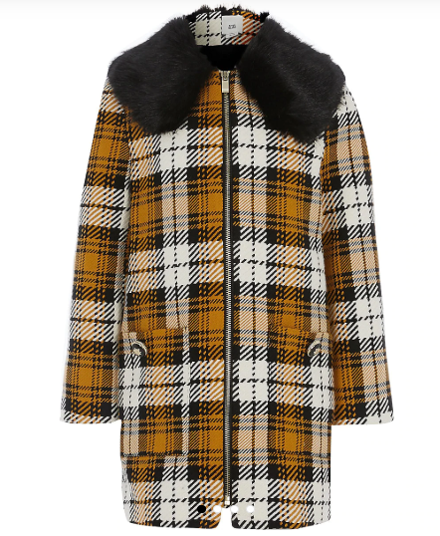**Price = £45.00**

* Cotton polyester fabric
* Check print
* Removable faux fur collar
* Long sleeve
* Zip-through front fastening
* Front patch pockets with crested button detail

1. **Women Blue Slim Fit Mid-Rise Clean Look Stretchable**

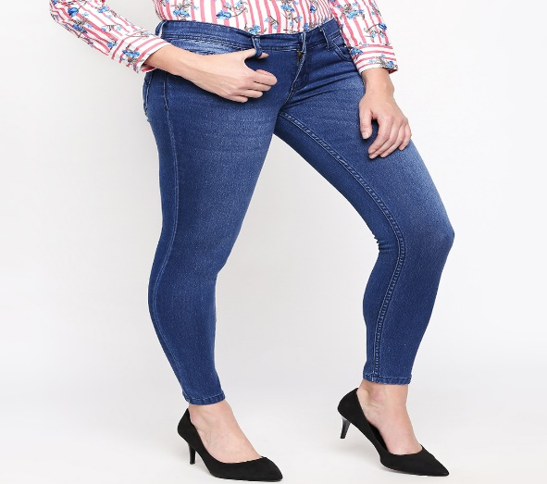**Price = $13.00**

Blue medium wash 5-pocket mid-rise jeans, clean look with light fade, has a button and zip closure, waistband with belt loops

* Slim fit
* Stretchable
* The model (height 5'8") is wearing a size 28
* Cotton, polyester and elastane

1. **Euphoria Perfume By Calvin Klein**

**Price = &40.53**

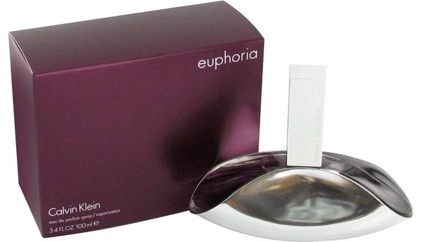

Euphoria by Calvin Klein Perfume. Euphoria by Calvin Klein is a woody, oriental scent has notes of pomegranate, black violet, black orchid, and mahogany. The subtle lotus blossom and persimmon notes add another layer of depth and exotic mystique to Calvin Klein Euphoria

* The bottle is just as exotic and innovative as the scent itself.
* The pomegranate, black orchid, and mahogany also reveal liquid amber.
* When wearing Calvin Klein Euphoria, women typically find that a strong and confident

1. **Princess Wishbone Ring**

**Price = $100.00**

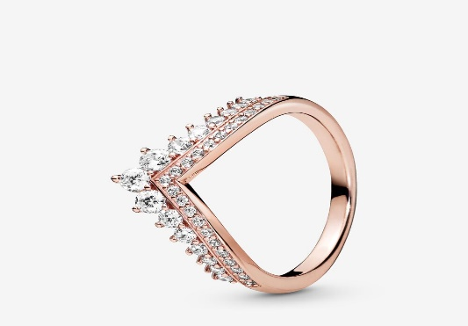

Our popular wishbone ring gets a royal makeover with the princess wishbone ring in Pandora Rose™ featuring a tiara design. Made with smooth and sparkling surfaces in rose gold hues, it's every princess' dream with its wishbone shape and tiara look achieved by layering individual crystals onto the band of the ring as well as setting them on its edge

* Gifting made easy
* Free Shipping and Returns
* Free and easy returns