***Srednja Tehnička Škola „Bugojno“***

****

Project's name:

**EfficientWorker**

**Students:**

**Petrović Armin**

**Imširović Velid**

Table of Contents

[1.ABSTRACT 3](#_Toc30578354)

[2.INTRODUCTION 4](#_Toc30578355)

[3.MATERIALS AND METHODS 5](#_Toc30578356)

[3.a ARDUINO IDE 6](#_Toc30578357)

[3.b VISUAL STUDIO CODE 7](#_Toc30578358)

[3.b.1 HTML 7](#_Toc30578359)

[3.b.2 CSS 8](#_Toc30578360)

[3.b.3 JS 8](#_Toc30578361)

[3.c ESP32 DEVELOPMENT BOARD 9](#_Toc30578362)

[3.d FINGERPRINT SCANNER 10](#_Toc30578363)

[3.e SD CARD AND SD CARD MODULE 11](#_Toc30578364)

[3.f WEBSOCKETS AND FROMS 12](#_Toc30578365)

[3.f.1 FORMS 12](#_Toc30578366)

[3.f.2 WEBSOCKETS 12](#_Toc30578367)

[3.g NTP GLOBAL TIME SERVERS 12](#_Toc30578368)

[4.RESULTS 12](#_Toc30578369)

[5.DISCUSSION 15](#_Toc30578370)

[6.CONCLUSION 18](#_Toc30578371)

[7.ACKNOWLEDGMENTS 18](#_Toc30578372)

[8.REFERENCES/BIBLIOGRAPHY 19](#_Toc30578373)

# 1.ABSTRACT

Over the past decade, with questionnares in August 2008, August 2010 and August 2018 it has been proven that about 50% of workers in USA think that they are underpaid. It means that they think they are not enough paid for the amount of work they do.

Also, in 2015, Payscale, compensation software company surveyed about 71,000 people in order to find relationship between pay and employee engagement. In this research, they found that **whopping two thirds of people (64%) thought they are underpaid**, but actually they have normal salaries. In addition to that, lot of people are not comfortable with fact that they are working way more than some of their colleagues, but they are getting paid equally. It's because their employers are paying them for the **amount of time spent doing their job, not the efficiency and quality of work they have done.**

Because of that, we decided to make first system that will help employers found out who is really working, and who is pretending to do so. Also, it will help workers to compare themselves to others in that same, or some other company, and see if they are overpaid, underpaid or paid normally for the work they do.

Based on that, employers will track their worker's progress and decide if he is necessary for his job as a work force or not. Also, workers will know if they are too good for the job, and based on that they can make some decisions about their next job, efficiency and self-improvement.

As you will see in the research paper, we built **functional, scalable system** to help employers track efficiency of their workers. System gets fully usable in environments where workers have precisely defined tasks. As we already mentioned, besides employers, we can help enthusiastic workers as well, no matter what job they are doing.

**The key is to be better than yourself. Be better, and happier worker.**

**Be EfficientWorker!**

# 

# 2.INTRODUCTION

Average working time is about 8 hours a day. Because of that, many of us would think that is also the amount of time person is doing the work he/she is paid for. But not actually. In the research conducted by [www.vouchercloud.com](http://www.vouchercloud.com), in which they pooled about 2000 UK office workers all above age of 18, **79% of them admitted that they are not productive all the time they spent at work**.

Furthermore, in this research they found that the **average productivity at work is amazingly just 2 hours and 53 minutes**. We were asking ourselves:what would happen if we could know when and how much is worker actually working, and free that worker for the time that left? What would happen is next:employer would have more happier and enthusiastic workers willing to work, workers would have more free time for themselves, and maybe even for extra thinking about job solutions and tasks, which is a win-win situation. That's the way we came up with the idea for the system.

**Our EWS (EfficientWorker System) is able to track all of worker's tasks, track time spent doing tasks, efficiency in last month, number of tasks currently done, and even history of efficiency through the year(s).**

How do we track tasks? That's where fingerprint sensor comes in. Firstly, before doing any task(s), worker needs to announce it to the system by placing his finger on sensor. After that, when he finishes, again he needs to tell it to our system by placing finger on the sensor.

With this technique we abstracted the 'task' as a word, and now its meaning strongly depends on the type of company and type of work. Task may be writing a function or a routine (software companies), making a bed (furniture factories) etc.

Below is a chart that represents activities that people are doing instead of working their job at work. These are informations from already mentioned research on 2000 UK office workers. They were allowed to select more than one option if more than one applied (All sources are given in resources/bibliography section):

Image 2.1 – Distractions at jobs

# 3.MATERIALS AND METHODS

Like most of the IT & Engineering projects, our system has hardware and software parts. Software that we used are next:

1. Arduino IDE
2. Visual Studio Code
   1. JavaScript
   2. HTML
   3. CSS

Hardware materials we used:

1. ESP32 Development Board
2. SD card & SD card module
3. Fingerprint sensor

Besides that, methods and technologies we used are mentioned below:

1. WebSockets & Forms
2. NTP global time servers

## 3.a ARDUINO IDE

Arduino IDE is very known Integrated Development Environment that is primarily used for programming arduino based boards. But you can also download all kinds of boards and program them in this IDE, which is exactly what we did here. We used it to program our ESP32 board, which worked quite well for us. We used it for programming ESP32 board because we have already worked few projects in this IDE, and it is very user friendly.

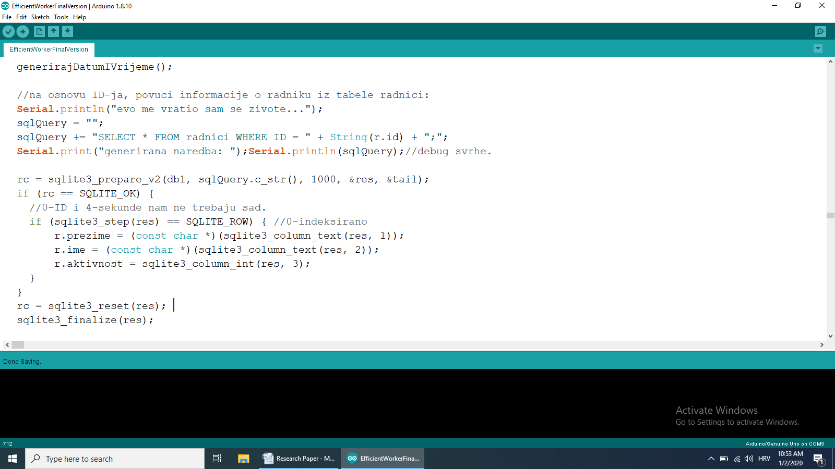

Image 3.1 – example of esp32 code in arduino IDE

## 3.b VISUAL STUDIO CODE

This IDE was used in order to write HTML, CSS and JavaScript code for website that is served by our ESP32 server. Type of file is automatically detected by typing proper extension for files (.html, .js etc), or selecting one by hand. We selected this IDE because it has a lot of features that helped us for quick and easy coding, such as automatic finishing of some of the keywords, lot of predefined things, etc..

Next pictures are showing samples of HTML, CSS, and JavaScript code in Visual Studio Code IDE respectively (for the sake of simplicity, we put all of our HTML, CSS, and JS in one file with .html extension).

### 3.b.1 HTML

HTML (Hyper Text Markup Language) is one of the most common languages for writing web pages, code sample is shown below:

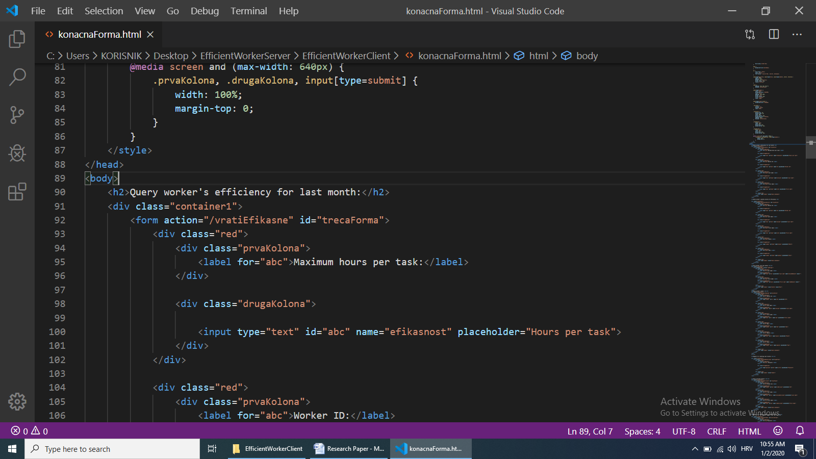

Image 3.2 – HTML code example

### 3.b.2 CSS

CSS is used along with the HTML, for styling web pages, which is what we used it for:

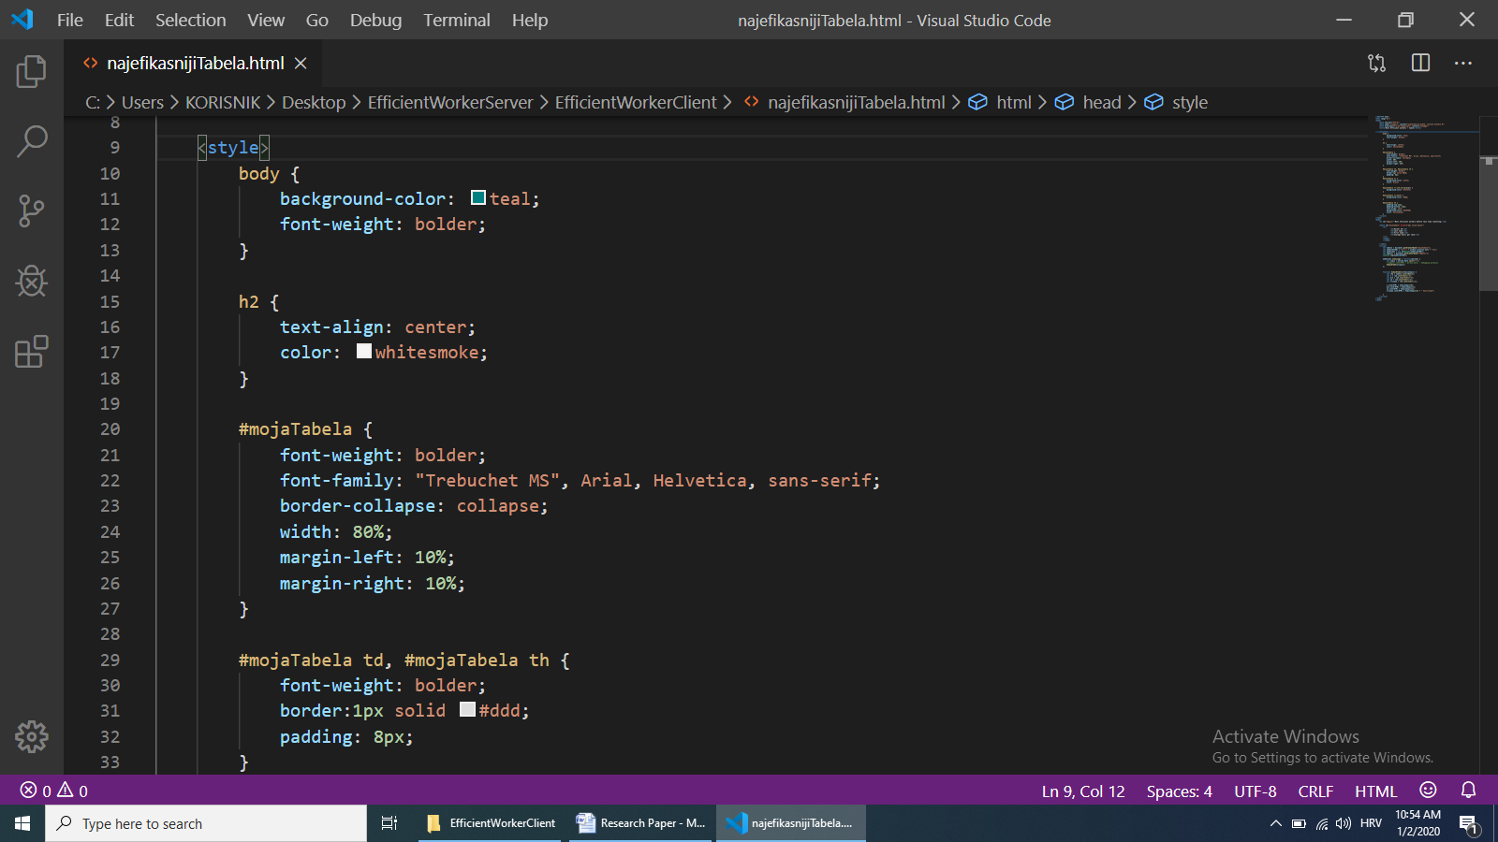

Image 3.3 – CSS code example

### 3.b.3 JS

JavaScript is used for website to be interactive (user gives some information, and he gets some information). We used it primarily for creating websocket connections with server, and displaying that information we got from server websocket to tables.

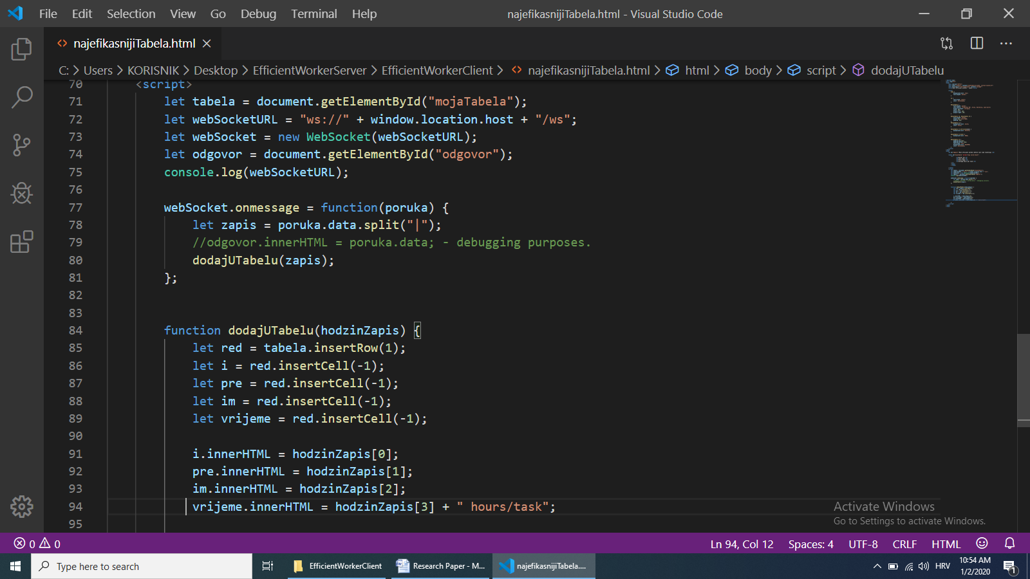

Image 3.4 – JavaScript code example

## 3.c ESP32 DEVELOPMENT BOARD

ESP32 is a series of low-cost, low-power system on a chip microcontrollers with integrated Wi-Fi and dual-mode Bluetooth. The ESP32 series have microprocessor in both dual-core and single-core variations and includes built-in antenna switches, RF balun, power amplifier, low-noise receive amplifier, filters, and power-managment modules. We used it to interact with fingerprint sensor, sd card module and to host web server on it.

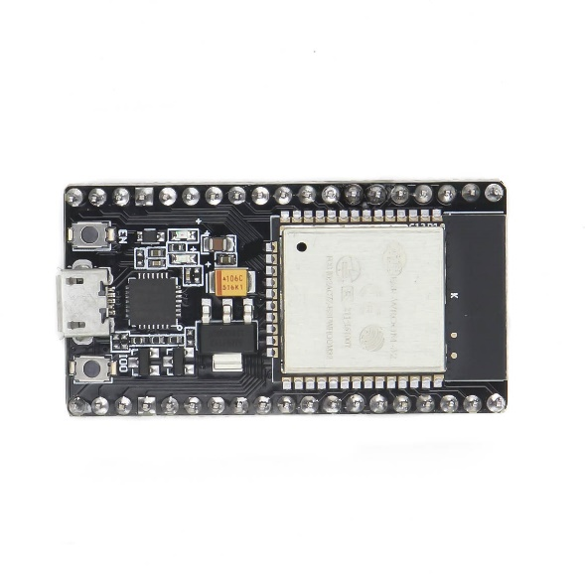

Picture 3.5 – ESP32 Development Board

## 3.d FINGERPRINT SCANNER

Fingerprint scanners are security systems of biometrics. Everyone has marks on their fingers, they can not be removed or changed. These marks have pattern and this pattern is called fingerprint. Because there are countless comibinations, fingerprints have become an ideal means of identification. So fingerprint scanners are now used in police stations, security industries, computers and mobile phones.

There are four types of fingerprint scanners: Optical scanners, Capacitive or CMOS, Ultrasound and Thermal. In this project we used optical fingerprint scanner.

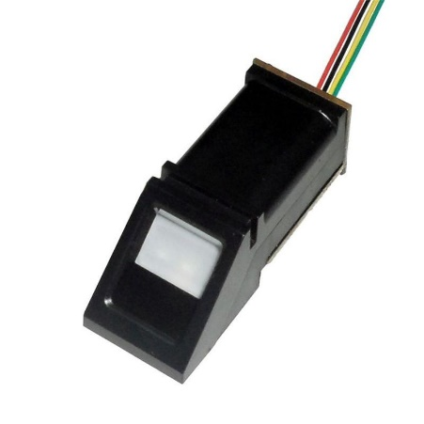

Picture 3.6 – optical fingerprint sensor

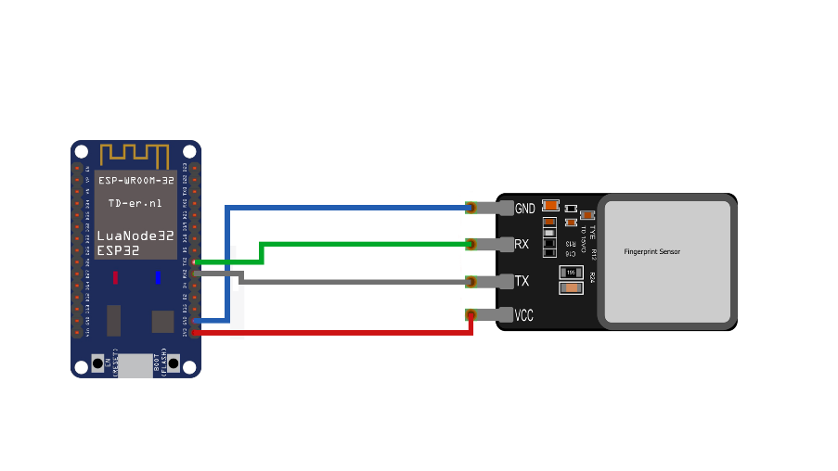

Picture 3.7 – connecting fingerprint scanner with esp32

## 3.e SD CARD AND SD CARD MODULE

Sd Card is used to store data to our database. To be able to establish communication between ESP32 and sd card and to store data on it we need sd card module.

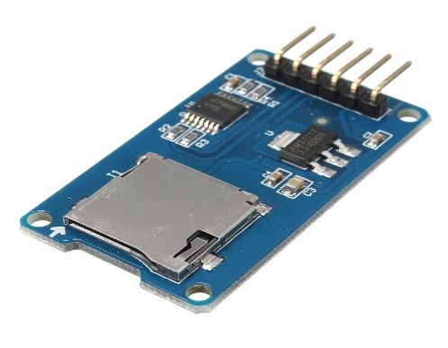

Picture 3.8 – example of SD card

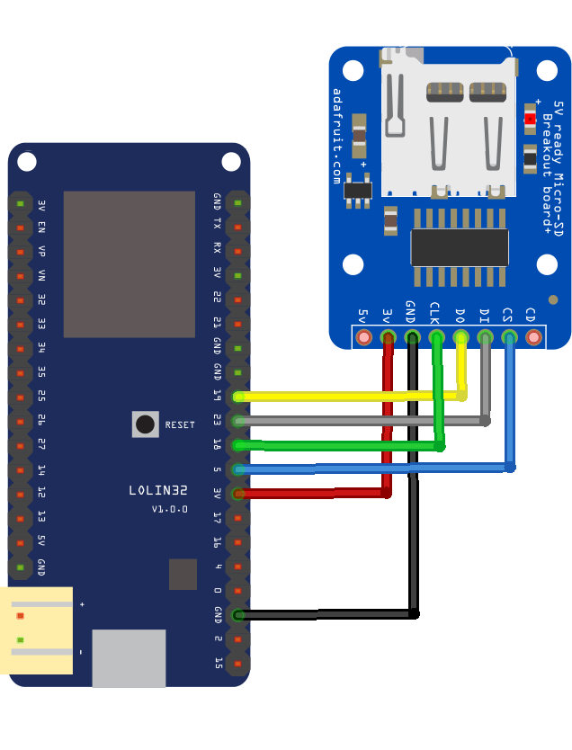

Picture 3.9 – connecting SD card with an esp32

## 3.f WEBSOCKETS AND FROMS

### 3.f.1 FORMS

Forms are the most popular way for client to communicate with server. We used HTTP GET and HTTP POST methods for querying our server's database.

### 3.f.2 WEBSOCKETS

Websockets are relatively young technology that first came up in 2011. It is mostly used for full duplex communication between server and client. We used it for sending records which are being displayed in table by html and JavaScript on the client side.

## 3.g NTP GLOBAL TIME SERVERS

We could also use RTC time clock, but as time pasts, its precision decreases. Because of that, and because we wanted to make something usable, we fetched time from NTP global time servers.

# 4.RESULTS

We built system that is able to help workers and employers build their relationship based on data of our system. It is unique and low cost (40 dollars aproximatelly) project, that we are very proud of. To summarize:

Employer can see history of efficiency of his workers, or efficiency in the last month. He can track time every task in his company started, and finished, and can search his workers to see current number of tasks finished, and time spent doing that tasks. Also he is able to reset records about tasks, and he is able to reset efficiency of his workers (which is recommended to do monthly to get monthly efficiency).

He can also query the most efficient workers by providing maximum hours per one task acceptable, and based on that give some bonuses or payrise for motivation of his worker(s). Below are forms that are used for querying the information described above:

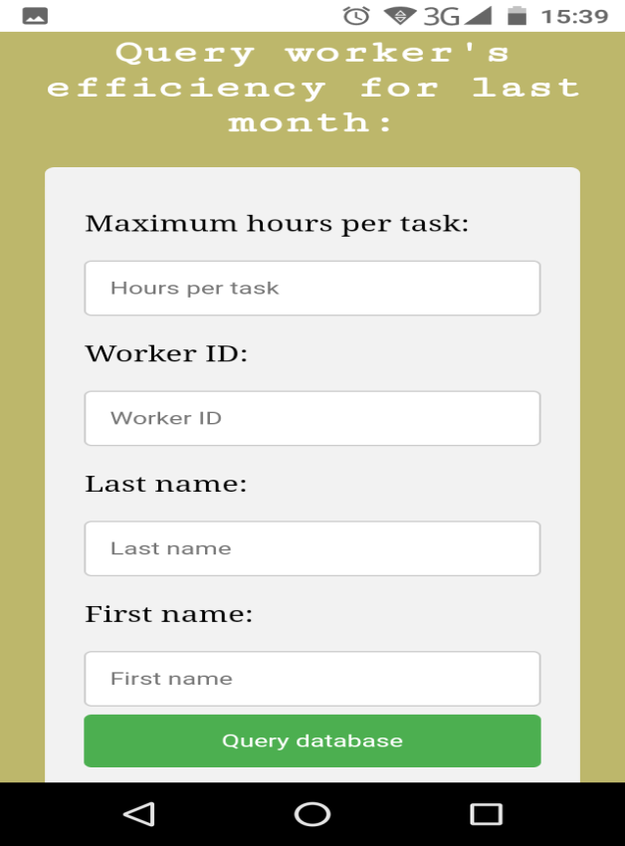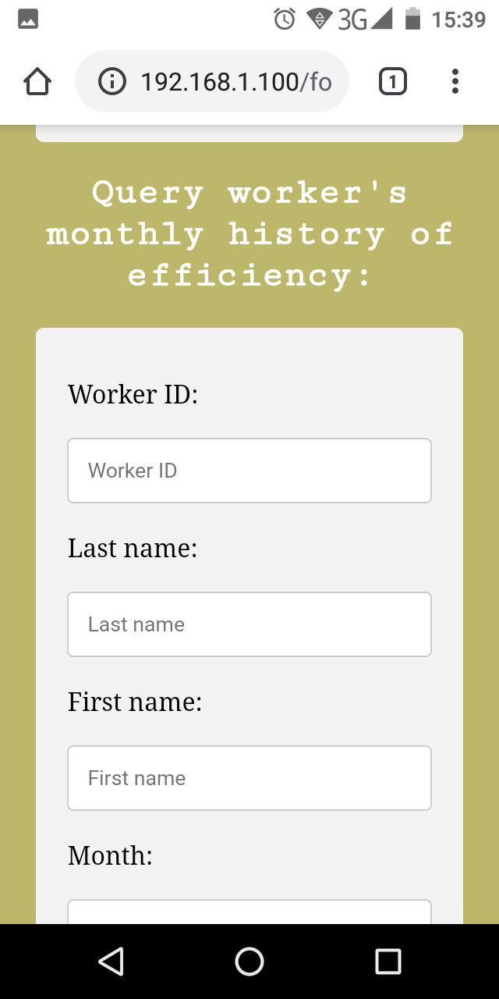

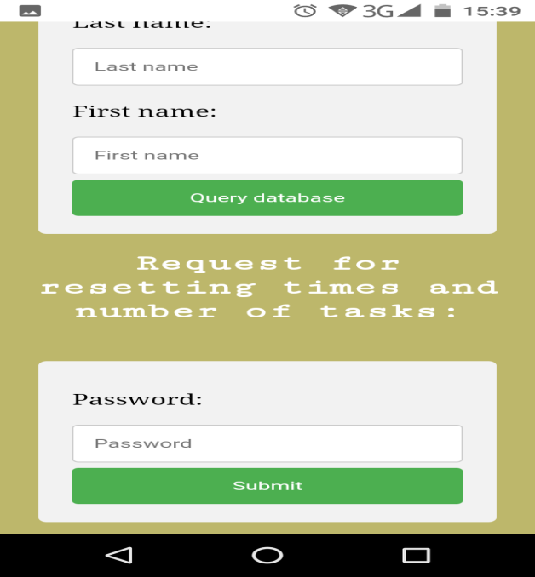 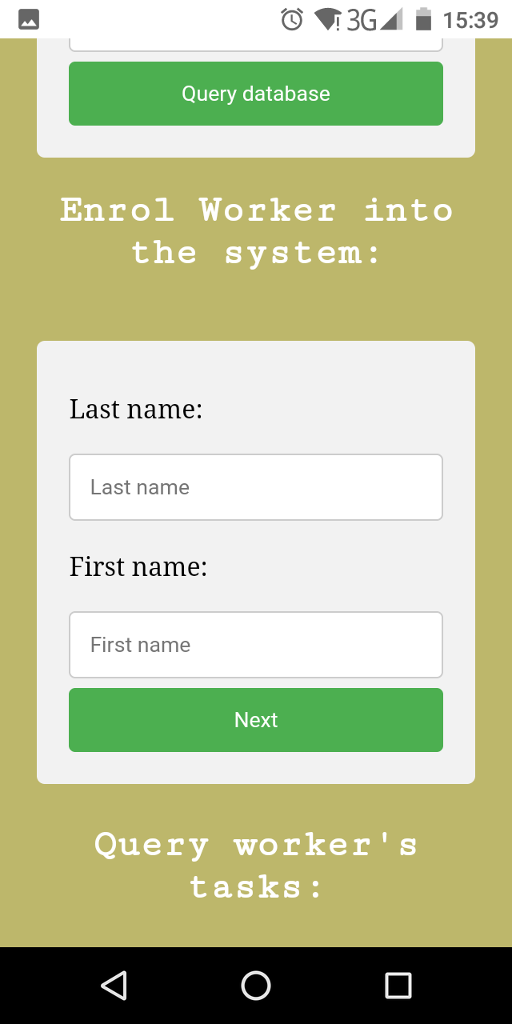  
 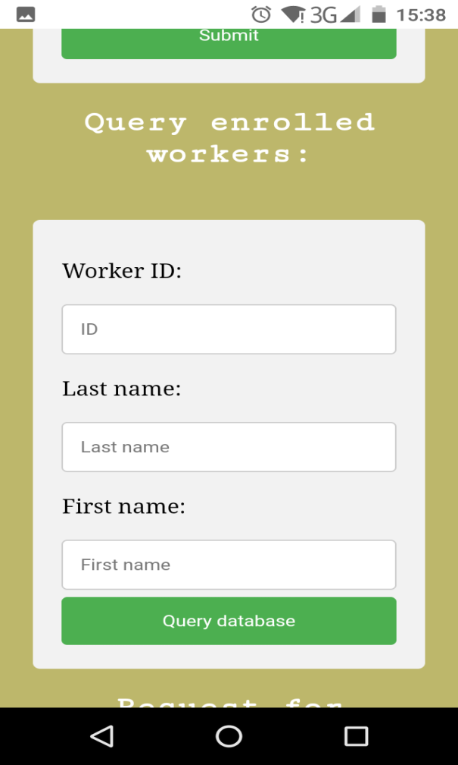 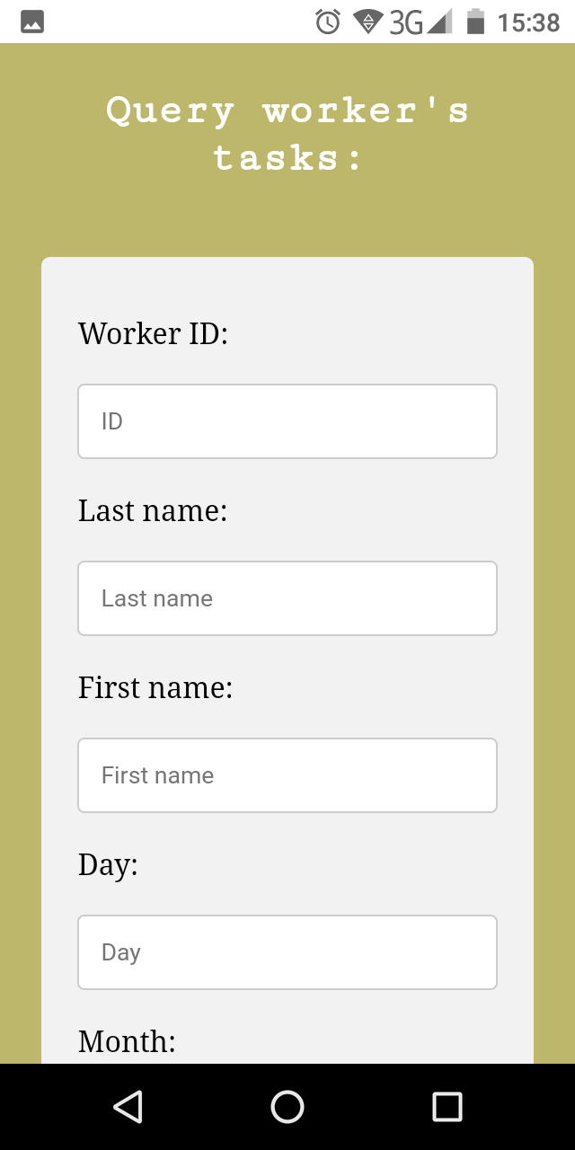

Picture 4.1 – Screenshots of forms on html page

# IMG_20191231_133138.jpg

Picture 4.2 – Final look of our system

# 5.DISCUSSION

We expected for our system to be functional and scalable, because we used databases to handle big amount of data, and pretty fast websocket technology.

Therefore, we took an experiment that, due to lack of time because of holidays was not very big. We made an agreement with our four professors from school for testing our system. We wanted to recreate real working environment, and to see if our EfficientWorker would have enough speed and precision when used.

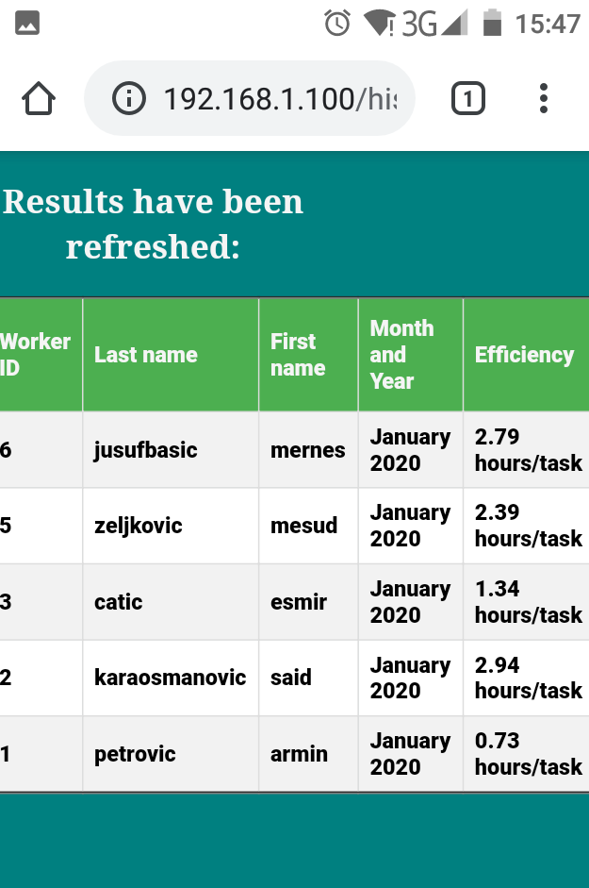We told our professors to put finger when they come, and to put finger when they are out of school. Basically, we said that their attendance will be an imaginary tasks that we will keep track of. The results from this experiment are quite satisfactory for us, and they are given in tables below:

Picture 5.1 – History of efficiencies

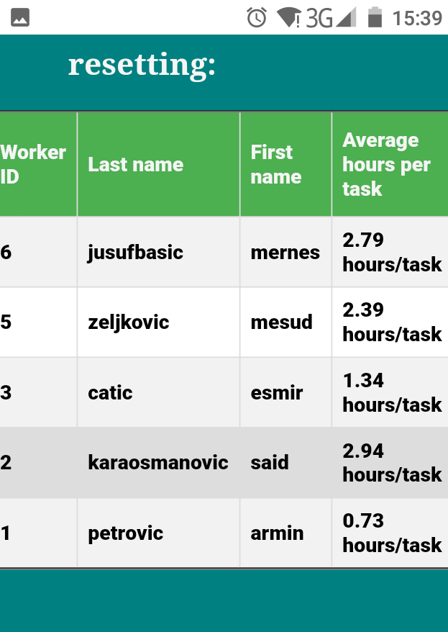

Picture 5.2 – Efficiencies from last month

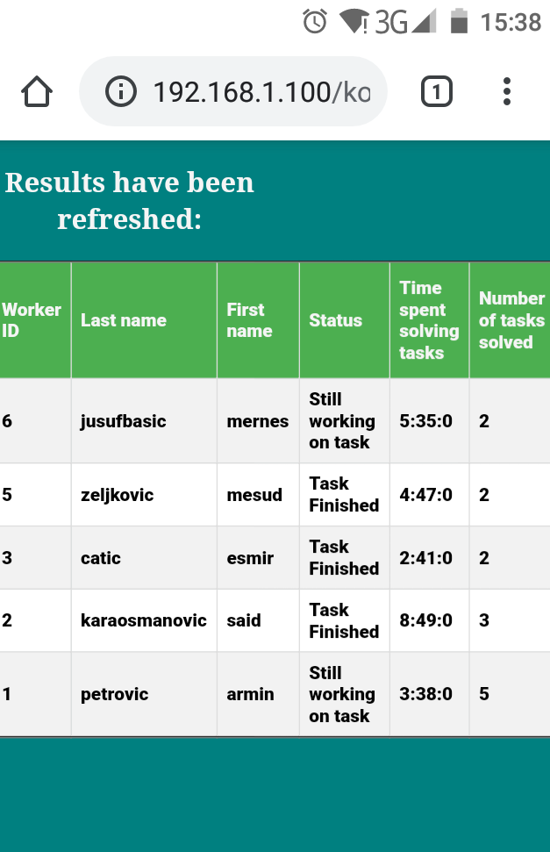

Picture 5.3 – Number of tasks and time spent doing that tasks

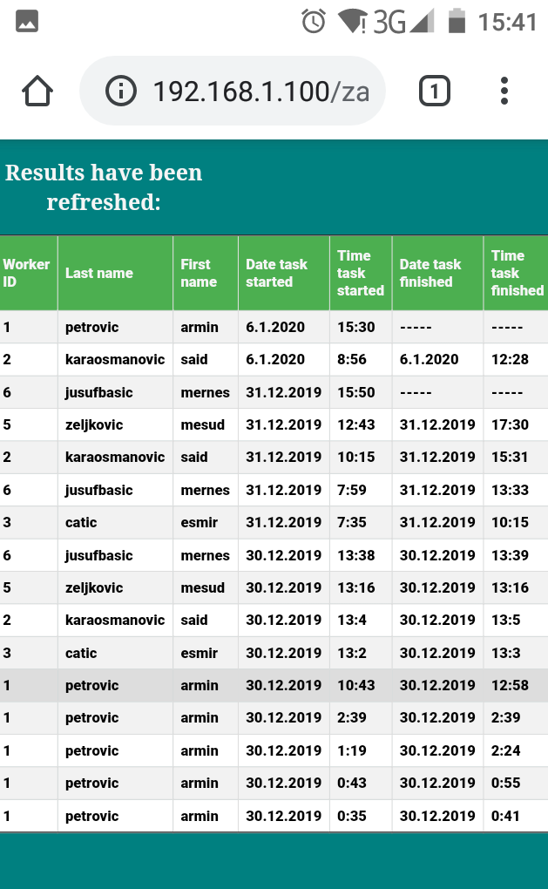

Picture 5.4 – Showing task records from our 'workers'

We are sure that the system is able to work for much more, but we could not experiment more because of the deadline for applications (also - winter holidays = low frequency of professors at school).

However, our intention is to fully check it in February, at the start of school with same experiment, but with more data.

# 6.CONCLUSION

We are very happy with what we did here. Because it is unique, but also fully working, we were thinking about making a patent out of it. Also, there is a lot of features that we can add in the future:

1. Making full website – not just one page
2. Enable viewing data from anywhere
3. Tracking worker's mood and comparing it to the work he/she has done
4. Getting domain name(although we have static ip adress of our server already)

Furthermore, together with our mentor, we went to Malak Janj in Donji Vakuf – company for making all sorts of things from wood. We had a meeting with one of their managers, where we spoke about adapting our system to their needs.

# 7.ACKNOWLEDGMENTS

We want to thank a small group of professors that were willing to help us with experiment we conducted, and they are: Karaosmanović Said (who is also our mentor for this competition), Jusufbašić Mernes, Zeljković Mesud, and Ćatić Esmir.

# 8.REFERENCES/BIBLIOGRAPHY

1)Four in ten U.S workers think they are underpaid, 28 August 2018,

<https://news.gallup.com/poll/241682/four-workers-think-underpaid.aspx>

2)Most people don't know whether they are paid fairly, December 2015,

<https://hbr.org/2015/10/most-people-have-no-idea-whether-theyre-paid-fairly>

3)Productivity of UK workers, 25 October 2017,

<http://www.deliberate.rest/?p=3169>

4)Arduino IDE official page, 6 January 2020 ,

<https://www.arduino.cc/en/main/software>

5)Visual Studio Code official page, 1 January 2020,

<https://code.visualstudio.com/>

6)Library for esp server hosting and websockets, 23 December 2019,

<https://github.com/me-no-dev/ESPAsyncWebServer>

7)Using sqlite3 database with esp32 using arduino IDE, 26 December 2019,

<https://github.com/siara-cc/esp32_arduino_sqlite3_lib>

8)Using fingerprint scanner with esp32, 17 November 2019,

<https://github.com/MAINAKMONDAL98/FINGERPRINT-SENSOR-OF-ADAFRUIT-USING-ESP-32>

9)Setting up Arduino IDE for esp32 board, December 2016,

<https://randomnerdtutorials.com/installing-the-esp32-board-in-arduino-ide-windows-instructions/>

10)ESP32 Development Board, 3 October 2019,

<https://www.ebay.com/itm/ESP-WROOM-32-ESP32-ESP32S-2-4GHz-WiFi-Bluetooth-Development-Board-for-Arduino/183688068095?hash=item2ac4a97bff:g:TkkAAOSwwkFc7fkd>

11)SD card module, 3 October 2019,

<https://www.ebay.com/itm/2pcs-SD-Card-Module-Slot-Socket-Reader-For-Arduino-ARM-MCU-Read-And-Write/381374955597?epid=1964934917&hash=item58cbb8004d:g:ncoAAOxy4YdTV9hO>

12)Fingerprint sensor, 3 October 2019,

<https://www.ebay.com/itm/DY50-Optical-Fingerprint-reader-Sensor-Modules-For-Arduino-Locks/322197616177?hash=item4b04797631:g:eJwAAOSwIi5dnwAF>