**QoS prediction system**

**Internet**

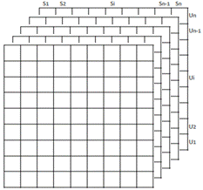

Users-services-times Matrices

QoS Dataset

User locations

Services locations

Neighborhood computation

Temporal QoS collector

Autoencoder

Training

Predict Missing Qos values