MailWorks Professional User Guide

Disclaimer
Software Version: 1.2 - 09/09/2002 (Usage Guide). Copyright © 2002 MailWorksPro.com - All Rights Reserved. THIS COPYRIGHT INFORMATION MUST REMAIN INTACT AND MAY NOT BE MODIFIED IN ANY WAY.
When you purchased this software you agreed to accept the terms of this Agreement. This Agreement is a legal contract, which specifies the terms of the license and warranty limitation between you and 'Mailworkspro.com'. You should carefully read the following terms and conditions before installing or using this software. Unless you have a different license agreement obtained from 'MailWorksPro.com', installation or use of this software indicates your acceptance of the license and warranty limitation terms contained in this Agreement. If you do not agree to the terms of this Agreement, promptly delete and destroy all copies of the Software.
Versions of the Software: Only one licenced copy of MailWorks Professional may be used on one web server.
License to Redistribute: Distributing the software and/or documentation with other products (commercial or otherwise) by any means without prior written permission from 'MailWorksPro.com' is forbidden. All rights to the MailWorks Professional software and documentation not expressly granted under this Agreement are reserved to 'MailWorksPro.com'.
Disclaimer of Warranty: THIS SOFTWARE AND ACCOMPANYING DOCUMENTATION ARE PROVIDED "AS IS" AND WITHOUT WARRANTIES AS TO PERFORMANCE OF MERCHANTABILITY OR ANY OTHER WARRANTIES WHETHER EXPRESSED OR IMPLIED. BECAUSE OF THE VARIOUS HARDWARE AND SOFTWARE ENVIRONMENTS INTO WHICH MailWorks Professional MAY BE USED, NO WARRANTY OF FITNESS FOR A PARTICULAR PURPOSE IS OFFERED. THE USER MUST ASSUME THE ENTIRE RISK OF USING THIS PROGRAM. ANY LIABILITY OF 'MAILWORKSPRO.COM' WILL BE LIMITED EXCLUSIVELY TO PRODUCT REPLACEMENT OR REFUND OF PURCHASE PRICE. IN NO CASE SHALL 'MAILWORKSPRO.COM' BE LIABLE FOR ANY INCIDENTAL, SPECIAL OR CONSEQUENTIAL DAMAGES OR LOSS, INCLUDING, WITHOUT LIMITATION, LOST PROFITS OR THE INABILITY TO USE EQUIPMENT OR ACCESS DATA, WHETHER SUCH DAMAGES ARE BASED UPON A BREACH OF EXPRESS OR IMPLIED WARRANTIES, BREACH OF CONTRACT, NEGLIGENCE, STRICT TORT, OR ANY OTHER LEGAL THEORY. THIS IS TRUE EVEN IF 'MAILWORKSPRO.COM' IS ADVISED OF THE POSSIBILITY OF SUCH DAMAGES. IN NO CASE WILL 'MAILWORKSPRO.COM' OR LIABILITY EXCEED THE AMOUNT OF THE LICENSE FEE ACTUALLY PAID BY LICENSEE TO 'MAILWORKSPRO.COM'.
Warning: This program is protected by copyright law. Unauthorized reproduction or distribution of this program, or any portion of it, may result in severe civil and criminal penalties, and will be prosecuted to the maximum extent possible under the law.

Introduction
The documentation shown below is included with each purchase of MailWorks Professional and acts as an informal guide to installing and using the powerful MailWorks Professional suite. If this guide fails to answer your questions, then please fill out our support form, which you can do here.
Both installing and using MailWorks Professional are extremely easy, and by simply browsing this user guide you should be able to start using MailWorks Professional immediately.

Web Server Requirements
- Operating System: Linux
- Web Server: Apache
- Scripting: PHP v4.1 or above
- Database: MySQL 3.23 or above
- Mail Server: You must have a mail server setup and configured through your php.ini file
- Browser: Internet Explorer v5.5 or above on a Windows PC. MailWorks Professional does not work on Macintosh's
- JavaScript: Must be enabled
- Other: Your PHP installation must support the set_time_limit() function and must also have magic quotes enabled. Both of these options are present in default installations so this will rarely cause problems.
Installation Guide
MailWorks Professional is a set of PHP scripts that should be copied to your web server. This installation guide will explain exactly how to get your copy of MailWorks Professional up and running in just minutes.
First off, extract the zip file that was attached to the email sent to you by our sales team. Make sure you preserve the directory structure, and that file names are kept in the proper format.
You should see one readme.html file and one MailWorksPro directory. Change into the MailWorksPro directory. FTP into your web server and change into your root directory, which should be something like /home/sites/mysite.com/html.
*** MailWorks Professional MUST be installed in your root directory ***
Upload the entire contents of the MailWorksPro directory. The directory structure on your web server should now look something like this:
/home/sites/mysite.com/html
/mwadmin
/ewp_images
/images
/include
/includes
/sql
/templates
/mwsubscribe
/images
Open up Internet Explorer and go to http://www.yoursite.com/mwadmin/, obviously replacing www.mysite.com with your domain name. Because you are loading MailWorks Professional for the first time, you will automatically be re-directed to the "First Time Setup" page. On this page you setup all of the options for your MailWorks site, your database, privacy policy, etc. The setup page looks like this:
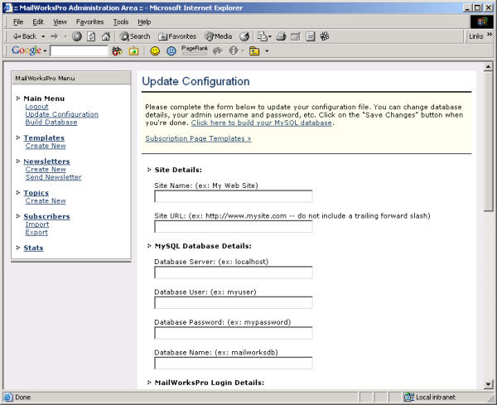
This page contains the following options which you must complete:
- Site Name: The name of your web site. This will appear on your subscription pages, which will be located at http://www.yoursite.com/mwsubscribe/
- Site URL: The full URL to your web site, such as http://www.yoursite.com. This should *not* including a trailing forward slash.
- Database Server: The IP address or host name of your MySQL database server, such as localhost, db.mysite.com, 203.24.45.196, etc.
- Database User: Your MySQL username
- Database Password: Your MySQL password
- Database Name: Your MySQL database name. MailWorks Professional *does not* create a database for you –- you must already have an empty database setup. Enter the name of your empty MySQL database in this field. If you don’t have a database setup then ask your web host to create one for you.
- Admin Username: The username to login to your MailWorks Professional administration area (http://www.yoursite.com/mwadmin).
- Admin Password: The password to login to your MailWorks Professional administration area.
- Use Templates?: You can customize the way your subscription forms look by specifying top and bottom templates for them. By default, this option is set to “no”, and your newsletter subscriptions forms for your visitors will appear with black text on a white background.
If you have site templates setup then click on the “Yes” radio button and enter the URL’s to the top and bottom templates in the fields provided. MailWorks Professional will load and display these templates whenever a user visitors your subscription page (http://www.yoursite.com/mwsubscribe).
- Privacy Policy: This rich text area is where you should enter your privacy policy relating to what you do with your subscribers email address and personal details when they subscribe to your newsletter, including whether they are kept confidential, whether you share them with partner companies, etc.
If you are unsure of how to construct a privacy policy then click here to load the privacy policy wizard.
Once you have completed the details on this page, click on the “Save Changes” button at the bottom of the page.

Building The Database
After your click on the “Save Changes” button, your conf.php file will be updated and you will be presented with a link to login to your MailWorks Professional admin area using the username and password that you entered into the first time setup screen in the last step.
After you’ve logged in successfully, click on the “Build Database” link in the menu down the left of the page. This will connect to your MySQL server and attempt to create 5 tables in your database. If any errors occur then double-check your MySQL details by clicking on the “Update Configuration” link in the menu down the left of the page.
If all went well then your MySQL database will now be setup and ready to go. At this point your installation of MailWorks Professional is complete and you are ready to create and send a sample newsletter, which is what we will look at now.
Creating + Sending Your First Newsletter
It takes literally 5-10 minutes to create and send your first newsletter with MailWorks Professional. This example will step you through the whole process and will also teach you how to import a subscriber list along the way.

Firstly, make sure you are logged into your MailWorks Professional admin area. Visit http://www.yoursite.com/mwadmin, replacing www.yoursite.com with your domain name.
Next, you will need to create a newsletter template. A template contains the basic information for a newsletter, and you create a newsletter based on a template. Click on the “Create New” link under the “Templates” section on the left menu. You should see a screen like this:

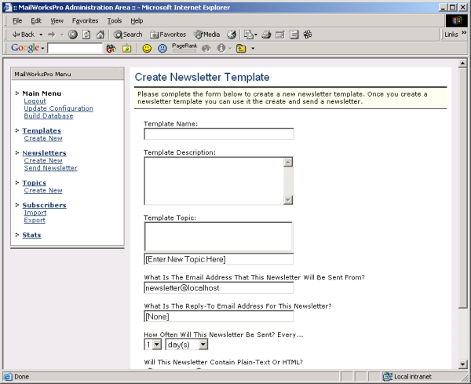

When your visitors goto your newsletter subscription page and subscribe, they are asked for some details and are also shown a list of newsletters to which they can subscribe. The details from the newsletter template that you are about to create are shown on this page.
The “Create New Template” page requires 7 fields to be completed:

- Template Name: The name of the newsletter template that you are creating, such as “The MailWorksPro.com Newsletter”.
- Template Description: A 4-5 line paragraph that describes this newsletter template. For example, “The MailWorks Professional newsletter contains information, special discounts and tips relating to MailWorks Professional”.
- Template Topic: Each newsletter template that you create will be listed under a topic on your subscription page. A topic is like a category and is the ideal way for sites that run more than one newsletter to categorize their newsletters. Some sample topics that you might like to use are “Our Newsletters”, “General Newsletters”, “Paid Newsletters”, “Members Only Newsletters”, etc. Click on the text field that says “[Enter Topic Here]” and type in your topic name.
- “Sent From” Email Address: When you send this newsletter to your subscribers the email header includes a from field, which shows where the newsletter came from. By default this will be something like mailer@yoursite.com. If you want to mask where the newsletter came from then enter something like newsletter@yoursite.com or support@yoursite.com.
- “Reply-To” Email Address: If your visitors reads your newsletter when it’s sent and clicks on the “reply” button in their mail program then the email address that their reply is sent to will be something like mailer@yoursite.com by default. You can redirect their replies to an existing email address by entering it in this field. An email address such as support@yoursite.com is a popular choice.
- Sending Frequency: How often will you send this newsletter? The sending frequency will be displayed next to each newsletter template on your subscription page. The most popular sending frequencies are weekly and monthly.
- Newsletter Format: You can send newsletters in text or HTML format. Depending on the option that you choose here, you will either be able to create your newsletters as plain-text or rich HTML.

Complete this form to create a sample newsletter template. Once you’re done, click on the “Add Template” button at the bottom of the page. Click on the “Continue” link to go to the list of current templates –- you should see your new template in this list.

Your new template will be shown on your subscription page, so goto http://www.yoursite.com/mwsubscribe/ and click on the “subscribe” link to see it (we will learn more about the subscription pages later). You should see something like this:

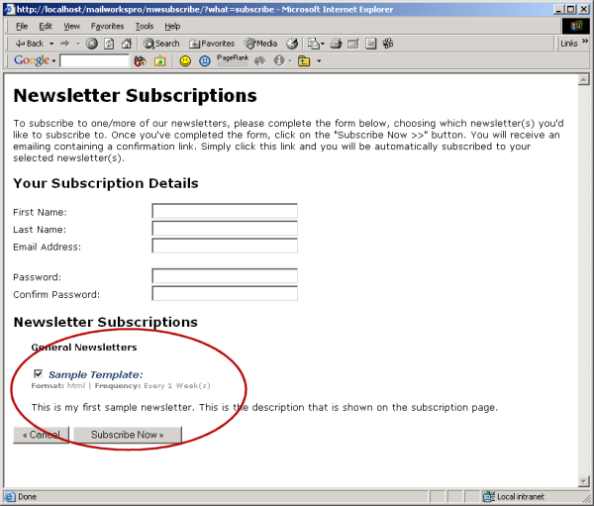

As you can see, your new template is listed and visitors can subscribe to it.

Creating The Newsletter
It’s now time to create a newsletter. Newsletters are based on templates and each template can have more than one newsletter. For example, let’s say that you run a site with just one newsletter. You create a template called “Joe’s Newsletter”. The template contains the details of when the newsletter is sent, its format, etc.

You send your newsletter each month, so each month you create a new newsletter based on the “Joe’s Newsletter” template. You might have a newsletter for February, one for March, one for April, etc –- each of these is a new newsletter based on the original template.
Let’s create your first newsletter now. Click on the “Create New” link under the “Newsletters” category on the menu down the left. You should see a screen like this:

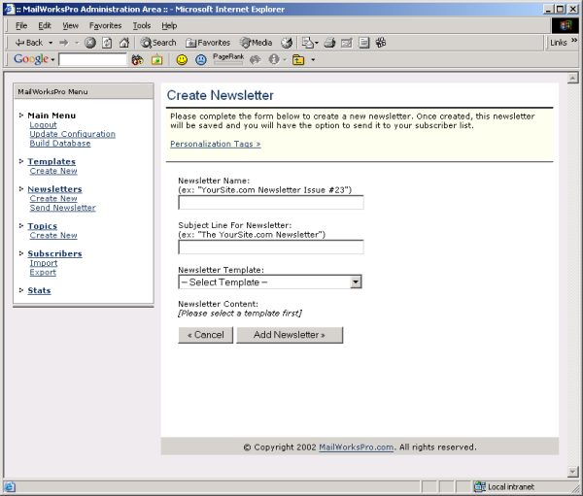

The “Create Newsletter” page has four fields which must be completed to create a new newsletter:

- Newsletter Name: The name of the newsletter you’re creating, such as “Joe’s Newsletter Issue #2”.
- Subject: The subject line that will be sent with the newsletter.
- Newsletter Template: The template upon which this newsletter is based. Once you select a template you will see either a text box or rich text area appear, where you can create the actual content for the newsletter.
- Newsletter Content: Depending on the selected template, either a text box or rich text area will appear. Enter the content of your newsletter here.

Here’s a sample completed “Create Newsletter” page for a HTML newsletter:
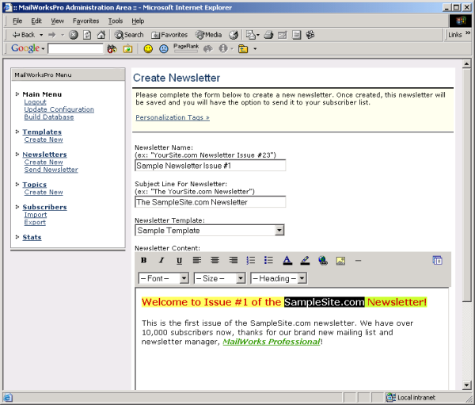

Once you’ve completed all of the fields, click on the “Add Newsletter” button at the bottom of the page. This will save your newsletter to the database. Click the “Continue” link to see your newsletter in the list:

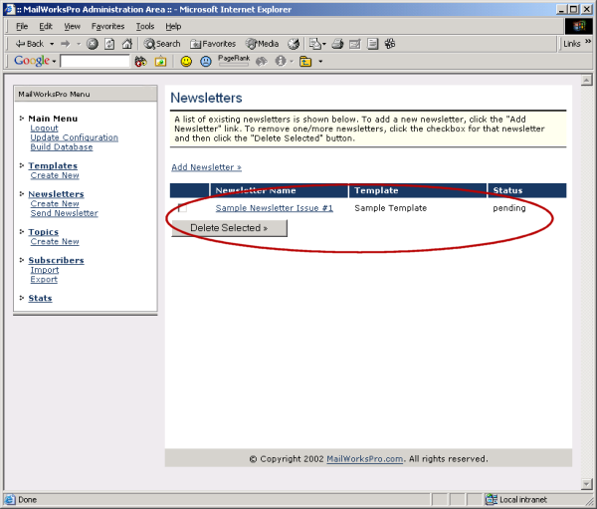

Look at the status field for this newsletter -– it is “pending”. A newsletter can have one of two status values: pending or sent. After you’ve created a newsletter it is pending, and once it’s sent its status changes to “sent”.

At this point we have created a template as well as a newsletter based on this template. The next step is to send the newsletter, but before we send the newsletter we need to build a subscriber list. We will look at two methods of doing that now: subscribing using the subscription forms and importing a list from a file on your hard drive.

Building A Subscriber List
First up, let’s manually add ourself to the subscriber list for our sample newsletter -– this will demonstrate both how to use the subscription forms and also how to manage subscribers. Fire up your web browser and go to http://www.yoursite.com/mwsubscribe, obviously replacing www.yoursite.com with the domain name of your web site. You should see a menu like this:

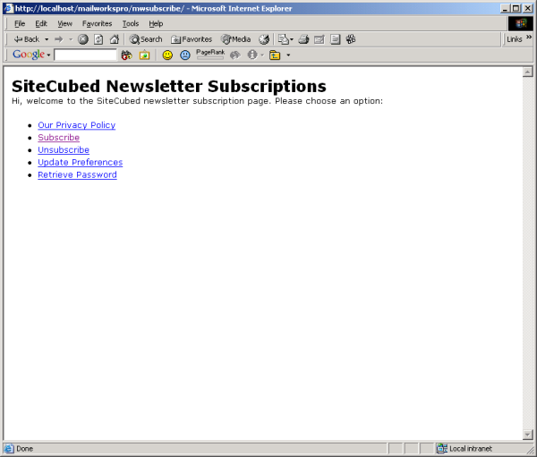

If you have chosen to use templates from the “Update Configuration” link in the admin area then your subscription page will obviously look different. There are 5 links here:

- Our Privacy Policy: Displays the privacy policy that you created when you setup MailWorks Professional earlier.
- Subscribe: Displays the subscription form where users can signup for your newsletter and enter their personal details.
- Unsubscribe: Displays a form to let users unsubscribe from your newsletter(s).
- Update Preferences: For existing subscribers, they can login and update their personal details and subscription preferences.
- Retrieve Password: Lets a user enter his/her email address and sends them a new subscription password via email.

We’re interested in the subscription form, so click on the “subscribe” link. You should see a page like this:

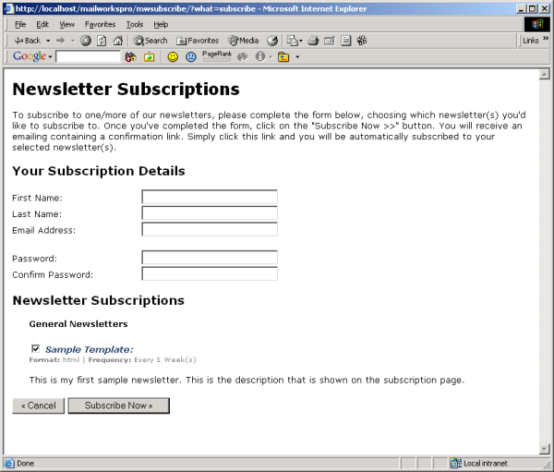

Complete this form with your own details to get a feeling for how it works. Make sure your sample newsletter is checked -– as you can see, the details for each newsletter template are shown with an option to subscribe to that newsletter.

Once you’ve completed this form, click on the “Subscribe Now” button. You will see a confirmation message telling you to check your email. MailWorks Professional sends each new subscriber a confirmation email to make 100% sure that they indeed did request to subscribe to your newsletter -– this eliminates nasty spammers and people signing up others without their permission.

Check your email. You should receive a confirmation email that looks something like this:

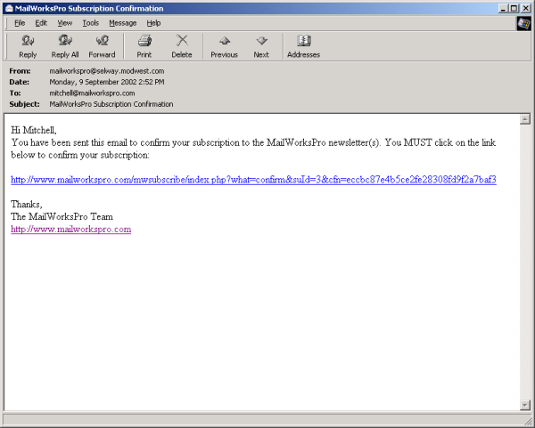

After clicking on this link your subscription status will be changed from “pending” to “subscribed”. Newsletters will only be sent to subscribed (i.e. confirmed) users.

To see your new subscription in the MailWorks Professional admin area, goto http://www.yoursite.com/mwadmin/, login and click on the “Subscribers” link in bold from the menu down the left. You should see a new subscriber:

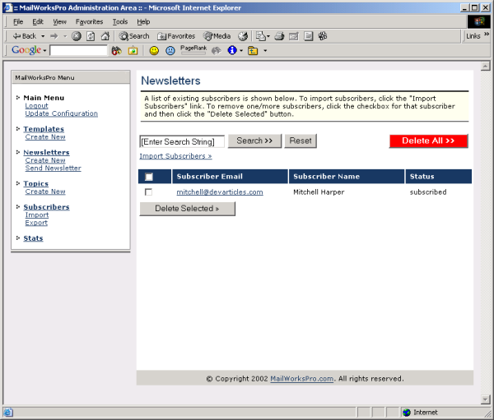

The next method build your subscriber list is to import an existing list of subscribers. We will look at how to do that now.

Importing Subscribers
If you’re already running a mailing list manager or have a list of subscribers, then you can import them with MailWorks Professional. Click on the “Import” link under the subscribers category on the menu down the left. You should see a page like this:

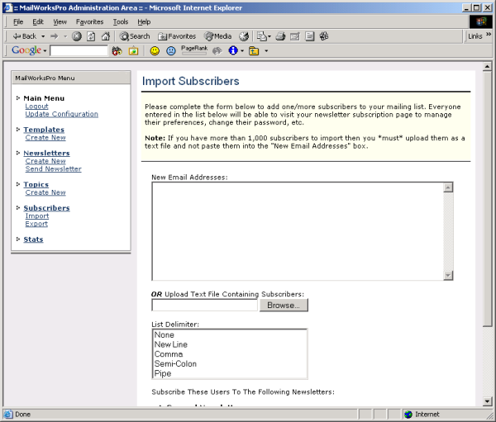

You have the option to either copy-paste a list directly into the text box or to upload a text file containing your subscribers. For this example we will create and upload a text file. Create a new text file called mysubscribers.txt. Enter the following into the file and save it (replacing yourdomain.com with your domain name):

subscriber1@yourdomain.com
subscriber2@yourdomain.com
subscriber3@yourdomain.com
subscriber4@yourdomain.com
subscriber5@yourdomain.com
subscriber6@yourdomain.com
subscriber7@yourdomain.com
subscriber8@yourdomain.com
subscriber9@yourdomain.com
subscriber10@yourdomain.com

Click on the “Browse…” button and choose the mysubscribers.txt file that you just created. Choose “New Line” for the list delimiter and make sure the checkbox for your sample newsletter is checked. Click on the “Import Subscribers” button and the subscribers will be automatically extracted from the mysubscribers.txt and added to your subscriber list.

All imported users are assigned random passwords –- they can goto http://www.yoursite.com/mwsubscribe to retrieve their password and manage their subscription preferences.

You will see a confirmation message that looks like this:

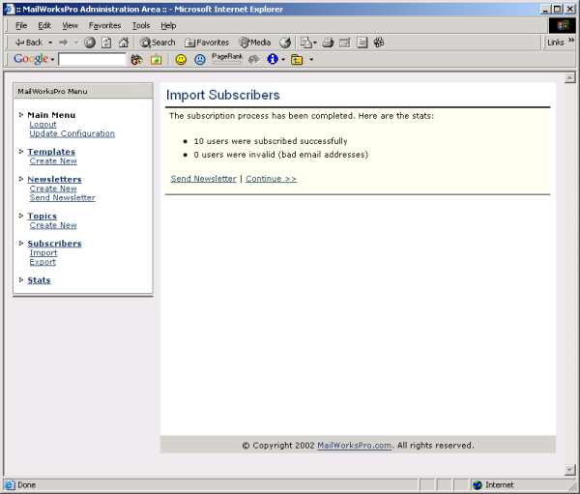

Easy! You can also export subscribers using the “export” link under the subscribers’ category. Feel free to play with subscription exporting before continuing.
Now that we’ve built a subscriber list we can send our sample newsletter. Let’s do that now.

Sending The Newsletter
Click on the “Send Newsletter” link under the Newsletters category. You will see the following screen:

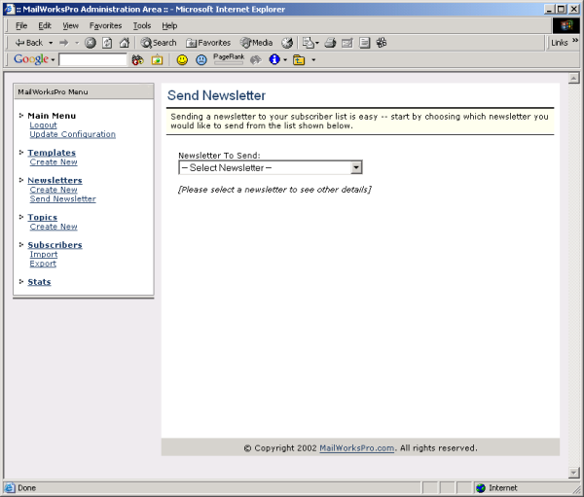

Click on the drop down list and choose your sample newsletter. The page will refresh showing a list of details for the selected newsletter, including how many subscribers it will be sent to:

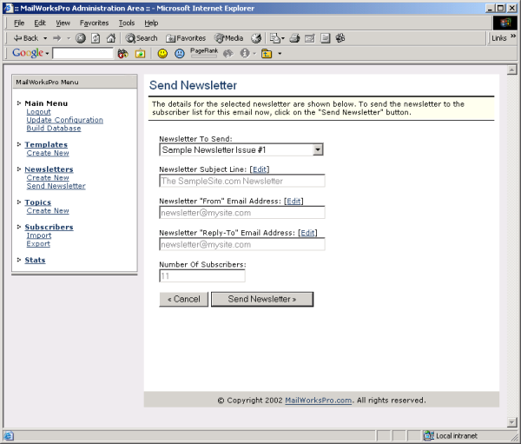

To put your newsletter sending on autopilot and have it sent directly from your web browser, click on the “Send Newsletter” button. Your newsletter will be sent to everyone on your list without any page refreshing, as shown below:

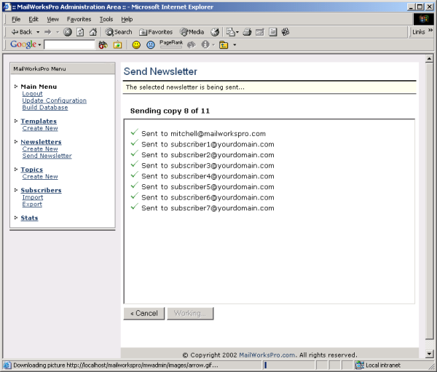

For each subscribe that the newsletter is sent to, a tick or cross is displayed along with their email address indicating whether the newsletter was sent to them successfully or not. When the newsletter is sent to all subscribers you will be taken to a statistics page that shows the details of the mailing, including how long it took:

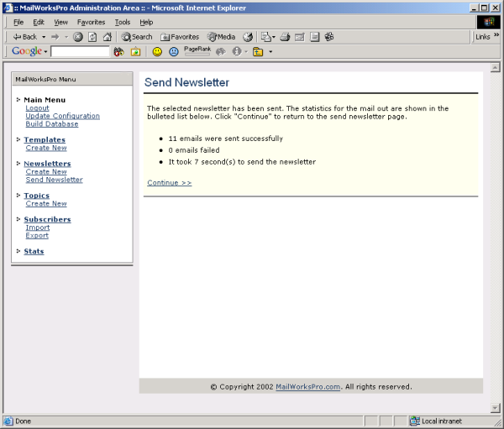

In previous steps you should’ve added yourself to your newsletter subscriber list. Check your email and you should see the newsletter in your inbox:

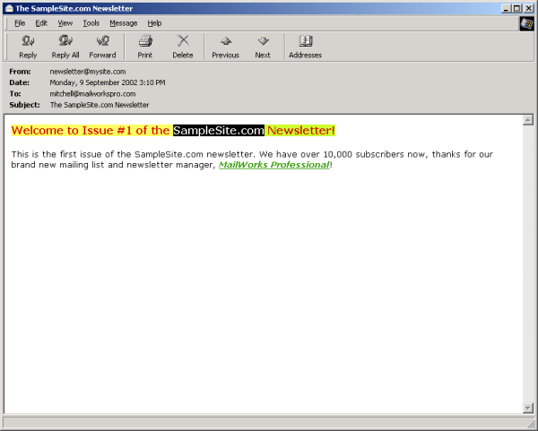

And that’s all there is to it! You’ve just learnt how to create a template as well as a newsletter. You’ve also learnt how to subscribe to your newsletter(s), import subscribers from a file and send your newsletter directly from your web browser with MailWorks Professional!

Viewing Statistics
MailWorks Professional tracks and displays powerful statistics that show you everything from how many new subscribers your list received today to how many subscribers came from .COM host names. Click on the “Stats” link on the menu down the left to view the stats page. It should look something like this:

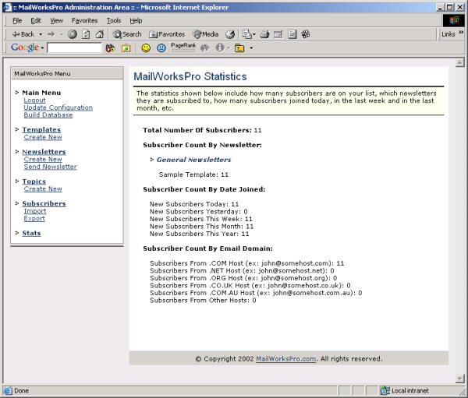

This page is extremely handy to view on a daily or weekly basis to see how your newsletter subscriber list is coming along. It’s a good idea to print these stats every week to track how your subscriber list grows over time.
Linking To Your Subscription Page
To build your subscriber list you need to link to your subscription page from your web site. The URL of your subscription page is your domain name plus “/mwsubscribe/” on the end.

For example, if you run http://www.pinktoycars.com and have installed and setup MailWorks Professional then the URL to your subscription page is:

http://www.pinktoycars.com/mwsubscribe/

Your MailWorks Professional administration area is accessible my placing “/mwadmin/” on the end of your domain, like this:

http://www.yourdomain.com/mwadmin/

You should promote your newsletter subscription page in various places throughout your web site. One of the most effective ways to get visitors to join your subscriber list is to display a popup window when they exit your web site.

If you’d like to add a popup page to your web site then create a simple HTML page that links to http://www.yoursite.com/mwsubscribe/ and use the popup window generator to create a popup to link to this page.

Conclusion
This setup guide has shown you how to use MailWorks Professional to maintain a subscriber list and send newsletters directly from your web browser. If you have any questions then please don’t hesitate to email us at support@mailworkspro.com. We are always happy and willing to answer any support questions that you may have.

