**Instance Stores**

An *instance store* (*ephemeral storage*) provides temporary block-level storage for your instance

located on disks that are physically attached to the host computer

ideal for temporary storage of information that changes frequently, such as buffers, caches, scratch data, and other temporary content,

instance type defines

* Defines Disk Size
* the type of hardware. While some provide Hard Disk Drive (HDD) instance stores, other instance types use Solid State Drives (SSDs) to deliver very high

No separate cost - included in the cost of an Amazon EC2 instance. Cost-effective

Data lost in below cases:

* The underlying disk drive fails.
* The instance stops (the data will persist if an instance reboots).
* The instance terminates.

**Elastic Block Store (Amazon EBS)**

Amazon EBS provides persistent block-level storage volumes for use with Amazon EC2 instances

automatically replicated within its Availability Zone to protect you from component failure, offering high availability and durability. Each Amazon EBS volume is designed for 99.999% availability

Amazon EBS is recommended when data must be quickly accessible (low latency) and requires long-term persistence

**EBS Volumes Types**

EBS Volumes Types

**Magnetic Volumes (Previous Generation – for reference only..)**

* have the lowest performance characteristics
* Low cost, cost-effective solution for appropriate workloads.
* volume can range in size from 1 GB to 1 TB
* average 100 *IOPS*, but has the ability to burst to hundreds of IOPS.
* billed based on the amount of data space provisioned, regardless of how much data you actually store on the volume
* They are best suited for:
  + Workloads where data is accessed infrequently
  + Sequential reads
  + Situations where low-cost storage is a requirement
* 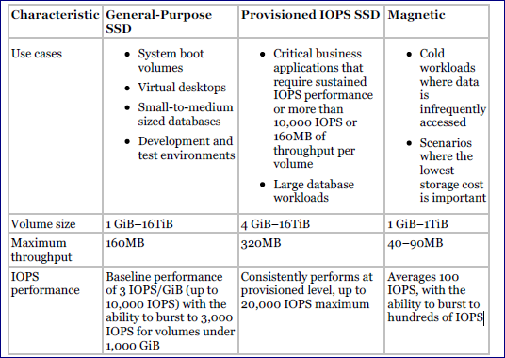

**General-Purpose SSD**

* strong performance at a moderate price
* cost-effective storage that is ideal for a broad range of workloads
* volume can range in size from 1 GB to 16 TB
* provides a baseline performance of three IOPS per gigabyte provisioned, capping at 10,000 IOPS.
* volumes under 1 TB also feature the ability to burst to up to 3,000IOPS for extended periods of time.

For instance, if you have a 500 GB volume you can expect a baseline of 1,500 IOPS. Whenever you are not using these IOPS, they are accumulated as I/O credits. When your volume then has heavy traffic, it will use the I/O credits at a rate of up to 3,000 IOPS until they are depleted. At that point, your performance reverts to 1,500 IOPS. At 1 TB, the baseline performance of the volume is already at 3,000 IOPS, so bursting behavior does not apply

* billed based on the amount of data space provisioned, regardless of how much data you actually store on the volume
* suited for a wide range of workloads where the very highest disk performance is not critical, such as:
  + System boot volumes (OS disk)
  + Small- to medium-sized databases ()
  + Development and test environment
* IOPS – 100/3000 – Minimum 100 IOPS , burstable to 3000 – 3 IOPS per GB

**Provisioned IOPS SSD**

* designed to meet the needs of I/O-intensive workloads, particularly database workloads that are sensitive to storage performance and onsistency in random access I/O throughput
* most expensive
* Highest performance
* size from 4 GB to 16 TB.
* During provision - specify not just the size, but also the desired number of IOPS, up to the lower of the maximum of 30 times the number of GB of the volume, or 32,000 IOPS
* You can stripe multiple volumes together in a RAID 0 configuration for larger size and greater performance. Amazon EBS delivers within 10 percent of the provisioned IOPS performance 99.9 percent of the time over a given year.
* Pricing is based on the size of the volume and the amount of IOPS reserved
* Price is more than General purpose SSD
* volumes provide predictable, high performance and are well suited for:
  + Critical business applications that require sustained IOPS performance
  + Large database workloads

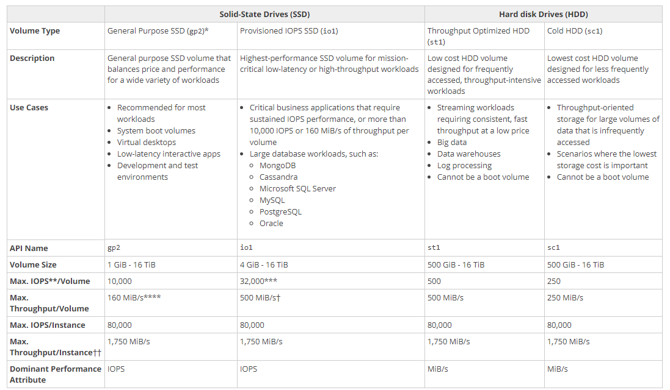

Throughput-Optimized HDD volumes are low-cost HDD volumes designed for frequent-access, throughput-intensive workloads such as big data, data warehouses, and log processing. Volumes can be up to 16 TB with a maximum IOPS of 500 and maximum throughput of *500 MB*/s. These volumes are significantly less expensive than general-purpose SSD volumes.

Cold HDD volumes are designed for less frequently accessed workloads, such as colder data requiring fewer scans per day. Volumes can be up to 16 TB with a maximum IOPS of 250 and maximum throughput of 250 MB/s. These volumes are

significantly less expensive than Throughput-Optimized HDD volumes.

An Amazon EBS-optimized instance uses an optimized configuration stack and provides additional, dedicated capacity for Amazon EBS I/O.

This optimization provides the best performance for your Amazon EBS volumes by minimizing contention between Amazon EBS I/O and other traffic from your instance.

When you select Amazon EBSoptimized for an instance, you pay an additional hourly charge for that instance.

Backup

**Snapshots**

Snapshots are incremental backups, which means that only the blocks on the device that have changed since your most recent snapshot are saved

snapshot is stored using Amazon S3 technology.

snapshot is free. You pay only the storage costs for the snapshot data

are stored in AWS-controlled storage and not in your account’s Amazon S3 buckets. This means you cannot manipulate them like other Amazon S3 objects

Snapshots are constrained to the region in which they are created, meaning you can use them to create new volumes only in the same region.

to restore a snapshot in a different region, you can copy a snapshot to another region

To use a snapshot, you create a new Amazon EBS volume from the snapshot.

the volume is created immediately but the data is loaded lazily

* This means that the volume can be accessed upon creation, and if the data being requested has not yet been restored, it will be restored upon first request. Because of this, it is a best practice to initialize a volume created from a snapshot by accessing all the blocks in the volume.

Snapshots can also be used to increase the size of an Amazon EBS volume. To increase the size of an Amazon EBS volume, take a snapshot of the volume, then create a new volume of the desired size from the snapshot. Replace the original volume with the new volume

**Recovering Volumes**

Because Amazon EBS volumes persist beyond the lifetime of an instance, it is possible to recover data if an instance fails. If an Amazon EBS-backed instance fails and there is data on the boot drive, it is relatively straightforward to detach the volume from the instance.

Unless the DeleteOnTermination flag for the volume has been set to false, the volume should be detached before the instance is terminated. The volume can then be attached as a data volume to another instance and the data read and recovered.

**Encryption Options**

* When you launch an encrypted Amazon EBS volume, Amazon uses the *AWS Key Management Service (KMS)* to handle key management.
* A new master key will becreated unless you select a master key that you created separately in the service.
* Your data and associated keys are encrypted using the industry-standard AES-256 algorithm
* The encryption occurs on the servers that host Amazon EC2 instances, so the data is actually encrypted in transit between the host and the storage media and also on the media
* Encryption is transparent, so all data access is the same as unencrypted volumes, and you can expect the same IOPS performance on encrypted volumes as you would with unencrypted volumes, with a minimal effect on latency.
* Snapshots that are taken from encrypted volumes are automatically encrypted, as are volumes that are created from encrypted snapshots.

**An Amazon EBS–optimized instance**

provides dedicated network capacity for Amazon EBS volumes.

provides the best performance for your EBS volumes by minimizing network contention between EBS and your instance.

**Volume create:**

* Volume type
* Size
* AZ
* Snapshot (Optional)
  + If encrypted – volume encrypted
  + If not – volume unencrypted..
* Encryption – This option is not provided if existing snapshot is selected.

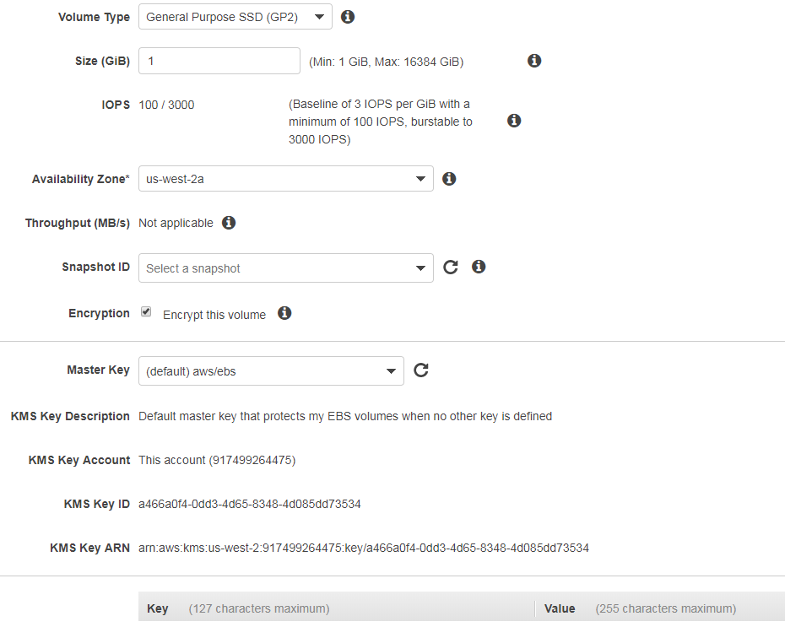

**Snapshot create**

Volume encrypted 🡪 Snapshot encrypted

Volume unencrypted 🡪 Snapshot unencrypted

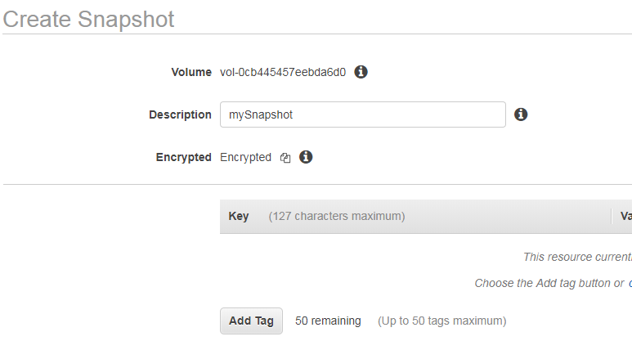

**How to encrypt a EBS volume**

1. Create a snapshot
2. Create a copy and encrypt it
3. Create an a volume – it will be encrypted..

**Changing the Encryption State of Your Data**

There is no direct way to encrypt an existing unencrypted volume, or to remove encryption from an encrypted volume. However, you can migrate data between encrypted and unencrypted volumes. You can also apply a new encryption status while copying a snapshot:

* While copying an unencrypted snapshot of an unencrypted volume, you can encrypt the copy. Volumes restored from this encrypted copy are also encrypted.
* While copying an encrypted snapshot of an encrypted volume, you can associate the copy with a different CMK. Volumes restored from the encrypted copy are only accessible using the newly applied CMK.

**You cannot remove encryption from an encrypted snapshot.**

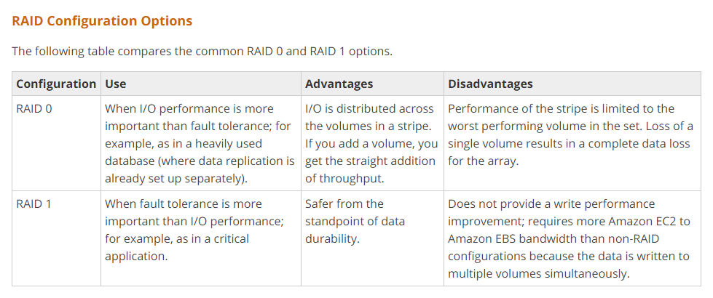

#### **Baseline Performance**

* Formula – 3 IOPS i.e. GiB * 3
* Calculation example
  + 1 GiB volume size =  3 IOPS (1 * 3 IOPS)
  + 250 GiB volume size = 750 IOPS (250* 3 IOPS)

#### **Maximum burst duration @ 3000 IOPS**

* How much time can 5400000 IO credit be sustained @ the burst performance of 3000 IOPS. Subtract the baseline performance from 3000 IOPS which would be contributed by the volume size
* Formula – 5400000/(3000 – Baseline performance)
* Calculation example
  + 1 GiB volume size @ 3000 IOPS with 5400000 the burst performance can be maintained for 5400000/(3000-3) = 1802 secs
  + 250 GiB volume size @ 3000 IOPS with 5400000 the burst performance can be maintained for 5400000/(3000-3*250) = 2400 secs

#### **Time to fill the 5400000 I/O credit balance**

* Formula – 5400000/Baseline performance
* Calculation
  + 1 GiB volume size @ 3 IOPS would require 5400000/3 = 1800000 secs
  + 250 GiB volume size @ 750 IOPS would require 5400000/750 = 7200 secs

Provisioned iops disk

Ratio : IOPS/disk size – should be less than 30..

4000/100 = 40 > 30

A user is trying to create a PIOPS EBS volume with 4000 IOPS and 100 GB size. AWS does not allow the user to create this volume. What is the possible root cause for this?

1. **The ratio between IOPS and the EBS volume is higher than 30**
2. The maximum IOPS supported by EBS is 3000
3. The ratio between IOPS and the EBS volume is lower than 50
4. PIOPS is supported for EBS higher than 500 GB size

**200/8 = 25 < 30**

A user is trying to create a PIOPS EBS volume with 8 GB size and 200 IOPS. Will AWS create the volume?

1. **Yes, since the ratio between EBS and IOPS is less than 30**
2. No, since the PIOPS and EBS size ratio is less than 30
3. No, the EBS size is less than 10 GB
4. Yes, since PIOPS is higher than 100

<http://jayendrapatil.com/aws-ebs-volume-types/>

EDS Raid configuration

For greater I/O performance than you can achieve with a single volume, RAID 0 can stripe multiple volumes together;

* USecase : Large or heavily used DB
* Need to setup replication

for on-instance redundancy, RAID 1 can mirror two volumes together.

* USecase : Critical applications

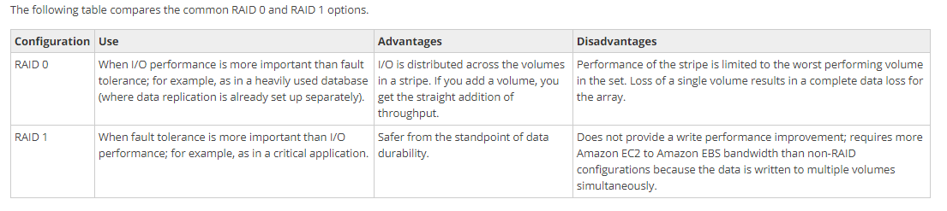

The resulting size of a RAID 0 array is the sum of the sizes of the volumes within it, and the bandwidth is the sum of the available bandwidth of the volumes within it. The resulting size and bandwidth of a RAID 1 array is equal to the size and bandwidth of the volumes in the array. For example, two 500 GiB Amazon EBS io1 volumes with 4,000 provisioned IOPS each will create a 1000 GiB RAID 0 array with an available bandwidth of 8,000 IOPS and 1,000 MB/s of throughput or a 500 GiB RAID 1 array with an available bandwidth of 4,000 IOPS and 500 MB/s of throughput.

Snapshots

To create a consistent set of snapshots for your RAID array, stop applications from writing to the RAID array and flush all caches to disk. To stop writes to the RAID array, you can take steps such as stopping the applications, stopping the instance, or unmounting the RAID array. After you've stopped all I/O activity, you can create the snapshots.

When restoring the EBS volumes in a RAID array from a set of snapshots, stop all I/O activity as you did when you created the snapshots and then restore the volumes from the snapshots.