AWS Storage Gateway is a hybrid storage service that enables your on-premises applications to seamlessly use AWS cloud storage. You can use the service for backup and archiving, disaster recovery, cloud data processing, storage tiering, and migration

Your applications connect to the service through a gateway appliance using standard storage protocols, such as NFS, SMB and iSCSI.

The gateway connects to AWS storage services, such as Amazon S3, Amazon Glacier, and Amazon EBS, providing storage for [files](https://aws.amazon.com/storagegateway/file/), [volumes](https://aws.amazon.com/storagegateway/#volume), and [virtual tapes](https://aws.amazon.com/storagegateway/vtl/) in AWS.

The service includes a highly-optimized data transfer mechanism, with bandwidth management, automated network resilience, and efficient data transfer, along with a local cache for low-latency on-premises access to your most active data.

The **File Gateway** presents a file interface that enables you to store files as objects in Amazon S3 using the industry-standard NFS and SMB file protocols, and access those files via NFS and SMB from your datacenter or Amazon EC2, or access those files as objects with the S3 API.

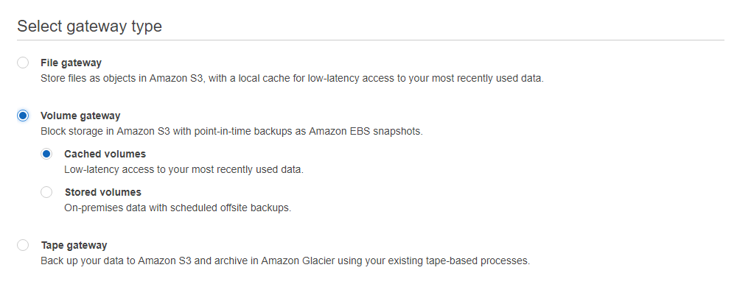

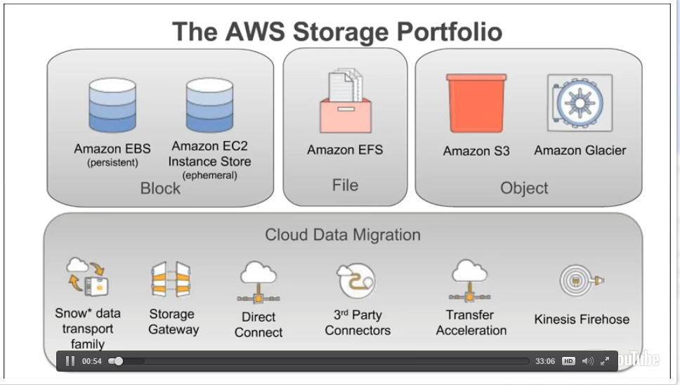

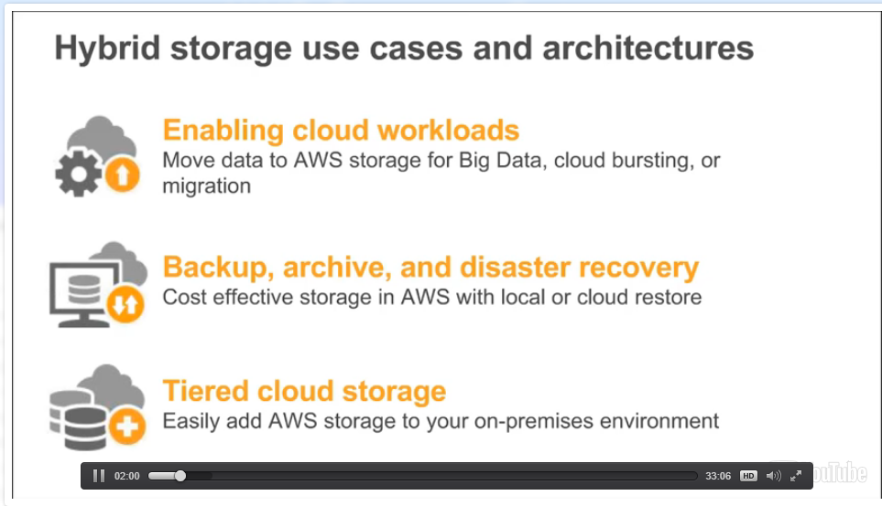

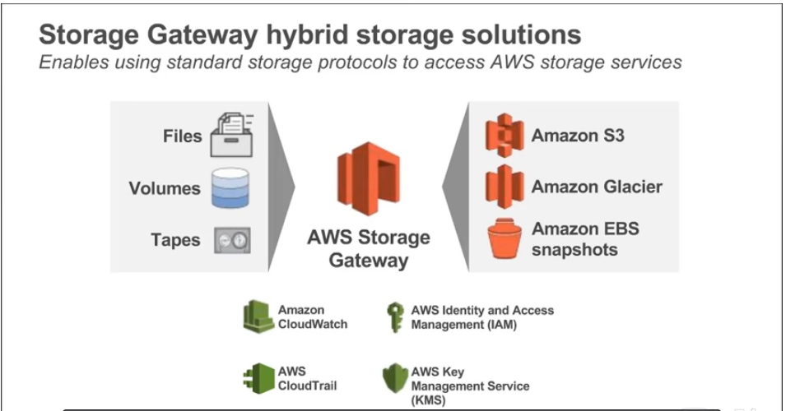

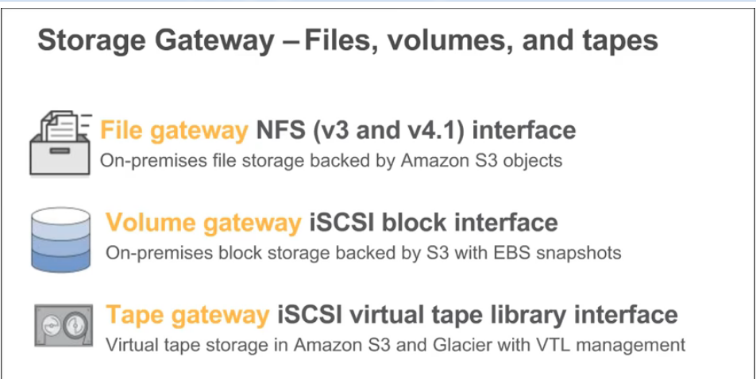

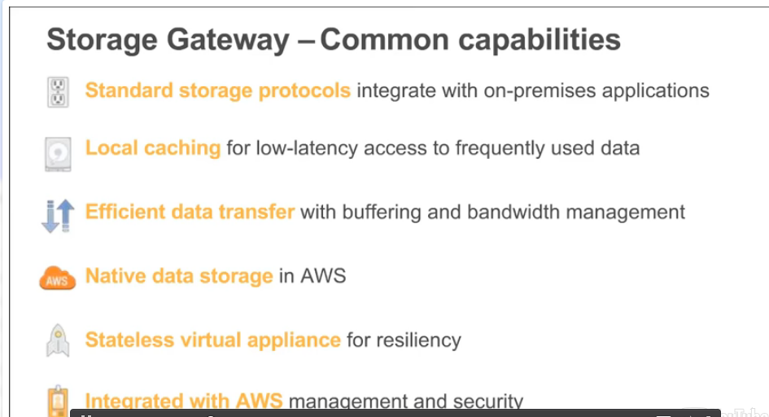

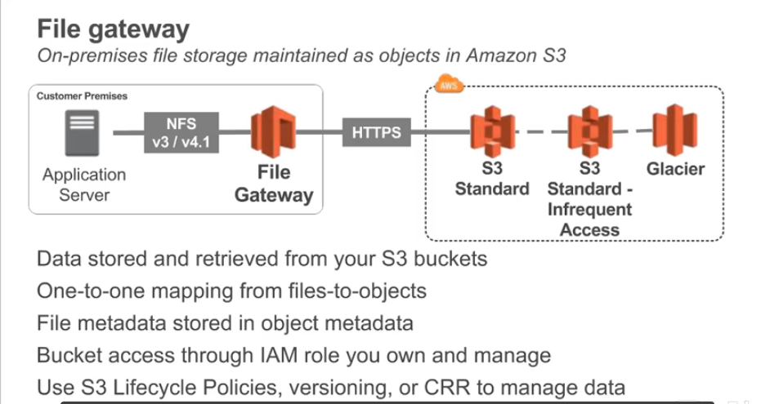

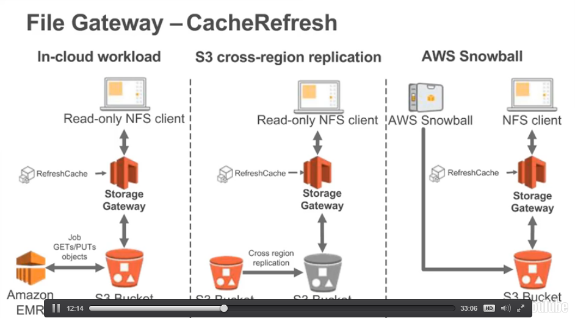

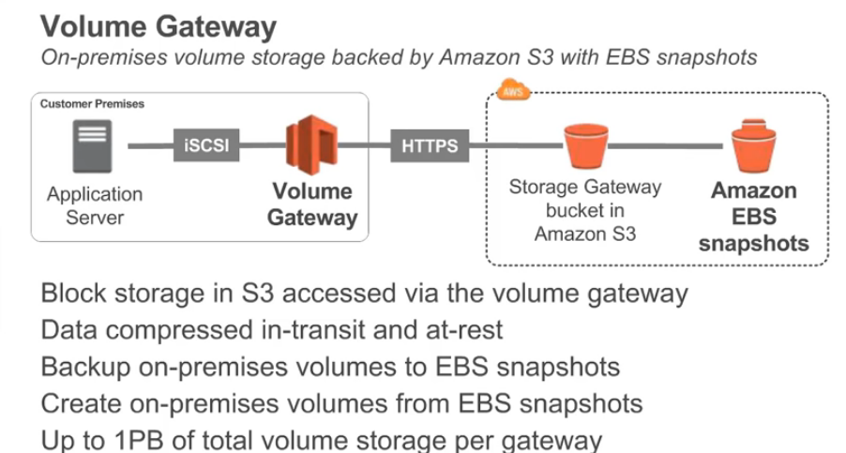

Use – just backup

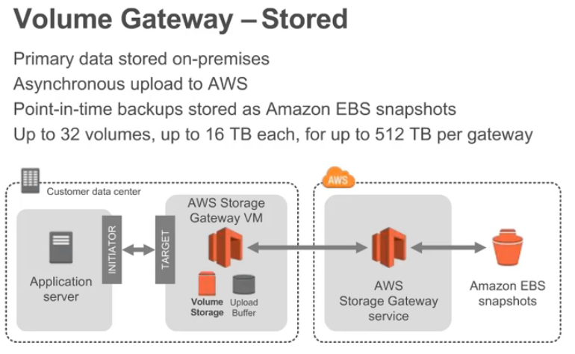

Use – backup + volume in AWS

