
INSURANCE · MOTOR · BULK POLICY GENERATION
Motor Portal Application
System Walkthrough, Functional Flow & Data Model
A bulk Excel
-
to
-
Policy issuance platform for Motor Class
-
E / Class
-
F products
—
covering upload,
validation, premium & GST computation, proposal creation, real
-
time payment tagging and policy
generation.
6
PROCESS STAGES
200
CASES / BATCH
3
PRODUCT CLASSES
15
SCREENS

C O N T E N T S

What This Deck Covers

01
Login & Authentication
Secure entry to the MIBL portal
02
Dashboard Selection
Product class + process, mandatory both
03
Excel Upload & Batch
Max 200 cases, unique Batch ID created
04
Batch Summary & Validation
Valid / invalid split, processing controls
05
Proposal & Policy
Premium → GST → Proposal → Payment → Policy
06
Reports & Search
Policy issue report export, search & print
07
Exception Handling
Invalid record remarks & cleanup
08
Data Model (ER)
Entities, keys & batch state machine
Motor Portal Application · Bulk Policy Generation 2
0 1 · S Y S T E M O V E R V I E W

What the Motor Portal Does

The Motor Portal is an operations console for
bulk motor
-
insurance policy issuance
.
Operators upload an Excel of vehicle/customer records and the platform drives each
record through validation, premium & GST computation, proposal creation, real
-
time
payment tagging and final policy generation
—
entirely batch
-
driven.
PRODUCTS
Motor Class
-
E, Motor Class
-
F & Eicher Motor
—
selected per upload session.
PROCESSES
Excel Upload · Batch Summary · Report · Search &
Print · Policy Cancel Upload.
BATCH LIMIT
Each uploaded file carries a maximum of 200
cases for controlled processing.
CD BALANCE
A side panel checks Cash
-
Deposit balance against
the chosen Master Policy.
INDICATIVE TECH CONTEXT
PRESENTATION
Server
-
rendered web portal (MIBL)
SERVICES
Batch · Validation · Premium · GST
PROPOSAL
Proposal Service → Proposal No.
PAYMENT
PF Service (real
-
time tagging)
POLICY
Policy Service → Policy No. + Cert
DATA
Relational store + audit log





END
-
TO
-
END USER JOURNEY
Six Stages, One Continuous Flow
STAGE 1
File Upload
Excel ≤200 records validated; unique Batch ID
created.
STAGE 2
Validation
Per
-
case checks; failures move to Invalid Records.
STAGE 3
Premium + GST
Base, add
-
ons, discount, net premium and GST.
STAGE 4
Proposal
Proposal No. generated for each valid case.
STAGE 5
Payment Tagging
PF Service tags payment in real time.
STAGE 6
Policy + Print
Policy No. issued; bulk certificate print enabled.
Batch status advances automatically: UPLOADED → VALIDATED → PREMIUM_CALCULATED → GST_CALCULATED → PROPOSAL_CREATED → PAYMENT
_PR
OCESSED → POLICY_CREATED →
PRINTED
0 1 · A U T H E N T I C A T I O N
STEP 1

Login — Secure Portal Entry

1
_LoginPage.png
—
operator sign
-
in
ON THIS SCREEN
•
Operator authenticates with Login ID and
Password.
•
“Forgot Password” supports self
-
service
credential reset.
•
Successful sign
-
in establishes the session
(
Welcome: admin) and lands on the
Dashboard.
•
Auth context is reused for every downstream
service call.
0 2 · D A S H B O A R D
STEP 2

Product & Process Selection
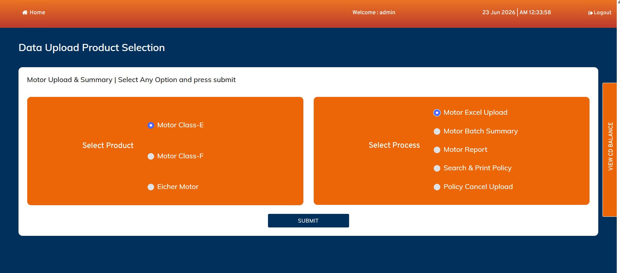
2
_Dashboard.png
—
Data Upload Product Selection
ON THIS SCREEN
•
Left: Select Product
—
Motor Class
-
E, Class
-
F
or Eicher Motor.
•
Right: Select Process
—
Excel Upload, Batch
Summary, Report, Search & Print, Policy
Cancel Upload.
•
Both selections are mandatory before Submit.
•
Here: Class
-
E + Motor Excel Upload chosen to
begin issuance.
0 2 · D A S H B O A R D
UTILITY

Balance Check
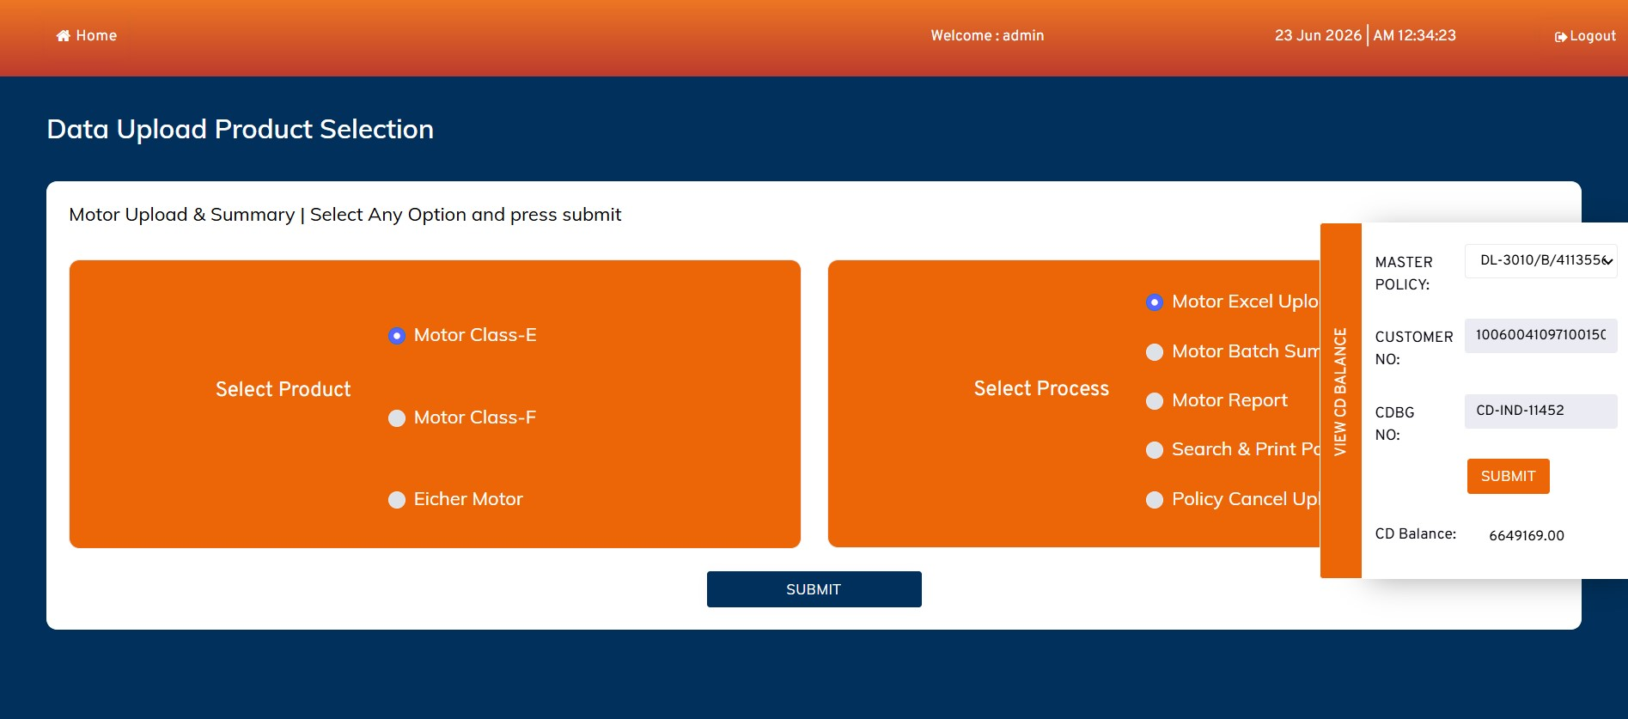
3
_Check_CD_Balnce_in_Dashboard_login.png
—
side panel
ON THIS SCREEN
•
“View CD Balance” side panel opens over the
dashboard.
•
Operator picks a Master Policy and supplies
Customer No. / CDBG No.
•
On Submit the available Cash
-
Deposit balance
is shown (e.g. 6,649,169.00).
•
Ensures sufficient funds exist before policies
consume premium.

STEP 3 Class-E Upload Page
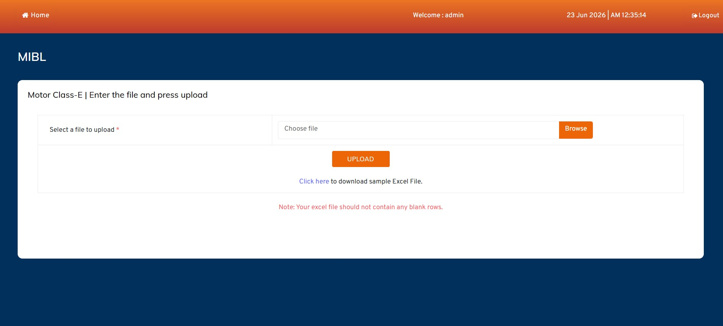
4
_Class_E_Upload_page.png
—
file entry
ON THIS SCREEN
•
Operator browses and selects the Class
-
E
Excel file, then presses Upload.
•
A sample Excel template is downloadable to
enforce the correct layout.
•
Note enforced: the file must not contain any
blank rows.
•
Column names, sequence and data types are
validated on upload.

STEP 3 Selecting the Excel File
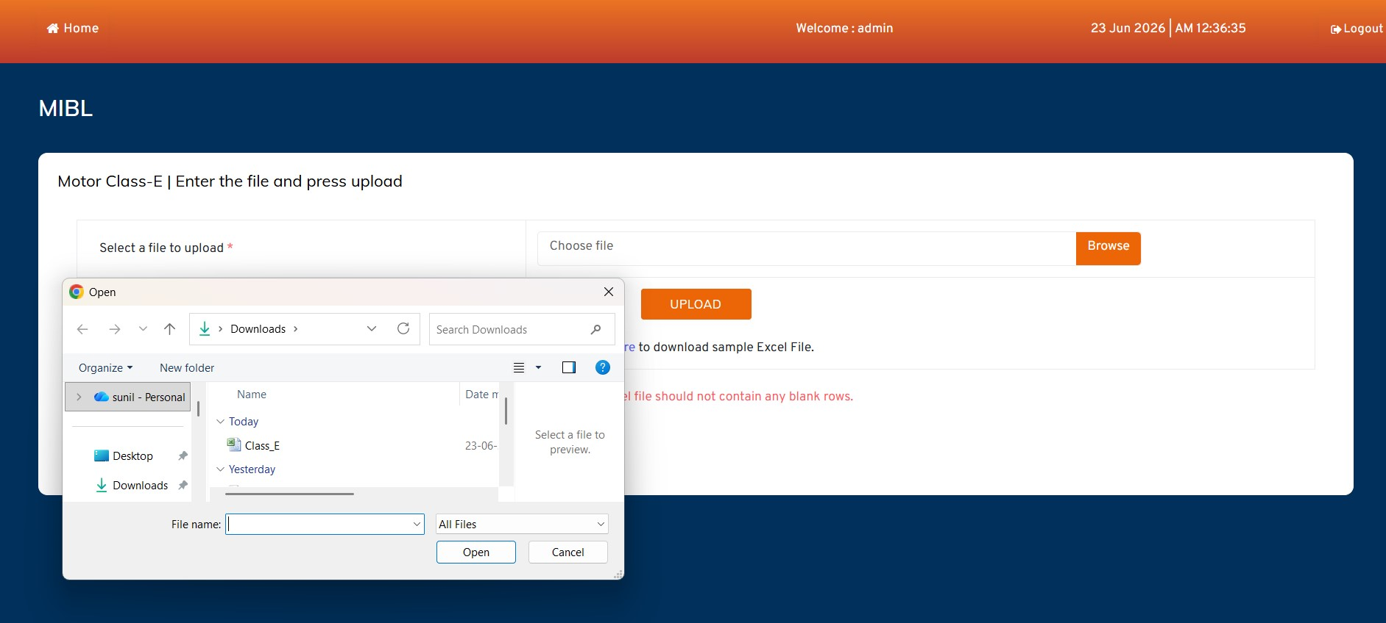
5
_Uploader_open_for_upload_class_E_file.png
—
OS file picker
ON THIS SCREEN
•
Native file chooser opens for the operator to
pick the Class
-
E workbook.
•
Only the prepared upload file (e.g. Class_E…)
should be chosen.
•
Selecting and confirming returns the path to
the Choose
-
file field.
•
Upload then streams the workbook to the
server for parsing.

BATCH ID Upload Success — Batch Created
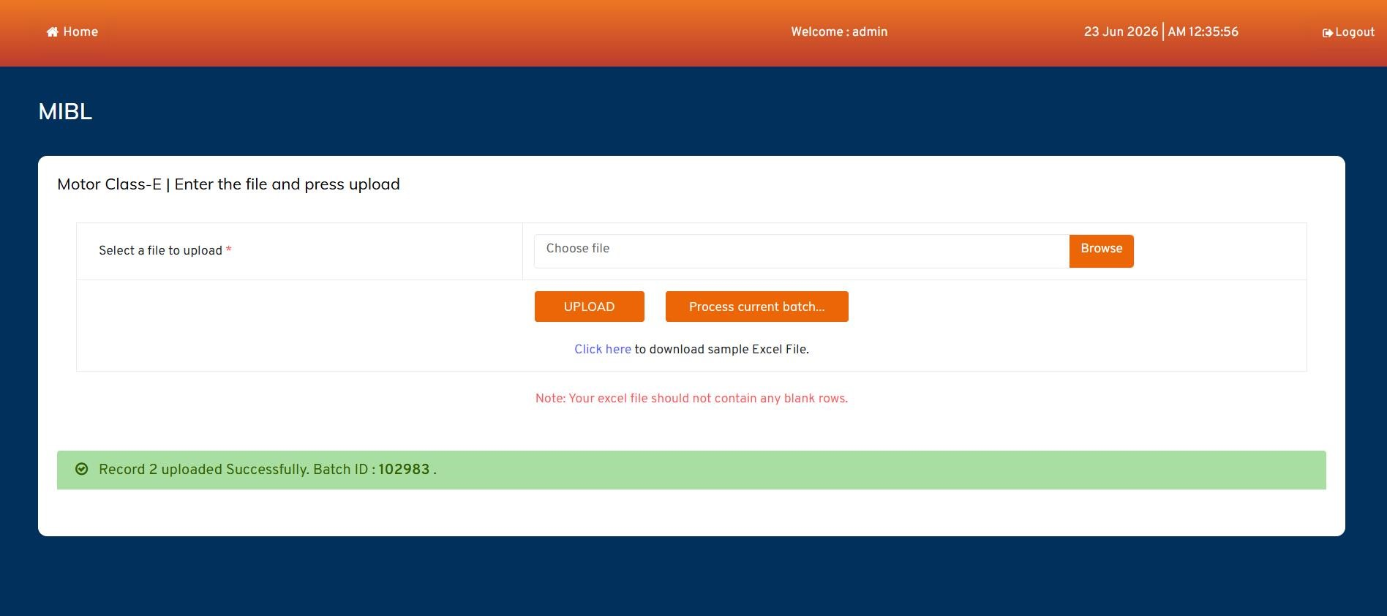
6
_File_Uploaded_and_batch_created.png
—
Batch ID 102983
ON THIS SCREEN
•
Confirmation: “Record 2 uploaded
Successfully. Batch ID: 102983”.
•
A unique Batch ID groups all records from this
file.
•
Batch status becomes UPLOADED and is now
ready to process.
•
“Process current batch…” lets the operator
proceed immediately.
0 4 · B A T C H S U M M A R Y
STEP 4

Switch to Motor Batch Summary
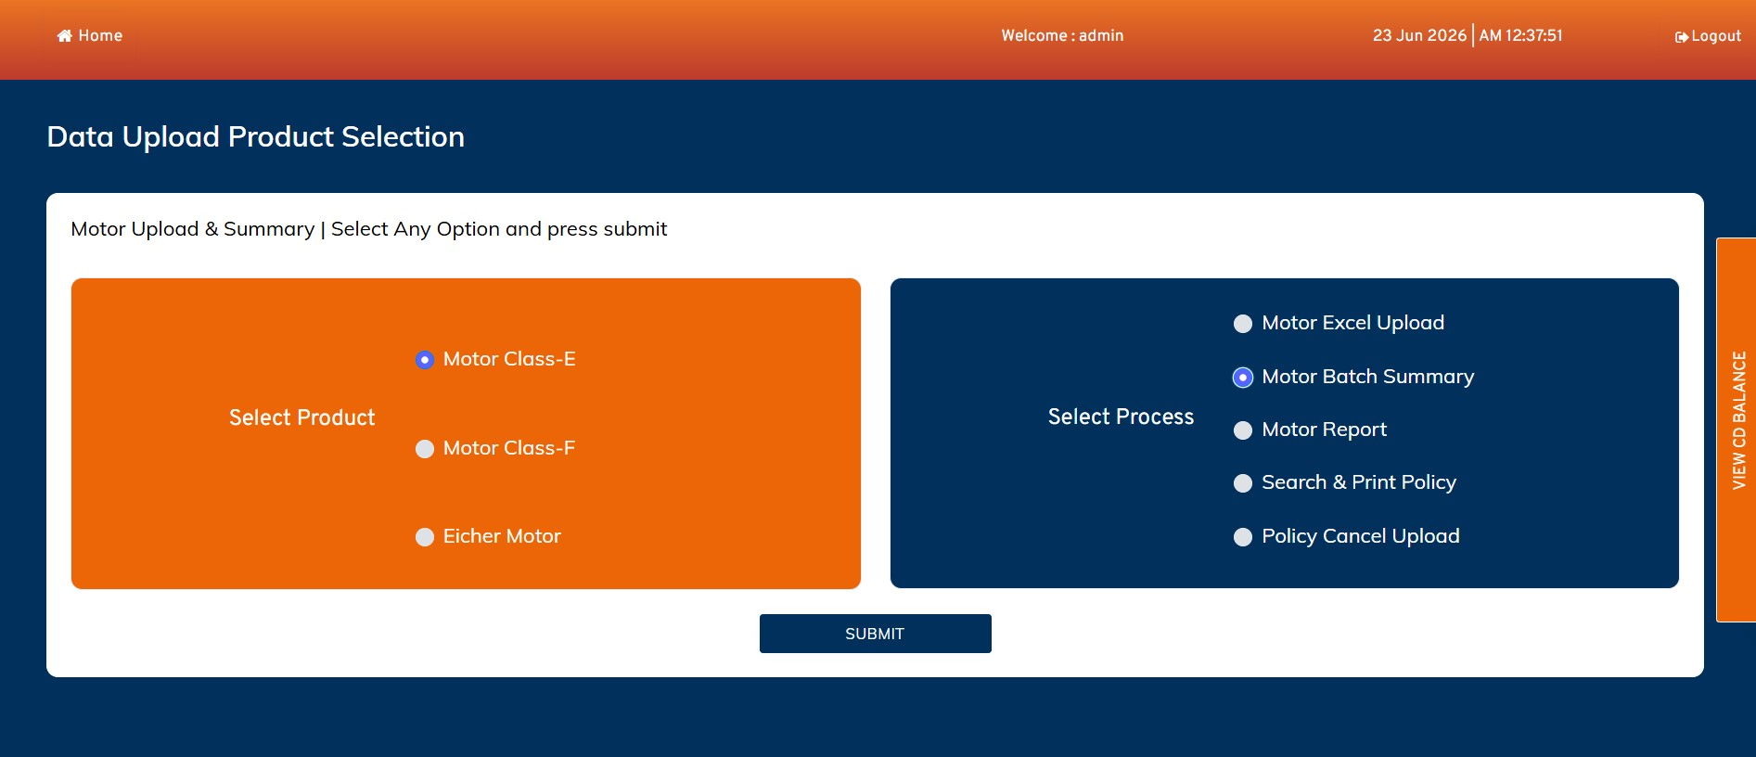
7
_select_Batch_summary_to_process_the_file.png
—
process selection
ON THIS SCREEN
•
Back on the dashboard the operator selects
Motor Batch Summary.
•
Product stays Class
-
E; process now targets the
batch console.
•
Submit opens the summary & payment
-
processing workspace.
•
This is the control room for validation,
proposal and payment.
0 4 · B A T C H S U M M A R Y
CONSOLE

Batch Summary & Counters
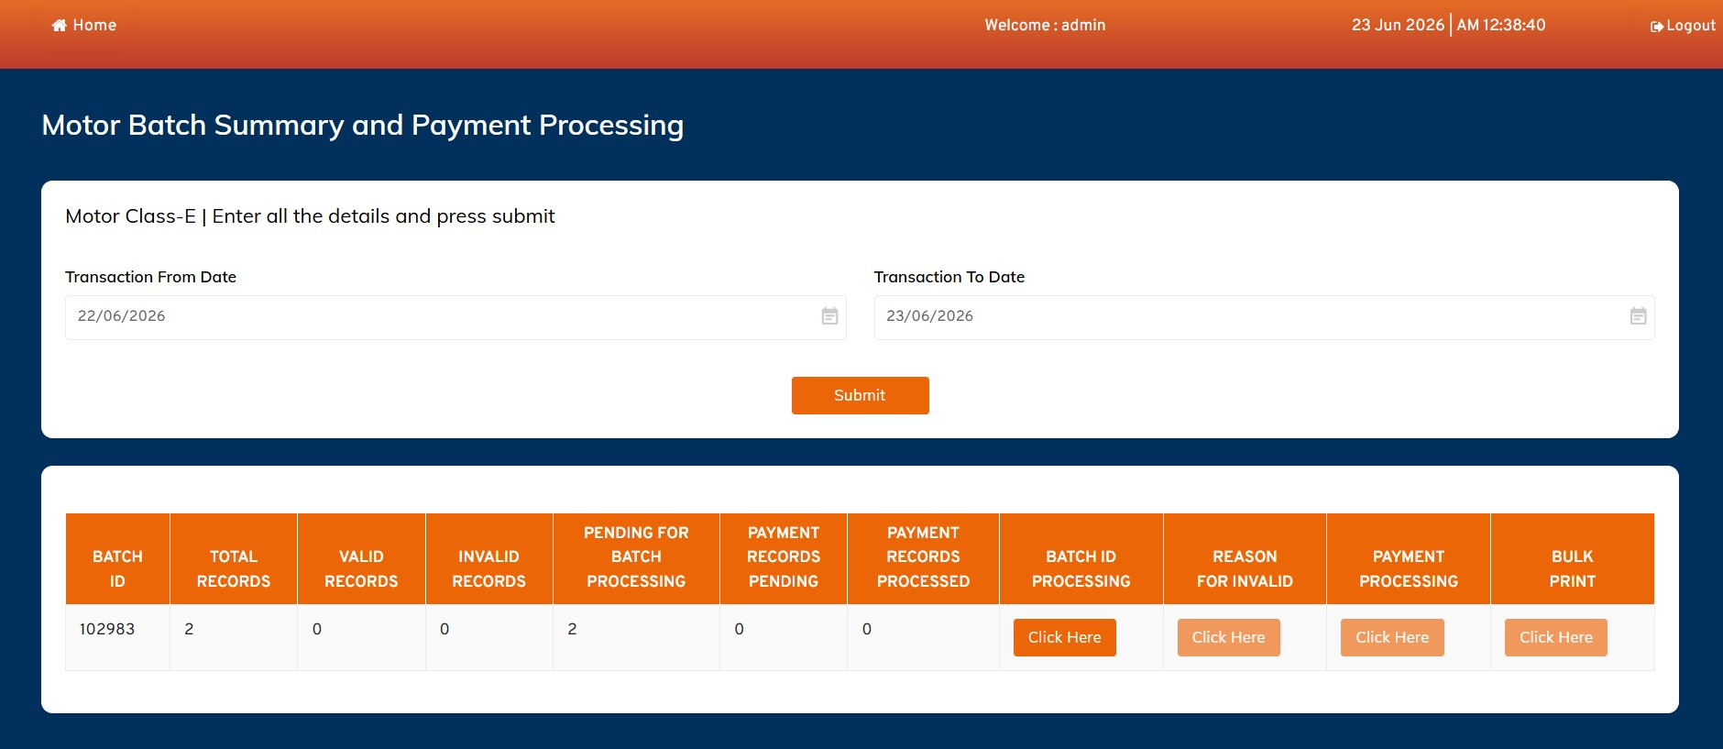
9
_Batch_Summery_List.png
—
summary grid with action buttons
ON THIS SCREEN
•
Filter by Transaction From/To Date to list
batches.
•
Counters: Total, Valid, Invalid, Pending for
Batch Processing, Payment Pending /
Processed.
•
Actions per batch: Batch ID Processing,
Reason for Invalid, Payment Processing, Bulk
Print.
•
Batch 102983 shows 2 total records, all
pending for processing.
0 5 · P R O P O S A L
PROPOSAL

Batch Processing — Proposals Created
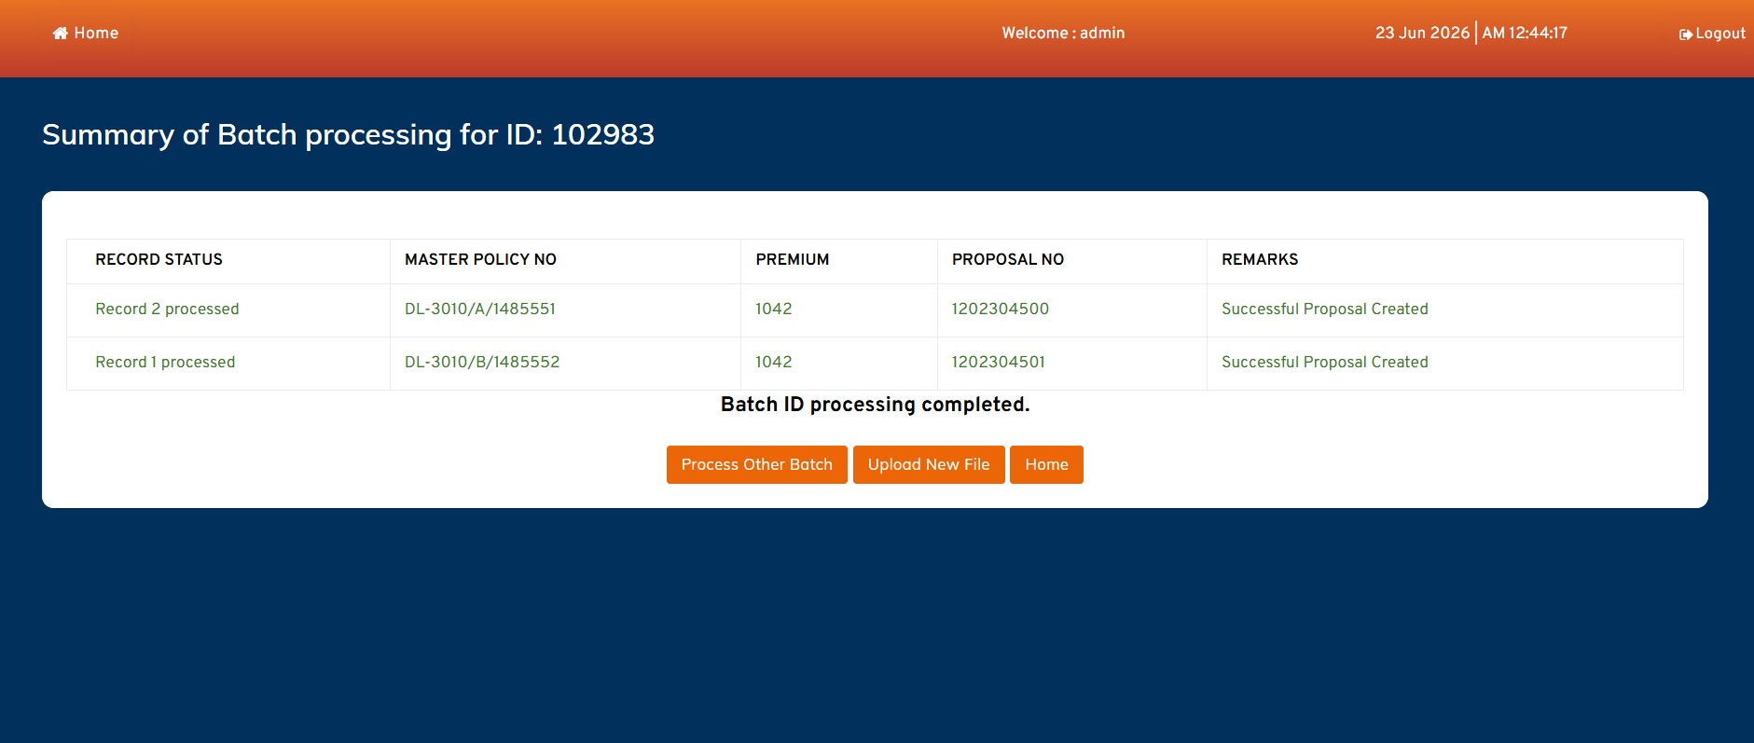
10
_Successful_proposal_created.png
—
proposals for Batch 102983
ON THIS SCREEN
•
“Batch ID Processing” validates each case,
then prices it.
•
Premium computed (Base + Add
-
ons −
Discount, plus GST).
•
A Proposal No. is generated per record (e.g.
1202304500/01).
•
Remarks read “Successful Proposal Created”;
status → PROPOSAL_CREATED.
0 6 · P A Y M E N T & P O L I C Y
POLICY

Payment Tagging → Policy Generated
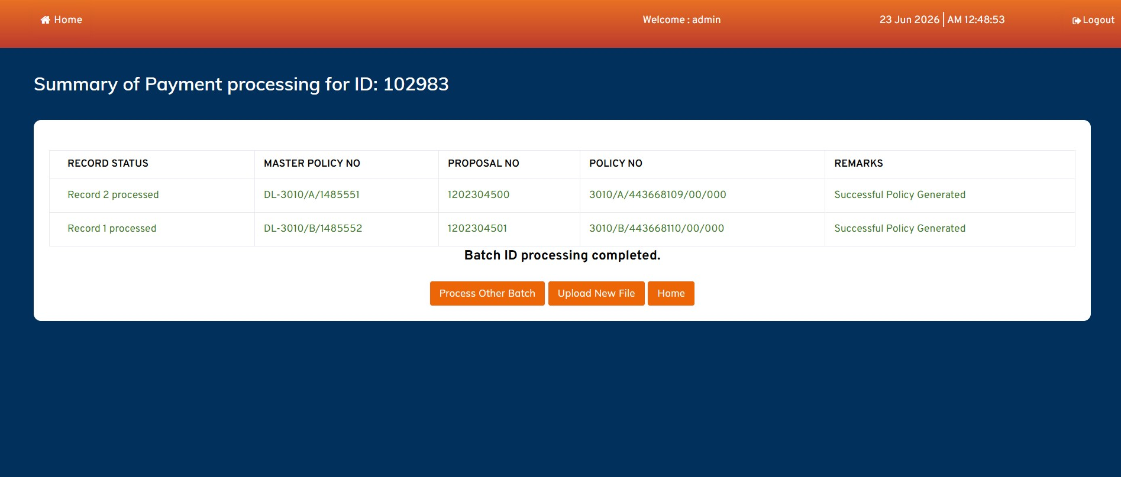
11
_Successful_Payment_and_Policy_Created.png
—
policies for Batch 102983
ON THIS SCREEN
•
“Payment Processing” calls the PF Service in
real time.
•
Flow: Proposal No. → Payment Tagging →
Policy Generation.
•
Each case receives a Policy No. (e.g.
3010/A/443668109/00/000).
•
Remarks: “Successful Policy Generated”;
status → POLICY_CREATED; Bulk Print
enabled.
0 7 · R E P O R T S
REPORTS

Select Motor Report
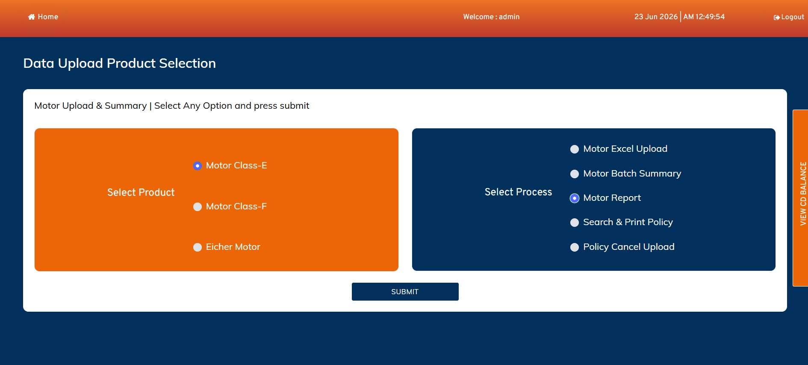
12
_Policy_Upload_Report.png
—
process selection
ON THIS SCREEN
•
Operator picks Motor Report on the
dashboard.
•
Used to extract a policy
-
upload / issuance
report.
•
Product context (Class
-
E) carries into the
report tab.
•
Submit opens the Motor Report workspace.
0 7 · R E P O R T S
EXPORT

Motor Report — Export
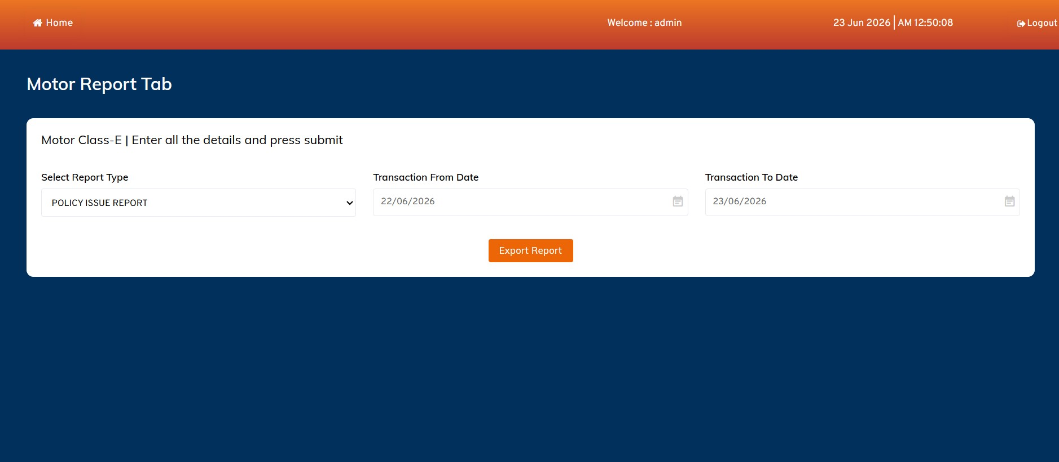
13
_Policy_Report_page.png
—
Motor Report Tab
ON THIS SCREEN
•
Choose Report Type (e.g. Policy Issue Report).
•
Set Transaction From Date and To Date as the
window.
•
Export Report produces a downloadable
Excel.
•
Supports reconciliation and policy
-
upload
reporting.
0 8 · S E A R C H & P R I N T
SEARCH

Select Search & Print Policy
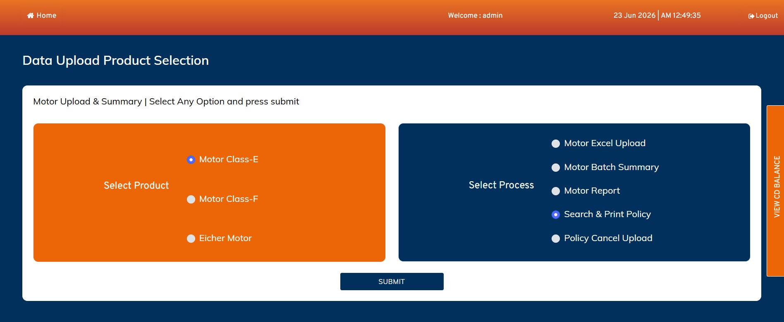
14
_Policy_Search_Option_in_dashboard.png
—
process selection
ON THIS SCREEN
•
Operator selects Search & Print Policy.
•
Enables single
-
policy lookup and certificate
print.
•
Class
-
E product context is retained.
•
Submit opens the search & print screen.
0 8 · S E A R C H & P R I N T
PRINT

Search Policy & Print Certificate
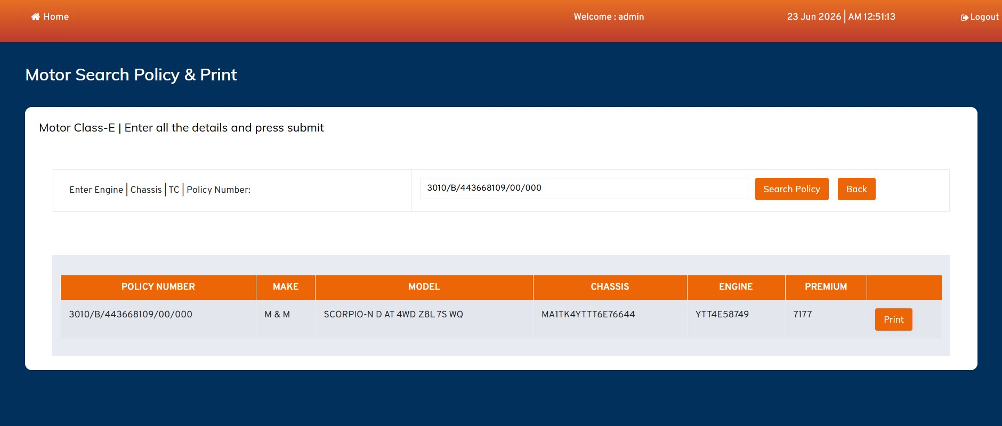
15
_Policy_Search_page.png
—
Motor Search Policy & Print
ON THIS SCREEN
•
Search by Engine, Chassis, TC or Policy
Number.
•
Result grid shows Policy No., Make, Model,
Chassis, Engine, Premium.
•
Example: M&M Scorpio
-
N, premium 7177,
Policy 3010/B/443668109…
•
Print issues the policy certificate for that
record.
E X C E P T I O N H A N D L I N G
EXCEPTION

Invalid Records & Remarks
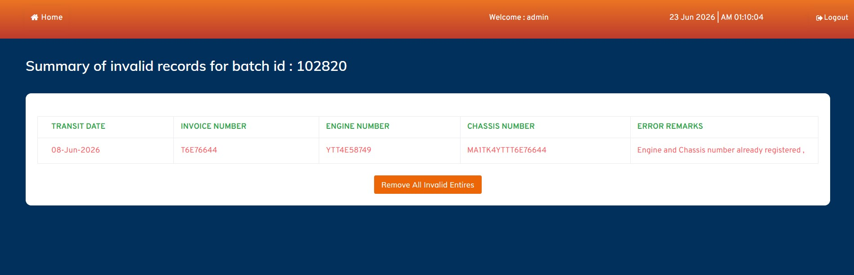
16
_Invalid_Records_.png
—
invalid summary for Batch 102820
ON THIS SCREEN
•
“Reason for Invalid” lists failed cases for a
batch.
•
Columns: Transit Date, Invoice No., Engine
No., Chassis No., Error Remarks.
•
Example remark: “Engine and Chassis number
already registered”.
•
“Remove All Invalid Entries” cleans the batch
so valid records proceed.

BATCH PROCESSING
Batch State Machine
1
UPLOADED
2
VALIDATED
3
PREMIUM_CALCULATED
4
GST_CALCULATED
5
PROPOSAL_CREATED
6
PAYMENT_PENDING
7
PAYMENT_PROCESSED
8
POLICY_CREATED
9
PRINTED
Validation failures branch records into an INVALID state; they are removed before the remaining valid cases advance to premiu
m,
proposal, payment and policy.

1 0 · V A L I D A T I O N R U L E S

What Every Record Is Checked Against

File / Structure
•
Excel format & extension
•
Mandatory columns present
•
Column sequence & names
•
No blank rows
•
Maximum 200 cases
Field / Datatype
•
Datatype match per column
•
Mandatory field values
•
Master Policy Number
•
Product mapping valid
Vehicle / Duplicate
•
Engine Number check
•
Chassis Number check
•
Vehicle duplication
•
Existing policy check
•
Duplicate transaction
Financial
•
Premium calculation
•
Add
-
ons & discount
•
GST calculation
•
CD balance sufficiency
1 2 · D A T A M O D E L



Core Entities (Detailed ER in Companion Doc)
USER_MASTER
Operators & auth
PRODUCT_MASTER
Class
-
E / F / Eicher
FUNCTION_MASTER
Process options
MASTER_POLICY
Master policy + CD
BATCH_MASTER
Batch header & status
BATCH_DETAIL
Per
-
case record
INVALID_RECORDS
Rejected cases
PREMIUM_DETAILS
Base / add
-
on / net
GST_DETAILS
GST over premium
PROPOSAL_MASTER
Proposal numbers
PAYMENT_DETAILS
PF payment tagging
POLICY_MASTER
Issued policies
POLICY_CERTIFICATE
Printable certs
REPORT_LOG
Report exports
AUDIT_LOG
Action trail
Relationship spine: USER_MASTER ‖–∞ BATCH_MASTER ‖–∞ BATCH_DETAIL → PREMIUM → GST → PROPOSAL → PAYMENT → POLICY ‖–∞ CERTIFICATE
A R C H I T E C T U R E

Components & Service Flow

EXPERIENCE
Portal UI (MIBL)
Auth / Dashboard
Upload / Search UI
PROCESSING
Validation Service
Premium & GST Engine
Proposal Service
INTEGRATION & DATA
PF Service (Payment)
Policy Service
Database + Audit
SUMMARY
One Upload → Validated, Priced & Issued in
Bulk
The Motor Portal turns a single Excel batch into issued motor policies through a controlled, auditable pipeline
—
upload → validation → premium & GST → proposal → real
-
time payment → policy → print
. Invalid cases are
isolated with clear remarks so clean records never stall.
Companion deliverable: Motor Portal
—
ER Diagram & Data Dictionary (Word).

