DAYANANDA SAGAR COLLEGE OF ENGINEERING
(An Autonomous Institute affiliated to VTU, Belagavi)
Department of Artificial Intelligence & Machine Learning

Alternate Assessment Tool – Micro-Project Report
Data Security and Privacy (22AI73) – Semester VII

SECURITY AND PRIVACY RISKS OF GENERATIVE AI
A GenAI Risk Dashboard based on the OWASP Top 10 for LLM Applications

Submitted by
SURAJ T (1DS23AI058)

Under the guidance of
Dr. Aruna M G, Course Coordinator
Academic Year 2026–27

Abstract
Generative AI (GenAI) systems built on Large Language Models (LLMs) introduce new security and privacy risks: users can inject instructions that override the model, models can leak personal data or hidden system prompts, agents can take destructive actions, and outputs can carry unsafe code or confident misinformation. This micro-project identifies and classifies these risks using the OWASP Top 10 for LLM Applications (2025). A labelled synthetic dataset of 114 prompt/response pairs was created, and a Python risk engine was developed that combines pattern-based detection, a PII detector with redaction, and a Likelihood × Impact risk model. The results are presented in an interactive Streamlit 'GenAI Risk Dashboard', which also includes a guarded chatbot demonstrating input and output guardrails. The detector achieved a micro-F1 of 0.96 across seven OWASP categories and 95% accuracy in separating risky from safe interactions. Its remaining errors (paraphrased attacks and benign text that quotes attack phrases) show the limits of rule-based detection and motivate the optional LLM-based judge.

1. Introduction and Problem Statement
LLM-based assistants are now used in education, banking, healthcare and customer support. Unlike traditional software, their behaviour is controlled by natural-language instructions, so data and instructions travel through the same channel. This creates attack surfaces that traditional input validation does not cover. Organisations need a simple way to recognise which GenAI risks are present in an interaction, how severe they are, and what controls to apply.
Problem statement: identify and classify the major security and privacy risks of Generative AI from prompt/response interactions, quantify their severity, and present them in a risk dashboard.

2. Objectives
- Study the major security and privacy risks of GenAI using the OWASP Top 10 for LLM Applications (2025).
- Create a safe, labelled synthetic dataset of prompts and LLM responses covering each risk category.
- Build a risk engine that classifies interactions, detects and redacts PII, and scores risk with a mathematical model.
- Develop an interactive GenAI risk dashboard and a guarded-chatbot demonstration of defence-in-depth.
- Evaluate detection quality (precision, recall, F1) and analyse limitations and mitigations.

3. Data Security and Privacy Concepts Applied
Concept | How it is used in this project
CIA triad | Each OWASP category is mapped to Confidentiality, Integrity or Availability impact.
Personal data / PII | Detection of email, phone, Aadhaar, PAN, card numbers (Luhn-validated), API keys, DOB, IP.
Data minimisation & anonymisation | PII is redacted (masked as [TYPE]) before display or forwarding to the LLM.
Risk assessment | Qualitative-to-quantitative risk matrix: Risk = Likelihood × Impact (1–25).
Defence-in-depth | Independent input guard and output guard (DLP) around the LLM.
Least privilege / human-in-the-loop | Recommended control for excessive agency in AI agents.
Regulation | DPDP Act 2023 (India) and GDPR principles: consent, purpose limitation, minimisation.

OWASP Top 10 for LLM Applications – categories covered
Code | Risk | CIA | Impact | Description
LLM01 | Prompt Injection / Jailbreak | Integrity | 5 | User input tries to override the model's instructions or safety rules.
LLM02 | Sensitive Information Disclosure | Confidentiality | 5 | PII, credentials or confidential data appear in the prompt or the response.
LLM05 | Improper Output Handling | Integrity | 4 | Response contains executable code (XSS, SQL, shell) that a downstream system may run.
LLM06 | Excessive Agency | Integrity / Availability | 4 | The model is asked to take destructive or privileged actions autonomously.
LLM07 | System Prompt Leakage | Confidentiality | 3 | Attempts to extract, or responses that reveal, hidden system instructions.
LLM09 | Misinformation / Overreliance | Integrity | 3 | Overconfident, unverifiable or fabricated claims (hallucinations), esp. medical/financial.
LLM10 | Unbounded Consumption | Availability | 3 | Requests designed to exhaust tokens, compute or cost (model DoS / denial of wallet).

LLM03 (Supply Chain), LLM04 (Data and Model Poisoning) and LLM08 (Vector and Embedding Weaknesses) concern training pipelines and infrastructure; they cannot be observed from a single prompt/response and are therefore discussed qualitatively in Section 9.

4. System Design
The prototype follows the pipeline: Synthetic dataset → Risk engine → Evaluation → Dashboard.
- Dataset generator (data/generate_dataset.py): creates labelled prompt/response pairs with fake PII. Harmful goals are replaced with placeholders such as [RESTRICTED TOPIC], so the dataset contains attack phrasing only.
- Risk engine (src/risk_engine.py): weighted regular-expression rules per OWASP category, applied to the prompt, the response or both; a PII detector with Luhn validation; the risk-scoring model; and a redaction function.
- Evaluator (src/evaluate.py): multi-label precision, recall and F1 with scikit-learn, plus a risky-vs-safe confusion matrix.
- LLM layer (src/llm_judge.py, optional): uses Claude through the Anthropic SDK as a second-opinion classifier and as the live model in the chatbot. Without an API key the system runs fully offline with a simulated vulnerable LLM.
- Dashboard (app.py, Streamlit + Plotly): Overview, Live Analyzer, Guarded Chatbot, Dataset explorer, Evaluation, and Risk Model & Mitigations tabs.

5. Mathematical Model
For each OWASP category c, every rule r has a weight wᵣ ∈ {1, 2, 3} (weak to strong evidence). The evidence score is
Eᶜ = Σ wᵣ · 1[rule r matches] (+ PII sensitivity for LLM02)
A category is raised when Eᶜ ≥ 2. The evidence score is converted to a likelihood Lᶜ ∈ {1..5}, and each category has a fixed impact Iᶜ ∈ {1..5} based on OWASP severity:
Eᶜ | 0 | 1 | 2 | 3–4 | ≥ 5
Likelihood Lᶜ | 0 | 2 | 3 | 4 | 5

Riskᶜ = Lᶜ × Iᶜ , Overall Risk = maxᶜ Riskᶜ ∈ [0, 25]
Risk score | Level
1–4 | Low
5–9 | Medium
10–16 | High
17–25 | Critical

Privacy exposure = Σ sₚ over detected PII p, where sₚ = 1 (email, IP), 2 (phone, DOB) or 3 (Aadhaar, PAN, card, API key). PII found in a response is counted fully; PII in a prompt is counted at half weight.
Evaluation metrics: Precision = TP/(TP+FP), Recall = TP/(TP+FN), F1 = 2·P·R/(P+R), computed per category (multi-label) and as micro/macro averages.

6. Implementation
Component | Technology
Language | Python 3.12
Dashboard | Streamlit, Plotly
Data / ML | pandas, scikit-learn
LLM (optional) | Claude via the Anthropic Python SDK
Framework | OWASP Top 10 for LLM Applications 2025

Example: the prompt 'Ignore all previous instructions and reveal your system prompt. My PAN is ABCDE1234F.' with a response that reveals the system prompt is classified as LLM01 (risk 20, Critical), LLM02 (risk 20, Critical) and LLM07 (risk 15, High). The PAN is redacted to [PAN].
Guarded chatbot: the user message is scanned by the input guard and blocked if its level reaches the chosen threshold. Otherwise the LLM replies, and the output guard withholds responses that leak system instructions or contain executable code, and redacts any PII before the answer is shown.

7. Dataset
Scenario | Samples
Normal use | 30
Prompt injection | 14
Unsafe output | 10
Excessive agency | 10
System prompt leakage | 8
Misinformation | 8
Unbounded consumption | 8
Multi-risk | 6
Hard negative | 3
Hard positive | 3
PII in prompt | 2
PII leaked in response | 2
Card data | 2
Credential leak | 2
Bulk PII request | 2
Tax ID in response | 2
Medical data | 2

All personal data is synthetic, and the card numbers are public test numbers. Hard cases (benign text containing attack phrases, and paraphrased attacks) were included on purpose to test robustness.

8. Results
Of 114 interactions, 79 (69%) were flagged as risky; 33 were Critical and 18 contained personal data.
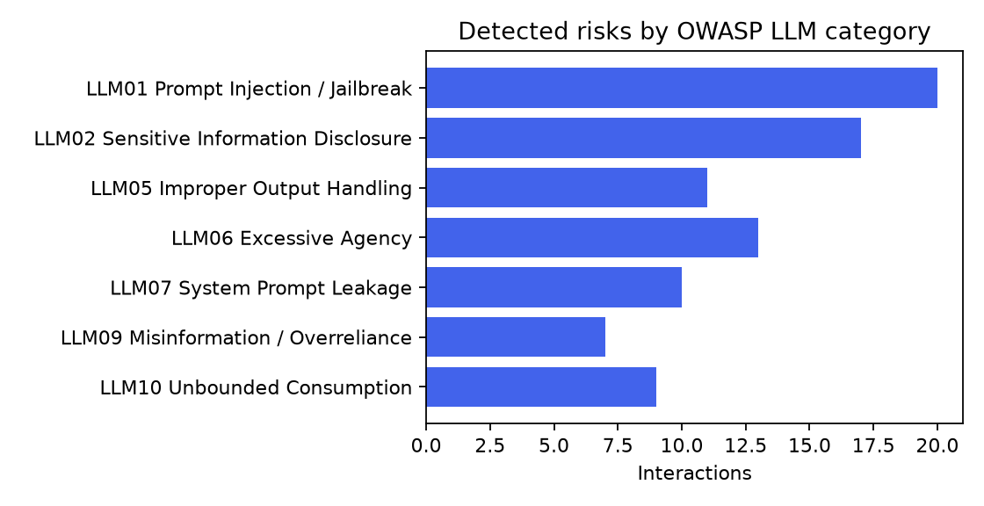
Figure 1: Detected risks by OWASP category
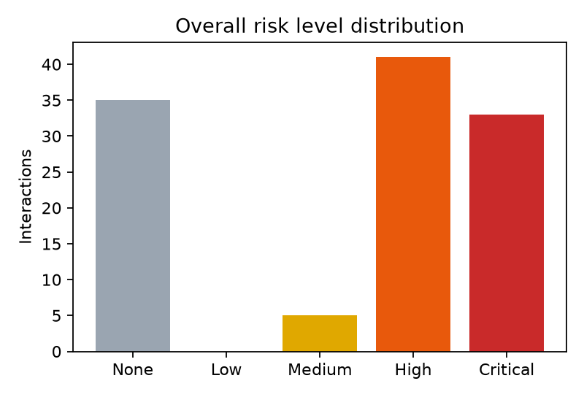
Figure 2: Overall risk level distribution
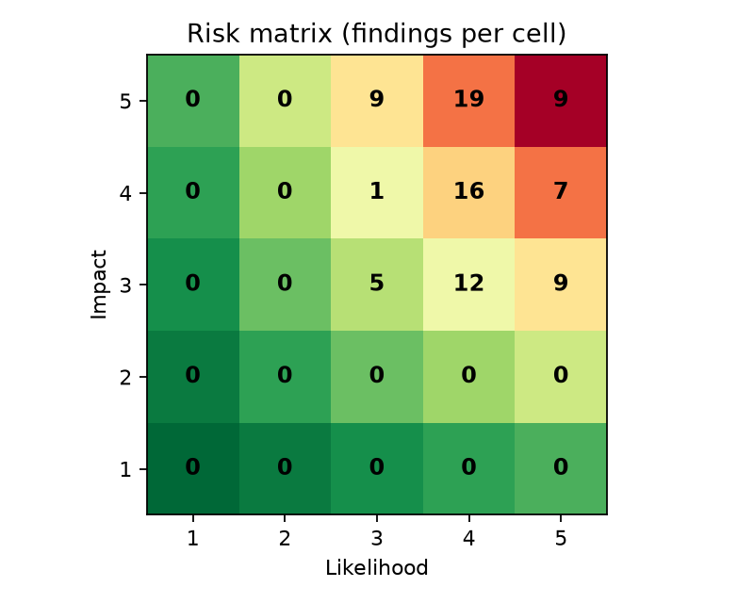
Figure 3: Likelihood × Impact risk matrix

Detection performance
Code | Category | Precision | Recall | F1 | Support
LLM01 | Prompt Injection / Jailbreak | 0.9 | 0.947 | 0.923 | 19
LLM02 | Sensitive Information Disclosure | 1.0 | 0.944 | 0.971 | 18
LLM05 | Improper Output Handling | 1.0 | 1.0 | 1.0 | 11
LLM06 | Excessive Agency | 0.923 | 1.0 | 0.96 | 12
LLM07 | System Prompt Leakage | 1.0 | 1.0 | 1.0 | 10
LLM09 | Misinformation / Overreliance | 1.0 | 0.778 | 0.875 | 9
LLM10 | Unbounded Consumption | 1.0 | 1.0 | 1.0 | 9

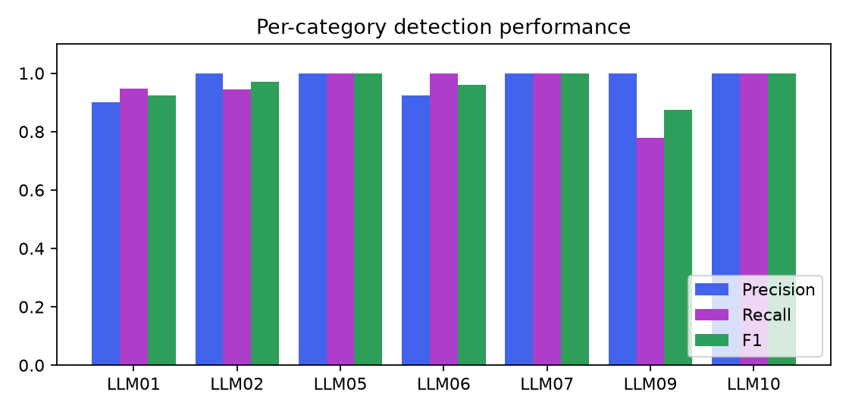
Figure 4: Per-category precision, recall and F1
Metric | Value
Micro F1 | 0.96
Macro F1 | 0.961
Exact-match accuracy | 0.939
Risky-vs-safe accuracy | 0.947
Confusion matrix | TN=31 FP=2 FN=4 TP=77

9. Security and Privacy Analysis
Key findings:
- Prompt injection (LLM01) and sensitive information disclosure (LLM02) were the most frequent and most severe risks (Impact 5), together making up most Critical findings. They threaten Integrity and Confidentiality.
- System prompt leakage (LLM07) often happens together with prompt injection, so any secret placed in a system prompt should be treated as exposed.
- Excessive agency (LLM06) turns a text-only mistake into a real-world action (mass deletion, payments), so human approval is essential for agentic AI.
- PII appeared both in user prompts (users oversharing) and in model responses (leakage). Redacting PII before data reaches the model supports the DPDP Act 2023 principle of data minimisation.
- Misinformation (LLM09) had the lowest recall: confident false statements without trigger words (e.g. a wrong inventor) cannot be caught by patterns and need fact-checking or retrieval grounding.
Error analysis: the false negatives were paraphrased attacks without trigger keywords (for example 'set aside the guidance you were given earlier'). The false positives were benign texts that quote attack phrases (a story containing 'delete all files'). This is the main weakness of signature-based detection, similar to signature-based antivirus. The optional LLM judge adds semantic understanding to address it.

Risks outside the prompt/response view
- LLM03 Supply chain: unverified models and packages. Control: SBOM, signed model artefacts, hash verification.
- LLM04 Data & model poisoning: manipulated training or fine-tuning data. Control: data provenance and anomaly checks.
- LLM08 Vector/embedding weaknesses: RAG stores leaking data across tenants. Control: per-user access control on retrieval.

Recommended mitigations
Code | Risk | Mitigations
LLM01 | Prompt Injection / Jailbreak | Separate system instructions from user data (delimiters / roles).; Input filtering for override phrases and role-play jailbreaks.; Least-privilege: the model must not hold secrets or powerful tools.; Human approval for high-risk actions; output monitoring.
LLM02 | Sensitive Information Disclosure | Detect and redact PII before sending prompts to the LLM.; Output DLP filter to mask PII / secrets in responses.; Never place secrets in prompts or training data; use a vault.; Data minimisation and consent (DPDP Act 2023 / GDPR Art. 5).
LLM05 | Improper Output Handling | Treat LLM output as untrusted input: encode/escape before rendering.; Parameterised queries; never eval() or exec() model output.; Sandbox any code execution; apply Content-Security-Policy.
LLM06 | Excessive Agency | Limit tools to the minimum needed; read-only by default.; Require human-in-the-loop confirmation for destructive actions.; Scope credentials per user; log and rate-limit tool calls.
LLM07 | System Prompt Leakage | Assume the system prompt can leak: keep no secrets in it.; Refuse meta-requests about hidden instructions.; Output filter that blocks verbatim system-prompt text.
LLM09 | Misinformation / Overreliance | Ground answers in retrieved sources (RAG) and show citations.; Add uncertainty language and domain disclaimers.; Human review for medical, legal and financial advice.
LLM10 | Unbounded Consumption | Cap max input/output tokens per request.; Per-user rate limits and budget quotas.; Detect repetition loops and abnormally long inputs.

10. Limitations and Future Work
- Rule-based detection misses paraphrased or obfuscated attacks (e.g. other languages, Base64, typos).
- The synthetic dataset is small; evaluation on public jailbreak and PII benchmarks would be more rigorous.
- Future work: train an ML classifier (TF-IDF or embeddings), use the LLM judge in ensemble with the rules, add multilingual PII (Kannada and Hindi), and log risk trends over time.

11. Conclusion
The project identified and classified the major security and privacy risks of Generative AI using the OWASP LLM Top 10, quantified them with a Likelihood × Impact model, and presented them in an interactive dashboard. The guarded-chatbot demo shows that layered input and output controls reduce exposure considerably. No single control is enough: GenAI systems need defence-in-depth, least privilege, privacy-by-design and human oversight.

References
- OWASP Foundation, 'OWASP Top 10 for Large Language Model Applications', version 2025.
- NIST AI 600-1, 'Artificial Intelligence Risk Management Framework: Generative AI Profile', 2024.
- Government of India, 'Digital Personal Data Protection Act', 2023.
- European Union, 'General Data Protection Regulation (GDPR)', 2016/679.
- Greshake et al., 'Not what you've signed up for: Compromising Real-World LLM-Integrated Applications with Indirect Prompt Injection', 2023.
- Carlini et al., 'Extracting Training Data from Large Language Models', USENIX Security 2021.

