User is asked to guess the number.

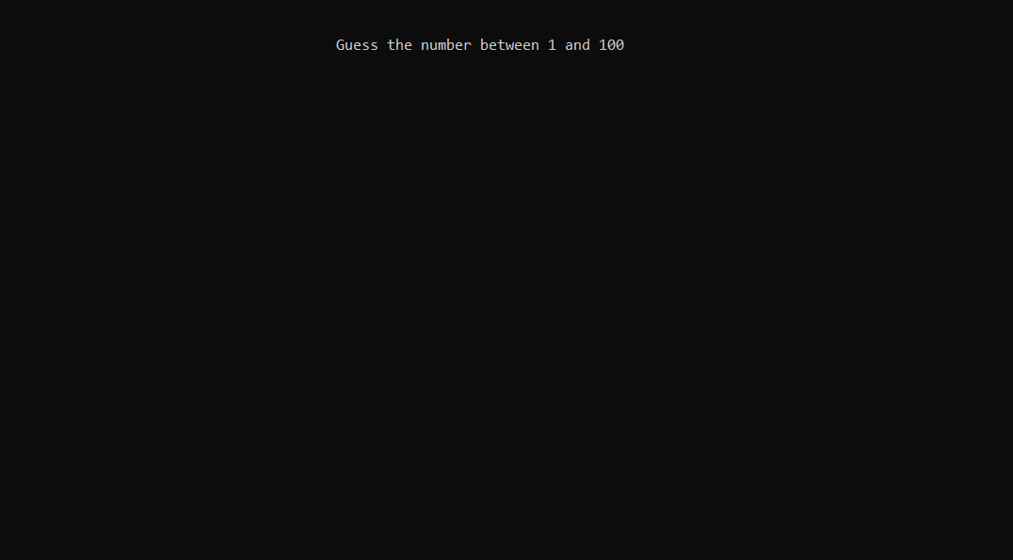

Suppose user guessed 60. Then it shows that actual number is lower than the input.

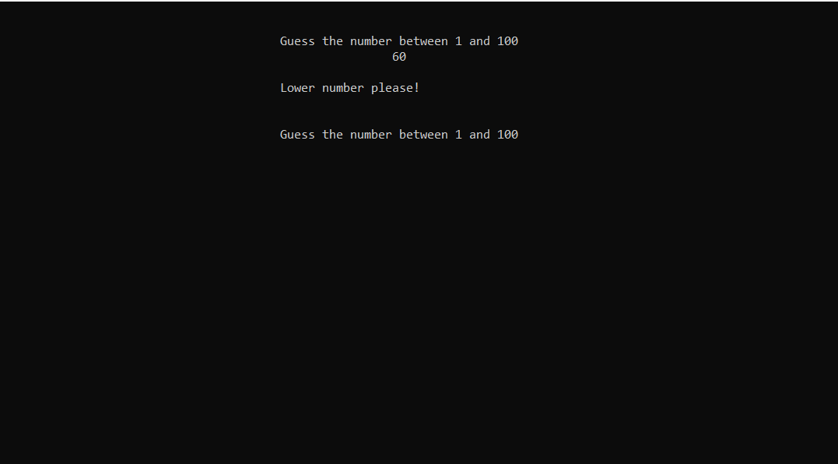

Now user has guessed 40. Then it shows that actual number is higher than the input.

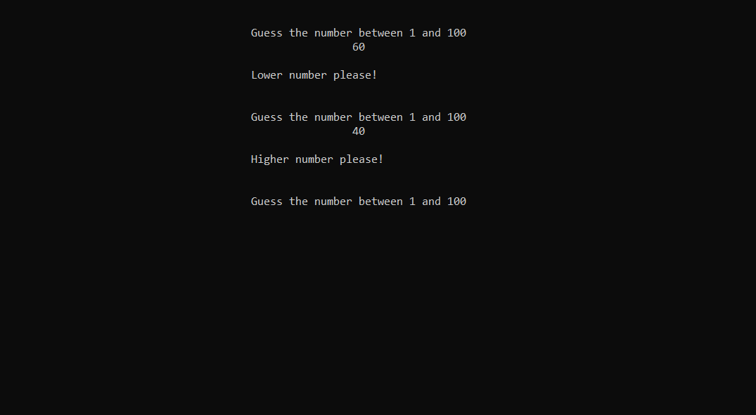

Now user has guessed 40. Then it shows that actual number is higher than the input.

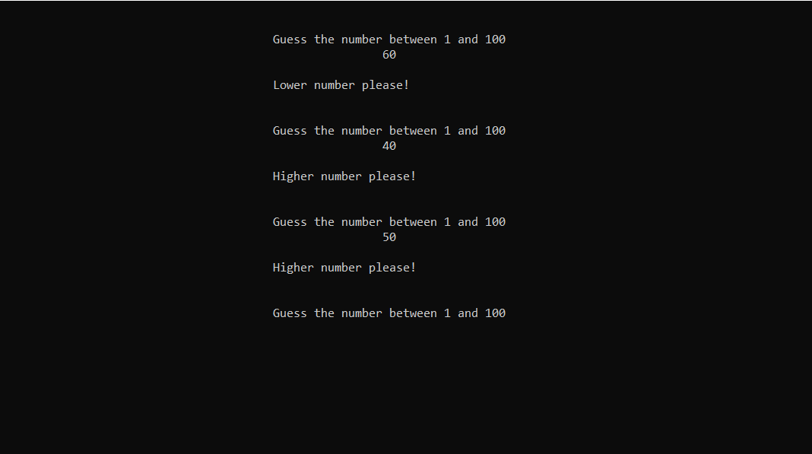

Suppose user guessed 55. Then it shows that actual number is lower than the input.

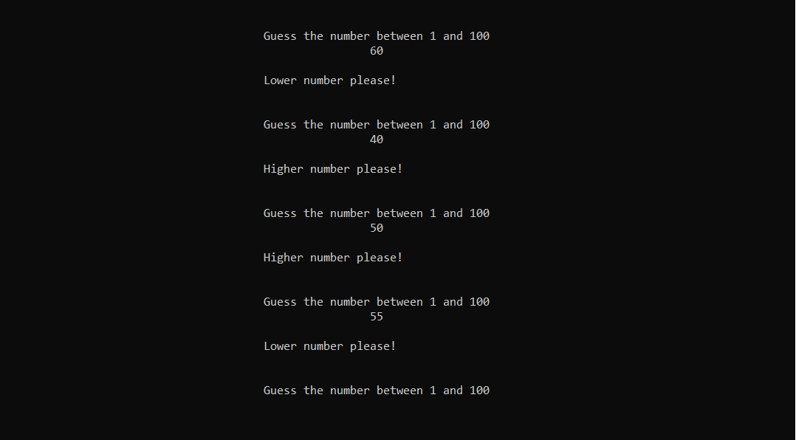

Suppose user guessed 52. Then it shows that actual number is lower than the input.

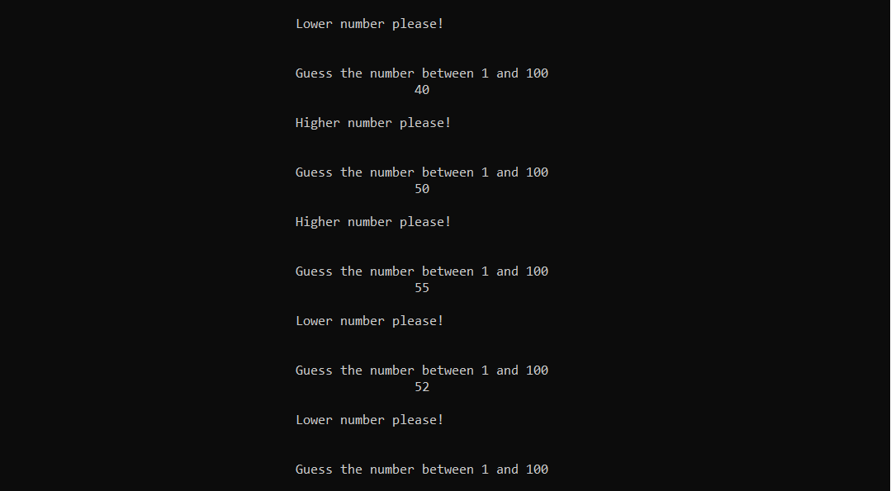

Now user has guessed 51. That is the actual number. It is also showing the number of attempts user took to guess the number.

