FIT3179

Data Visualization I

Shuangkun Fan

Project URL: [Did the Chinese team do well?](https://public.tableau.com/views/Asgmt1/Dashboard1?:language=en-US&publish=yes&:display_count=n&:origin=viz_share_link)

Words count: 964

**Project Description**

Domain: The domain of this data visualization project is about the performance of the Chinese team in the 2019 FIBA basketball world cup. It mainly includes the analysis of several major statistics of basketball, such as shooting, player height, etc.

Why: The purpose of this data visualization project is to help Chinese basketball fans analyze the strengths and weaknesses of Chinese men's basketball players by visualizing them in a more intuitive way.

Who: The target audience should include all fans of the Chinese men's basketball team and anyone who cares about the performance of the Chinese men's basketball team, which also includes fans of the men's basketball teams of other countries, i.e., the opponents of the Chinese men's basketball team.

**What**

The main data was obtained from a GitHub repository called **FIBA-Basketball-World-Cup**, which contains data on all countries for the 2019 FIBA Basketball World Cup, including rosters, schedules, game results, and player data. However, for this project I only needed the data of the Chinese team, so I cleaned up the data of each file accordingly and kept only the data of the Chinese players. And also some data is gained from the official FIBA Website.

Figure – Shoot Chart

For this shot chart, the data here includes mainly the latitude and longitude of the shot location, which is the numerical continuous data, and the Event Type is categorical data. The X-axis shows the basketball court baseline and the Y-axis shows the basketball’s sideline.

Figure - Team leader

Team leader is a chart that lists the most efficient players in each position based on their efficiency ratings. There are three different stats, points, rebounds and assists. They are all numerical continuous data.

Figure – Player Efficiency

This player efficiency bubble chart shows mainly the efficiency values and positions of all Chinese men's basketball team members, they are numerical continuous data and categorical data respectively.

图表

Figure – Lower Section

These five charts present each of the five important stats of a player: points, rebounds, blocks, assists and the player's height distribution. They are all continuous data.

For the bar chart, the rows show different player (categorical based on their position), and column shows the four different stats respectively. And the histogram shows the player height on X-axis and the count of player on the Y-axis.

**Why and How**

As mentioned above, this visualization could help Chinese basketball fans analyse the strengths and weaknesses of Chinese men's basketball players by visualizing them in a more intuitive way. It also allows to see an individual player’s shot and other performance visually. So we can get a more intuitive look at the stats of the members of the Chinese men's basketball team from a big picture perspective.

Figure

The mark used in the shot chart is the points to indicate the shot location of player for all games. Channels used here are Color Hue and Shape, as there are five different colors are used which indicate the five different positions in the basketball sport including center, power forward, small forward shooting guard and point guard. And also Shape indicates the event type of each shotting, whether it is made or missed.

Figure

The mark used in the bubble chart is the circle to indicate a particular player. Channels used here are Color Hue and Size. The larger size means the higher efficiency of a player.

Figure

The mark used in this bar chart is the lines to indicate the number of stats for the three different categories. Channels used here are Color Hue and length, as there are three different colours are used which indicate the three types of data, and length indicates the number of points, rebounds and assists.

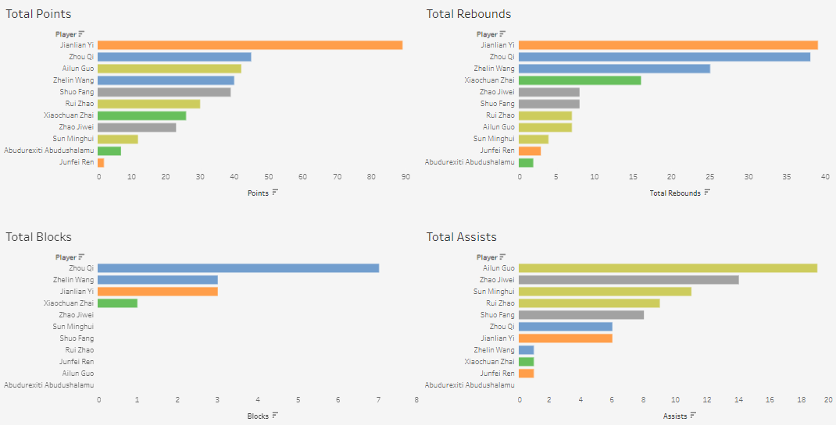

Figure

For those four chats, the mark used in bar chart is the lines to indicate the number of stats for the four different categories. Channels used here are Color Hue and length, as there are five different colours are used which indicate the five different position, and length indicates the number of points, rebounds, blocks and assists.

Figure

The mark used in the histogram is the line, and channels used here are length to indicate the number of people in each interval.

**Design:**

Layout:

The layout of the whole project is very simple, mainly divided into two sections, top and bottom, and two sections, left and right. The top section is for team leader chart and shoot chart and player efficiency. The bottom section is divided into two sections, offensive data against defensive data. The reading order is from top to bottom, and the title of each figure has horizontal and vertical alignment according to the line of sight. And the top, bottom, left and right of the project have a margin of 4 pixels reserved for white space.

Color:

The colors are also very simple: the background of the project is light gray, the title is black and bold, and the team leader image uses the same color as the jersey as the channel. five different locations are also used as channels in five relatively easy to distinguish colors.

Figure-ground:

The different sections are mainly identified by the larger as well as the thicker font titles. For example, the five graphs in the lower section are indicated by the text of the 5 skey stats panel.

Typography:

The title font uses Times New Roman, which is a serif font. Because this project is more like a magazine type, and serif is usually used for headings and titles. The font for the body is tableau regular, which is Sans serif, and it is used because it looks clean and clear.

Storytelling:

This visualisation is most likely a Magazine Style story telling genre as it has title on the top and with some explanation for the project.

**Reference list:**

FIBA-Basketbal-World-Cup/data at master · gkaramanis/FIBA-Basketbal-World-Cup. (n.d.). Retrieved September 5, 2022, from GitHub website: <https://github.com/gkaramanis/FIBA-Basketbal-World-Cup/tree/master/data>

*2019 Nike & Jordan Brand Basketball Federation Uniforms*. (n.d.). UNISWAG. Retrieved September 5, 2022, from <https://www.uniswag.com/blog/2019-nike-jordan-brand-basketball-federation-uniforms>

‌

**Appendix:**

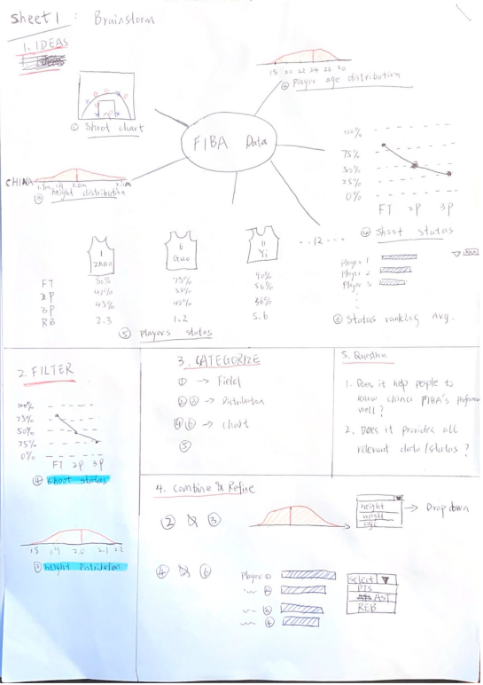

**5DS – Sheet 1**

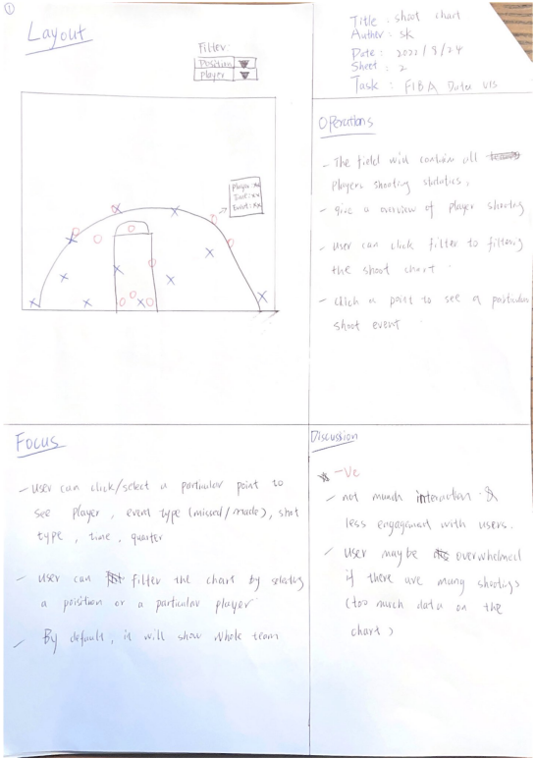

**5DS – Sheet 2**

**5DS – Sheet 3**

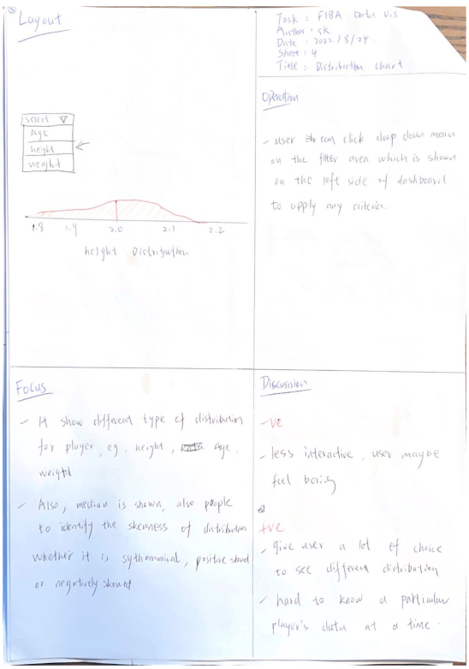**5DS – Sheet 4**

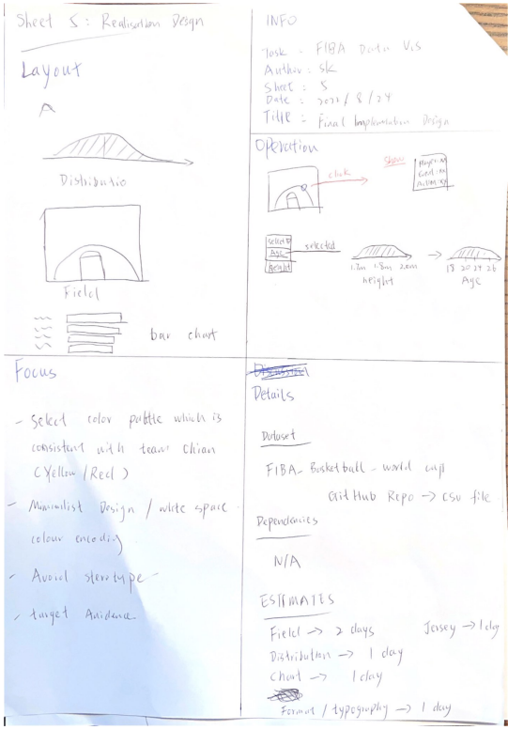

**5DS – Sheet 5**