FIT3179

Data Visualization 2

Shuangkun Fan

Project URL: [United States Tourist Guide](https://imswagk727.github.io/FIT3179/Asgmt2/project/index.html)

Git Repo: <https://github.com/imswagk727/FIT3179/tree/main/Asgmt2>

Words count: 792

**Project Description**

Domain: The domain of this data visualization project is a US travel guide and analysis made based on data from 2019. It covers four main areas, which country has the most visitors to the United States, when is the right time to visit, what mode of transportation people use to travel to the United States, and what is the traveller’s touring style to the United States? As well as the main one, it includes a map presenting the number of arrivals in the United States, which covers which states have the most travellers.

Why: The purpose of this data visualization project is to provide visitors to the United States with some basic knowledge about which states are tourist destinations and when it is appropriate to visit them.

Who: The target audience should be all visitors who will be traveling to the United States, or who have plans to go and want to go to the United States, and may include people who want to learn about U.S. travel data.

**What, Why and How**

The primary data is obtained from the Our world in Data website, which includes data on the nationalities of U.S. arrivals, this includes the number of people arriving from all countries, but in this project, I only needed the U.S. data, and so I cleaned the dataset accordingly. Also, Statista which includes data on the modes of transportation used by travellers. The weather is obtained from the US Weather Bureau website.

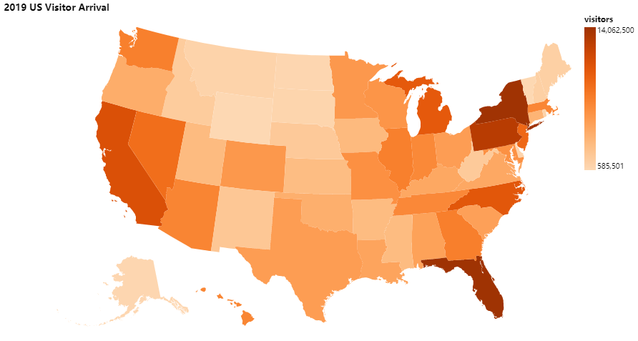

Figure - 2019 U.S. Visitor Arrival

In Figure 1, I mainly use data including the latitude and longitude of the U.S. to visualize the number of visitor arrivals in each state. mark is geoshape, in this case each state, and channel is colour luminance used to indicate the number of visitor arrivals in each state, which is quantitative data. The brighter colour value mean the higher number of visitors for each state.

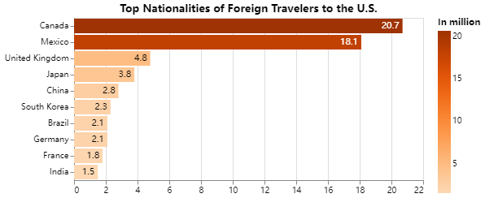

Figure 2 - Top Nationalities of Foreign Travelers to the U.S

Figure 2 is a bar chart which shows the number of people from different countries who travel to the U.S. They are categorical and quantitative data respectively. The mark used in this bar chart is the lines to indicate the number of people for each countries. Channels used here is the length, it indicates the number of people.

Figure 3- Monthly Temperature

This graph (Figure 3) is mainly based on the temperature of the ten states with the most visitors arrivals on map (Figure 1), which is numerical continuum data. So, I used the line and two points for the mark here, because the temperature includes low and high temperature, so that you can clearly see the temperature range, and the temperature trend of the year.

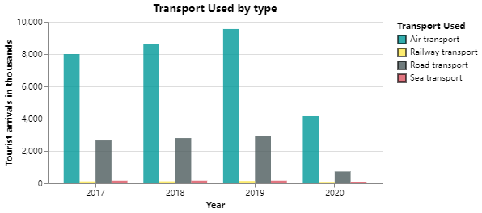

Figure 4 - Transport used by type

Figure 4 includes data on the four different modes of transportation used by travelers to reach the U.S. between 2017 and 2020, and I used color hue to encode the transportation mode data because it is categorical data. Then mark is used here as bar to indicate the number of tourists.

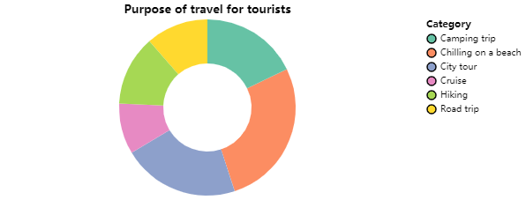

Figure 5 - Purpose of travel for tourists

Figure 5 mainly includes the types of tourist tours, here there are six different categories, and the channel is color hue. Data type is quantitative. The mark used here is circular arc to indicate is proportion of each travel category.

**Design:**

Layout:

The whole page is simple and divided into three parts: the top part is the title and description of this visualization project, the middle part is the map, and the bottom part is the four diagrams of the four questions. The reading trail starts with the title in the top left corner and has a margin of 40 pixels between each section of the different images. the left and right sides also retain equal widths.

Color:

The colors are also very simple: the background of the project is light gray, the title is black and bold, and keep the minimalist color choice for the chart.

Figure-ground:

The background is in gray, and the foreground is in white. This allows for better differentiation.

Typography:

The title font uses Roboto Slab, which is a serif font. Because this project is more like a magazine type, and serif is usually used for headings and titles. The font for the body is Source Sans Pro, which is Sans serif, and it is used because it looks clean and clear. Also, The different sections are mainly identified by the larger as well as the thicker section titles. For example, “U.S popular Destination” and “Who” are using same

Storytelling:

This visualisation is most likely a Magazine Style story telling genre as it has title on the top and with some explanation for the project.

**Reference list:**

Roser, M. (2018). *Tourism*. Our World in Data.

<https://ourworldindata.org/tourism>

Lock, S. (2021, October 13). *Topic: Tourism worldwide*. Statista. <https://www.statista.com/topics/962/global-tourism/#dossierKeyfigures>

*November Average Weather in Each U.S. State*. (n.d.). Www.extremeweatherwatch.com. Retrieved October 17, 2022, from <https://www.extremeweatherwatch.com/us-state-averages/month-november>

*Top Nationalities of Foreign Travelers to the U.S.* (n.d.). Www.infoplease.com. <https://www.infoplease.com/world/travel-transportation/top-nationalities-foreign-travelers-us>

*Usa free icons designed by Freepik*. (n.d.). Flaticon. Retrieved October 17, 2022, from <https://www.flaticon.com/free-icon/usa_449508>

**Appendix:**

**5DS – Sheet 1**

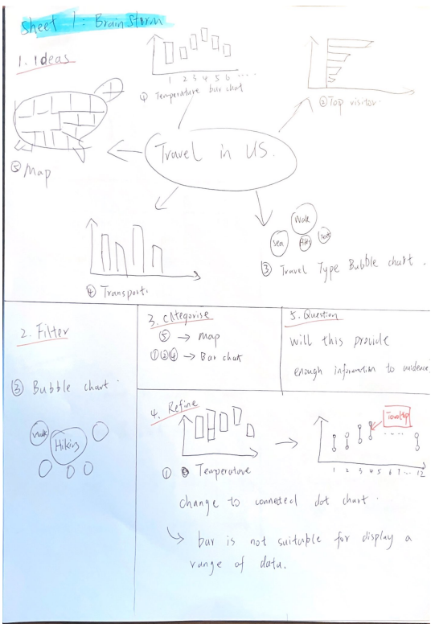

**5DS – Sheet 2**

**5DS – Sheet 3**

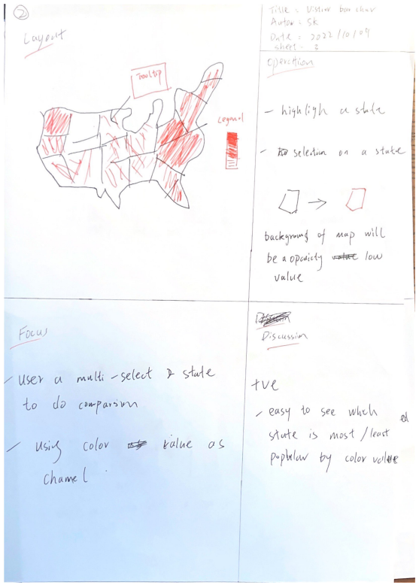

**5DS – Sheet 4**

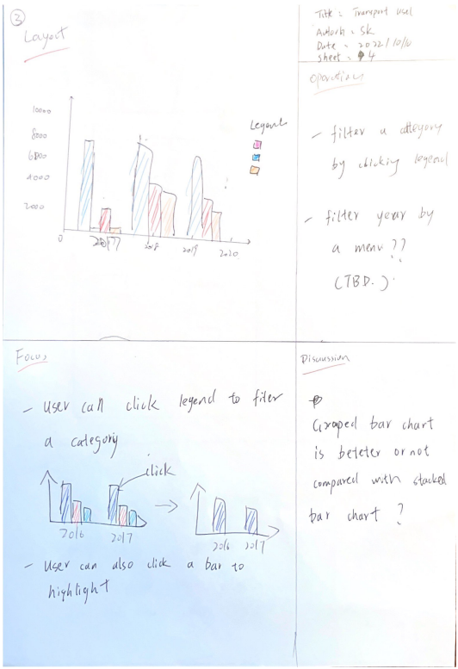

**5DS – Sheet 5**

