

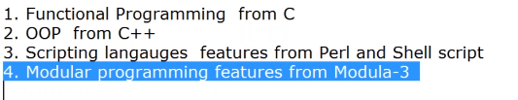

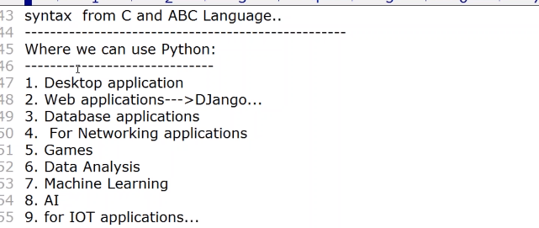

Python is case sensitive

Python identifier can have many characters No Limit

only _ and alphanumeric Allowed in idetifier

**Identifier Starts with one underscore (_) private**

**Identifier Starts with two underscore (__) strongly private**

**Identifier Starts and end with two underscore (__VariableName__) language specific Idetifier**

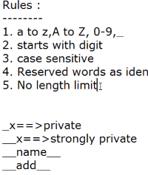

Python has five standard Data Types:

* [Numbers](http://developer.rhino3d.com/guides/rhinopython/python-datatypes/#numbers)
* [String](http://developer.rhino3d.com/guides/rhinopython/python-datatypes/#string)

[List](http://developer.rhino3d.com/guides/rhinopython/python-datatypes/#list) mylist = **[**'Rhino', 'Grasshopper', 'Flamingo', 'Bongo']

[**Tuple**](http://developer.rhino3d.com/guides/rhinopython/python-datatypes/#tuple): mytuple = **(**'Rhino', 'Grasshopper', 'Flamingo', 'Bongo')

[**Dictionary**](http://developer.rhino3d.com/guides/rhinopython/python-datatypes/#dictionary): room_num = {'john': 425, 'tom': 212}

room_num = {'john': 425, 'tom': 212}

room_num['john'] = 645 *# set the value associated with the 'john' key to 645*

**print** (room_num['tom']) *# print the value of the 'tom' key.*

room_num['isaac'] = 345 *# Add a new key 'isaac' with the associated value*

**print** (room_num.keys()) *# print out a list of keys in the dictionary*

**print** ('isaac' **in** room_num) *# test to see if 'issac' is in the dictionary. This returns true.*

Python 2.0 had Long data type but 3.0 dont have long only int and float

python always display in decimal Form

bin();

oct();

hexx()

so we can supply any kind of input , it will change to corresponding function

like

>>> bin(10)

'0b1010'

>>> bin(0x11)

'0b10001'

>>> bin(0o11)

'0b1001'

same for octa and hexa aswell

>>> hex(12)

'0xc'

>>> hex(16)

'0x10'

>>>

floating only allowed decimal

f=12.12 yes

f=0X23.89 wrong

f=1.2341e3 =1234.1 right

complex data

x=10+4j;

x.real=10

x.imag=4

*******************

x=123

v=123

x is v>>>>>>>True(till 0-256 only for int and stirng value not for complex and float)

x=[1,2,3,4]

b=byte(x)---immutable and only 0 to 256 can range

x=[1,2,3,4]

b=bytearray(x)---mutable

List and tuple

**Tuple**-immutable ()

**List** - mutable []

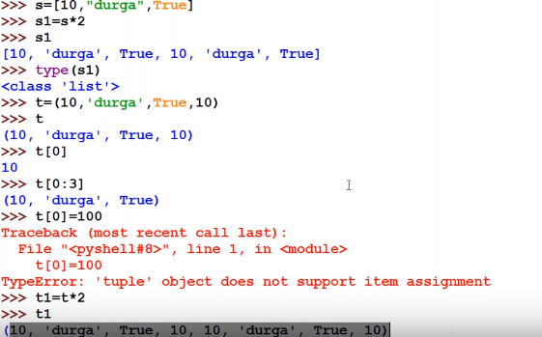

[ ] list.

() tuple

{} dict and set

empty set vs empty dict

empty set --s=set()

empty dict d={};

add in dict

d[300]='sunny'



not char data type in python, so handled by only str

like str='c';

**All fundamental data type is immutable, object remain same if you assign other then another objet will create**

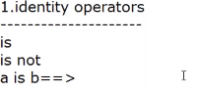

**2.MemberShip Operator**



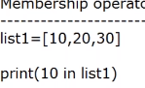

>> age = 15

>>> # Conditions are evaluated from left to right

>>> print('kid' if age < 18 else 'adult')

kid

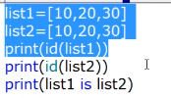

**IS operator Address comparsison**

**== operator content comparison**

**Passing command line argument**

from sys import argv

print(*"no of command line argument:"*,len(argv))

print(*"list of command line argument:"*,argv)

print(*"Comamnd line arguments one by one"*)

for x in argv:

print(x)

**split multiple numbers**

a,b,c=[eval(x) for x in raw_input(*"Enter 3 numbers:"*).split(*","*)]

print(type(a))

print(type(b))

print(type(c))

print(*"product: "*, a*b+c)

**// Add all aruguments**

from sys import argv

args=argv[1:3] # from which index it has to start and where to end as first index is file name

sum=0

for x in args:

n=int(x)

sum+=n

print(sum)

from sys import argv

#print(argv[23]) # IndexError: list index out of range

print(argv[23:34]) # list index out of range will not come



print(*"Ram"*+*"Sahu"*) RamSahu

print(*"Ram"*,*"Sahu"*) Ram Sahu # space will be added

print(*"Niwas"*\*3)

*************

a,b,c=10,20,30

print(*"sas:"*,a,b,c)

('sas:', 10, 20, 30)

**************

a,b,c,d=2,3,6.45,*"test"*

print(*"%i %i %f %s"* %(a,b,c,d))

2 3 6.450000 test

