2757 10mbps

ifconfig - used for displaying current network configuration

cat /etc/*release or cat /proc/version. --TO check OS version

Wget-- stands for "web get". It is a command-line utility which downloads files over a network.

SSH, or Secure Shell, is a protocol used to securely log onto remote systems.

It is the most common way to access remote Linux servers

$ ssh -p 731 10.10.10.111

port p

Telnet vs SSH

Secure Shell, commonly known as SSH, and Telnet are two network protocols that have been used widely at

one point in time or another. They are both used to connect to remote servers in order to facilitate some sort of

communications. The primary difference, which also led to one superseding the other, is in security. SSH offers

security mechanisms that protect the users against anyone with malicious intent while Telnet has no security

measures whatsoever.

Telnet was designed to work within a private network and not across a public network where threats can appear.

Because of this, all the data is transmitted in plain text, including passwords. This is a major security issue and

the developers of SSH used encryptions to make it harder for other people to sniff the password and other

relevant information. Telnet also omits another safety measure called authentication. This ensures that the

source of the data is still the same device and not another computer. Without authentication, another person

can intercept the communication and do what he wishes. This is also addressed in SSH as it uses a public key

to authenticate the source of the data.

Number of Users Login -->> who --count

grep "one" test.txt

grep "two" *.txt

grep -i "TWO" *.txt - ignore case snsitive

[ram.sahu@app04 ~]$ grep -in w$ test1 line end with w -n for line no, -i for case sensitive

[ram.sahu@app04 ~]$ grep -in ^s test1 line start with s-n for line no, -i for case sensitive

egrep- used for multiple pattern

[ram.sahu@app04 ~]$ egrep "user|in" test1

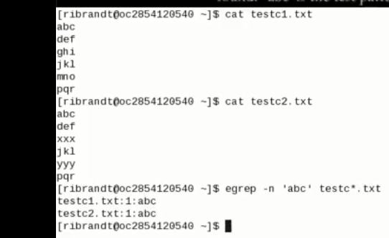

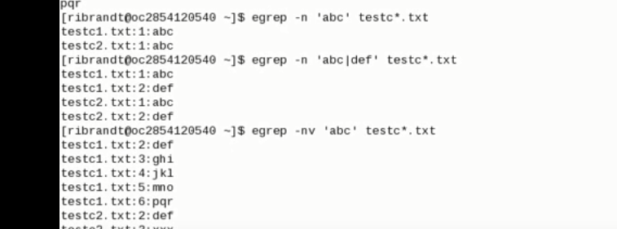

**to view top 10 lines**

**head -10 data.json**

from below

**tail -10 data.json**

mv Move Rename a oldname to newname.

less command in Linux with Examples

Less command is linux utility which can be used to read contents of text file one page(one screen) per time. It has faster access because if file is large, it don’t access complete file, but access it page by page.

For example, if it’s a large file and you are reading it using any text editor, then the complete file will be loaded to main memory, but less command don’t load entire file, but load it part by part, which makes it faster.

**mv ram.txt ram1.txt**

rm Remove Delete filename

rmdir Delete an existing directory provided it is

1. How to Create an Empty File

# touch sheena

2. create multiple files

# touch sheena meena leena

touch Update access and modification time of a file.rcp Remote file copy[ram.sahu@app04 ~]$ gzip fs

The du Command

The du (disk usage) command enables you to specify directories to show disk space

usage on a particular directory

telnet Make terminal connection to another host

ssh Secure shell terminal or command

connection

scp Secure shell remote file copy

sftp secure shell file transfer program

Telnet vs SSH

They are both used to connect to remote servers in order to facilitate some sort of communications.

SSH offers security mechanisms that protect the users against anyone with malicious intent while Telnet has no

security measures whatsoever.

Telnet was designed to work within a private network and not across a public network where threats can appear.

Telnet was designed to work within a private network and not across a public network where threats can appear.

Because of this, all the data is transmitted in plain text, including passwords. This is a major security issue and

the developers of SSH used encryptions to make it harder for other people to sniff the password and other

**Relevant information.**

1. SSH and Telnet commonly serves the same purpose

2. SSH is more secure compared to Telnet

3. SSH encrypts the data while Telnet sends data in plain text

4. SSH uses a public key for authentication while Telnet does not use any authentication

5. SSH adds a bit more overhead to the bandwidth compared to Telnet

6. Telnet has been all but replaced by SSH in almost all uses

w-- Show what logged in users are doingwho-- List logged in usersusers-- Print names of logged in users

uname --Display name of the current systemtop-- Display all system processes

The df Command

The first way to manage your partition space is with the df (disk free) command. The

command df -k (disk free) displays the disk space usage in kilobytes, as shown below

The du Command

The du (disk usage) command enables you to specify directories to show disk space

usage on a particular directory.

File creattion command

Touch

CAT

cat >> file1 append to file1

mv for file move and rename

change permission---

chmod is used to change the permissions of files or directories.

create link hard link and short link

hard link - if we delete the main file then data still exisit in the link so hard link, its like creating a copy file

ln f5 f5_ln

softlink - if we delete the main file then data does not access with the link its like shortcut

ln -s f5 f5_ln

for line, words, chars

$ Wc file1

# Netstat command displays various network related information such as network connections, routing tables, Netstat command in Linux

Netstat command displays various network related information such as network connections, routing tables, interface statistics, masquerade connections, multicast memberships etc.,

A **routing table** is a set of rules, often viewed in **table**format, that is used to determine where data packets traveling over an Internet Protocol (IP) network will be directed. All IP-enabled devices, including **router**s and switches, use **routing tables**.

interface statistics, masquerade connections, multicast memberships etc.,

locate

The locate - a.k.a. find - command is meant to find a file within the Linux OS

The basic difference is FIND is for searching files and directories at system level while GREP is for searching a

pattern inside a file.

Sed command is mostly used to replace the text in a file. The below simple sed command replaces the word

"unix" with "linux" in the file.

>sed 's/unix/linux/' file.txt

awk command examples

Remove duplicate lines using awk

open read only fille

vim -R /etc/passwd

create read only file.

$ touch file

$ chmod 400 file

3. How will you find which operating system your system is running on in UNIX?

By using command "uname -a" in UNIX

Kill process

kill -9 PID

How do you copy file from one host to other?

Many options but you can say by using "scp" command.

1. How do you find which processes are using a particular file?

By using lsof command in UNIX.

2. How do you find which remote hosts are connecting to your host on a particular port say 10123?

By using netstat command execute netstat -a | grep "port" and it will list the entire host which is connected to

this host on port 10123.

3. What is nohup in UNIX?

nohup is a special command which is used to run process in background, but it is slightly different than & which

is normally used for putting a process in background. An UNIX process started with nohup will not stop even if

the user who has stared log off from system. While background process started with & will stop as soon as

user logoff.

10. How do you find whether your system is 32 bit or 64 bit ?

Either by using "uname -a" command or by using "arch" command.

What are the links and symbolic links in a UNIX file system?

Symbolic links are the files that only contain the name of another file. The operations on the symbolic link are

directed to the file pointed by it. Both the limitations of links are eliminated in symbolic links.