Parking Platform Project Report
A full-stack parking discovery and management platform with Next.js frontend and Laravel (JWT) backend. Drivers search and book nearby spaces; Providers/Admins manage spaces, availability, bookings, and basic income snapshots.

Tech Stack
Frontend: Next.js 16 (App Router), React 19, Tailwind CSS 4
Backend: Laravel API with tymon/jwt-auth (REST /api/v1)
Maps: Leaflet (no API key) + optional Google Places

Key Features
Driver: address/GPS search, live availability, book/cancel, booking timeline.
Provider/Admin: create spaces, set availability, manage bookings (confirm/check-in/out/cancel), income snapshot.
Auth: phone + password; JWT stored client-side (localStorage).

Architecture
Next.js App Router UI with client-side fetch helper (apiFetch) calling Laravel /api/v1. Leaflet map picker and live map components for search/creation flows. JWT auth persisted client-side.
Backend exposes endpoints: /auth/login|register|refresh, /spaces + availability, /search + /search/nearby + /geocode, /bookings (create/cancel/confirm/check-in/out), /reports/provider/monthly.

ER Diagram
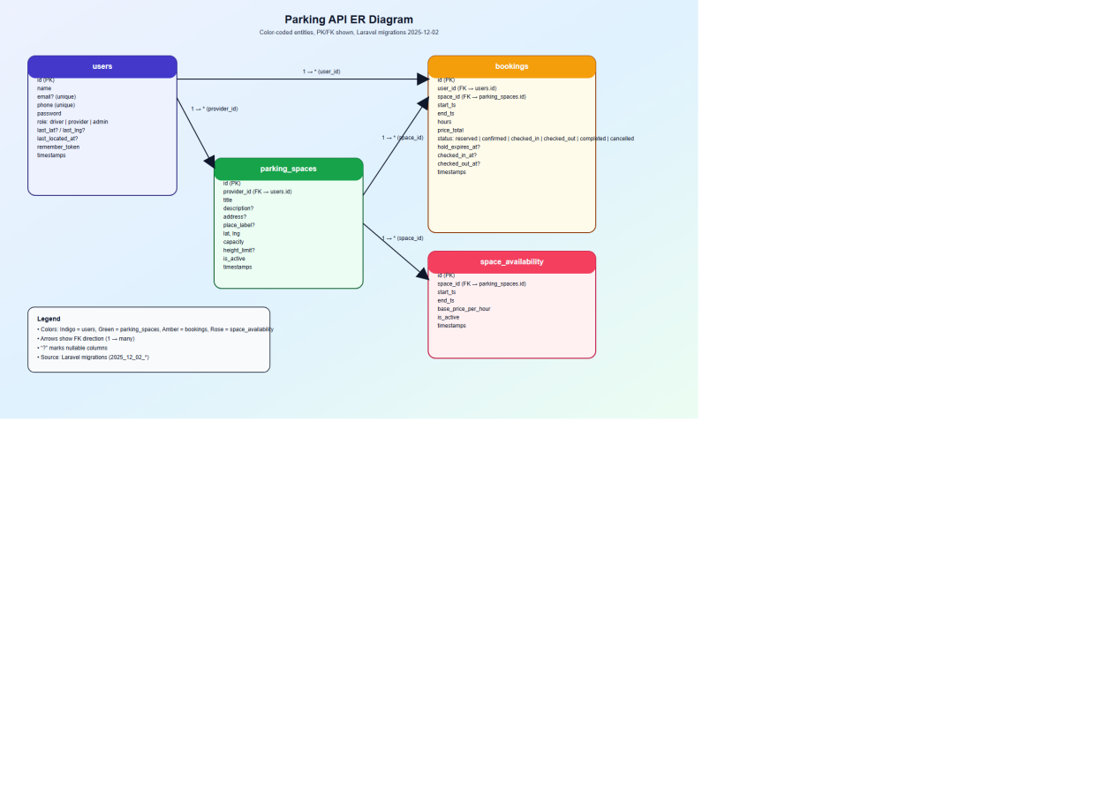

User Interaction Diagram
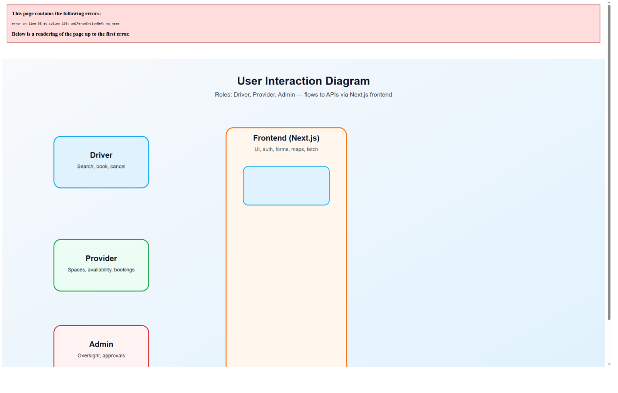

Data Model
users(id, name, phone unique, email?, role driver|provider|admin, password, last_lat?, last_lng?, last_located_at?, timestamps).
parking_spaces(id, provider_id→users, title, description?, address?, place_label?, lat, lng, capacity, height_limit?, is_active, timestamps).
space_availability(id, space_id→parking_spaces, start_ts, end_ts, base_price_per_hour, is_active, timestamps).
bookings(id, user_id→users, space_id→parking_spaces, start_ts, end_ts, hours, price_total, status reserved|confirmed|checked_in|checked_out|completed|cancelled, hold_expires_at?, checked_in_at?, checked_out_at?, timestamps).

Setup
Backend: php artisan migrate --seed; php artisan serve (http://127.0.0.1:8000).
Frontend: create .env.local with NEXT_PUBLIC_API_BASE=http://127.0.0.1:8000/api/v1; npm install; npm run dev (http://localhost:3000).

Risks & Next Steps
Security: JWT in localStorage; consider httpOnly cookies + refresh tokens.
Reliability: external geocode/map services can rate-limit; add fallbacks.
Quality: add automated tests (auth, search, booking, provider flows).

