Image labeling for experiment 2:

Image labeling for experiment 2:

1. Put the Labeling_v1.m and Labeling_v1.fig in the main folder where the subfolders of images are stored. Please delete all the label.csv and data.csv which are created from previous programs. **(Please copy and paste both files)**

2. Then double click on the Labeling_2.m to open in Matlab. (Please do not open Labeling_2.fig)

3. The Matlab window should look like the following window. **(If there is no run button then first click on the editor tab at the top then the run button will appear)**

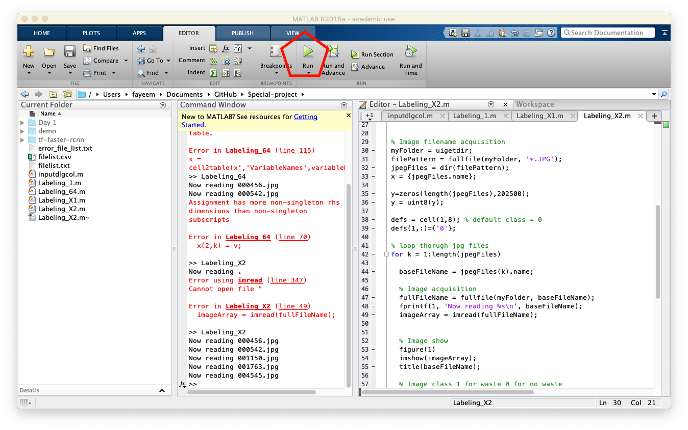

4. Press the run button. A new user interface will be opened which looks like the following figure.

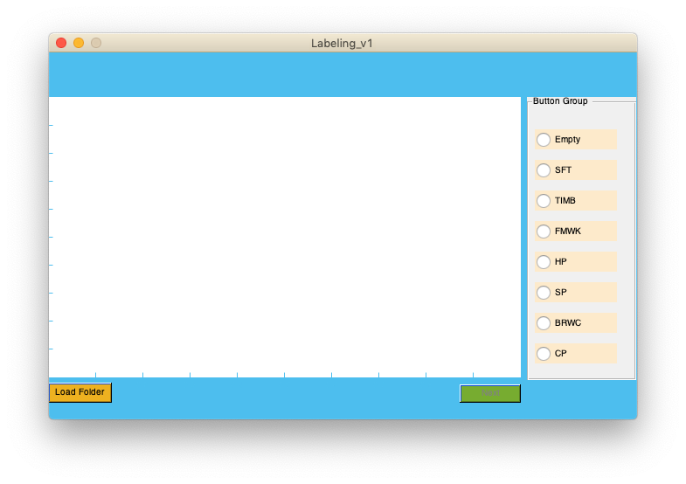

**(Please check the window carefully that the “Load Folder” button is active and the “Next” button is inactive. If not then close the window and run from ‘Labeling_v1.m’ again. )**

4. Press “Load Folder” button. A browser window will be open as shown in the figure. Select the image folder and press “select Folder” on windows “open” in mac.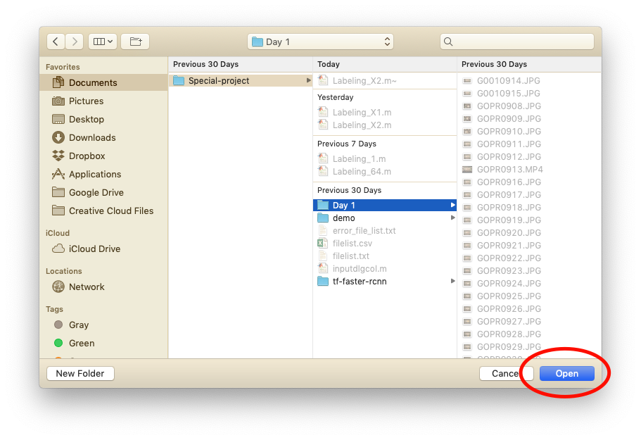

5. The first image will be opened in the window, and the next button will be activated.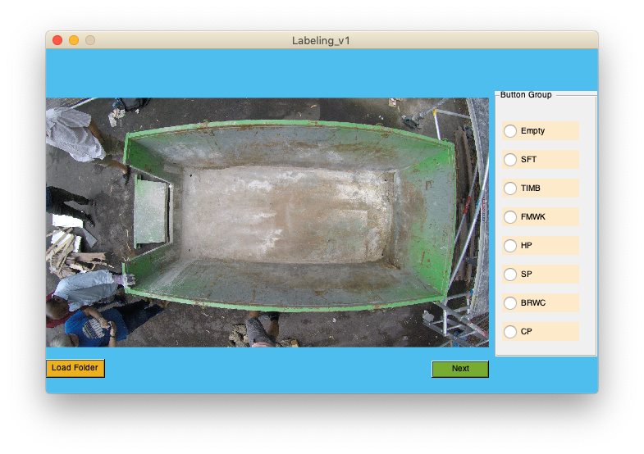

6. You can select classes from the right panel for the shown image then click next. You can select only one class because in experiment 1 one image should have one class only.

In the figure, I selected “Empty” because the bin is empty.

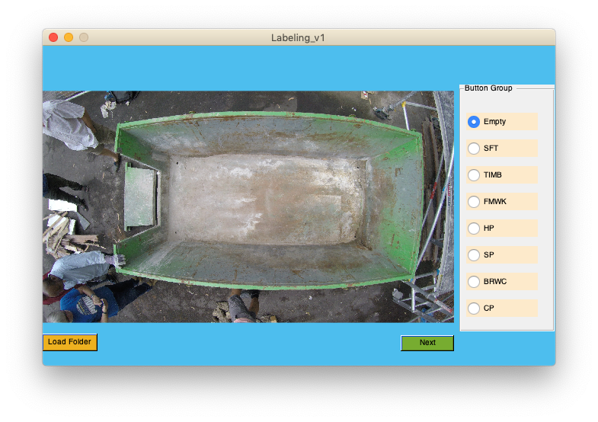

7. By pressing next the class and image name will be saved in “label.csv,” file the image data will be saved in “data.csv” file and the next image will be shown in the figure panel. Select the classes according to the image and then click next.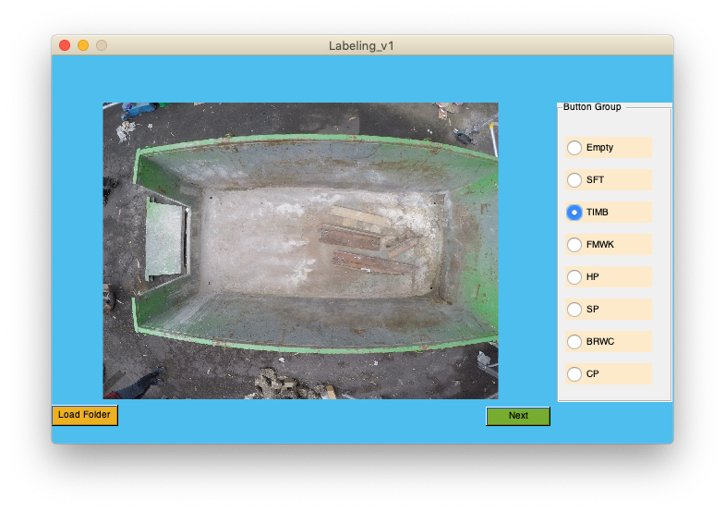

8. You can close the window any time and return to the program from step 2. The labeling will start from the image where you left. (Please do not delete ‘label.csv’ and ‘data.csv’ if you want to resume your labeling from the last image.)

9. After labeling all the image in a folder, the figure will show a notice, and the next button will be inactive like the following figure:

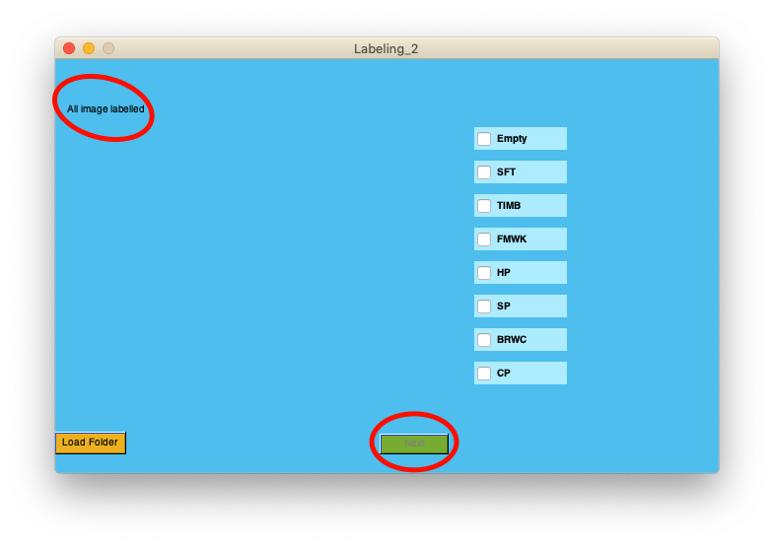

10. If you have finished labeling of images of a folder but accidentally open again from “Load Folder,” do not worry the window will show a notice and the next button will inactive like the following figure:

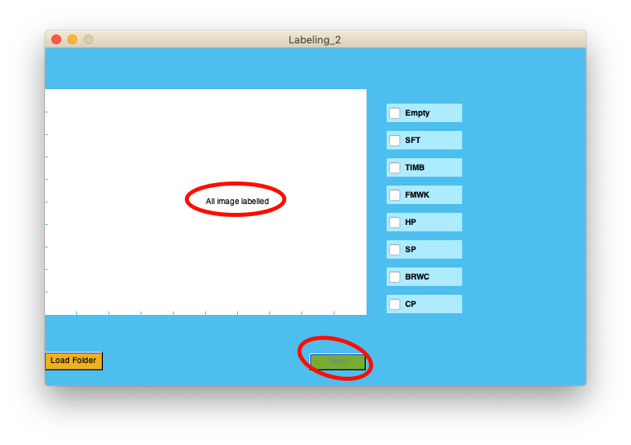

**Cautions:**

**• Please delete ‘label.csv’ and ‘data.csv’ files, which are created from previous programs, from the image folders before starting labeling by ‘Labeling_v1.m’.**

**• Do not delete ‘label.csv’ and ‘data.csv’ files if you started labeling from ‘Labeling_v1.m’ and want to resume your work from the middle of a folder. The labels will be saved automatically in the files. You can always close the window and later select the folder. The labeling will be started from the image where you left.**

**• If you want to start label images from the first image, delete the ‘label.csv’ and ‘data.csv’ files.**