Automating UAV with Integration of Raspberry PI 4 Model B

Report

Objective
The main aim and objective of this report is to explain our journey of integrating the Raspberry Pi 4 Model B with the UAV drone. What kind of sensors and camera did we used ? How they were integrated with the UAV model and what kind of configuration was made to the UAV to automate the whole process.

Raspberry Pi 4 Model B and Sensors
In the beginning we worked on understanding our Raspberry model, how do we interact with our model using Python ? The first task was to install Raspberry Pi OS into the circuit, and configure it. We were successfully able to Flash the OS into the SD card and boot our system. Next thing, we worked on installing all the required libraries to the OS. Our main aim was to interact with the sensors using the Raspberry. After successfully wiring the sensors we worked on writing the code required to initialize the VL53L0X sensor and testing the sensor at different distance making sure it is working properly and saving the results in CSV format as well.

TCA9548A (Multiplexer)
Next thing we want to avoid controlling all of our sensors using Raspberry Pi 4 only because this would not be cost effective and the bundle of different wires mixed together can making debugging harder later on. To avoid this we used Mux I.e the TCA9548A multiplex, through this circuit we could control multiple sensors at once using different channels from the MUX, our only work was the control the Mux using python. Luckily most of the libraries required to control different sensors were already available in python. Therefore, the configuration did not cause us any difficulty​. Moreover, the picture of wiring is also attached as a sort of proof of our work.

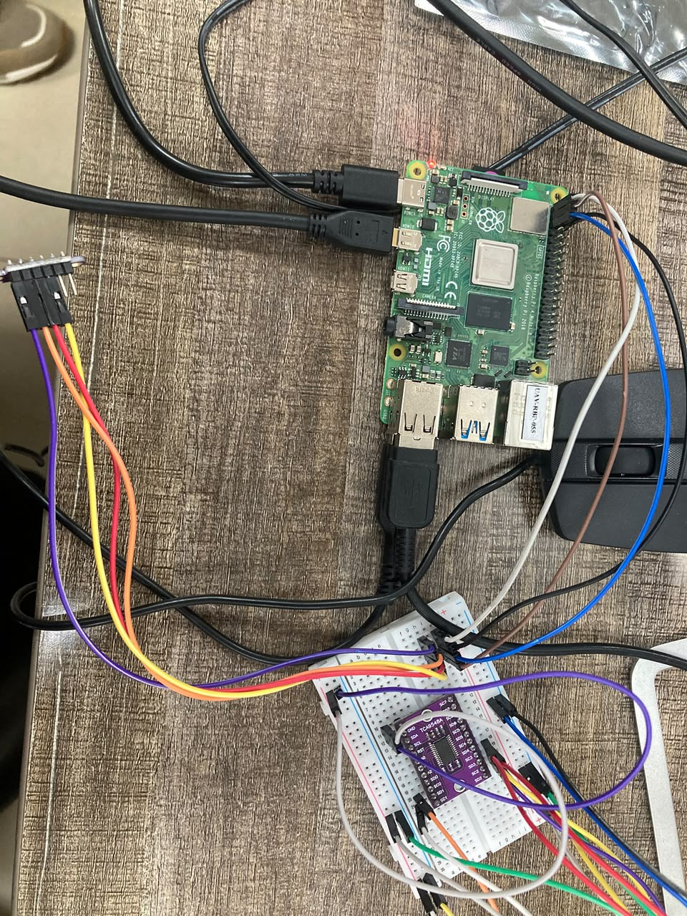
Raspberry Pi 4 Model B and Camera.
Moving forward we worked on the integration of the camera with the Raspberry Pi circuit. Since Raspberry Pi 4 had a built default setting to detect and connect the camera, our main work was to enable the camera from the interference setting of the Raspberry Pi 4 and it worked perfectly fine. Similarly since python3 also had a library to control the camera, therefore controlling the camera using python3 not difficult as well.

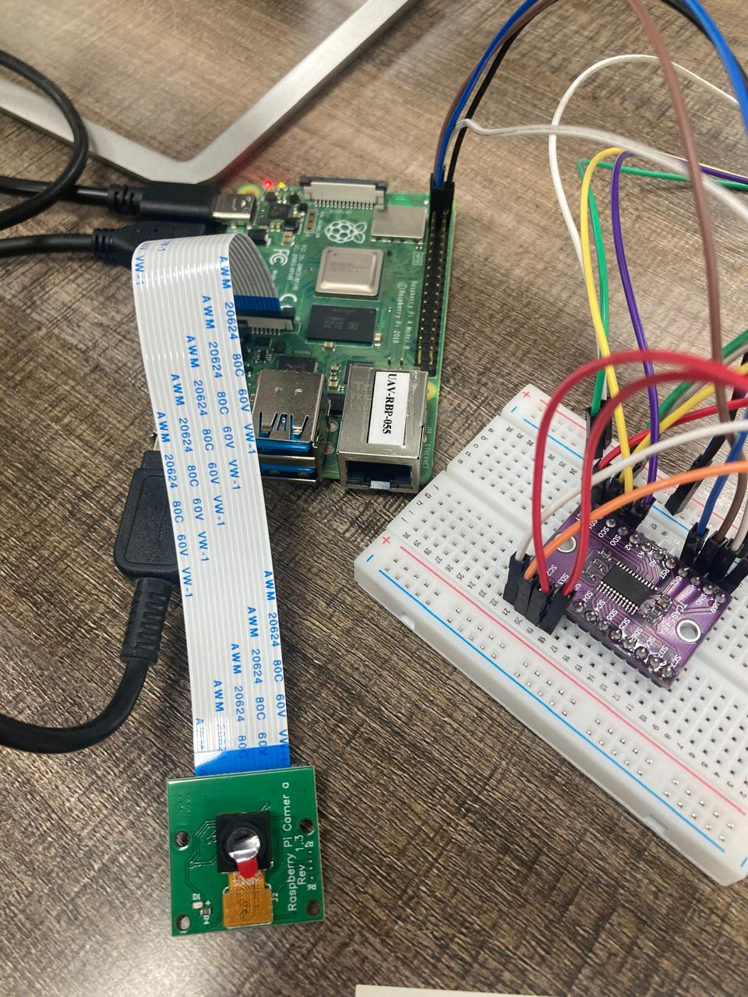
Drone Calibration with Mission Planner.
After Raspberry, our main worked shifted toward calibrating our UAV with Pixelhawk and MissionPlanner. Pixelhawk acted as the flight controller for our UAV. We had to calibrate our UAV compass , RC , GPS and Motors using Mission Planner. Some of the steps involved to calibrate our UAV are shown in the images below.
