
IUBAT- International University of Business Agriculture and Technology

Assignment on Assembly Language
(CSC 197)

Prepared for:
Humayun Kabir Biswas
Assistant Professor

Prepared by:
Name: Imtiaz Zaman Mehedi
ID: 17103024
Section: C
BCSE Department
Date: July 22, 2018

Answer to the question no: 1
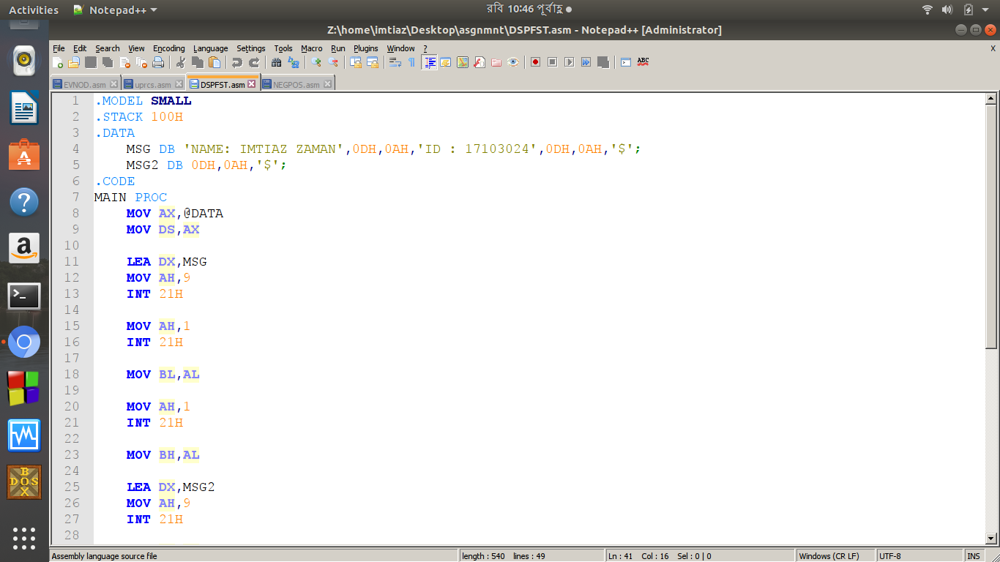

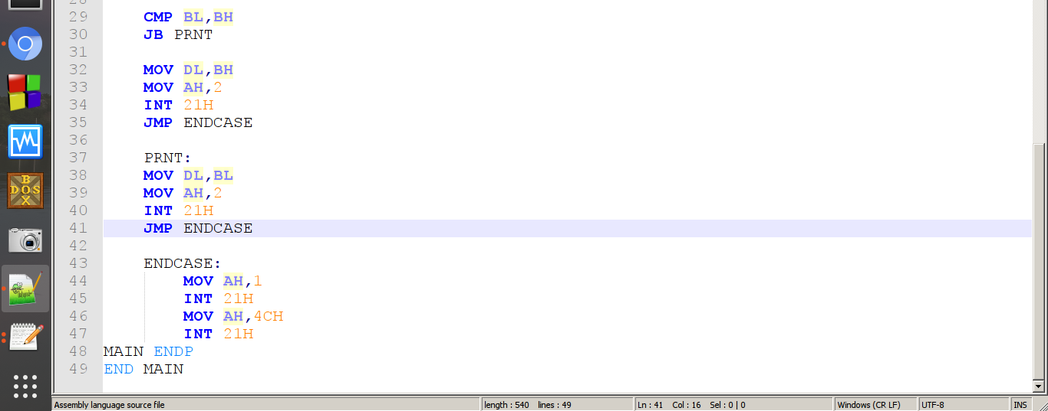

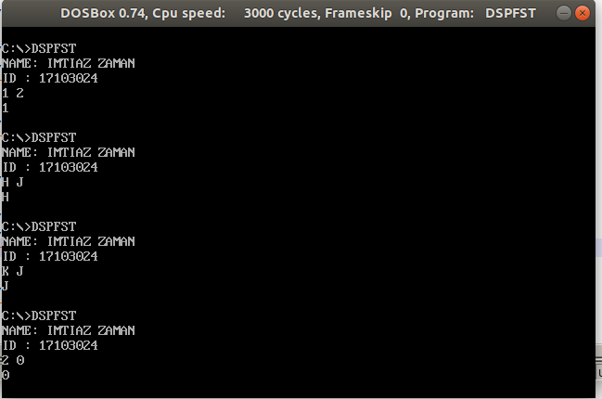

Answer to the question no: 2

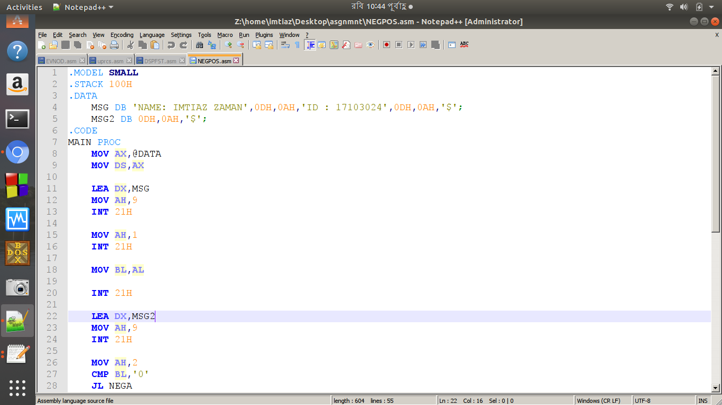
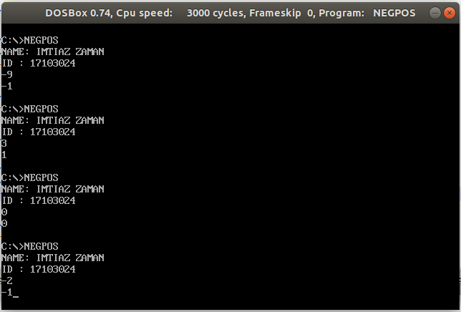
Answer to the question no: 3
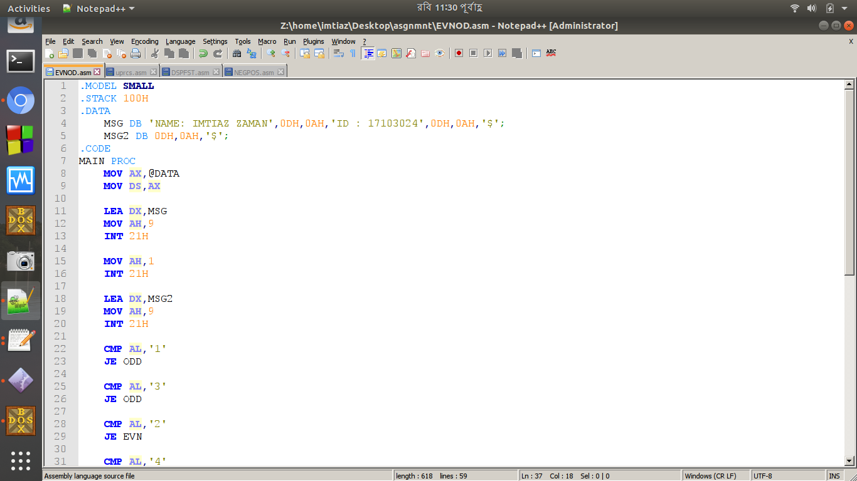
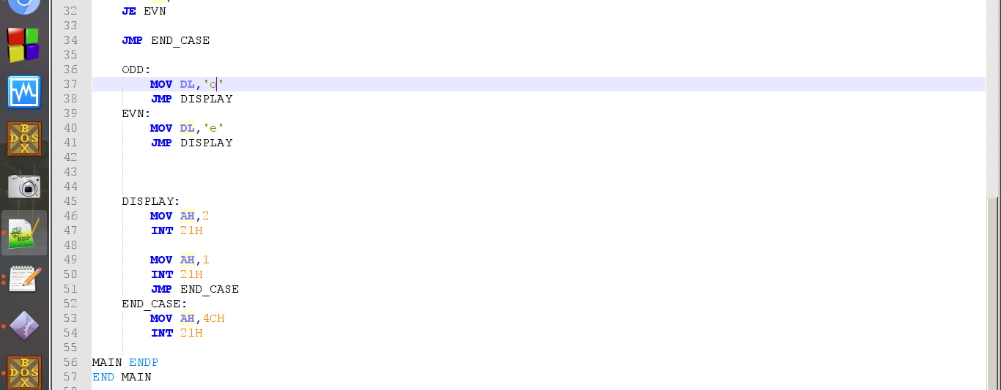
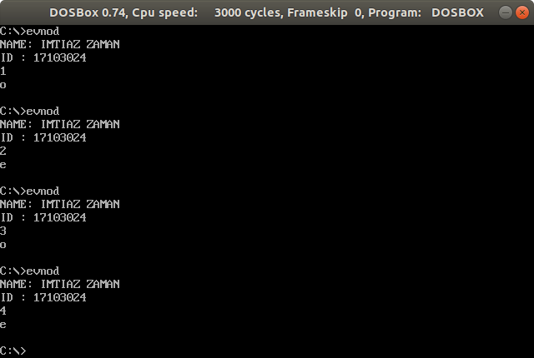

Answer to the question no: 4
