
IUBAT- International University of Business Agriculture
and Technology

Assembly Language Programming Assignment – 2

Prepared for:
Humayun Kabir Biswas
Assistant Professor

Prepared by:
Name: Imtiaz Zaman Mehedi
ID: 17103024
Section: C
BCSE Department
Date: 29 July 2018

PROGRAM NO :01

;a program to read a character from the keyboard and display it at the next position
;of the same line.

.MODEL SMALL
.STACK 100H
.CODE
MAIN PROC
MOV AH,1 ;TAKE A CHARACTER AS INPUT
INT 21H

MOV DL,AL
MOV AH,2 ;PRINT THE CHARACTER
INT 21H

MOV AH,1
INT 21H

MOV AH,4CH ;EXIT DOS
INT 21H
MAIN ENDP
END MAIN

INPUT AND OUTPUT:

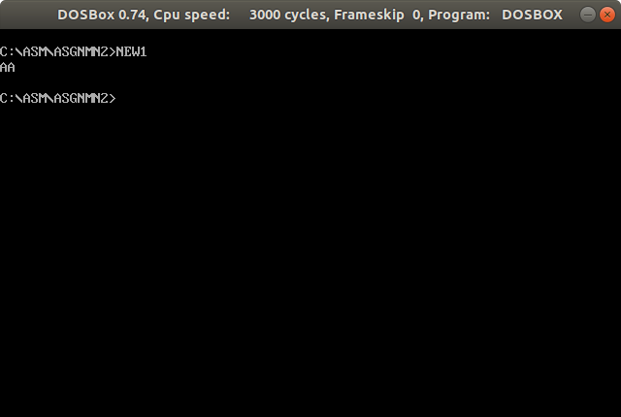

PROGRAM NO :02

;a program to read a lower case character from the keyboard and display it at the
;beginning of the next line in uppercase.

.MODEL SMALL
.STACK 100H
.CODE
MAIN PROC
MOV AH,1 ;INPUT FUNCTION
INT 21H ;TAKE INPUT

SUB AL,20H ;MAKE IT UPPERCASE

MOV BL,AL

MOV AH,2 ;OUTPUT FUNCTION
MOV DL,0DH ;CARRIAGE RETURN
INT 21H
MOV DL,0AH ;LINE FEED
INT 21H

MOV DL,BL
INT 21H ;PRINT UPPERCASE LETTER

MOV AH,1
INT 21H

MOV AH,4CH ;EXIT DOS
INT 21H
MAIN ENDP
END MAIN

INPUT AND OUTPUT:
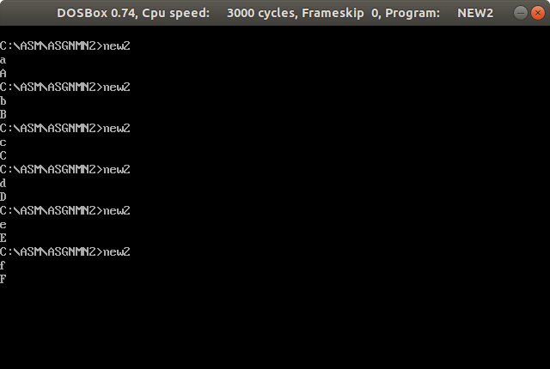

PROGRAM NO :03

;a program to prompt the user, and read first, middle and read last initials of a
;person’s name, and display them down the left margin.

.MODEL SMALL
.STACK 100H
.DATA
NEWLINE DB 'ENTER THREE INITIALS:$'
NEWLINE1 DB 0AH,0DH
X DB ?,0AH,0DH
Y DB ?,0AH,0DH
Z DB ?,'$'

.CODE
MAIN PROC
MOV AX,@DATA
MOV DS,AX

MOV AH,9
LEA DX,NEWLINE
INT 21H

MOV AH,1 ;INPUT FUNCTION

INT 21H ;TAKE THREE VALUE AND MOVE IT TO X,Y AND Z
MOV X,AL

INT 21H
MOV Y,AL

INT 21H
MOV Z,AL

MOV AH,9
LEA DX,NEWLINE1 ;PRINT FIRST TO UNTIL '$' CHARACTER OF THE DATA ;SEGMENT
INT 21H

MOV AH,1
INT 21H

MOV AH,4CH ;EXIT DOS
INT 21H
MAIN ENDP
END MAIN

INPUT AND OUTPUT:
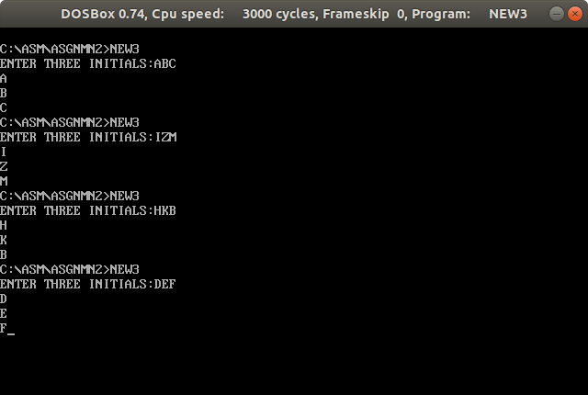
PROGRAM NO :04

;a program to display a”?” read two decimal digits whose sum is less than 10 display them and their sum on the
;next line, with an appropriate message.

.MODEL SMALL
.STACK 100H
.CODE
MAIN PROC
MOV AH,2 ;PRINT '?' CHARACTER
MOV DL,'?'
INT 21H
MOV DL,' '
INT 21H

MOV AH,1 ;INPUT FUNCTION
INT 21H ;TAKE INPUT:FIRST NUMBER

MOV BL,AL

MOV AH,2
MOV DL,' '
INT 21H

MOV AH,1
INT 21H ;TAKE INPUT:SECOND NUMBER

ADD BL,AL ;ADD TWO NUMBER
SUB BL,30H

MOV AH,2 ;PRINT NEW LINE
MOV DL,0AH
INT 21H
MOV DL,0DH

INT 21H

MOV DL,BL
INT 21H ;PRINT RESULT

MOV AH,1
INT 21H

MOV AH,4CH ;EXIT DOS
INT 21H
MAIN ENDP
END MAIN

INPUT AND OUTPUT:

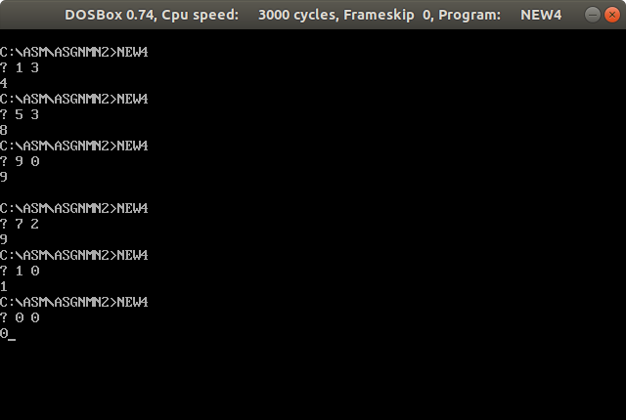

PROGRAM NO :05

;Write a program to display a”?” read three characters, and then display them in the
;middle of an 11×11 box of asterisks.

.MODEL SMALL
.STACK 100H
.DATA
A DB ?
B DB ?
D DB ?
E DB ?
.CODE
MAIN PROC
MOV AX,@DATA ;INITIALIZE THE DATA SEGMENT
MOV DS,AX

MOV DL,'?' ;PRINT '?'CHARACTER
MOV AH,2

INT 21H

MOV AH,1 ;INPUT 3 CHARACTERS
INT 21H
MOV A,AL

INT 21H
MOV B,AL

INT 21H
MOV D,AL

MOV AH,2

MOV DL,0AH ;PRINT NEWLINE
INT 21H
MOV DL,0DH
INT 21H

MOV CX,0CH ;OUTER LOOP COUNTER
PRNT: ;OUTER LOOP
MOV E,0BH ;COUNTER FOR INNER LOOP
DEC CX
JNZ ITERATION
JMP ENDCASE
ITERATION: ;INNER LOOP
CMP CX,6H ;AFTER FIVE ITERATION OF OUTER LOOP
JZ BELOW ;GO TO 'BELOW' LABEL

MOV DL,'*' ;PRINT '*'CHARACTER
INT 21H

DEC E
JNZ ITERATION
MOV DL,0AH
INT 21H
MOV DL,0DH
INT 21H
JMP PRNT
BELOW: ;PRINT 6TH LINE OF OUTPUT
CMP E,0
JE NEWLINE ;IF 6TH LINE FINISHED GO FOR PRINT THE 7TH LINE
MOV DL,'*'
INT 21H
DEC E
CMP E,7H
JNZ BELOW
MOV DL,A
INT 21H
DEC E
MOV DL,B
INT 21H
DEC E
MOV DL,D
INT 21H
DEC E
JMP BELOW
NEWLINE: ;PRINT A NEWLINE AND GO TO THE OUTER LOOP AGAIN
MOV DL,0AH
INT 21H
MOV DL,0DH

INT 21H
JMP PRNT
ENDCASE: ;DOS EXIT
MOV AH,4CH
INT 21H

MAIN ENDP
END MAIN

INPUT AND OUTPUT:

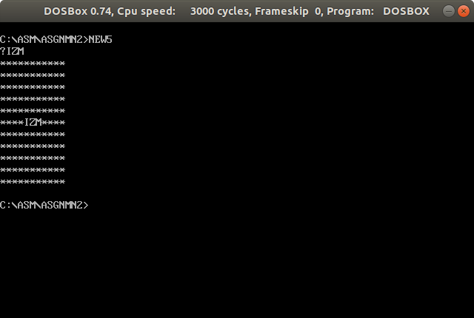

PROGRAM NO :06

;a program to prompt the user, read a character, and if it is an uppercase letter,
;display it at the beginning of the next line.

.MODEL SMALL
.STACK 100H
.CODE

MAIN PROC

MOV AH,1 ;INPUT A CHARACTER
INT 21H

MOV BL,AL

CMP BL,'A' ;CHECK WHETHER IT IN BETWEEN 'A' TO 'Z' OR NOT
JNGE ENDCASE

CMP BL,'Z'
JNLE ENDCASE

MOV AH,2 ;IF IT IS PRINT THE NEW LINE AND THE CHARACTER
MOV DL,0AH
INT 21H
MOV DL,0DH
INT 21H

MOV DL,BL
INT 21H
ENDCASE: ;DOS EXIT
MOV AH,1
INT 21H
MOV AH,4CH
INT 21H
MAIN ENDP
END MAIN

INPUT AND OUTPUT:

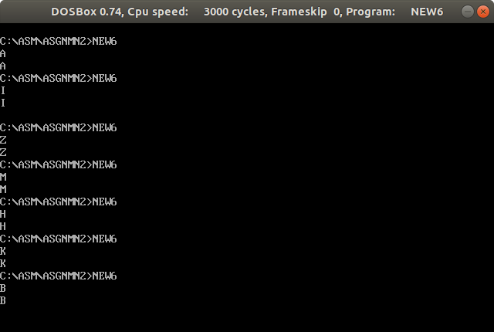

PROGRAM NO :07

;a program that will prompt the user to enter a hex digit character (0 – 9 or A – F),
;display it on the next line in decimal. If the user enters an illegal character, prompt the
;use to try again.

.MODEL SMALL
.STACK 100H
.DATA
A DB 'ENTER A HEX DIGIT: $'
B DB 0AH,0DH,'IN DECIMAL IT IS $'
D DB 0AH,0DH,'DO YOU WANT TO DO IT AGAIN?$'
E DB 0AH,0DH,'ILLEGAL CHARACTER _ ENTER 0...9 OR A...F:$'
.CODE
MAIN PROC
MOV AX,@DATA ;INITIALIZE THE DATA SEGMENT
MOV DS,AX

FST1:
LEA DX,A ;ENTER A HEX DIGIT
MOV AH,9
INT 21H
FST2:
MOV AH,1 ;INPUT A CHARACTER
INT 21H
MOV BL,AL

CMP BL,'0' ;CHECK WHETHER IT IS IN BETWEEN 0 TO 9
JNGE LABEL1
CMP BL,'9'
JNLE LABEL1

LEA DX,B ;PRINT THE DIGIT IN BETWEEN 0 TO 9
MOV AH,9
INT 21H

MOV AH,2
MOV DL,AL
INT 21H
JMP LABEL3
LABEL1: ;CHECK WHETHER IT IS IN BETWEEN 'A' TO 'F'
CMP BL,'A'
JNGE LABEL2
CMP BL,'F'
JNLE LABEL2

LEA DX,B ;PRINT DECIMAL FORM IF IT IS IN BETWEEN 'A' TO 'F'
MOV AH,9
INT 21H

CMP BL,'A'
JE P1
CMP BL,'B'
JE P2
CMP BL,'C'
JE P3
CMP BL,'D'
JE P4
CMP BL,'E'
JE P5

CMP BL,'F'
JE P6
LABEL2: ;PRINT MESSAGE IF IT IS ILLEGAL AND WANT ANOTHER INPUT
LEA DX,E
MOV AH,9
INT 21H
JMP FST2
LABEL3: ;ASK USER FOR DOING IT AGAIN OR NOT
LEA DX,D
MOV AH,9
INT 21H

MOV AH,1
INT 21H
CMP AL,'Y'
JE NEWLINE
CMP AL,'y'
JE NEWLINE
JMP ENDCASE
P1: ;PRINT THE DECIMAL FORM OF 'A'
MOV AH,2
MOV DL,'1'
INT 21H
MOV DL,'0'
INT 21H
JMP LABEL3
P2: ;PRINT THE DECIMAL FORM OF 'B'
MOV AH,2
MOV DL,'1'
INT 21H
MOV DL,'1'
INT 21H
JMP LABEL3
P3: ;PRINT THE DECIMAL FORM OF 'C'
MOV AH,2
MOV DL,'1'
INT 21H
MOV DL,'2'
INT 21H
JMP LABEL3
P4: ;PRINT THE DECIMAL FORM OF 'D'
MOV AH,2
MOV DL,'1'
INT 21H
MOV DL,'3'
INT 21H
JMP LABEL3
P5: ;PRINT THE DECIMAL FORM OF 'E'
MOV AH,2
MOV DL,'1'
INT 21H
MOV DL,'4'
INT 21H
JMP LABEL3
P6: ;PRINT THE DECIMAL FORM OF 'F'
MOV AH,2
MOV DL,'1'
INT 21H
MOV DL,'5'
INT 21H
JMP LABEL3
NEWLINE: ;PRINT A NEW LINE AND GO FOR START FROM FIRST

MOV AH,2
MOV DL,0AH
INT 21H
MOV DL,0DH
INT 21H
JMP FST1
ENDCASE: ;DOS EXIT
MOV AH,1
INT 21H
MOV AH,4CH
INT 21H
MAIN ENDP
END MAIN

INPUT AND OUTPUT:

