**Prerequisite before installing R studio**: Install R

Install R from here: <https://cran.r-project.org/bin/windows/base/>

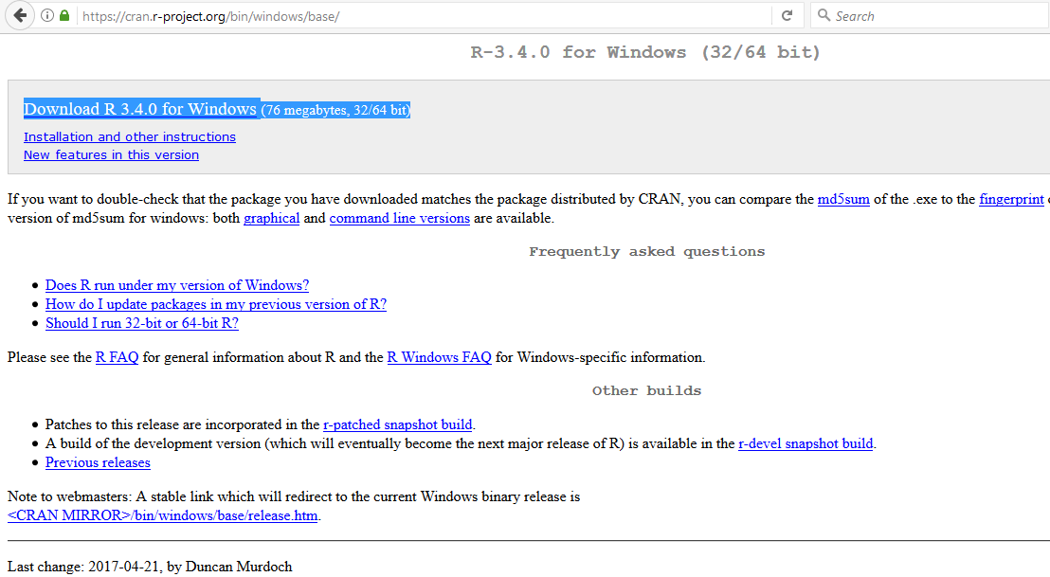

Click on download link:

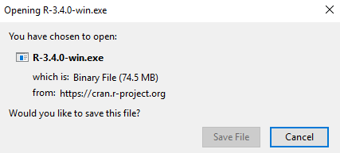

Click save and wait until the download has finished. Once the download is finished go to the folder where .exe file is located, right click on the file and click “Run as administrator”

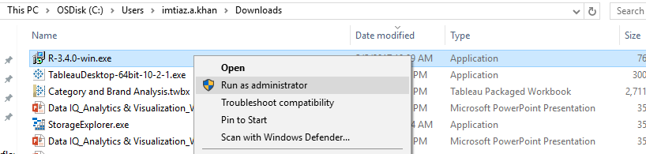

Select English and click ok

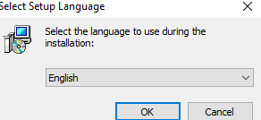

Click Next

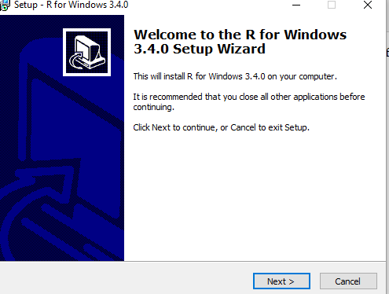

Click Next again

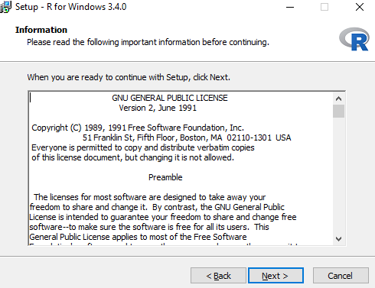

Click next again, it shows the default location where the program is installed

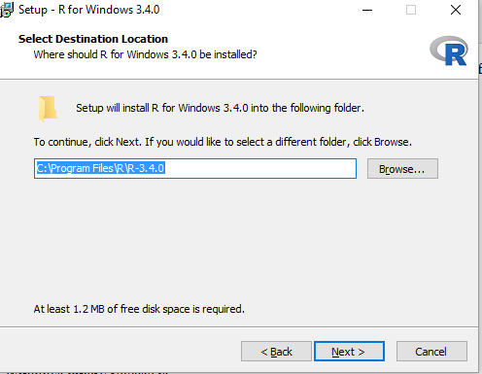

Click Next again, don’t uncheck any check boxes.

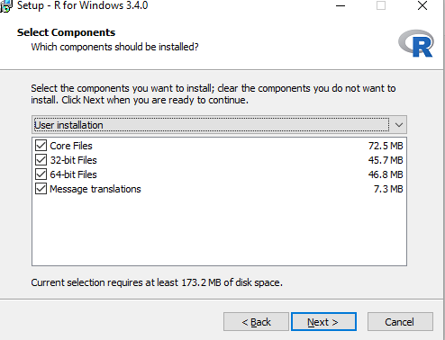

Click Next

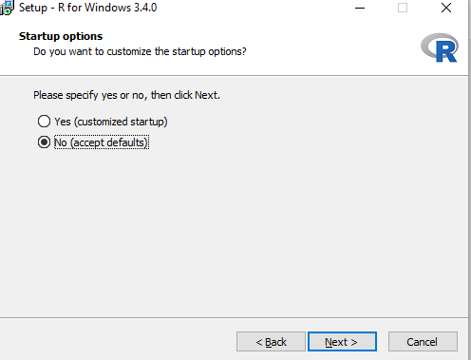

Click next

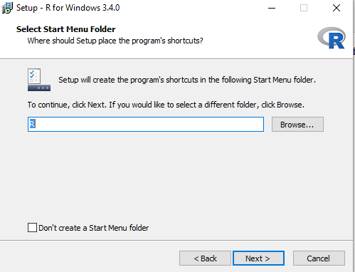

Click next again

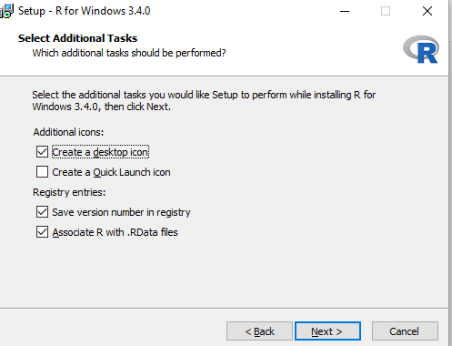

Setup will install the R on your computer, wait until the process is finished.

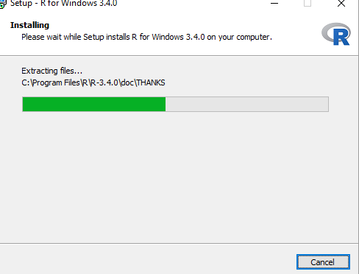

Click Finish to finish the installation.

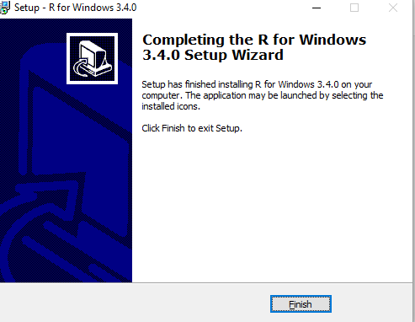

Now you have completed the pre-requisite to install **Rstudio**, go to the below location to and download R studio

Install R studio from here: <https://www.rstudio.com/products/rstudio/download/>

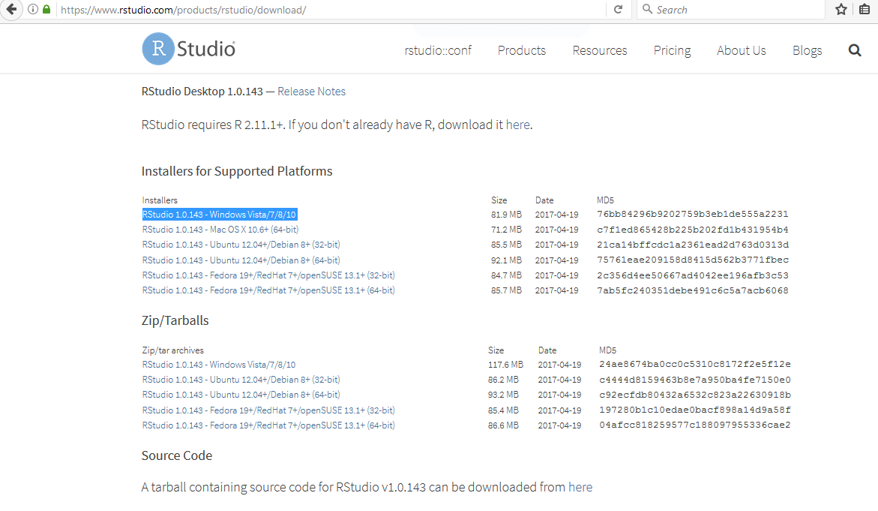

Click on the version highlighted in the document

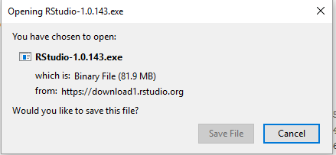

Click Save file.

The file starts to download, After the download has finished go to the folder where the file is present.

Right click on the file and click “**Run as Administrator**”

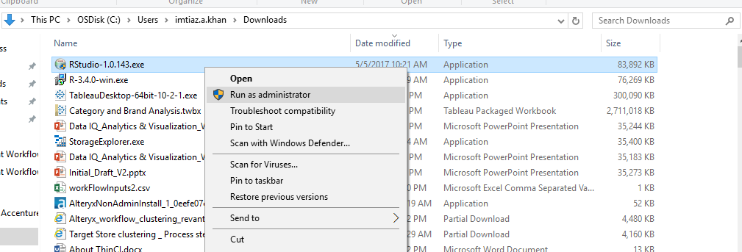

Click Next

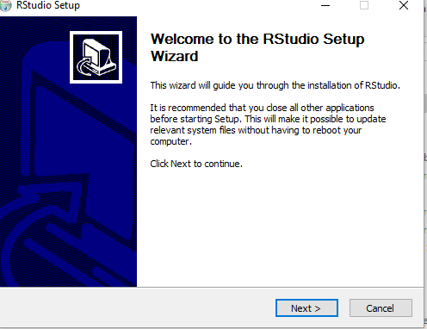

Click Next

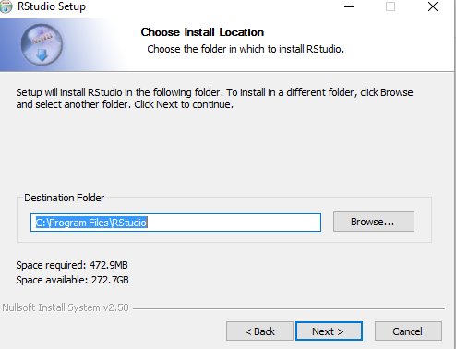

Click Install

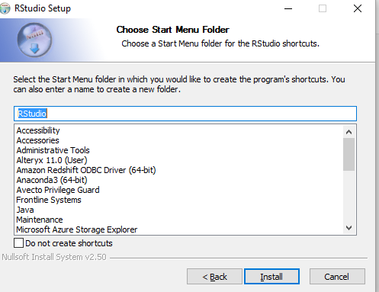

Installation proceeds as below, wait until the installation is complete.

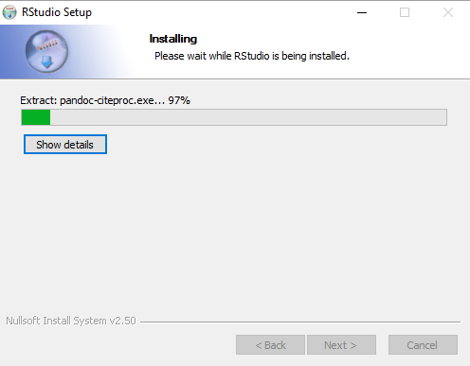

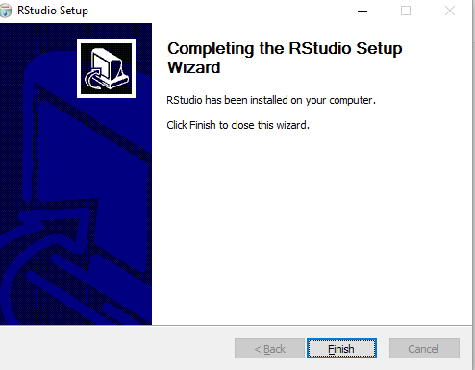

Click Finish**, R studio is successfully installed.**