

**NORTHSOUTH UNIVERSITY**

**PROJECT NAME: *BUS MANAGEMENT SYSTEM***

**SUBMITTED BY:**

**Afia Maliha Aysharjo: 1711418642**

**Imtiaz Ahmed: 2013552642**

**Rakeen Aziz: 1731931642**

**Date: 5th January,2022**

**Bus Management System**

In this project we are going to work on Bus Management System. In our country bus services are very poor. It is very difficult for the people to use the bus service. We are trying to develop an bus management system which makes transportation easier than expected. In this system people can easily have the opportunity to book their seats without facing any unpleasant situation. He/she can see the pathways of his/her destination, reserve seats, make payments through online, even cancel the reservation from home. People can use bus transportation more comfortably and there will be no gathering or overcrowding, these are the facts which are the main reason to demotivate people for using bus service. We are here to give a comfortable system so that people are more into bus services as they have lost all their interest about it and at the same time using technologies to make it easier for people so that they get more motivation to use it.

**Problem Definition:**

If we consider the history of the bus services that are provided by our country, what we will see is the bitter experiences of people that are now increasing rapidly. Bus journey was always an unpleasant experience for the people of our country as they face many problems such as lacking of seats, overcrowding, taking more passengers without having any seats, charging extra money for various unusual reasons.

At present, poor service and worst environment are making the passengers who use bus services in Dhaka city regularly very uncomfortable. They have to face a number of problems like- long waiting period, traffic jam, increased amount of fare, over-crowd, unavailability of seats, rude behavior of the bus staff members, delayed boarding time, discomfort inside the bus, transport inadequacy during peak hour and many more.

If we see one article of “*The Daily Star”* we can see an experience shared by a passenger who has shared her experience:

“I wish I had wings so that I could fly to my school!”- dreams Nuha Amin (not her real name), a student of class VI of Agrani High School and College. Little Nuha who takes a local bus to reach her school cannot reach the ceiling to hold on the handles, yet she manages a place to stand in the crowd with a heavy school bag on her back. While getting down, she always tries to stand close to the gate of the bus, but the passengers often push her in the middle making it difficult for her to get down.

Nuha's experience is one of the most common scenarios that the local bus commuters face on a regular basis in Dhaka today. Now-a-days, according to the regular passengers, the local bus services have failed to meet their travel needs because of the existing poor-quality services which mostly create trouble for the children, women and disabled persons.

Reference: <https://www.thedailystar.net/star-weekend/existing-crisis-local-buses-150220>

Thus, the problems of using the bus services can be described.

**Motivation of my choice:**

In this project we are going to work on Bus Management System where we are basically working on bus services and what motivates us to work on this particular project is the regular passengers who take the bus services that have failed to meet their travel needs because of the existing poor-quality services which mostly create trouble for the children, women and disabled persons. So, we are going to work on a project that will be time oriented, Budget friendly and there will be no overcrowding as people can book their seats from their respective home. At the same time, people will meet with a new technological way to enjoy their journey.

**Background:**

Here we are going to discuss about some web facilities that claim to provide advance transport services we are going to talk about the advance service of our Bus Management System that makes our service different from others:

**Sohoz:**

• In case of seat reservation ,Sohoz doesn’t refund whether someone cancels their seat or they appear late. However, as a ticket selling agent, Shohoz.com is bound to comply with the terms set by the operator/event organizer/vendor whose ticket it is selling. So, if the operator/event organizer denies refund even though claim was made within the terms mentioned in their page, Shohoz.com will be unable to issue such refund.

• On the other hand, our service claims to refund 70% of the exact money that someone pays for seat reservation. And this reservation will be made on any circumstance whether it is the late arrival of the passenger or the cancellation of the seat.

• In case of seat cancellation sohoz needs some written procedure like Ticket PNR (required if a ticket was issued), Mobile number used while buying the ticket, Category (e.g Bus/Launch), Date of payment, Method of Payment (e.g., bkash, COD, card), Mobile payment (for mobile payments), Card type (e.g., Visa) and last 4 digits (for card payments). But in case of our service we have a very simple process where a tab will be provided where a passenger needs to add only their OTP no. That was provided during their reservation and they just need to press cancel my reservation button on that particular page and then another OTP will be send on their phone after entering the OTP number their reservation will be cancelled successfully.

• Eid tickets are non-refundable and cannot be cancelled or rescheduled- this one particular line doesn’t make any sense as there will be no cancellation there will be no question of giving any refund. But in case of any festival our system is always providing you the best and reasonable solution so we are going to have the same policy of giving 70% of refund on any cancellation. (https://www.shohoz.com/)

**Uber**

• In case of Uber, this app is not pocket friendly. Moreover, Uber only provides Cars and Bikes which may create a lot of traffic jam and moreover this is something that may not help us in case of public welfare as a large number of times will be destroyed by staying lodged in traffic jam

• Uber makes the most of your time on the road on the platform with the largest network of active riders. But in case of our project there will be some particular busses that may carry some significant number of passengers that may help to decrease the traffic jam on roads. (https://www.uber.com/bd/en/s/d/kochab/)

**Pathao**

• In case of Pathao they mainly prefer to hand-to-hand payment as they are not much acceptable towards online digital payment system.

• If we are paying online through bKash the whole payment mainly takes a lengthy process to reach to the rider that’s why they prefer hand to hand process.

• Pathao mainly works for bike service and food delivery service. So that mainly creates a lot of traffic because of the increasing number of the bikers. (https://pathao.com/bn/)

In case of our system there will be both hand to hand procedure and Online payment procedure and none of them are lengthy process in fact there will be a quick system of payment that will create no delay.

**Coach Charter Europe**

• Coach charter Europe is an international System where there is a system called “Guided Tour Service” which will provide a guideline to the passengers that will indicate some beautiful and historical places that the passengers may enjoy on their way to their journey.

• We want to add these features in our project where we will hire a guide from any Guide Hiring Agencies like Bangladesh Scenic, Guruwalk, Rent a guide, With locals etc. Let’s say a tourist agency wants to hire a bus from our service system, we are going to provide a tourist guide from our end that will be a complementary for our side for such kind of agencies. (https://www.coach-charter-europe.de/services/)

**Solution of the problem**

In order to solve such problems:

• Initially we want to build a web application that will allow its users to log into their accounts from where they can pay online and get a verification code which they will use after reaching to their destinations. They can also pay by cash after getting on a bus. This will solve the transport inadequacy during peak hour and will also solve the payment problem like charging no extra money.

• The web application will be interfaced with multiple servers from which all the data of the users .It will keep only the necessary information of the users and after a certain period the data will be removed. By using this web-application people don’t need to wait for the particular bus and so there will be no chance of overcrowdings and unhealthy situation.

Inquery/booking/payment Maintain master

BUS

RESERVATION

USER

Tickets/service details

ADMIN

**Specification of the project:**

**Relationship:**

* In this ER Diagram there is no Weak Entity.
* The relationship between Bus and Admin is Many to one because many Buses manage by a single Admin.
* The relationship between Bus and Reservation is One to one because One Bus get One Reservation.
* The relationship between Reservation and Admin is Many to one because Many Reservations manages in single Admin.
* The relationship between Reservation and User is Many to one because Many Reservations book in a single Admin.

**Entities & their Attributes:**

* **Bus has this attribute:** bus_Id, total Seat, date, time
* Reservation has this attribute: bus_Id, status, price, seat_rev, date
* **User has this attribute**: user_Name, user_phone, user_Password, user_Email. Here user_Email & user_Phone is multivalued attribute
* **Admin has this attribute:** admin_Name, admin _phone, admin _Password, admin _Email. Here admin_Email & admin_Phone is multivalued attribute.

**ER Diagram:**

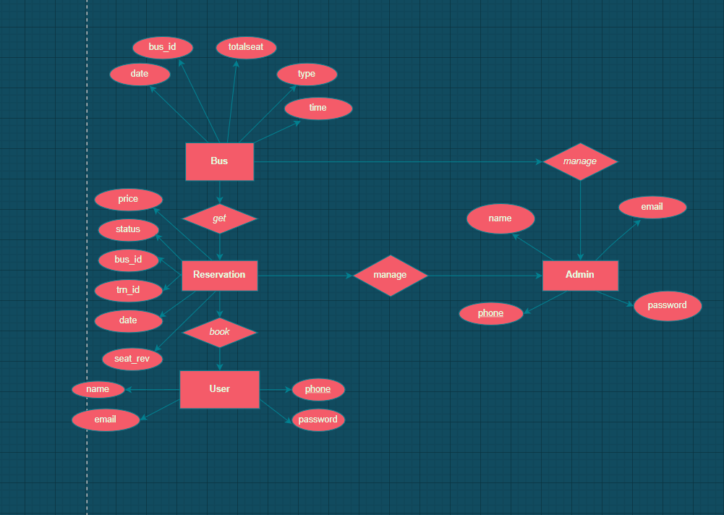

**Figure1.1:ER diagram**

**Relational Table:**

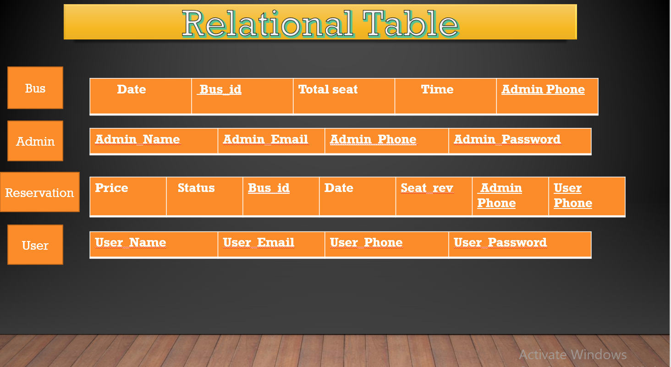

**Figure1.2: Relational Table**

**Normalization Form(1 NF):**

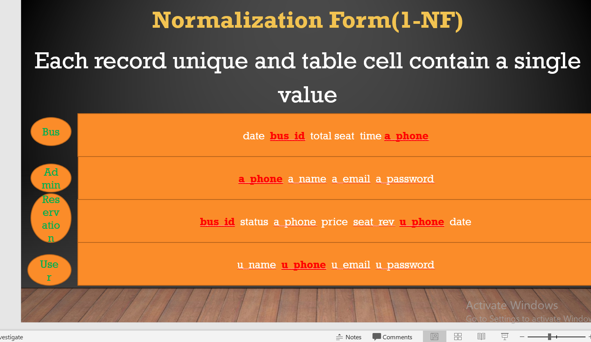

**Figure1.3:Normalization Form(1NF)**

**Normalization Form(2NF):**

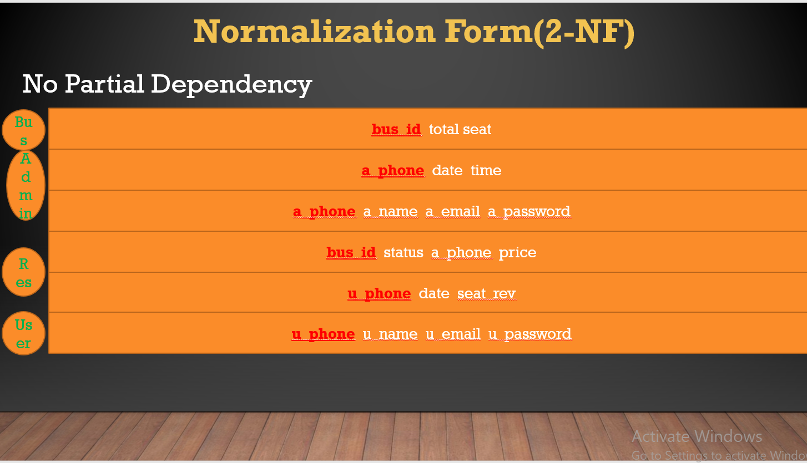

**Figure1.4:Normalization Form(2NF)**

**Normalization Form(3 NF):**

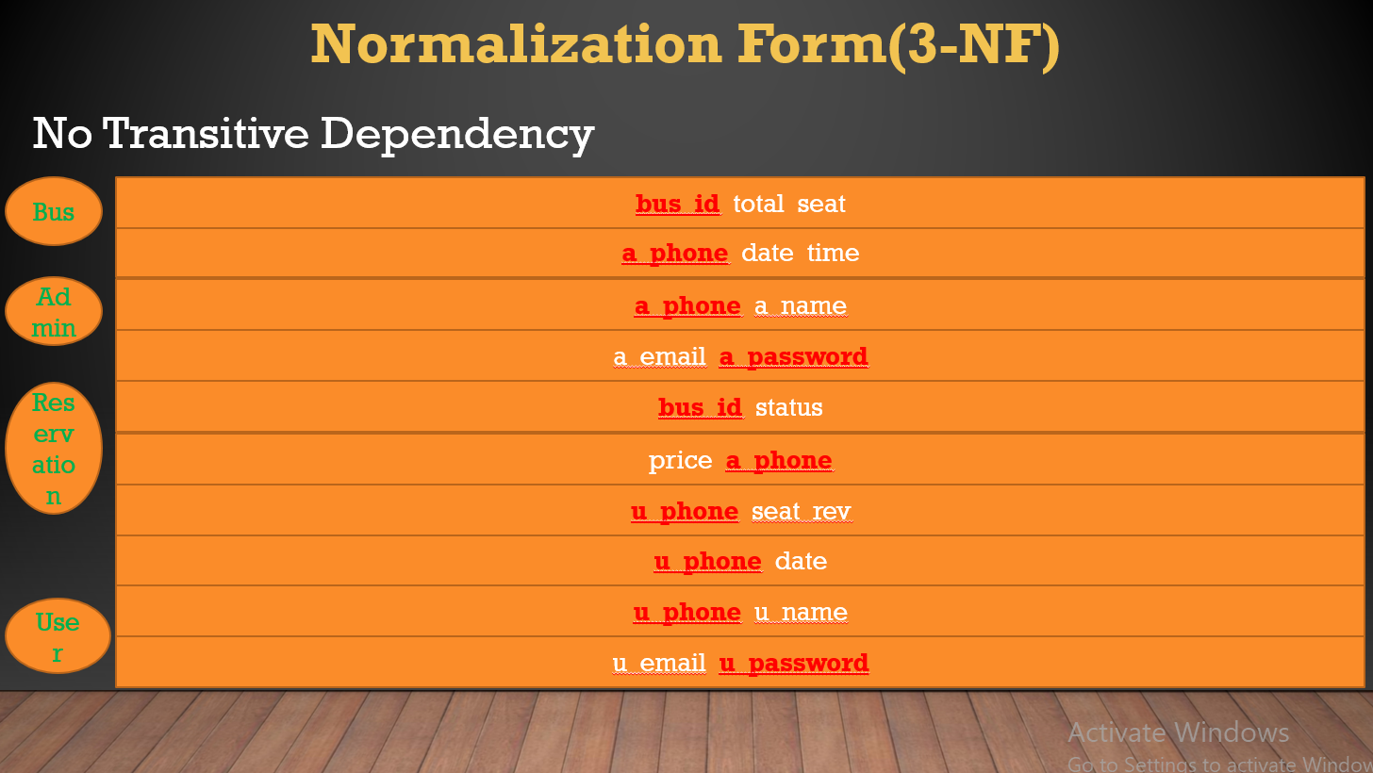

**Figure1.5:Normalization Form(3NF)**

**Normalization Form(4 NF):**

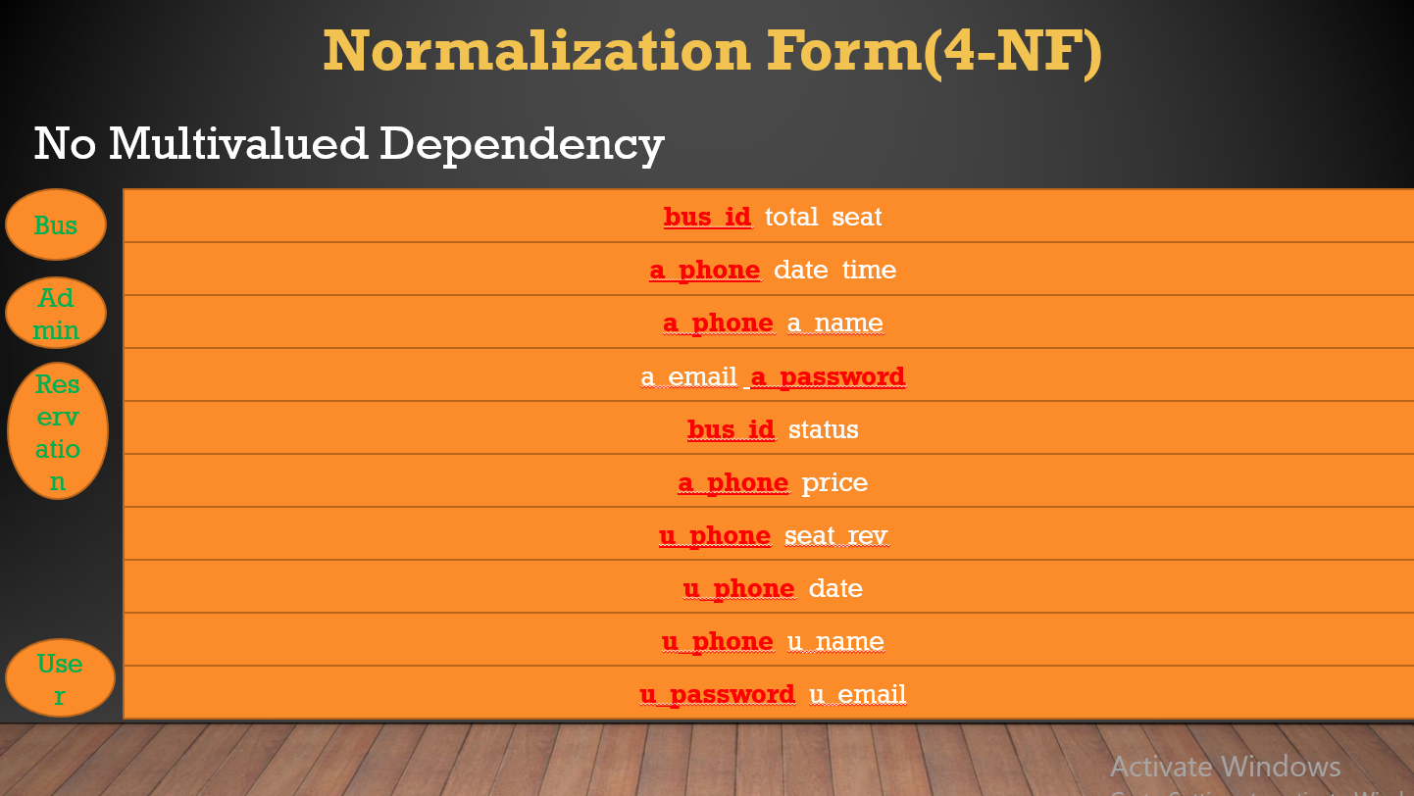

**Figure1.6:Normalization Form(4NF)**

**Gantt Chart:**

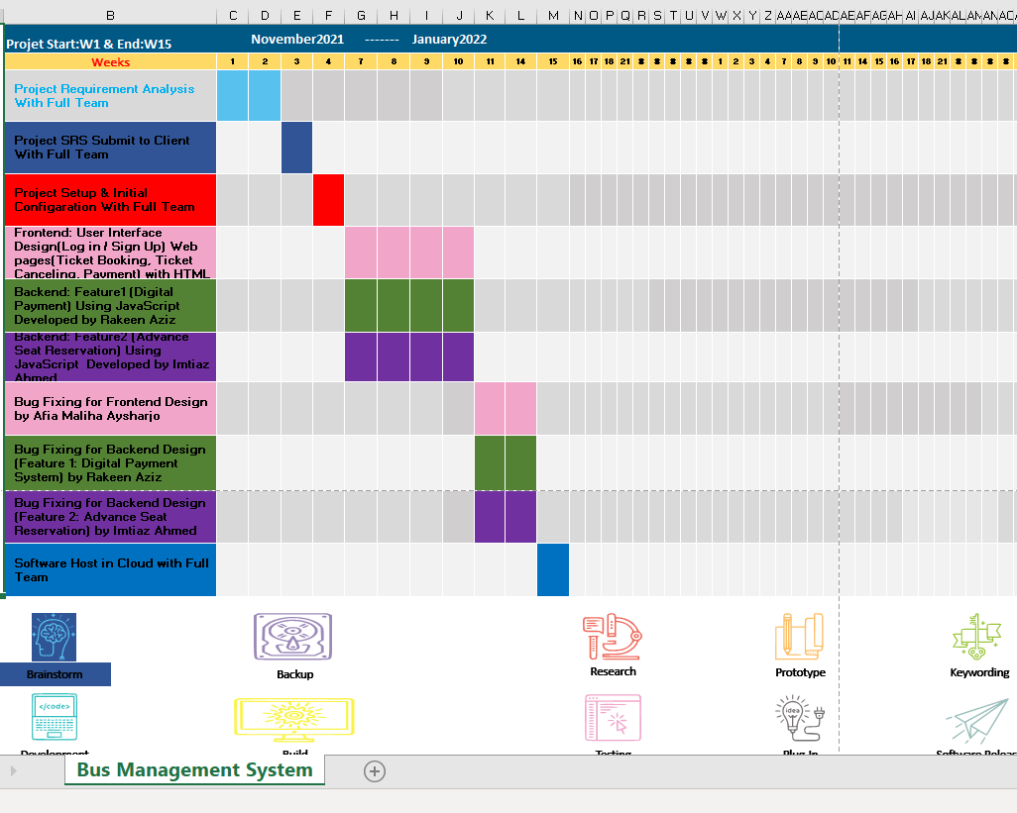

**Figure1.7: Gantt Chart of Bus Management System**

**Features:**

* Digital Payment
* Advance Seat Reservation

**Tools:**

**Frontend:**

HTML, CSS

**Backend:** PHP

**Conclusion:**

* The proposed system will help passengers to improve their commuter productivity.
* It make the schedules very frequent and easily useable to the users.
* The proposed system is web-based.