Tree View Practical

1. Run the Application so that you we see the First page as below.

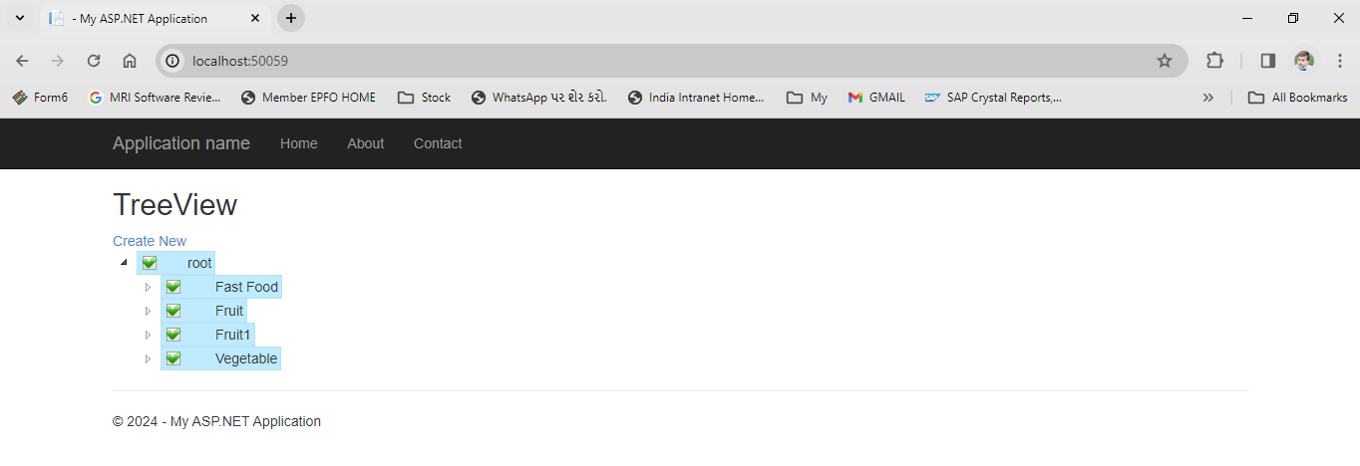

1. Click the link **Create New** which is highlighted below to create new node or child node.

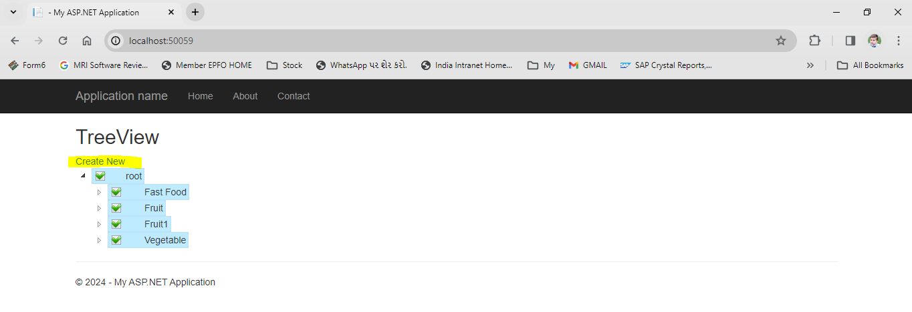

1. You will redirect below page.
   1. Select Parent node from the dropdown list if you want to create child node.
   2. Please leave the dropdown selection as it is if you want create Parent node.
   3. Checked the check box if you want to make active node/child.
   4. Click on create button.

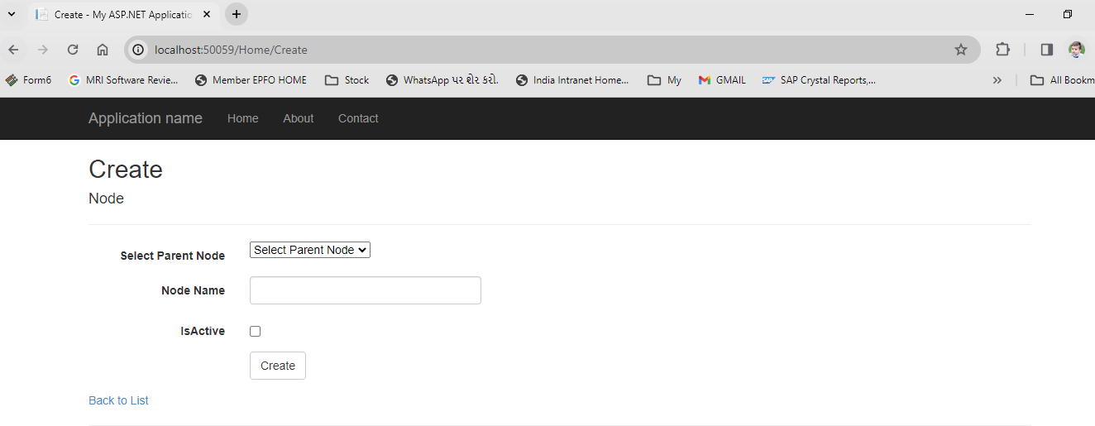

1. After creation of child/parent node you will redirect on mail page in which you will see the newly created parent/child node.