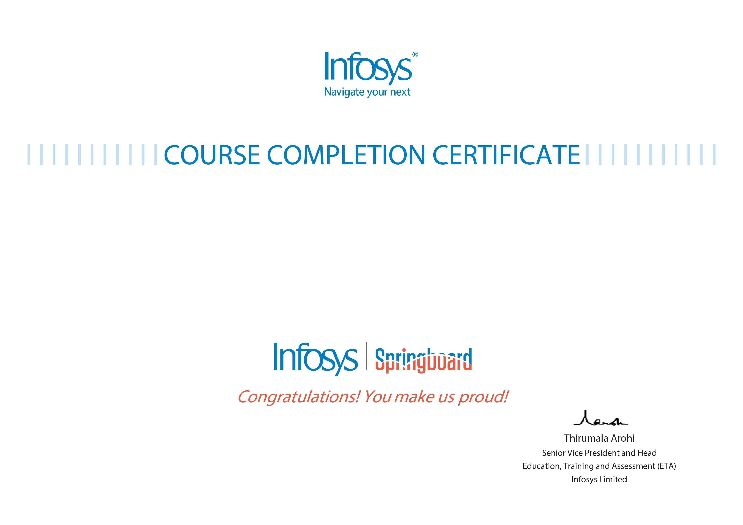
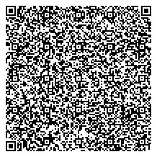
Anash Imtiyaz
Effective Communication Skills - Verbal and Non-Verbal Training
The certificate is awarded to
for successfully completing the course
on September 4, 2023
Issued on:
Tuesday, September 5, 2023
To verify, scan the QR code at
htt
ps://verif
y
.onwin
g
span.co
m

