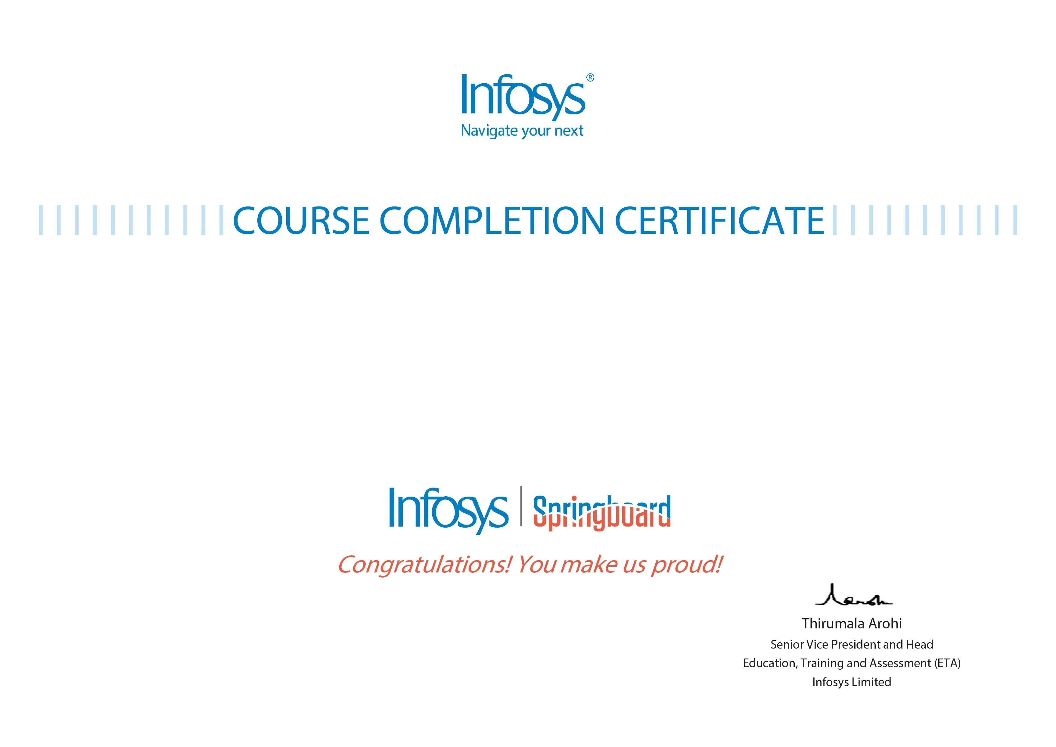
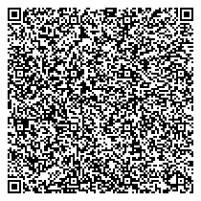
Anash Imtiyaz
Microsoft Word 2016
The certificate is awarded to
for successfully completing the course
on August 28, 2023
Issued on:
Tuesday, August 29, 2023
To verify, scan the QR code at
htt
ps://verif
y
.onwin
g
span.co
m

