Chisel Usable Limit.
Please check Chisel length after pulling out chisel from hammer without taking off Retainer Pin.
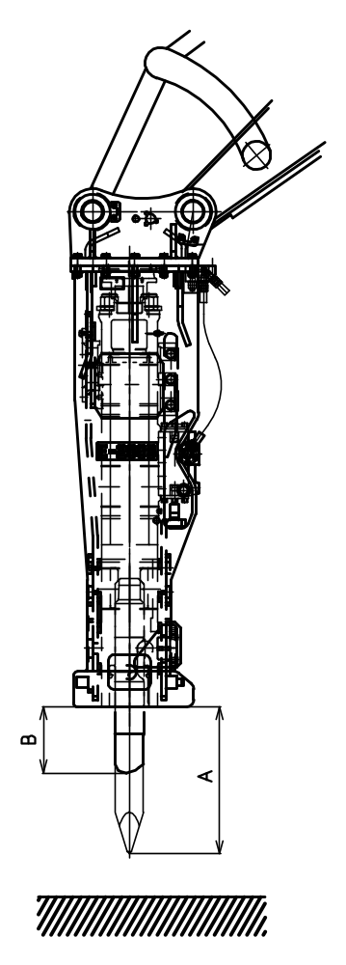
A: New chisel length.
B: Usable limit length.
（ｍｍ）
Model | Len  Length (A) |  |  |  | Usable Limit  (B)
Model | Standard |  | New Standard |  | Usable Limit  (B)
Model | P/E/FX | PC | P/E/FX | PC | Usable Limit  (B)
GH-06 | ― | ― | 348 | ― | 225
GH-07 | ― | ― | 371 | ― | 240
GH-1 | ― | ― | 397 | ― | 260
GH-2 | ― | ― | 419 | ― | 270
GH-3 | ― | ― | 466 | ― | 300
GH-4 | ― | ― | 517 | ― | 335
GH-6 | ― | ― | 567 | ― | 365
GH-7 | ― | ― | 719 | 733 | 410
GH-9 | ― | ― | 692 | 708 | 410
GH-10 | 683 | 699 | 783 | 799 | 410
GH-12 | 751 | 771 | 851 | 871 | 440
GH-15 | 795 | 815 | 895 | 915 | 470
GH-18 | 867 | 892 | 967 | 992 | 510
E-210/A/B/C | 715 | 715 | 715 | 715 | 430
E-213/A/B | 691 | 691 | 791 | 807 | 410
E-216/A/B | 739 | 739 | 839 | 859 | 440
E-220/A | 850 | 850 | 950 | 970 | 510
E-225/A | 842 | 842 | 942 | 967 | 510

