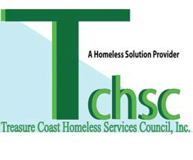­­­­

**TREASURECOASTHOMELESSSERVICES COUNCIL,INC.**

**2525 St. Lucie Avenue**

**Vero Beach, FL 32960**

**772-778-4234**

**772-567-7790**

Please email the copies of the following documents to me:

* Picture ID for head of household
* Social security cards for head of house hold
* Lease with details of the lease and signature page.
* Name/number/ email of the owner of your rental.
* Employer statement regarding adults in household being laid off directly related to Coronavirus- 19 (COVID-19)
* Proof of household income before you were laid off due to COVID, including a print out of your Child support income

**Proof of all household income**: check stubs; child support, income from wages, salaries, tips, bank statements for last two months, business income, interest& dividend income, retirement& insurance income, unemployment & disability income, welfare assistance, alimony, gift