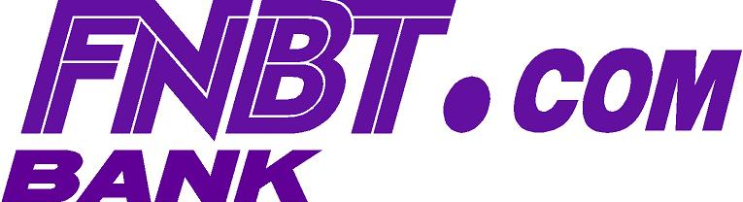

ELECTRONIC BANK STATEMENT INSTRUCTIONS

To access your FNBT.COM BANK Electronic Statement, clicking here which will take you to https://estatements.fnbt.com/webems. You will be directed to a Log In screen (see below) where you will input your Username and Password (see instructions below).

Welcome to FNBT.COM EMail Statements

Username: | 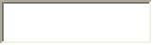
Password:
 | 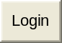
FIRST TIME USERS:
Enter USER NAME which is your Social Security Number
Enter PASSWORD which is the last four digits of your Social Security Number.
Click on “Login”
Click on “My PDF Statement” to view any of the bank statements listed (180 days of history is maintained)
Once you have successfully Logged In the first time, we recommend that you change your password to an alpha-numeric eight character password. To change the password, click on the "Change Password" link.
COMPUTER SYSTEM REQUIREMENTS TO ACCESS AND VIEW YOUR STATEMENT:

- An IBM or Macintosh compatible computer
- Internet Access
- An Internet Browser
- Adobe Acrobat Reader – Click here for free download - http://www.acrobat.com or click downloads link.
- Netscape Navigator 4.08/Netscape Communicator 4.7 or later versions
- Microsoft Internet Explorer 4.01 or later versions (4.51 for Mac users) To download a free copy, click here

Information sent through FNBT.COM BANK pages is secure and uses Secure Socket Layer (SSL) protocol. SSL technology secretly encrypts information that is being sent over the Internet between your computer and FNBT.COM BANK, helping to ensure that the information remains confidential. The use of SSL requires that the Customer have an SSL compatible browser. While older browser versions may support SSL sessions, FNBT.COM BANK strongly recommends the following browsers: For Windows and Unix operation systems: Netscape Navigator 4.08 or later; Netscape Communicator 4.07 or later; and Microsoft Internet 4.01 or later. For Macintosh: Netscape Navigator 4.08 or later; Netscape Communicator 4.07 or later; and Microsoft Internet Explorer 4.5 or later.

If you change your email address, please notify the bank at FNBTmail@fnbt.com to ensure timely electronic delivery of your monthly bank statements and other important account notifications.

Should you need assistance during business hours, Monday through Friday 8:00 am CT to 5:00 pm CT, you may:

Call 850-796-2000 or
Email FNBTmail@fnbt.com or
LIVE CHAT at www.fnbt.com

Revised 3.1.2011
FDIC~EQUAL HOUSING LENDER

