

**EAI 320: Artificial Intelligence**

Imtiaz Mukadam

U13083113

Assignment 8: Neural Networks

# Introduction

Neural networks are complex statistical learning structures that are used to classify discrete data sets. The concept of a neural network loosely resembles a biological neuron structure. The network is trained during backward propagation where the weights of a neural network is updated during supervised training i.e. a training data set with known outputs calibrate the network. The network is then used as a classifier during feed forward operation, where an unknown class input is fed into the network, and classified by the network based on the current weights of the network.

# Results

## Backward propagation concept – Question 1

The network is constructed to accept a matrix input of D-1 features, where the input matrix into the back_propagation() algorithm is a matrix of size D, including an input bias. The algorithm also accepts a target matrix which is used to train the network. If initial weight values are not provided to the function, random weight values between 0 and 1 are used as initial values.

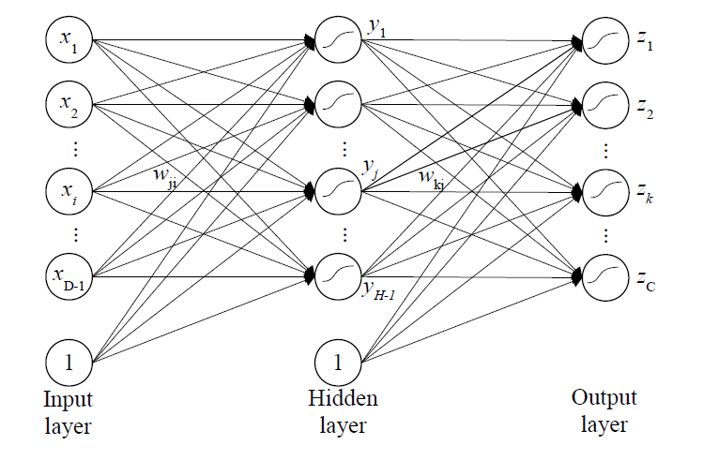

Figure Neural network structure

## Decision Boundary – Question 2

An input set of 2 features are provided to construct a decision boundary that resembles an arrow. The input dataset provide is of size D-1=720, and resembles graphical indices. The binary target set provided is used to train the network; thereafter a 21X21 surface plot is constructed to depict the decision boundary.

With H = 5, and a learning rate of 0.0001, the following output is achieved:

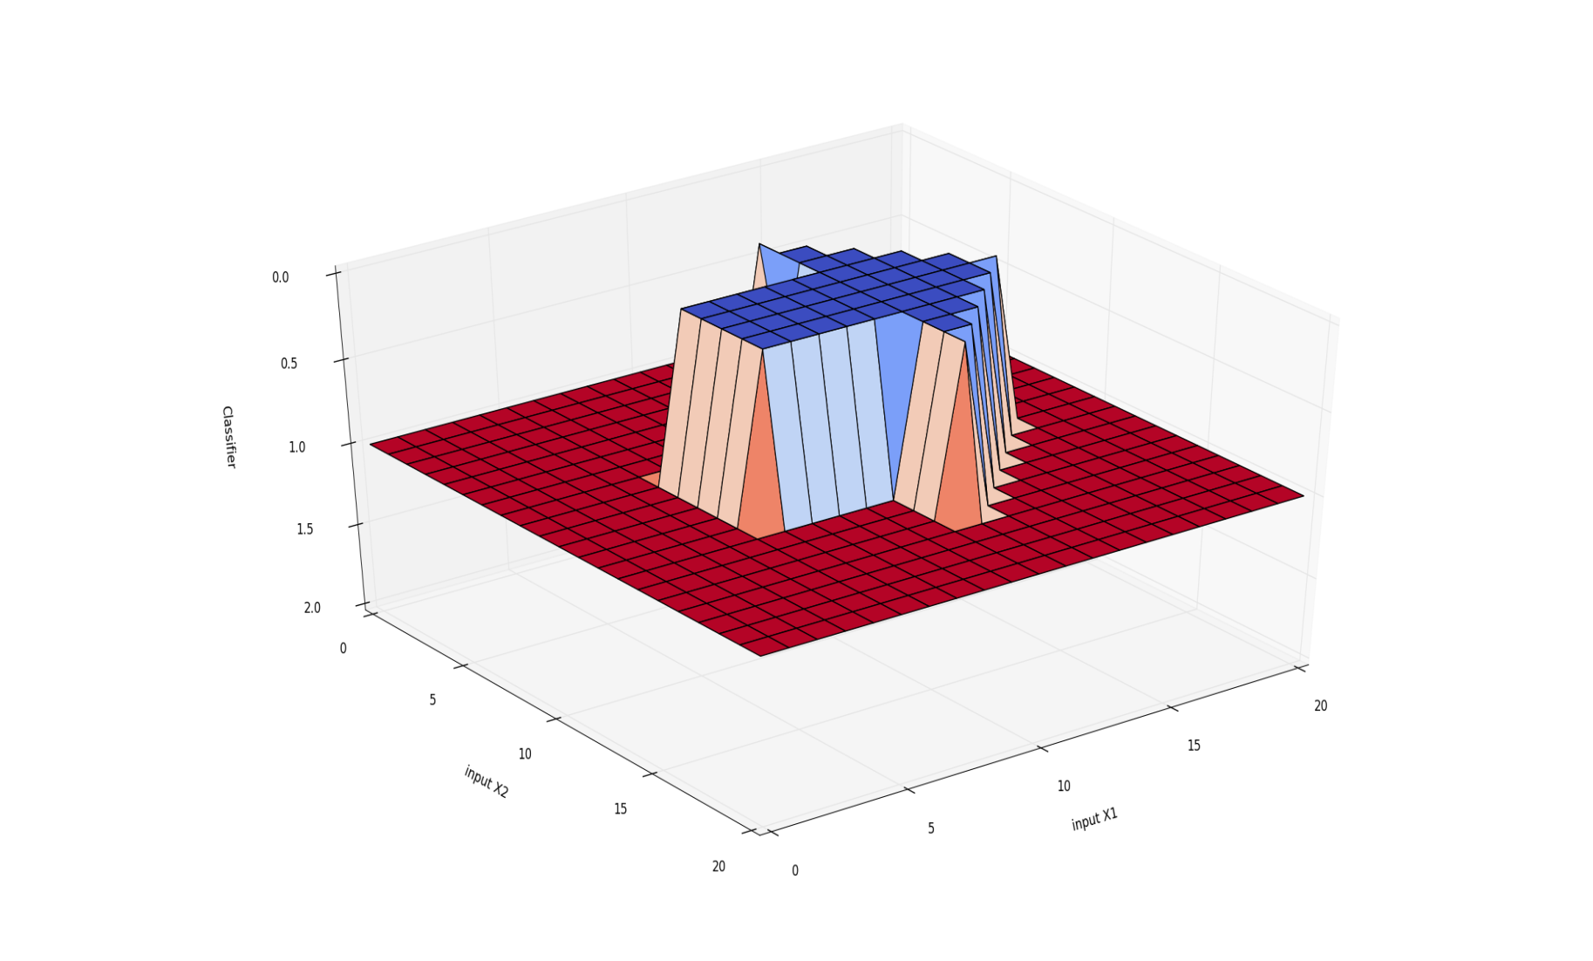

Figure Decision boundary surface plot result

# Discussion

The back propagation can be seen as the learning half of the neural network where the internal weights of the network are trained and updated during supervised learning. There are many factors that affect the backpropagation operation.

* Network depth – or the H value of the network, is the number of hidden neurons or nodes within the neural network structure. The greater the amount of hidden neurons, the more ‘deeper’ the learning during each epoch. However, increasing the number of neurons consequently increases the number of weights which increases the process time during each epoch.
* Learning rate – this can be seen as the degree of weight change per epoch. When the learning rate is small, the update of weights is small and thus a smaller error change is expected. This results in a greater amount of epochs for the error threshold to be reached. Thus a high learning rate leads to faster convergences to the training output. However, if the leaning rate is excessively large, the output of the network diverges and does not successfully update its weights.
* Iteration limit – When using a small learning rate or a network with a large hidden layer, it is useful to limit the number of epochs during the algorithm. The rate of change of the weights becomes significantly small after a significantly large number of epochs during the back propagation process.