**Lab Report No: 02**

**Name of the lab report: Basic Linux command.**

Writer Name: MD. Imtyaz Ahmed

ID: IT-17017

**Q.** What is Linux command?

**Answer :** Linux could be a Unix-Like software system. All the Linux/Unix commands square measure run within the terminal provided by the Linux system. This terminal is simply like prompt of Windows OS. Linux/Unix commands square measure case-sensitive. The terminal may be accustomed accomplish all body tasks. This includes package installation, file manipulation, and user management. Linux terminal is user-interactive. The terminal outputs the results of commands that square measure nominative by the user itself.

**15 essential Linux commands :**

1. pwd
2. ls
3. cd
4. mkdir & rmdir
5. rm
6. touch
7. man & --help
8. cp
9. mv
10. locate
11. Echo
12. Cat
13. nano, vi, jed
14. Sudo

**15**. du

**Description:**

**1. pwd** — once you 1st open the terminal, you're within the home directory of your user. to grasp that directory you're in, you'll be able to use the “pwd” command. It offers United States of America absolutely the path, which suggests the trail that starts from the basis. the basis is that the base of the UNIX classification system. it's denoted by a forward slash( / ). The user directory is typically one thing like "/home/username".



**2. Is** – Use the "ls" command to know what files are in the directly you are in.You can see all the hidden files by using the command“ls –a”.

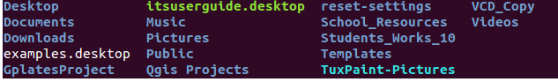

**3. cd**— Use the"cd ” command to travel to a directory.For example you're within the home folder,and you would like to travelto the downloads folder,then you'll be able to sort in “cd Downloads”.



**4. mkdir & rmdir** — Use the mkdir command when you need to create a folder or a directory. For example, if you want to make a directory called “DIY”, then you can type “mkdir DIY”. Remember, as told before, if you want to create a directory named “DIY Hacking”, then you can type “mkdir DIY\ Hacking”. Use rmdir to delete a directory. But rmdir can only be used to delete an empty directory. To delete a directory containing files, use rm.  
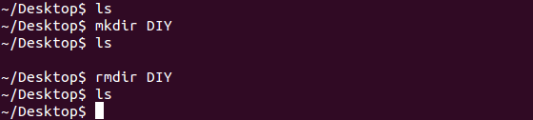

**5. rm**-- Use the ‘rm’command to delete files and directions.  


**6.Touch**-- the Touch command is used to create a file.  


7. **man & --help** — To know more about a command and how to use it, use the man command. It shows the manual pages of the command. For example, “man cd” shows the manual pages of the cd command. Typing in the command name and the argument helps it show which ways the command can be used (e.g., cd –help).

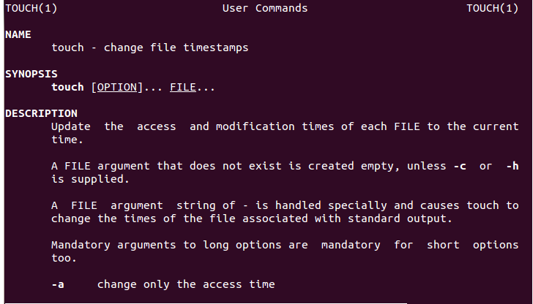

**8. cp** — Use the cp command to copy files through the command line. It takes two arguments: The first is the location of the file to be copied, the second is where to copy.  
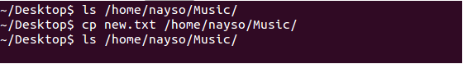

**9. mv** — Use the mv command to maneuver files through the statement. we will conjointly use the mv command to rename a file. as an example, if we wish to rename the file “text” to “new”, we will use “mv text new”. It takes the 2arguments, similar to the cp command.

**10. find** — The find command is employed to find a go into a UNIX operating system system, similar to the search command in Windows. This command is helpful after you do not know wherever a file is saved or the particularname of the file. victimization the -i argument with the command helps to ignore the case (it does not matter if it'smajuscule or lowercase). So, if you would like a file that has the word “hello”, it provides the list of all the files in your UNIX operating system system containing the word "hello" after you sort in “locate -i hello”. If you keep in mind 2 words, you'll separate them victimization associate degree asterisk (*). as an example, to find a file containing the words "hello" and "this", you'll use the command “locate -i *hello*this”.

**11. echo** — The "echo" command helps US move some information, sometimes text into a file. as an example, if you would like to make a brand new computer file or boost associate degree already created computer file, you simply got to sort in, “echo howdy, my name is mukit>> new.txt”. you are doing not got to separate the areas by victimization the backward slash here, as a result of we have a tendency to place in 2 triangular brackets once weend what we want to put in writing.

**12. Cat**-Use the Cat command to show the contents of a file.

**13. nano, vi, jed** — nano and vi area unit already put in text editors within the UNIX operating system statement. The nano command may be a smart text editor that denotes keywords with color and may acknowledge most languages. And vi is less complicated than nano. you'll produce a brand new file or modify a file victimization this editor. as an example, if you wish to form a brand new file named "check.txt", you'll produce it by victimization the command “nano check.txt”. you'll save your files once redaction by victimization the sequence Ctrl+X, then Y (or N for no). In my expertise, victimization nano for hypertext mark-up language redaction does not appear nearly as good, due to its color, therefore i like to recommend jed text editor. we'll return to putting in packages before long.

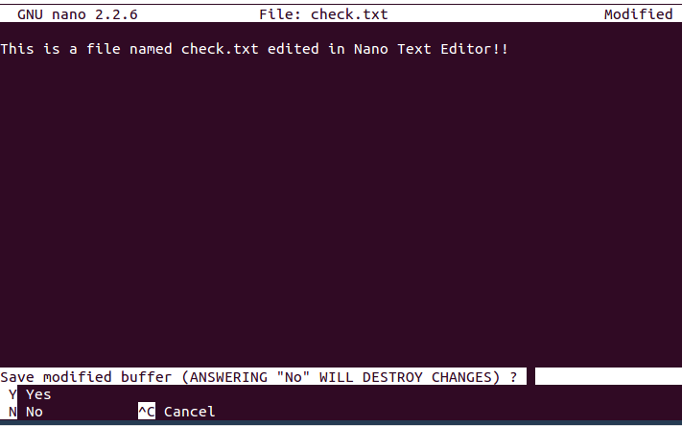

**14. sudo** — A widely used command in the Linux command line, sudo stands for "SuperUser Do". So, if you want any command to be done with administrative or root privileges, you can use the sudo command. For example, if you want to edit a file like viz. alsa-base.conf, which needs root permissions, you can use the command – sudo nano alsa-base.conf. You can enter the root command line using the command “sudo bash”, then type in your user password. You can also use the command “su” to do this, but you need to set a root password before that. For that, you can use the command “sudo passwd”(not misspelled, it is passwd). Then type in the new root password.

**15. du** — Use du to know the disk usage of a file in your system. If you want to know the disk usage for a particular folder or file in Linux, you can type in the command df and the name of the folder or file. For example, if you want to know the disk space used by the documents folder in Linux, you can use the command “du Documents”. You can also use the command “ls -lah” to view the file sizes of all the files in a folder.  


END