*Analyzing Amazon Sales data*

***Wireframe Documentation***

Homepage

As per the problem statement, we have divided analysis into three sections: -

# Impact of Rainfall in Price:

In this section we designed our first dashboard and tried to interpret the followings

* + Relation between Rainfall and Average Housing Price

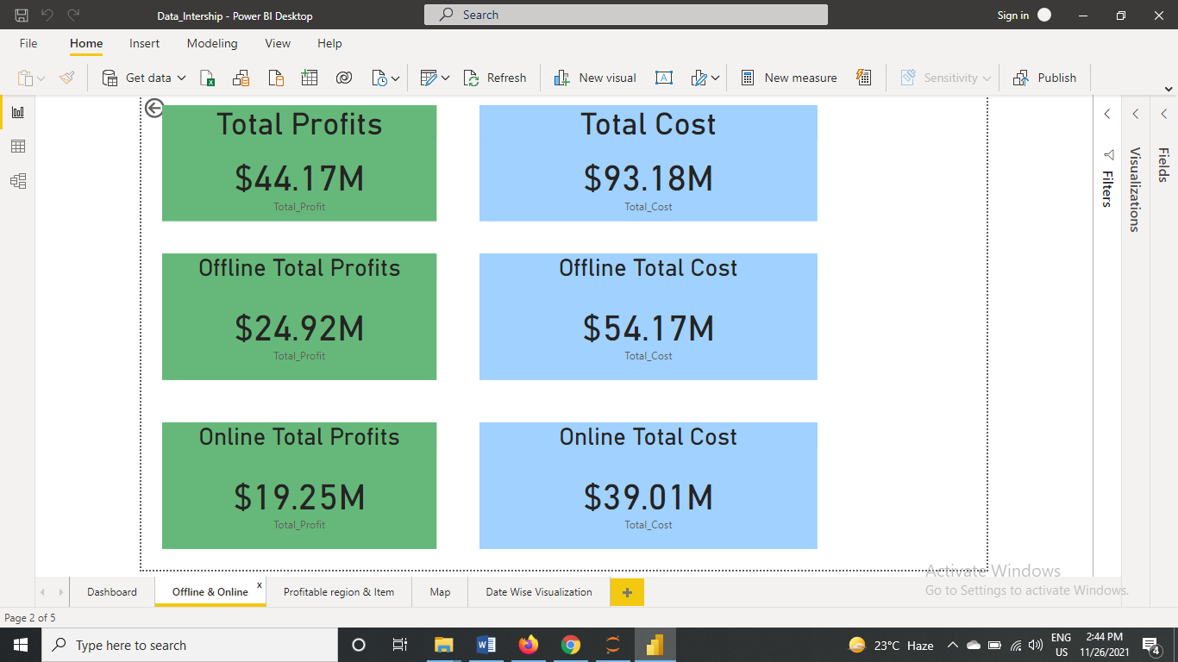

* + Rainfall and Average House Price across the cities

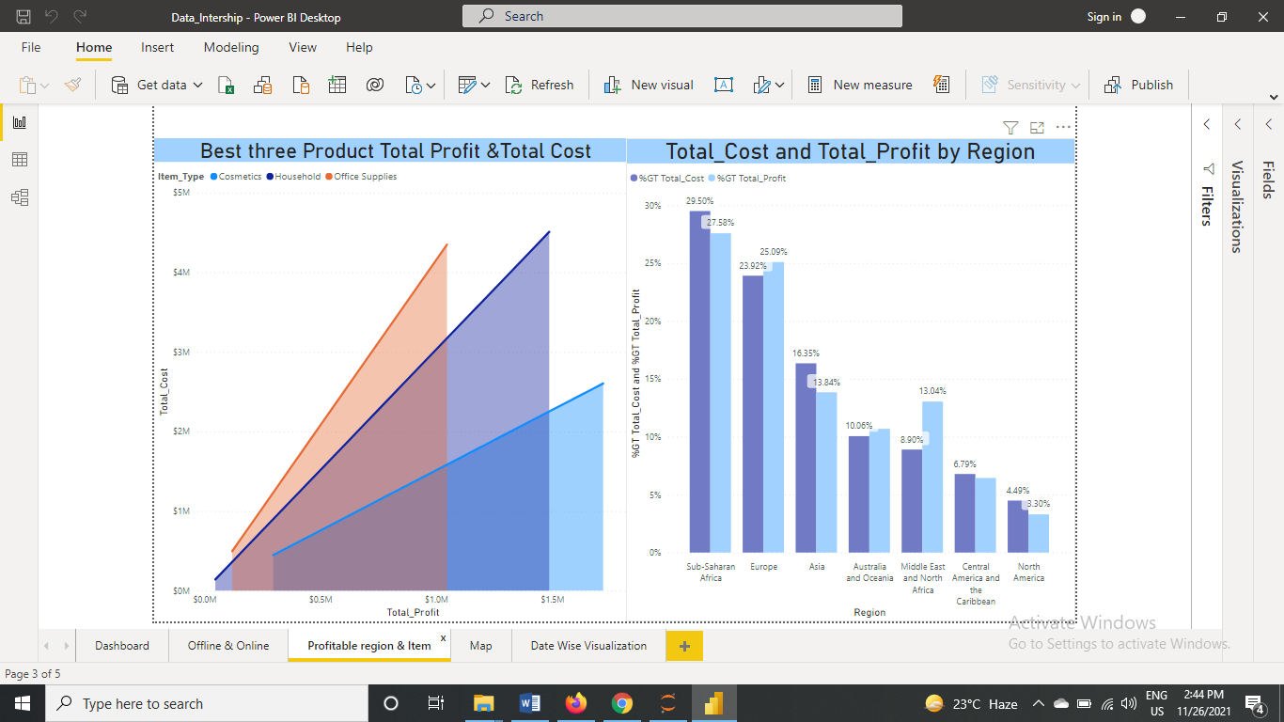

* + Relation between Rainfall and size of the housing

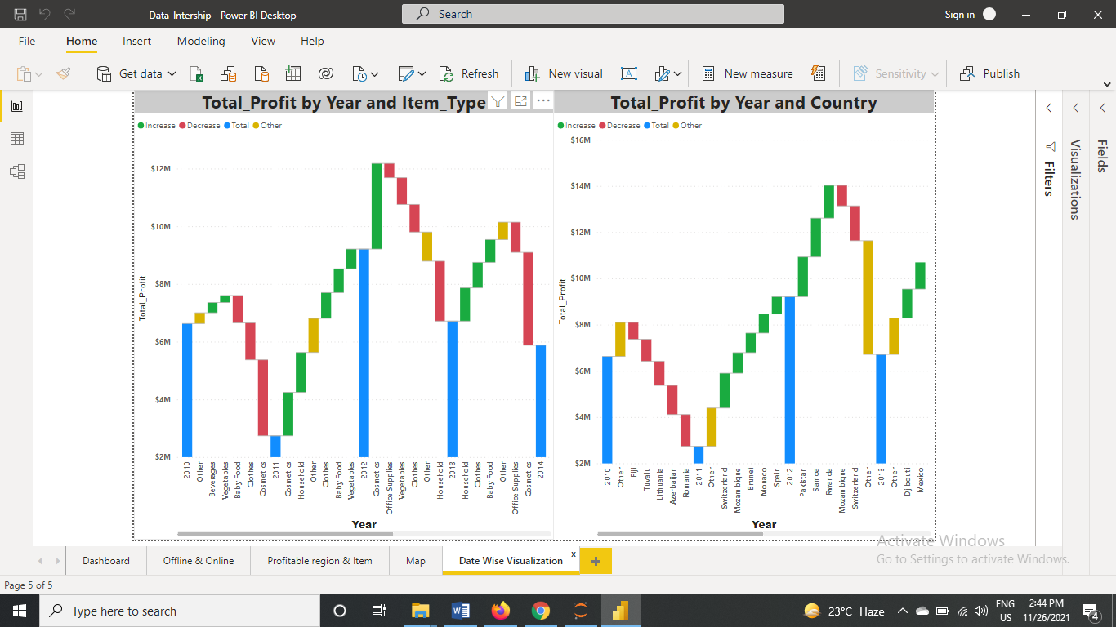

# Influence of Parking facilities on House Price Prediction

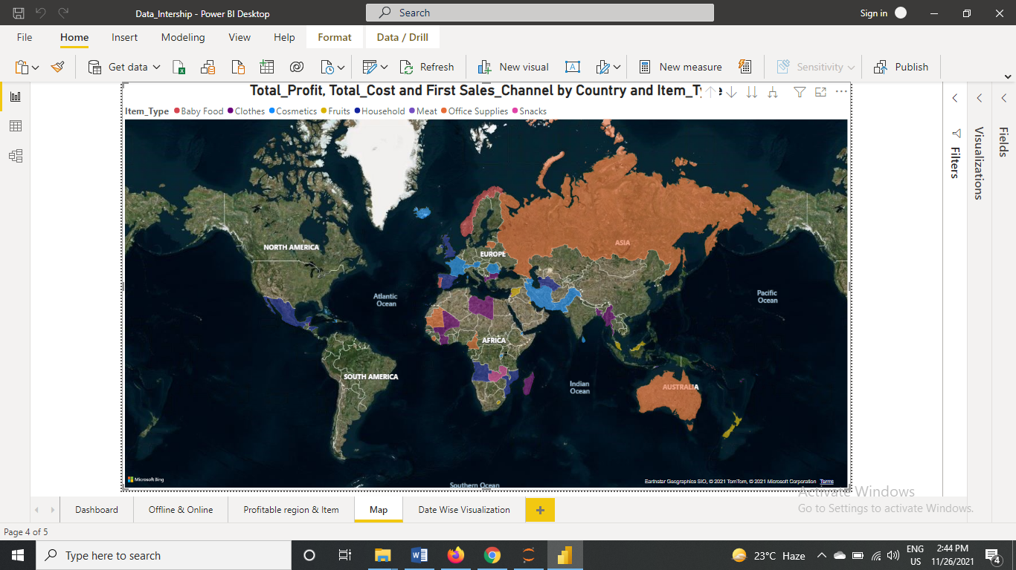

Here, we have our second dashboard and interpret the followings--

* + Distribution of House Price across the Cities