June 08, 2022

# SOFTWARE ENGINEERING

ASSIGNMENT NO.3





UMER AHMED BCS203182

## CHAUDHRY FOUZAN BCS203168

ZOHAIB MAILK BCS203183



# Question No.1 CLO 1

## Identify Functional:

1. Voters should be able to view the details of all parties.
2. Voter will be given option to select and finalize his/her vote.
3. System should be able to identify the fingerprints of the voter verify from NADRA.
4. System should properly save the voter records with proper serial number.
5. voters view should be independent.
6. once the vote is confirmed it should not be update or delete.
7. After the confirmation of vote notification should be sent to voter.
8. Verification of voter from NADRA will be mandatory.
9. Presiding officer can check voter info any time he wants.
10. Results should be valid and without any delay.

## Non-Functional Requirements:

1. Performance
2. Scalability
3. Capacity
4. Reliability
5. Recoverability
6. Maintainability
7. Serviceability
8. Security
9. Manageability
10. Environmental
11. Data Integrity
12. Usability

## Draw all Use Case diagrams

## Case Descriptions

|  |  |
| --- | --- |
| Use case Name: |  |
| Description: |  |
| Primary Actor: | Voter |
| Secondary Actor: | None |
| Precondition: |  |
| Postconditions |  |

|  |  |
| --- | --- |
| Use case Name: |  |
| Description: |  |
| Primary Actor: | NADRA |
| Secondary Actor: | None |
| Precondition: |  |
| Postconditions |  |

|  |  |
| --- | --- |
| Use case Name: |  |
| Description: |  |
| Primary Actor: | Election Commission of Pakistan |
| Secondary Actor: | None |
| Precondition: |  |
| Postconditions |  |

|  |  |
| --- | --- |
| Use case Name: |  |
| Description: |  |
| Primary Actor: | Presiding Officer |
| Secondary Actor: | None |
| Precondition: |  |
| Postconditions |  |

## Draw Domain Model

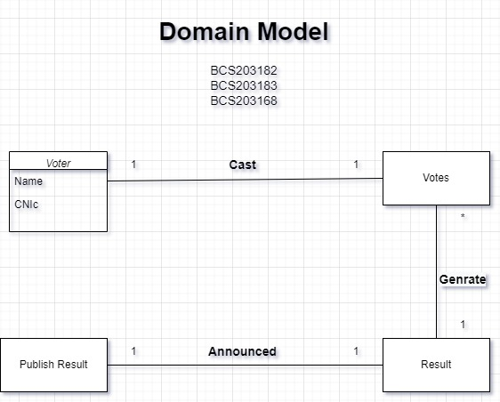

## Draw Class Diagram

