In our childhood, we all want to be a magician like harry potter. We just wing our wand in the air and the magic happens. We also want that blanket which Harry used to get invisible. As we all know, in reality, all these things don't exist.

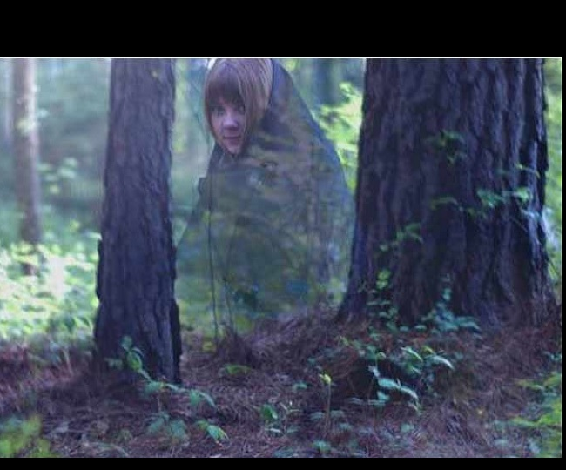

Today, we know we are surrounded by technology. With the help of technology, we can do many impossible things in different ways. In computer science, programming can do anything.

We all know about the python programming language. I didn’t mean about the python snake :P. Python is a very wide programming language and it has many awesome libraries for doing amazing tasks.

Now I'm picking one of the libraries from the python OpenCV. It stands for open-source computer vision. This library is used in the recognition of images, text, video capturing, etc.

Using this, We have made an amazing project, which invisible the red color objects from the video like the blanket of happy potter do.

**Algorithm Explanation**,

We have used three main libraries of python "cv2" for video capturing, frame reading, pixel management, color management of the video, "NumPy" which is used to do mathematical manipulation with the pixels of the video, flipping the order of matrices. and "time" for delays.

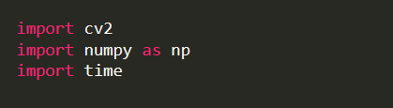

Firstly, what we have done is, we record the background of the video from the start. For recording, we have created a function. Then we storing the captured video in a variable name cap. then we provide a delay of 1 sec. Then we read each frame of video and store in the background variable which was initially zero. Then we flip the background values in the x-axis and return the value of the background.

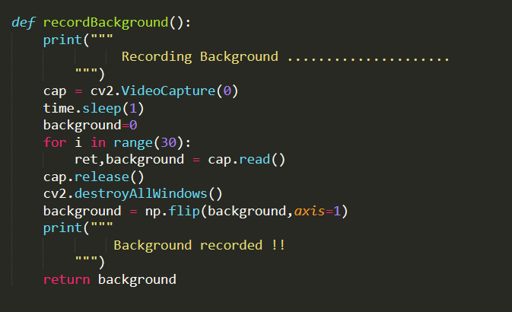

Now the main logic of the project begins. We have created a function to getInvisible. In this function, we write the main logic of the code. We get the background value from the record background function. Then inside the loop, we convert the color of the image from BGR to HSV color format. then we use GaussianBlur function to remove noises and distortion from the video frames. Then we created the two masks for the different shades of red color and add then to generate the final mask. Then we are replacing pixels of mask with the pixels of background. and show it on the output screen.

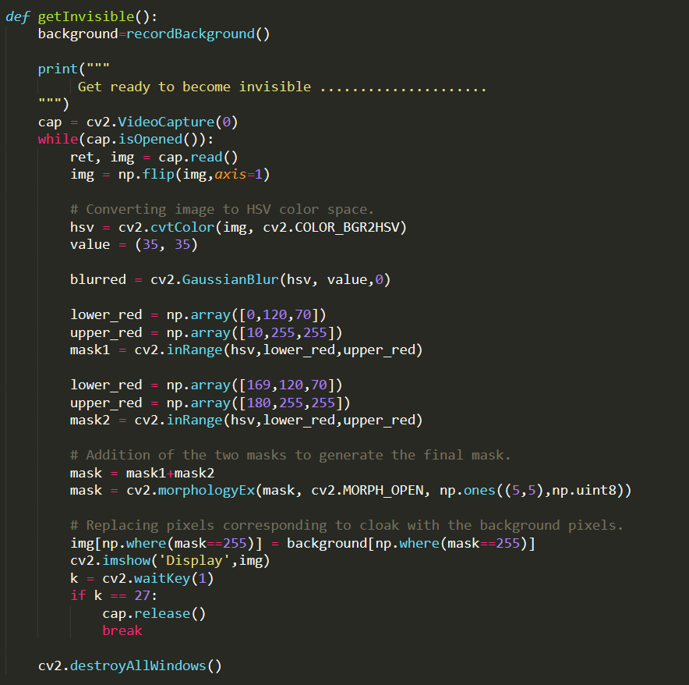

### **What is HSV color space?**

The HSV color space represents colors using three values

1. **Hue** : This channel encodes color color information. Hue can be thought of an angle where 0 degree corresponds to the red color, 120 degrees corresponds to the green color, and 240 degrees corresponds to the blue color.
2. **Saturation** : This channel encodes the intensity/purity of color. For example, pink is less saturated than red.
3. **Value** : This channel encodes the brightness of color. Shading and gloss components of an image appear in this channel.

Unlike RGB which is defined in relation to primary colors, HSV is defined in a way that is similar to how humans perceive color.So when I say, I need a particular color and select the hue component then depending on the saturation component I get different shades of that color and further depending on the value component I get different Intensities of a particular shade of the color.